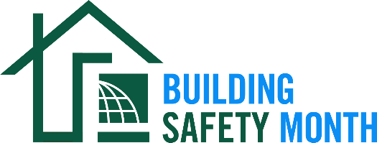

Sample Press Release

Dear Member: This news release template will help you tell your residents and elected officials about Building Safety Month and the important role you play in the safety of your community. Fill in the appropriate information. Be sure to include any special events you will be holding in conjunction with Building Safety Month and, if available to you, seek assistance from your jurisdiction’s Public Information Officer. Distribute the release in April or early May to your local media. You can also post it on your website and use on Twitter, Facebook, LinkedIn and other social media websites.

For Immediate Release | Contact: Name Here
Month Day, 2021 | Contact Phone Number
Website URL | Contact Email

(Jurisdiction name) joins International Code Council for the celebration of Building Safety Month 2021
(Insert subtitle about your local event/activities – ex. City XYZ is hosting a virtual happy hour on May XX to promote building safety and resilience)

CITY, STATE – In May 2021, (Name of jurisdiction and department) will participate in the 41st annual Building Safety Month, a worldwide campaign presented by the International Code Council, its members and partners to promote building safety. This year’s campaign, “Prevent, Prepare, Protect. Building Codes Save,” will be held virtually this year, raising awareness about the importance of building codes in ensuring safety in the spaces in which we live, work and learn.

As we prepare ourselves for the increased severity and frequency of natural disasters, building safety is even more important. Disaster mitigation through the adoption and enforcement of building codes is one of the best ways for communities to prepare and protect against future disasters. Homes and buildings that are built in compliance with building safety codes and the officials who enforce the codes are essential to helping communities minimize the risks of death, injury and property damage in the event of a disaster.

This year’s campaign themes are: Week One, May 1-9, Energy Innovation; Week Two, May 10-16, Training the Next Generation; Week Three, May 17-23, Water Safety and Week Four, May 25-31, Disaster Preparedness.

Local events to celebrate Building Safety Month include (list any activities you have planned, including date, time and location).

“No longer are places of residence simply a family living space; they’ve taken on the role of extended work, school, gym and entertainment centers,” said (name of jurisdiction, your title, your first and last name). “With a greater demand to create safe cities of the future, buildings need to account for increased capacity, dangers from natural disasters and resource shortages, and a wide range of public safety concerns. Building Safety Month provides homeowners, government officials and the public with the necessary information for ensuring safety in the spaces where they live, work and learn.”
With an extensive history dating back to 2200 B.C and the Code of the Hammurabi, king of the Babylonian Empire, building codes have protected the public for thousands of years. The regulation of building construction in the United States dates back to the 1700s. Today, the International Codes, developed by the Code Council and adopted by our community, are the most widely used and adopted set of building safety codes in the U.S. and around the world.

Learn more about Building Safety Month at www.buildingsafetymonth.org or join the conversation on social media using #BuildingSafety365.

###

About (Insert Jurisdiction Name)
(Insert boilerplate language about your jurisdiction)

