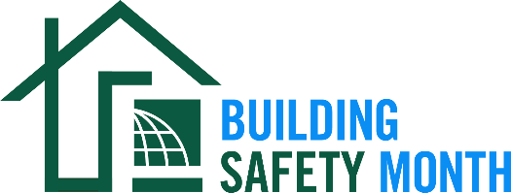

Sample Press Release

Dear Friend: This news release template will help you tell your residents and elected officials about Building Safety Month and the important role you play in the safety of your community. Fill in the appropriate information. Be sure to include any special events you will be holding in conjunction with Building Safety Month and, if available to you, seek assistance from your municipality’s or company’s Public Information Officer. Distribute the release in April or early May to your local media. You can also post it on your website and use on Twitter, Facebook, LinkedIn and other social media websites.

For Immediate Release | Contact: Name Here
Month Day, 2022 | Contact Phone Number
Website URL | Contact Email

(Municipality/Company name) joins International Code Council for the celebration of Building Safety Month 2022
(Insert subtitle about your local event/activities – ex. City XYZ is hosting a virtual happy hour on May XX to promote building safety and resilience)

CITY, STATE – In May 2022, (Name of municipality/department/company) will participate in the 42nd annual Building Safety Month, a worldwide campaign presented by the International Code Council, its members and partners to promote building safety. This year’s campaign, “Safety for All: Building Codes in Action,” raises awareness about the importance of building codes in ensuring safety in the spaces in which we live, work and learn.

Homes and buildings that are built in compliance with building safety codes and the officials who enforce the codes are essential to helping communities become affordable, resilient, and energy and water-efficient. Building Safety Month provides homeowners, government officials, and the public with the necessary information and resources to prepare and protect our built environment.

This year’s campaign themes are: Week One, May 1-8, Planning for a Safe & Sustainable Tomorrow; Week Two, May 9-15, Exploring Careers in Building Safety; Week Three, May 16-22, Understanding Disaster Mitigation; May 23-31, Creating a Safe & Abundant Water Supply

Local events to celebrate Building Safety Month include (list any activities you have planned, including date, time and location).

(Insert a quote from your local city or state leader about the significance of Building Safety Month, your municipality’s participation in Building Safety Month, or the importance of building codes.)

With an extensive history dating back to 2200 B.C and the Code of the Hammurabi, king of the Babylonian Empire, building codes have protected the public for thousands of years. Today, the International Codes, developed by the Code Council and adopted by our community, are the most widely used and adopted set of building safety codes in the world.

Learn more about Building Safety Month at www.buildingsafetymonth.org or join the conversation on social media using #BuildingSafety365.

###

About (Insert Municipality Name)
(Insert boilerplate language about your municipality)

