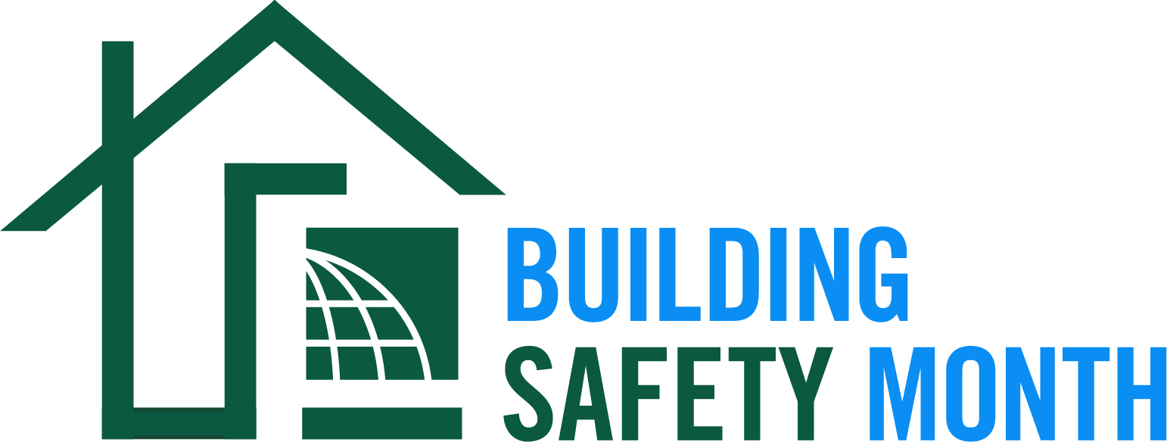

How to Submit a Proclamation for Countries Worldwide
- Please fill out the document on page 2 or use the language to create your own proclamation.
- Send your document to communications@iccsafe.org.
- Our communications team will review and post your proclamation on our Building Safety Month 2023 Proclamations page:

Proclamation
Building Safety Month — May 2023

Whereas our (City, Town, County, State) is committed to recognizing that our growth and strength depends on the safety and essential role our homes, buildings and infrastructure play, both in everyday life and when disasters strike, and;

Whereas our confidence in the resilience of these buildings that make up our community is achieved through the devotion of vigilant guardians––building safety and fire prevention officials, architects, engineers, builders, tradespeople, design professionals, laborers, plumbers and others in the construction industry––who work year-round to ensure the safe construction of buildings, and;

Whereas these guardians are dedicated members of the International Code Council, a nonprofit that brings together local, state, territorial, tribal and federal officials who are experts in the built environment to create and implement the highest-quality codes to protect us in the buildings where we live, learn, work and play, and;

Whereas these modern building codes include safeguards to protect the public from hazards such as hurricanes, snowstorms, tornadoes, wildland fires, floods and earthquakes, and;

Whereas Building Safety Month is sponsored by the International Code Council to remind the public about the critical role of our communities’ largely unknown protectors of public safety––our local code officials––who assure us of safe, sustainable and affordable buildings that are essential to our prosperity, and;

Whereas “It Starts with You,” The theme for Building Safety Month 2023, encourages us all to raise awareness about building safety on a personal, local and global scale, and;

Whereas each year, in observance of Building Safety Month, people all over the world are asked to consider the commitment to improve building safety, resilience and economic investment at home and in the community, and to acknowledge the essential service provided to all of us by local and state building departments, fire prevention bureaus and federal agencies in protecting lives and property.

NOW, THEREFORE, I, _______________________________, (Mayor, Supervisor, Commissioner, Governor) of the (City, Town, County, State) of ____________________________, do hereby proclaim the month of May 2023 as Building Safety Month. Accordingly, I encourage our citizens to join us as we participate in Building Safety Month activities.

_________________________________________________________________________
Signature

