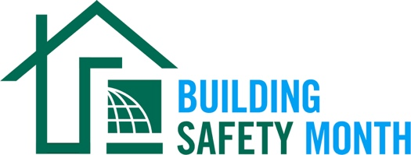

***Sample Press Release***

*This news release template will help promote your community’s involvement with Building Safety Month. Fill in the appropriate information. Be sure to include any special events being held in conjunction with Building Safety Month and, if available to you, seek assistance from your* *municipality’s or company’s Public Information Officer. Distribute the release in April or early May to your local media. You can also post it on your website and social media channels.*

|  |  |
| --- | --- |
| For Immediate Release | Contact: Name Here |
| Month Day, 2025 | Contact Phone Number |
| Website URL | Contact Email |

***(Municipality/Company name*) Joins International Code Council for the Celebration of Building Safety Month 2025**

*(Insert subtitle about your local event/activities – ex. City XYZ is hosting an in-person event for kids on May XX to promote building safety)*

**CITY, STATE –** Throughout the month of May, ***(Name of municipality/department/company)*** will participate in the 45th annual Building Safety Month, a worldwide campaign presented by the International Code Council, its members, and partners to promote building safety. This year’s campaign, “Game On!” encourages people to get involved in all aspects of building safety. The campaign also makes the connection between building codes and personal safety, as well as the important work done by building safety professionals in our communities.

This year’s campaign addresses how building safety impacts everyone on a personal, local, and global level.

* Week 1: The Warm Up, May 1–3 highlights how building safety impacts our daily lives including the places where we work, learn and play.
* Week 2: Build Your Offense, May 4–10 focuses on creating a plan to actively support building safety programs in your community.
* Week 3: Build Your Defense, May 11–17 encourages preparation for natural hazards such as severe weather, wildfires, earthquakes and more with our disaster toolkits.
* Week 4: The Starting Lineup, May 18–24 is a chance to meet building safety professionals and learn about rewarding careers in building safety.
* Week 5: Going Into Overtime, May 25–31 looks ahead to see what’s next for the building safety industry, including global trends, artificial intelligence and more.

Local events to celebrate Building Safety Month include ***(list any activities you have planned, including date, time and location)***.

***(Insert a quote from your local, city or state leader about the significance of Building Safety Month, your municipality’s participation in Building Safety Month, or the importance of building codes.)***

Learn more about Building Safety Month at [www.buildingsafetymonth.org](http://www.buildingsafetymonth.org) or join the conversation on social media using #BuildingSafety365.

###

**About *(Insert Municipality Name)***

(Insert boilerplate language about your municipality)