CECD1-XX-22

**Proponents:** John Bade (johnbade@2050partners.com

## Revise as follows:

**C403.11.6 Heat recovery for space conditioning in healthcare facilities.**

Where heating water is used for space heating, a ~~condenser~~ heat pump chiller meeting the requirements of Table C403.3.2(15) for heat recovery ~~system~~ and uses the cooling *system* return water as the heat source shall be installed where ~~provided that~~ ~~all of~~ the following are true:

1. The building is a Group I-2, Condition 2 occupancy.

2. The total design chilled water capacity for the Group I-2, Condition 2 occupancy, either air cooled or water cooled, required at cooling design conditions exceeds 3,600,000 Btu/h (1100 kw) of cooling.

3. Simultaneous heating, including *reheat*, and cooling occurs above 60°F (16°C) outdoor air temperature.

The ~~required~~ heat recovery system shall have a cooling capacity ~~that is~~ of not less than 7 percent of the total design chilled water capacity of the Group I-2, Condition 2 occupancy at peak design conditions.

**Exceptions:**

~~1. Buildings that provide 60 percent or more of their reheat energy from on-site renewable energy or site-recovered energy.~~

~~2.~~ Buildings in Climate Zones 5C, 6B, 7, and 8.

**Reason Statement:**

Section C403.11.6, “Heat Recovery for Space Conditioning in Healthcare Facilities,” requires heat recovery in most acute inpatient hospitals. The existing language refers to “condenser heat recovery.” The heat source was intended to be the chilled water return, and the economic justification was built on that. The diagram shows a parallel and in-series system. Both are acceptable ways to meet the requirement.

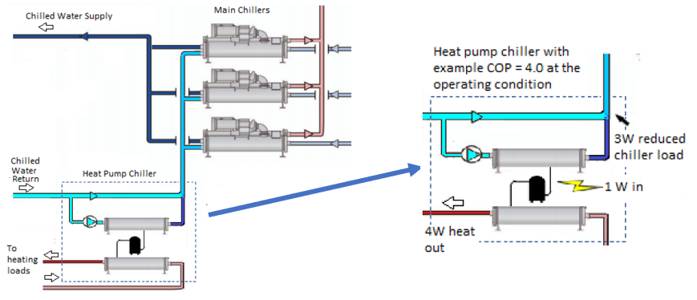

Figure 1. Heat pump chiller piped in series

Figure 2. Heat pump chiller piped in parallel

The term “condenser heat recovery” has led some users to believe that the heat source can be water leaving the main chiller condenser. While this method does recover heat, it does not reduce the load on the chillers. Using the chilled return water as the heat source saves much more energy.

Reviewers should know that the misunderstanding extends to the ASHRAE 90.1-2019 User’s Manual. The intent of the language is not correctly described. This discrepancy will be addressed.

ASHRAE SSPC 90.1 passed addendum cu, which is nearly identical to this proposal. It was included in the 2022 version of the standard. The addendum can be found at this link:

<https://www.ashrae.org/file%20library/technical%20resources/standards%20and%20guidelines/standards%20addenda/90_1_2019_cu_20220630.pdf>

*Economic justification:*

This addendum clarifies existing requirements. The economic justification was completed when Section 6.5.6.3 was created for the 2019 version of ASHRAE 90.1, and the same rationale was used for IECC 2021. The justification was based on recovering heat from the chilled water return.

*Cost of construction:*

This proposal neither increases nor decreases the cost of construction. The exception for site recovered energy was removed because there is no first cost increase to use the chilled water return system as the heat source rather than the chiller condenser water. The exception for on-site renewable energy was removed because there are now separate requirements for on-site renewable energy elsewhere in the standard.