Replace C503.5 in its’ entirety with the following:

C503.5 Lighting systems. Lighting systems that are part of the alteration shall comply with Sections C503.5.1 and C503.5.2.

C503.5.1 Interior Lighting and Controls. Interior lighting and controls in alterations shall comply with the following:

1. Where the size or configuration of interior spaces is altered, those spaces shall be included in the lighting power compliance calculations required by C405.3 and lighting controls in those spaces shall comply with C405.2 and C408.

2. Where lighting controls are added or altered within a space, the lighting controls within that space shall comply with C405.2 and C408.

3. Where the connected interior lighting power within a space is altered that space shall be included in the lighting power compliance calculations required by C405.3 and the existing lighting controls for that space shall undergo functional testing as follows:

3.1 Verify that manual controls function.

3.2 Verify that occupant sensors automatically turn off the lights when spaces are unoccupied.

3.3 Verify that timeswitch controls are functioning, set to the correct day and time, programmed with scheduled off times, and provided with fresh backup batteries (where applicable).

Exception: Any space where the connected lighting power is reduced by at least 20 percent is not required to be included in the lighting power calculations required by C405.3.

C503.5.2 Exterior Lighting and Controls. Alterations to exterior lighting and controls shall comply with the following:

1. Where the connected exterior lighting power is increased by more than 10 percent, all exterior lighting, including lighting which is not proposed to be altered, shall comply with C405.5, and all lighting which is added or altered shall be controlled in accordance with C405.2 and C408.

2. Where exterior lighting controls are added or altered, those portions of the lighting control system which are added or altered shall comply with C405.2 and C408.

ALTERATIONS

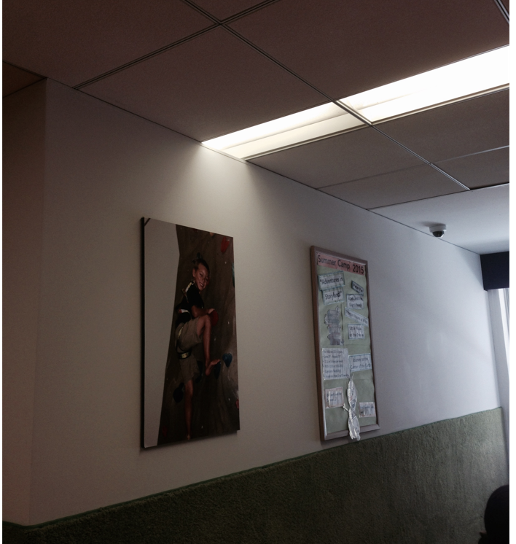
This chart identifies many possible lighting systems alterations and explains why CEPI-230 would either require compliance or provide an exception from code compliance.

Interior Lighting System Alterations
Proposed Alteration | Require Compliance | Exempt | Reason
Add a luminaire(s) | Lighting power | Lighting controls | If wattage is proposed to be increased then compliance should be demonstrated with lighting power requirements. Existing lighting controls can remain, provided they are shown to be functional.
Remove a luminaire(s) that results in <20% power reduction | Lighting power | Lighting controls | Given the dramatic improvements in lighting technology it should always be possible to either reduce connected lighting power by 20% or comply with current code. This is not a terrible burden to impose. Existing lighting controls can remain, provided they are shown to be functional.
Remove a luminaire(s) that results in ≥20% power reduction |  | Lighting power and controls
Relocate existing luminaires within a space |  | Lighting power and controls | If the overall quantity of lights within the space is not changing then let people move lights around for better distribution, etc. Existing lighting controls can remain, provided they are shown to be functional.
Relocate existing luminaires from one space to another. | Covered under “add a luminaire” / “remove a luminaire” above.
Combine existing spaces or subdivide an existing space. | Lighting power and controls |  | Quite often an Owner will try to reduce the cost of planning changes by not doing any “above ceiling work”. This is problematic in a number of ways including fire protection systems and HVAC. From a lighting standpoint it will often mean that lighting controls no longer work properly, with resulting inefficiencies.
Change the type of an existing space. |  | Lighting power and controls | Not a “change of use or occupancy”. Rather, a private office is converted to a storage room, or a teacher lounge is converted to a classroom. It would be too difficult to enforce efficiency requirements in a situation like this as these types of changes would not ordinarily require a filing.
Reballast / relamp existing luminaire where the wattage increases. | Lighting power | Lighting controls | If wattage is proposed to be increased then compliance should be demonstrated. Existing lighting controls can remain, provided they are shown to be functional.
Reballast / relamp existing luminaire(s) resulting in <20% power reduction | Lighting power | Lighting controls | Given the dramatic improvements in lighting technology it should always be possible to either reduce connected lighting power by 20% or comply with current code. This is not a terrible burden to impose. Existing lighting controls can remain, provided they are shown to be functional.
Reballast / relamp existing luminaire(s) resulting in ≥20% power reduction |  | Lighting power and controls
Alter or add to existing lighting control systems. | Lighting controls | Lighting power | An alteration to an existing lighting control system could cause the system to become less efficient, so it is necessary to demonstrate compliance in any spaces where controls are being added or altered. For example, you could add a switch to an existing control system which improves lighting efficiency by subdividing an existing control zone, or you could add that switch in such a way that it bypasses an occupancy sensor or overrides the daylight responsive controls and makes the lighting less efficient. There are also instances where experts could honestly disagree about whether a particular proposed alteration is more efficient or less efficient than the existing lighting controls. For all of these reasons, the simplest option is to always require compliance when control systems are being altered. However, it should be possible to upgrade lighting controls without being required to simultaneously upgrade the luminaires.

Exterior Lighting Alterations
Proposed Alteration | Require Compliance | Exempt | Reason
Add luminaire(s) with >10% increase in connected lighting power across the site | Lighting power for entire site + lighting controls for added lighting | Lighting controls for existing lighting | Where a significant increase in installed lighting wattage is proposed it should be necessary to demonstrate compliance with current code, even though this is not easy as compliance must be demonstrated for the entire site. It is not clear how you could determine the allowed lighting wattage for just a portion of the site. For example, how would you apportion the “Base Site Allowance” across a 10-acre site when you are only proposing to alter the lighting in one small corner? For lighting controls, on the other hand, it is straightforward to comply with the lighting controls requirements only for the added light(s).
Reballast / relamp existing luminaire(s) with >10% increase in connected lighting power across the site
Add luminaire(s) with ≤ 10% increase in connected lighting power across the site |  | Lighting power and controls | These projects are not ordinarily filed, and given the difficulty of demonstrating compliance for exterior lighting (see above) demonstrating compliance with current code would be a significant administrative burden for these small projects.
Remove a luminaire(s)
Relocate existing luminaires
Reballast / relamp existing luminaire(s) with ≤ 10% increase in connected lighting power across the site
Reballast / relamp existing luminaire where the wattage decreases.
Change the configuration / layout of site components without altering lighting. |  | Lighting power and controls | As long as no changes to lighting are proposed, it should be permissible to convert a lawn to an “overflow parking area” or to convert part of a parking lot to a pedestrian plaza without demonstrating compliance with the lighting requirements in the code.
Alter or add to existing lighting control systems. | Lighting controls that are being added or altered | Lighting power + lighting controls which are not proposed to be altered | An alteration to an existing lighting control system could cause the system to become less efficient, so it is necessary to demonstrate compliance for those portions of the system which are being added or altered. There are also instances where experts could honestly disagree about whether a particular proposed alteration is more efficient or less efficient than the existing lighting controls. For all of these reasons, the simplest option is to always require compliance when control systems are being altered. However, it should be possible to upgrade the lighting control system without upgrading the luminaires, and it should also be possible to upgrade just a portion of the exterior lighting controls without being required to upgrade the entire exterior lighting control system. For example, if a high school wanted to add a timeswitch to shut off lights in their parking lot after midnight, they should be allowed to do this without also being required to upgrade the controls for the sports field lighting to meet current code.

