**International Code Council**

**Chapter Annual Report and   
Chapter Awards/Reward Program**

Good news ICC Chapter Leaders!

The main ICC Chapter benefit programs are all available under one application process! Complete the ICC Chapter Annual Report by March 15 of each year and you’ll be eligible for

* One Chapter Education Benefit Day for the next year
* One complimentary registration to the next Annual Conference or Chapter Leadership Academy (Academy registration includes travel cost reimbursement)
* Consideration for Chapter of the Year or a Chapter Merit Award
* Points earned and redeemed in the Chapter Rewards Program

To reach the Annual Report, access your chapter’s account information.

**Log in to your myICC page.** Use your email address and the password you use for other ICC activities. After you log into [www.iccsafe.org](https://protect-us.mimecast.com/s/bdOyCXDR13tXZwyZuDpU6d?domain=iccsafe.org), you’ll see the link to myICC under the login area:

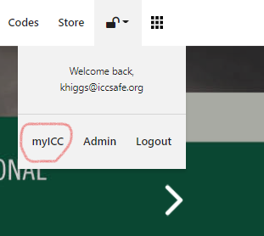

When you reach your myICC page, **choose Chapters** from the left side of the screen, then **choose Manage Chapter**.

From the next screen, **click on the Annual Report tab** and **choose “Add Annual Report.”**

The Annual Report is in two parts. If you wish to receive your Chapter Education Benefit Day and complimentary registration, **complete Part 1** only. If you wish to be included in the Chapter Awards Program and to enter and redeem points in the Chapter Rewards Program, **complete Part 2** as well. Part 2 points may be added to throughout the year and will be redeemed after the end of the year.

Questions? **Email** [chapters@iccsafe.org](mailto:chapters@iccsafe.org) or **contact Chapter Relations** at 888-ICC-SAFE (888-422-7233) x5268.