

**ICC 1100-20xx**

|  |
| --- |
|  |
|  |

**Standard for**

**Spray-applied Polyurethane Foam Plastic Insulation**

**Public Input Draft #2**

|  |
| --- |
|  |
|  |

**The Public Input Draft #2 for ICC 1100 Standard for Spray-applied Polyurethane Foam Plastic Insulation is available for public input. The IS-FPI Committee has held 1 public meeting to develop this draft dated July 2017. Public input is requested on Public Input Draft #2. ~~Line through text to be deleted.~~ Underline text to be added. For access to the Comment Forms go to** [**IS-FPI ICC 1100**](https://www.iccsafe.org/codes-tech-support/codes/code-development-process/standards-development/is-fpi/)

**The Public Input deadline is September 4, 2017**

**TABLE OF CONTENTS**

**CHAPTER 1 APPLICATION AND ADMINISTRATION**

Section 101 General

Section 102 Scope

Section 103 Compliance Alternatives

Section 104 Referenced Documents

**CHAPTER 2 DEFINITIONS**

Section 201 General

Section 202 Defined Terms

**CHAPTER 3 PHYSICAL AND PERFORMANCE REQUIREMENTS**

Section 301 Physical Properties

Section 302 Fire Performance

Section 303 Installation

**CHAPTER 4 REFERENCED STANDARDS**

**CHAPTER 1**

**APPLICATION AND ADMINISTRATION**

**SECTION 101**

**GENERAL**

**101.1 Purpose.** The purpose of this standard is to establish the minimum requirements for spray-applied polyurethane foam plastic thermal insulation for physical properties, performance requirements in compliance with the intent of the model building codes for a variety of construction applications and basic installation requirements.

**SECTION 102**

**SCOPE**

**102.1 Scope.** This standard applies to single- and multiple-component spray-applied polyurethane foam plastic insulation intended for use in variety of nonstructural building construction applications. This standard is limited to *spray-applied foam plastic* insulation that is sprayed in place where, during the application, the *spray-applied foam plastic* insulation is applied in a liquid or frothed state and permitted to free-rise and cure in situ.

This standard provides diversified test procedures for qualifying fire performance characteristics of *spray-applied foam plastic* insulation exceeding the maximum thickness tested in accordance with ASTM E84 or UL 723 and for qualifying *alternative ignition barrier assemblies* and *alternative thermal barrier assemblies*.

**SECTION 103**

**COMPLIANCE ALTERNATIVES**

**103.1 Compliance alternatives.** Nothing in this standard is intended to prevent the use of designs, products or technologies as alternatives to those prescribed by this standard, where equivalence is provided, and such equivalence is approved by the administrative authority adopting this standard.

**SECTION 104**

**REFERENCED DOCUMENTS**

**104.1 Reference documents.** The codes and standards referenced in this standard shall be considered part of the requirements of this standard to the prescribed extent of each such reference. Chapter 4 contains a complete list of all referenced standards.

**CHAPTER 2**

**DEFINITIONS**

**201 GENERAL**

**201.1 General.** For the purpose of this standard, the terms listed in Section 202 have the indicated meaning.

**201.2 Undefined terms.** The meaning of terms not specifically defined in this document or in referenced standards shall have ordinarily accepted meanings such as the context implies.

**201.3 Interchangeability.** Words, terms and phrases used in the singular include the plural and the plural the singular.

**SECTION 202**

**DEFINED TERMS**

**AIR IMPERMEABLE INSULATION.** An insulation which, at a given thickness, allows a maximum total air leakage rate of 0.02 L/s-m2 (0.004 ft3/min-ft2) when tested at a 75 Pa pressure differential in accordance with ASTM E283 or ASTM E2178, as amended in this standard.

**ALL CONSTRUCTION PLANES.** Within an attic or crawl space, any surface exposed to the interior space of the attic regardless of its orientation within that space.

**ALTERNATIVE IGNITION BARRIER ASSEMBLY:** An assembly consisting of either the exposed *spray-applied foam plastic* or the *spray-applied foam plastic* with a fire-protective *covering*, that has been tested in accordance with and complies with the conditions of acceptance of Section 302.2.4 of this Standard.

**ALTERNATIVE THERMAL BARRIER ASSEMBLY:** An assembly consisting of either the exposed *spray-applied foam plastic* or the *spray-applied foam plastic* with a fire-protective *covering*, that complies with the Special Approval section of the International Building Code or the Specific Approval section of the International Residential Code. Referenced test procedures include NFPA 286, UL 1715, FM 4880 or UL 1040.

**COVERING.** Any material forming a protective layer or membrane, including boards, sheet goods or liquid-applied coating materials which protect *spray-applied foam plastic* from environmental effects such as fire or ultra-violet light exposure.

**FREE RISE.** A condition of application wherein the *spray-applied foam plastic* is applied to a substrate or within a cavity and allowed to expand in at least one direction without constraint.

**IGNITION BARRIER.** A protective covering applied over foam plastic insulation in attics and crawlspaces to increase the time it takes for the foam plastic to become involved in a fire.

**INSULATION APPLICATIONS.** *Insulation applications* are those applications where the *spray-applied foam plastic* insulation is applied on or in building elements or construction assemblies which are not *roofing applications*.

**ROOFING APPLICATIONS.** *Roofing applications* are those applications wherein the *spray-applied foam plastic* insulation is applied to the exterior of a roof deck as a component of a roof assembly.

**SPRAY-APPLIED FOAM PLASTIC.** Single- and multi-component, spray-applied polyurethane foam plastic insulation used in nonstructural applications which are installed at locations wherein the material is applied in a liquid or frothed state, permitted to free rise and cure in situ.

**THERMAL BARRIER.** A material applied over *spray-applied foam plastic* insulation designed to slow the temperature rise of the foam during a fire situation and delay its involvement in the fire.

**UTILITIES.** For the purposes of attic and crawlspace entry, *utilities* include, but are not limited to, mechanical equipment, electrical wiring, fans, plumbing, fuel-fired or electric hot water heaters, and fuel-fired or electric furnaces.

**CHAPTER 3**

**PHYSICAL AND PERFORMANCE REQUIREMENTS**

**SECTION 301**

**PHYSICAL PROPERTIES**

**301.1 General.** *Spray-applied foam plastic* insulation shall comply with the requirements as stated in Table 1. Where the number of test specimens is not specified in the applicable test methods, a minimum of five specimens shall be used.

**Exception:** *Spray-applied foam plastic* insulation used in *roofing applications* shall comply with the requirements in either ASTM C1029, Type III or IV, or ASTM D7425, as applicable.



**TABLE 1. PHYSICAL PROPERTIES OF LOW-DENSITY SPRAY-APPLIED FOAM PLASTIC**

**(nominal core density less than 1.5 pcf)**

|  |  |  |  |  |  |
| --- | --- | --- | --- | --- | --- |
| **PROPERTY** | **TESTS** | **VALUE** | | **NUMBER OF SAMPLES** | **SAMPLE PREPARATION** |
| Thermal Resistance | ASTM C177,  ASTM C518, or  ASTM C1363 | Minimum closed cell content of 90% | As reported | 5 at each thickness | (a) 73 ± 2°F (23 ± 1°C) and 50 ± 5 % relative humidity for 180 ± 5 days;  or  (b) 140 ± 2°F (60 ± 1°C) and dry heat for 90 ± 2 days |
| Closed cell content of less than 90% | As reported | 5 at each thickness | (a) 73 ± 2°F (23 ± 1°C) and 50 ± 5 % relative humidity for 30 days min.  or  (b) 73 ± 2°F (23 ± 1°C) and 50 ± 5 % relative humidity for 180 ± 5 days;  or  (c) 140 ± 2°F (60 ± 1°C) and dry heat for 90 ± 2 days |
| Core Density | ASTM D1622 | As Reported | | 3 | In accordance with Section 6.3 of the standard |
| Tensile Strength | ASTM D1623 | Minimum closed cell content of 90% | 5.0 lbf/in2 (21 kPa) min | 5 | In accordance with test standard |
| Closed cell content of less than 90% | 3.0 lbf/in2 (21 kPa) min |
| Dimensional Stabilitya | ASTM D2126 | 15% max total change | | 2 min | In accordance with Notesa below |

For SI: 1 pfc = 16.02 kg/m3, 1 lbf/in2 = 6.89 kPa

**aNotes:** Dimensional stability sample preparation for low-density *spray-applied foam plastic*.

1. Spray a sufficient quantity of foam to provide at least two samples measuring a minimum of 4-inch x 4-inch (100 mm x 100 mm) x thickness determined by the manufacturer (but no less than 1 inch) to a suitable clean and dry substrate. Allow *spray-applied foam plastic* to cure on the substrate.
2. Remove *spray-applied foam plastic* from the substrate and condition the foam to a constant mass but no less than 72 hours at 73.4 ± 4°F (23 ± 2°C) and 50 ± 10% relative humidity prior to cutting the samples.
3. Cut at least two specimens measuring a minimum of 4-inch x 4-inch (100 mm x 100 mm) x thickness determined by the manufacturer (minimum 1 inch).
4. Expose the specimens to 158 ± 4°F (70 ± 2°C) and 97 ± 3% relative humidity for 168 ± 2 hours. Measure the percent change in the length, width and thickness directions of the sample after 24 ± 1 hours and 168 ±2 hours.

**TABLE 2. PHYSICAL PROPERTIES OF MEDIUM-DENSITY SPRAY-APPLIED FOAM PLASTIC**

**(nominal core density 1.5 – 3.5 pcf)**

|  |  |  |  |  |
| --- | --- | --- | --- | --- |
| **PROPERTY** | **TESTS** | **VALUE** | **NUMBER OF SAMPLES** | **SAMPLE PREPARATION** |
| Thermal Resistance | ASTM C177,  ASTM C518, or  ASTM C1363 | As reported | 5 at each thickness | Samples shall be conditioned at:  (a) 73 ± 2°F (23 ± 1°C) and 50 ± 5 % relative humidity for 180 ± 5 days; or  (b) 140 ± 2°F (60 ± 1°C) and dry heat for 90 ± 2 days |
| Core Density | ASTM D1622 | As reported | 3 | In accordance with Section 6.3 of the test standard |
| Tensile Strength | ASTM D1623 | 15 lbf/in2 (100 kPa) min | 5 | In accordance with test standard |
| Compressive Strength | ASTM D1621 | 15 lbf/in2 (100 kPa) min | 5 | In accordance with test standard |
| Dimensional Stability | ASTM D2126 | 15% total change | 2 min | In accordance with ASTM C1029, Section 9.4 and 10.6 |

For SI: 1 pfc = 16.02 kg/m3, 1 lbf/in2 = 6.89 kPa

**301.2 Thermal Resistance.** Thermal resistance shall be determined in accordance with ASTM C177, ASTM C518 or ASTM C1363. Test specimen density shall be within ±10 percent of the nominal density intended for use.

The reporting of thermal resistance shall be based on a mean-test temperature of 75°F ± 5°F (23.8°C ± 2.8°C) with a minimum temperature gradient of 40°F (22°C). Supplemental thermal resistance values at other mean temperatures may be included at the option of the manufacturer. *R*-values of less than 10 shall be rounded to the nearest tenth. *R*-values of 10 or more shall be rounded to the nearest whole number.

The thermal-resistance (*R*-values) for the *spray-applied foam plastic* shall be established for the range of thicknesses and the density intended for use. Nominal thicknesses tested shall be 1 inch (25.4 mm) and a thickness greater than or equal to 31/2 inches (89 mm). Calculated *R*-values for thicknesses between 1 inch (25.4 mm) and the maximum thickness tested shall be based on linear interpolation. Calculated *R*-values for thicknesses greater than the maximum thickness tested shall be extrapolated based on tested *R*-values at the maximum thickness tested.

**Exception:** For *spray-applied foam plastic* that is intended for use at a thickness less than 31/2 inches, tests shall be conducted at a 1-inch (25.4 mm) thickness and at the maximum thickness intended for use. Calculated R-values shall follow the rounding and interpolation rules stated above.

All samples shall be conditioned as set forth in Table 1 or Table 2, as applicable.

**301.3 Air Permeance.** When determination of the air permeance of the *spray-applied foam plastic* is sought, the air permeance shall be measured in accordance with ASTM E283 or ASTM E2178. *Air impermeable insulation* is defined as insulation which allows a maximum total air leakage rate of 0.02 L/s-m2 (0.004 ft3/min-ft2) when testing is at a 75 Pa pressure differential.

Testing in accordance with ASTM E283 shall be modified as follows:

1. The test frame shall be a minimum of 24 inches (610 mm) square, and a 1/2-inch-thick (12.7 mm), low-density fiberboard substrate complying with ASTM C208 fastened and sealed on the panel edges. The fiberboard shall have a minimum air permeance of 1.0 L/s-m2 (0.20 ft3/min-ft2).
2. The *spray-applied foam plastic* insulation shall be applied at the minimum thickness that recognition is sought.
3. The test pressure difference shall be 75 Pa (1.57 lb/ft2).
4. Air flow shall be by both infiltration and exfiltration.

Total air leakage shall be reported as the larger result from the infiltration and exfiltration tests. When testing results confirms the air permeance equal to or less than the total air leakage rate to qualify as *air impermeable insulation*, the report shall state the spray foam does qualify as an *air impermeable insulation* at the tested thickness (report in inches).

**301.4 Vapor Retarder.** When determination of the vapor retarder classification of the *spray-applied foam plastic* is sought, the vapor retarder classification shall be determined based on testing in accordance with ASTM E96, Procedure A (desiccant method). Based on the results of testing the vapor retarder classification shall be assigned based on the following at the thickness and density tested:

* Class I: 0.1 perm or less
* Class II: 0.1 < perm ≤ 1.0 perm
* Class III: 1.0 < perm ≤ 10 perm

**SECTION 302**

**FIRE PERFORMANCE**

**302.1 GENERAL.** Testing performed in accordance with any of the tests listed in Section 302 shall be performed on *spray-applied foam plastic* insulation at the maximum thickness and density intended for use. Section 302.2 applies to low-density and medium-density *spray-applied foam plastic* insulation; Section 302.3 applies to *roofing applications*.

**302.2 Insulation Applications**

**302.2.1 Surface-Burning Characteristics Tests.**

**302.2.1.1 Flame-Spread Index.** The insulation shall exhibit a maximum flame-spread index of 75 when tested in accordance with ASTM E84 or UL 723 at the maximum thickness and density intended for use, but no greater than 4 inches (102 mm).

**302.2.1.2 Smoke-Developed Index.** The insulation shall exhibit a maximum smoke-developed index of 450 when tested in accordance with ASTM E84 or UL 723 at the maximum thickness and density intended for use, but no greater than 4 inches (102 mm).

**302.2.1.3 Testing of thicknesses greater than 4 inches.** For *spray-applied foam plastic* insulation that is intended to be applied at a thickness greater than 4 inches (102 mm), fire testing shall be conducted in accordance with NFPA 286 (with acceptance criteria of Section 803.1.2.1 of the International Building Code), FM 4880, UL 1040, UL 1715.

**302.2.2 Use with a 15-minute Thermal Barrier.** When the *spray-applied foam plastic* insulation is intended to be installed with a 15-minute *thermal barrier* separating the insulation from the interior of a building, the there is no limitation on the thickness when the *spray-applied foam plastic* has a flame-spread index no greater than 25 and smoke-developed index no greater than 450 when tested in accordance with ASTM E84 or UL 723 at a thickness of 4 inches (102 mm) and the maximum density intended for use.

**302.2.3 Alternative Thermal Barrier Assembly.** When the *spray-applied foam plastic* insulation is intended to be installed without the use of a *thermal barrier* separating the insulation from the interior of a building, the requirements of this section shall apply.

**302.2.3.1 Room Corner Fire Tests.** The *spray-applied foam plastic* insulation shall be qualified by use of one of the room corner fire tests specified in Sections 302.2.3.1.1, 302.2.3.1.2, 302.2.3.1.3 or 302.2.3.1.4. The testing shall be performed on *spray-applied foam plastic* insulation at the maximum thickness and density intended for use. Placement of the gas burner or wood crib under this section shall comply with the maximum average measured distance between the burner or crib as shown in Figure 1.

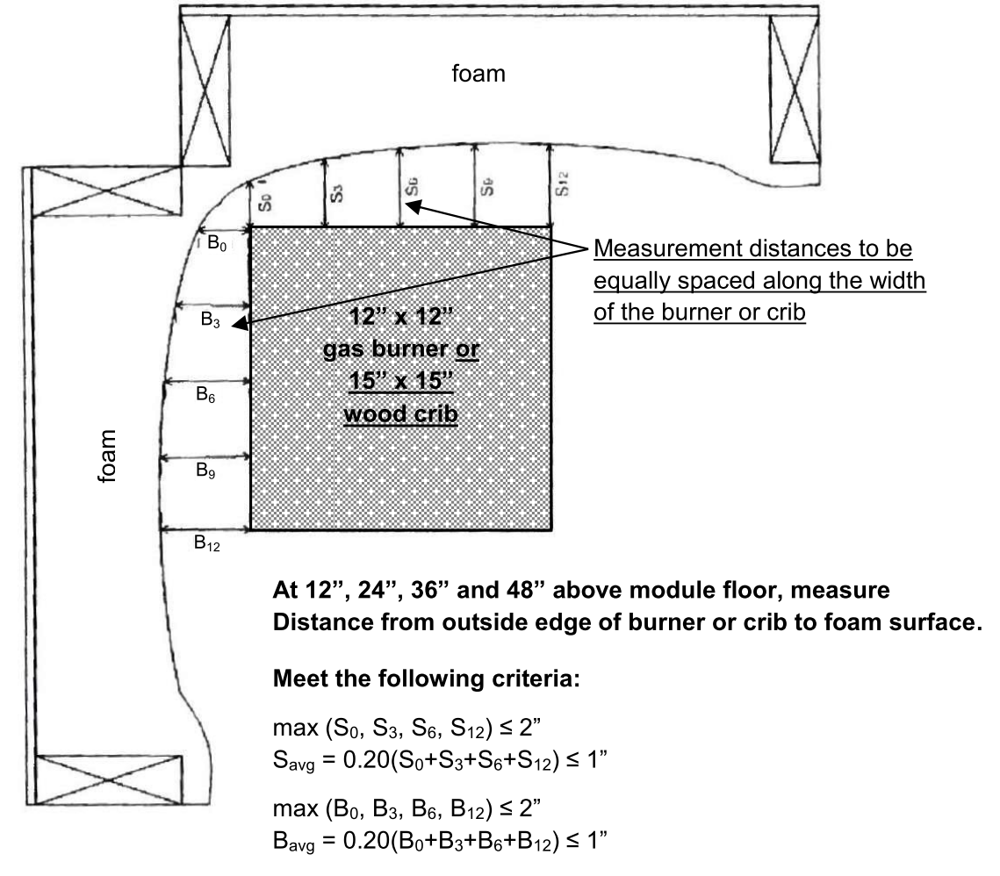**FIGURE 1—MEASUREMENT POINTS FOR BURNER SPACING FROM FOAM**

**302.2.3.1.1 NFPA 286.** When the *spray-applied foam plastic* insulation is tested in accordance with NFPA 286 it shall comply with the following Conditions 1 through 5:

1. During the 40 kW exposure, flames shall not spread to the ceiling.

2. The flame shall not spread to the outer extremity of the sample on any wall or ceiling.

3. Flashover, as defined in NFPA 286, shall not occur.

4. The peak heat release rate throughout the test shall not exceed 800 kW.

5. The total smoke released throughout the test shall not exceed 1,000 m2.

**302.2.3.1.2 UL 1715.** When the *spray-applied foam plastic* insulation is tested in accordance with UL 1715 the requirements of Sections 302.2.3.1.2.1 through 302.2.3.1.2.1.3.5 shall apply.

**302.2.3.1.2.1 Smoke Determination.** Determination of excessive smoke levels shall be as follows and shall consider the following:

**302.2.3.1.2.1.1 Visual documentation.** Smoke determination shall be recorded in accordance with the visual records procedures within UL 1715; digital video and photographic documentation is permitted. Video and still photographs shall be in color and time stamped. ~~Visual documentation (movies, videotapes) of the smoke generated during the room test.~~ Where a high level of smoke is generated during the test, the *spray-applied foam plastic* insulation will be considered to fail the test.

**~~302.4.1.2.1.2 Protocol for Video Recording.~~** ~~Video recording of the UL 1715 test shall comply with the requirements of Sections 302.4.1.2.1.2.1 and 302.4.1.2.1.2.2~~

**~~302.4.1.2.1.2.1 Lighting.~~** ~~300-watt flood-type, quartz halogen lamp shall be positioned in the corner diametrically opposite the crib, near the floor level. The lamp shall be aimed at the wall corner/ceiling intersection above the crib or burner.~~

**~~302.4.1.2.1.2.2 Video equipment and documentation.~~** ~~A video camera with a mechanically adjustable iris, adjusted to prevent automatic closing of the iris opening due to brightness of the fire (at least 50 percent open), shall be used. A video monitor shall be used to determine when adjustments and compensation for the brightness of the ignition flames are needed. The camera mount shall be adjusted so that the camera lens is approximately 3 feet (914 mm) from the floor. The camera angle and magnification shall be adjusted until the top of the doorway and the top of the crib or burner are visible and the ceiling area directly above the fire is in full view.~~

~~A clock or timer depicting “real time” shall be included in all videos and shall be clearly seen throughout the test period. For the UL 1715 test, the start of the test shall be when the alcohol-soaked excelsior is ignited.~~

~~Immediately prior to ignition of the crib or burner, the date and laboratory test report identification number shall be filmed.~~

**302.2.3.1.2.1.2 Test specimen.** For each test, when the test is for wall systems only, a new section of uncoated and unpainted 5/8-inch-thick (15.9 mm) gypsum wallboard, 2 feet by 2 feet (610 mm by 610 mm), shall be installed in the ceiling at the wall corner intersection directly above the crib.

**302.2.3.1.2.1.3 Reports of test results.** The test report shall provide the details described in Sections 302.4.1.2.1.4.1 through 302.4.1.2.1.4.5.

**302.2.3.1.2.1.3.1 Description.** The description of the room test setup, with details of the test room construction and materials tested.

**302.2.3.1.2.1.3.2 Observations.** The test observations, commencing with crib ignition and ending with a final description of panels after all combustion ceases.

**302.2.3.1.2.1.3.3 Thermocouple readings.** Temperature readings from all thermocouples.

**302.2.3.1.2.1.3.4 Condition of acceptance.** A statement of passing or failing based upon observation of test conditions and smoke levels generated during the test.

**302.2.3.1.2.1.3.5 Photographic records.** A photographic record of the test.

**302.2.3.1.3 Special Approval (Alternative Thermal Barrier Assembly).** When the *spray-applied foam plastic* insulation is intended to be installed as a component of an *alternative thermal barrier assembly*, the assembly shall be qualified by one or more of the following methods:

1. Room corner fire tests in Section 302.2.3.1.1 or 302.2.3.1.2.
2. Other fire tests related to actual end-use configurations as permitted in Section 2603.9 of the International Building Code or Section R316.6 of the International Residential Code, as applicable.

When a *covering* or coating is used to cover the *spray-applied foam plastic* insulation, the thickness of the *covering* shall be identified in units appropriate for the specific *covering* or coating. In the case of liquid-applied coatings, the installed thickness (in mils), in both wet film thickness and dry film thickness, and the corresponding application rate (in square feet per gallon) shall be identified and included in the test report.

**302.2.3.1.4 FM 4880 or UL 1040.** Where the *spray-applied foam plastic* assembly is tested in accordance with FM 4880 or UL 1040 the assembly is limited to use in areas with a minimum clear ceiling height of 20 feet (6096 mm).

**302.2.4 Alternative Ignition Barrier Assembly.** When the *spray-applied foam plastic* insulation is intended to be installed as a component of an *alternative ignition barrier assembly* (i.e. without the use of a code-prescribed *ignition barrier* separating the insulation from the interior of the attic or crawl space), the requirements of Section 302.2.4.1 or 302.2.4.2, respectively, shall be complied with. All testing shall be conducted with the foam plastic installed at the maximum density and maximum thickness intended for use over the substrates, as described in the test standard.

**302.2.4.1 Testing for Alternative Ignition Barrier Assembly for Use in Attics.**

**302.2.4.1.1 General.** When the *spray-applied foam plastic* insulation is intended to be installed as a component of an *alternative ignition barrier assembly* (i.e. without a code-prescribed *ignition barrier*), the assembly shall be qualified by testing as set forth in either Section 302.2.4.1.2 (Test Method A) or 302.2.4.1.3 (Test Method B). Assemblies tested in accordance with Section 302.2.4.1.2 or 302.2.4.1.3 are acceptable for installation on *all construction planes*. The requirements of this section apply to both an exposed *spray-applied foam plastic* insulation or to a *spray-applied foam plastic* insulation system using a *covering*.

**302.2.4.1.2 Test Method A.** When Test Method A is used, testing shall be performed in accordance with NFPA 286 with the modifications specified in Sections 302.2.4.1.2.1 and 302.2.4.1.2.2 and shall use one of the configurations specified in Section 302.2.4.1.2.2.1 or Section 302.2.4.1.2.2.2.

**302.2.4.1.2.1 Ignition Source.** The standard gas burner shall be used. The burner shall be positioned such that it is in contact with both sidewalls in the test corner of the fire test room as indicated in Figure 1.

**302.2.4.1.2.2 Specimen Mounting.**  The test specimens shall be mounted in accordance with the configuration described in either Section 302.2.4.1.2.2.1 (Configuration A) or Section 302.2.4.12.2.2 (Configuration B). Whichever configuration is used, the interior room dimensions as required by the NFPA 286 test procedure shall be maintained.

**302.2.41.2.2.1 Configuration A.** When Configuration A is used, the fire test room shall be completely lined with one layer of 5/8-inch-thick (15.9 mm), Type X gypsum wallboard. The *spray-applied foam plastic* insulation shall be applied directly to the gypsum wallboard at the maximum thickness and density intended for use. The *spray-applied foam plastic* insulation shall be applied to both the three test walls and the test ceiling. If a *covering* is used over the foam, it shall be applied to both the walls and the ceiling at the same minimum thickness or coverage rate intended for use.

**302.2.4.1.2.2.2 Configuration B.** When Configuration B is used, the three walls of the test room without the doorway shall be constructed with wood studs sized to the same depth as the test specimen, 93 inches (2362 mm) high, 24 inches (610 mm) on center with a single top and bottom plate, as shown in Figure 2. The exterior side of the walls shall be covered with one layer of 5/8-inch-thick (15.9 mm), Type X gypsum wallboard. The *spray-applied foam plastic* insulation shall be sprayed to fill each stud cavity and be continuous from the bottom plate to the top plate and from stud to stud. The ceiling of the test room shall be constructed as shown in Figure 3. The ceiling shall consist of wood joists sized to the same depth as the test specimen at 24 inches (610 mm) on center. A total of five joists shall be used and they shall run parallel with the 12-foot length (3.6 m) of the test room (front to back). The two outboard joists shall rest on the top plates of the walls. The exterior side of the ceiling shall be covered with one layer of 5/8-inch-thick (15.9 mm), Type X gypsum wallboard. The *spray-applied foam plastic* insulation shall be sprayed to fill each joist cavity and will be continuous from the front to the back and from joist to joist. If a coating is used over the foam, it shall be applied to both the walls and the ceiling at the same minimum thickness or coverage rate intended for use.

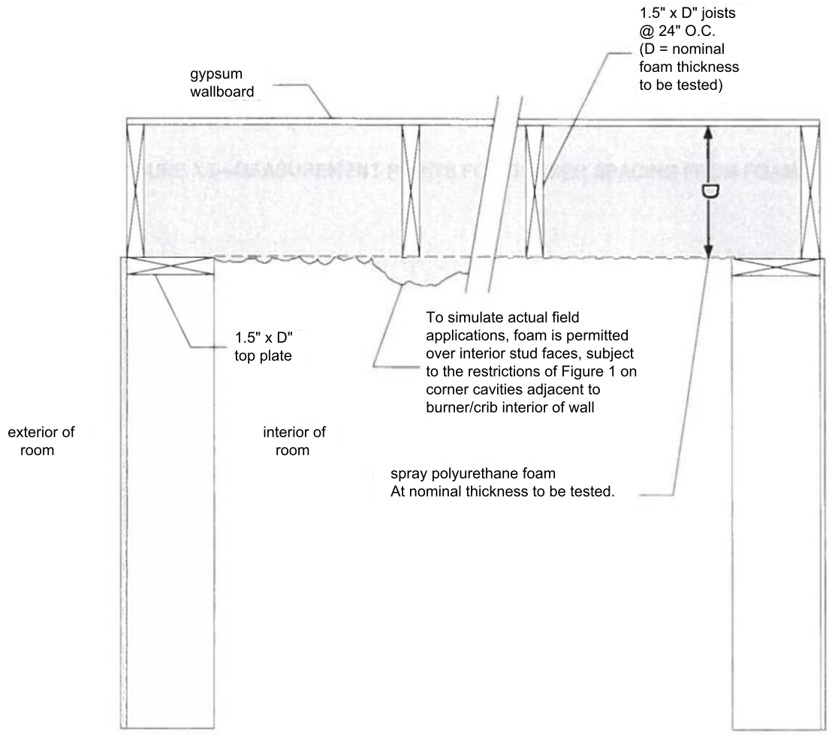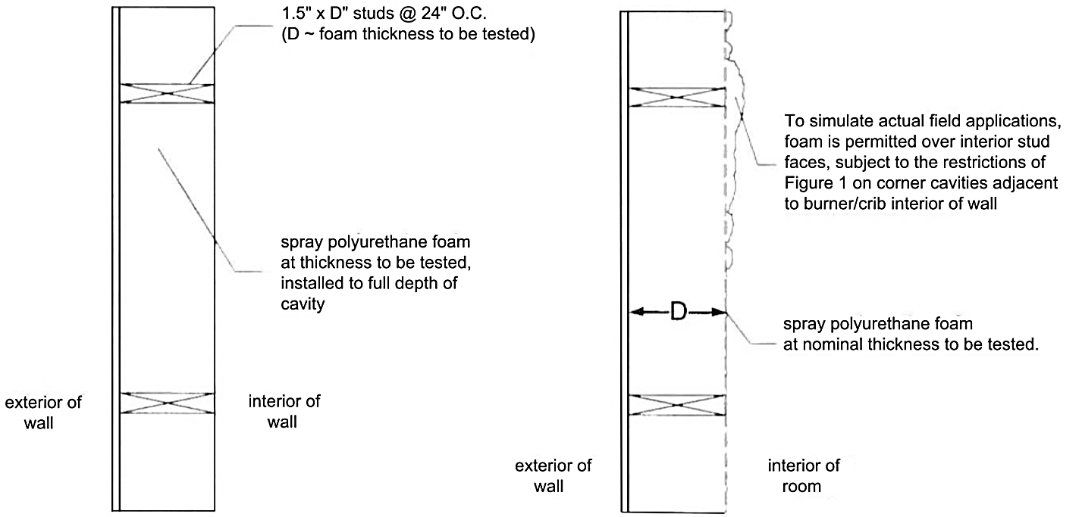**FIGURE 2—TOP VIEW OF WALL CONSTRUCTION**

**FIGURE 3—SIDE VIEW OF CEILING CONSTRUCTION**

**302.2.4.1.2.3 Coatings.** Where a coating is applied over the foam, the coating thickness shall be measured using the dry-film thickness technique (DFT), using one of the methods described in Sections 302.2.4.1.2.3.1 or 302.2.4.1.2.3.2.

**302.2.4.1.2.3.1 Method 1 (Slit-sample method).** When Method 1 is used, two slit samples shall be taken within 24 inches (610 mm) of the corner where the burner will be placed. The slit samples shall be approximately 1/2-inch deep (12.7 mm), between 2 to 3 inches long (51 to 76 mm), and 1/2 inch (12.7 mm) wide. One face of the slit sample (where the measurements will be made) shall be cut perpendicular to the surface of the spray polyurethane foam.

The coating thickness shall be measured at four random locations on the face of each slit sample using an optical comparator so that eight coating thickness shall be reported. The thinnest and the thickest spots on the slit samples shall be avoided. The average of these eight measurements shall be used to determine the average coating thickness.

The holes from which slit samples were taken shall be filled with a nonflammable caulk or sealant.

Weight or volume of the coating applied to the entire module area in (lb/ft2 or Gallons/ft2) shall be recorded along with the measured DFT.

**302.2.4.1.2.3.2 Method 2 (Medallion/target method).** When Method 2 is used, two metal medallions shall be installed within 24 inches (610 mm) of the corner where the burner is to be placed. The medallions shall be a minimum of 2 inches by 2 inches (51 mm by 51 mm) with a 1/4-inch-diameter (6.4 mm) hole in the center and a nail or screw shall be installed in the hole to fasten the medallion to the foam surface.

The coating thickness (dry mils film thickness) shall be measured at four random locations of each medallion sample using an optical comparator or caliper. The thinnest and the thickest spots on the samples shall be avoided. The average of these eight measurements shall be used to determine the average coating thickness.

The bare spots on the foam where the medallions were removed shall be coated with nonflammable caulk, coating or sealant prior to conducting the test.

**302.2.4.1.2.4 Test Corner Configuration.** The installation of the *spray-applied foam plastic* insulation shall be done in a manner as to provide as smooth a surface as possible, especially in the wall areas that will be adjacent to and above the burner. The maximum allowable deviations shall be in accordance with Figure 1.

**302.2.4.1.2.5 Test Data.** During the test, the test parameters in Items 1 through 4 shall be determined:

1. Time at which the Heat Release Rate exceeds 1 MW.

2. Time at which the heat flux to the floor exceeds 20 kW/m2.

3. Time at which the average upper layer temperature exceeds 600ºC.

4. Time at which flames exit the doorway.

**302.2.4.1.2.6 Test Report.** In addition to the requirements for reporting stated in NFPA 286, the items 1 through 4 shall be reported:

1. Type, description, average thickness and nominal density of the *spray-applied foam plastic* insulation wall and ceiling specimens.

2. The type, description, and nominal thickness (in mils) or application rate (in gallons per 100 square feet) of coating, if used as part of the insulation system.

3. Time recorded for each test parameter from Section 302.4.1.3.1.4.

4. Average of the four time values indicated in Item 302.4.1.3.1.4.

**302.2.4.1.2.7 Conditions of Acceptance.** A test shall be determined to be successful when the average time for attainment of the four measured test parameters specified in Section 302.2.4.1.2.6, Item 4, is 4 minutes 18 seconds or greater.

**Note:** This condition of acceptance is based on comparison of results for the tested assembly versus results for a code-prescribed ignition barrier applied over foam plastic insulation.

**302.2.4.1.2.8 Attic Installation Limitations.** When testing is in accordance with Section 302.2.4.1.2, the Conditions 1 through 7 regarding installation under the International Building Code or the International Residential Code shall apply.

1. Entry to the attic shall only be to service *utilities*, and no storage is permitted.

2. There shall be no interconnected attic areas.

3. Air in the attic shall not be circulated to other parts of the building.

4. Attic ventilation is provided when required by Section 1203.2 of the International Building Code or Section R806 of the International Residential Code, except when *air impermeable insulation* is permitted in unvented attics in accordance with the Section 1203.3 of the International Building Code or Section R806.5 of the International Residential Code.

5. The foam plastic insulation shall be limited to the maximum thickness and density tested.

6. Combustion air is provided in accordance with Section 701 of the International Residential Code, where applicable.

7. The installed coverage rate or thickness of coatings, if part of the insulation system, shall be equal to or greater than that which was tested.

**302.2.4.1.2.9 Attic Floors.** When Test Method A is used to qualify the use of the *spray-applied foam plastic* on attic floors, the maximum thickness shall be based on the maximum thickness applied on the walls. When the testing incorporated a *covering* or coating was used on the test walls, it shall be required for the attic floor application also.

**302.2.4.1.3 Test Method B.** When Test Method B is used, tests shall be conducted in accordance with NFPA 286 with the conditions of acceptance specified in Section 803.1.2.1 of the International Building Code; or UL 1715 with conditions of acceptance as specified in Section 302.2.3.1.2. The reported thickness shall be in accordance with Figures 2 and 3. Placement of the burner or wood crib shall be in accordance with the standard being used for testing, with the measured distance between the burner or crib and the interior surface of the assembly as described in Figure 1.

**302.2.4.1.3.1 Attic Installation Limitations.** When testing is in accordance with Section 302.5.1.3, the Conditions 1 through 4 regarding installation under the International Building Code or International Residential Code shall apply.

1. Attic ventilation is provided when required by Section 1203.2 of the International Building Code or Section R806 of the International Residential Code.

2. The foam plastic insulation shall be limited to the maximum thickness and density tested.

3. Combustion air is provided in accordance with Section 701, where applicable.

4. The installed coverage rate or thickness of coatings, if part of the insulation system, shall be equal to or greater than that which was tested.

**302.2.4.1.3.2 Attic Floors.** When Test Method B is used to qualify the use of the *spray-applied foam plastic* on attic floors, the maximum thickness shall be based on the maximum thickness applied on the ceiling. When the testing incorporated a *covering* or coating was used on the test walls, it shall be required for the attic floor application also.

**302.2.4.1.3.3 Attic Floors Only.** When the insulation is intended to be installed on the attic floor only without a prescriptive *ignition barrier*, the prescribed *ignition barrier* shall not be required when the exposed *spray-applied foam plastic* or *spray-applied foam plastic* with a *covering* or coating is tested in accordance with ASTM E970, where the measured critical radiant flux is equal to or greater than 0.12 watt per square centimeter. The initial sample thickness shall be sufficient such that upon completion of the ASTM E970 test, at least 1/2 inch (12.7 mm) of the foam thickness remains across the entire sample panel. Consistent thickness and flatness of the specimen surface shall be established by taking three foam thickness measurements using a 3-inch (76 mm) disk-pin probe. The measurements shall be taken along the centerline of the specimen at 1/4 L, 1/2 L, and 3/4 L from the end of the specimen, where L is the length of the test specimen. These three thickness measurements shall not deviate by more than 1/2 inch (12.7 mm). The maximum thickness of foam plastic will be the foam plastic thickness applied to the ceiling of room test modules tested in accordance with Section 302.2.1.3.

**302.2.4.2 Testing for Alternative Ignition Barrier Assembly for Use in Crawl Spaces.**

**302.2.4.2.1 General.** When the *spray-applied foam plastic* insulation is intended to be installed as a component of an *alternative ignition barrier assembly* (i.e. without a code-prescribed *ignition barrier*), the assembly shall be qualified by testing as specified in either Section 302.2.4.2.2 (Test Method A) or 302.2.4.2.3 (Test Method B). The requirements of this section apply to both an exposed *spray-applied foam plastic* insulation or to a *spray-applied foam plastic* insulation system using a *covering*.

**302.2.4.2.2 Test Method A.** When Test Method A is used, testing shall be performed as set forth in Sections 302.2.4.1.2 through 302.2.4.1.2.7.

**302.2.4.2.2.1 Crawl Space Installation Limitation:** When testing is in accordance with Section 302.2.4.2.2, the Conditions 1 through 7 regarding installation under the International Building Code or the International Residential Code shall apply.

1. Entry to the crawl space shall only be to service *utilities*, and no storage is permitted.

2. There shall be no interconnected crawl space areas.

3. Air in the crawl spaces shall not be circulated to other parts of the building.

4. Under-floor (crawl space) ventilation is provided when required by Section 1203.3 of the International Building Code or Section R408.1 of the International Residential Code, as applicable.

5. The foam plastic insulation shall be limited to the maximum thickness and density tested.

6. Combustion air is provided in accordance with IMC Section 701, where applicable.

7. The installed coverage rate or thickness of coatings, if part of the insulation system, shall be equal to or greater than that which was tested.

Use of the *spray-applied foam plastic* insulation in an unvented crawl space is limited to testing in accordance with Section 302.2.4.2.2.2.1 Option 1, or application with a code-prescribed *ignition barrier*.

**302.2.4.2.2.2 Test Method B.** When Test Method B is used, testing shall be performed in accordance with Section 302.2.4.2.2.2.1 (Option 1) or Section 302.4.2.2.2.2.2 (Option 2).

**302.2.4.2.2.2.1 Testing (Option 1).** Tests shall be conducted in accordance with NFPA 286 with the conditions of acceptance specified in Section 803.1.2.1 of the International Building Code; or UL 1715 with conditions of acceptance as specified in Section 302.2.3.1.2. The reported thickness shall be in accordance with Figures 2 and 3. Placement of the burner or wood crib shall be in accordance with the standard being used for testing, with the measured distance between the burner or crib and the interior surface of the assembly as described in Figure 1.

**302.2.4.2.2.2.1.2 Crawl Space Installation Limitations.** When testing is in accordance with Section 302.2.4.2.2.2.1, the limitations 1 through 4 on installation shall apply:

1. Under-floor (crawl space) ventilation shall be provided in accordance with Section 1203.3 of the International Building Code or Section R408 of the International Residential Code, as applicable.

2. Combustion air shall be provided in accordance with Section 701 of the International Mechanical Code, where applicable.

3. The foam plastic insulation shall be limited to the maximum thickness and density tested.

4. The installed coverage rate or thickness of coatings, if part of the insulation system, shall be equal to or greater than that which was tested.

**302.2.4.2.2.2.2 Testing (Option 2).** Comparative crawl space fire tests shall be conducted in accordance with this section to compare the performance of the exposed *spray-applied foam plastic insulation* under identical test conditions as described in Sections 302.2.4.2.2.2.2.1 through 302.2.4.2.2.2.2.6 to that of the *spray-applied* *foam plastic* insulation covered with a prescriptive *ignition barrier*.

**302.2.4.2.2.2.2.1 Test Configuration.** A sub-floor assembly shall be mounted on top of a three- sided wall module. The simulated crawl space module shall consist of three 8-ft square (0.74 m2) [outside dimensions ± 2 inches (51 mm)] walls, each 48 ± 2 inches (1219 mm ± 51 mm) high, and built of nominal 4-inch-wide (102 mm) by 8-inch-high (203 mm) by 16-inch-long (406 mm) concrete blocks with a full open space on one side of the structure. Masonry walls or module walls constructed of wood or metal studs with two layers of 1/2 inch (12.7 mm) gypsum board are not prohibited where the interior dimensions are the same as for a concrete block module, i.e., 88 ± 2 inch-wide (2235 mm ± 51 mm) and 92 ± 2 inch-deep (2337 mm ± 51 mm). If wood or metal stud construction is used, the studs shall be located inside the module, i.e., the width of the module is equal to the distance between the interior faces of the gypsum board attached to the side walls and the depth is equal to the distance between the front opening and the interior face of the gypsum board attached to the back wall.

The floor/ceiling above the crawl space shall be built using nominal 2- by 8-inch by 8-ft (2.4 m) floor joists on 16-inch (406 mm) centers, with 2- by 8-inch joist headers, all bearing on 2- by 4-inch sill plates and surfaced with 15/32-inch-thick (12 mm), 4-ply, APA graded A-C plywood sub-flooring. The use of joists and headers with a larger depth, e.g., 2 by 10 inch, 2 by 12 inch, etc. shall be permitted.

All construction lumber (joists and studs, if used) shall be of the same species and grade for all tests conducted to qualify the *spray-applied foam plastic* insulation.

The joists shall be oriented perpendicular to the camera's line-of-sight. The floor of the test chamber shall be covered with approximately 1 inch (25.4 mm) of sand. To provide additional protection, covering the floor with 1/2 inch (12.7 mm) gypsum board before installing the 1 inch (25.4 mm) layer of sand is not prohibited.

**302.2.4.2.2.2.2.2 Ignition Source.** The fire source shall be a 22-lb (9.9 kg) wood crib constructed of nominal 2- by 2-inch No. 1 select grade white pine (no knots), 15-inch square (9677 mm2) in plan, spaced approximately 11/2-inch (38 mm) apart and fastened at right angles with a single nail at each end. ± 0.5%. The crib shall be placed in a rear corner of the crawl space 1 inch (25.4 mm) from each wall surface and supported approximately 4 inch (102 mm) above the floor on small sections of refractory brick. The crib sticks of the bottom layer shall be parallel to the side walls.

Approximately 150 ml of ethyl alcohol in a circular or square metal pan with a surface area of 36 to 40 in2 (23226 to 25806 mm2) placed under the crib shall be used for ignition.

**302.2.4.2.2.2.2.3 Test Duration and End Point Comparison Criteria.** The following items 1 and 2 shall be measured and reported:

1. Time to flames emerging from the front of the crawl space.

2. Time to burn-through of the floor/deck system. If burn-through is not reached prior to laboratory personnel ending the test, the time at which the test was ended and reason for ending the test shall be reported.

**302.2.4.2.2.2.2.4 Documentation.** The test shall be recorded with photographs and video documentation positioned to view the entire front of the open side of the module. A timing reference, mechanical or electronic, shall be included in all photographic and video records.

**302.2.4.2.2.2.2.5 Test Report.** The report shall include the following items 1 through 6:

1. Name and location of facility where test is conducted.

2. A description of the tested assembly with emphasis on the insulation type (including facings), thickness, density and attachment details.

3. Photographic and video documentation: pre-test, during (including timing) and post-test.

4. A summary of visual observations including time to flames exiting the module and/or burn through of the sub-floor.

5. Conclusions in the form of a statement of findings summarizing the fire performance of the assembly; and, as appropriate, compared to a control assembly.

6. Signature of a representative engineer or officer of the test facility.

**302.2.4.2.2.2.2.6 Installation Limitations.** When testing is in accordance with this section, the following limitations 1 through 7 regarding use and installation shall apply:

1. Entry to the crawl space is only to service *utilities* and no storage is permitted.

2. There are no interconnected crawl space areas.

3. Air in the crawl space is not circulated to other parts of the building.

4. Under-floor (crawl space) ventilation is provided, when required by Section 1203.3 of the International Building Code or Section R408 of the International Residential Code, as applicable.

5. The foam plastic insulation is limited to the maximum thickness and density tested.

6. Combustion air is provided in accordance with Section 701 of the International Mechanical Code, where applicable.

7. The installed coverage rate or thickness of coatings, if part of the insulation system, shall be equal to or greater than that which was tested.

**302.2.5 Exterior Walls of Types I, II, III and IV Construction (International Building Code).** When the *spray-applied foam plastic* insulation is intended for use in certain building types defined in Section 602 of the International Building Code where noncombustible materials are required, the *spray-applied foam plastic* insulation shall be qualified for use in exterior walls of building Types I, II, III and IV by testing in accordance with Section 302.2.5 provided the results of testing meet criteria according to Section 2603.5 of the International Building Code. In addition, where the exterior wall is required to have a fire-resistance rating, the testing requirements of Section 302.2.6 shall apply.

**302.2.5.1 Vertical and Lateral Fire Propagation.** Testing of the specific wall assembly shall be performed in accordance with NFPA 285. The NFPA 285 test reports shall include details of the assembly tested.

**302.2.5.2 Potential Heat.** The potential heat content of the *spray-applied foam plastic* shall be determined by testing performed in accordance with NFPA 259.

**302.2.5.3 Ignition Properties.** When required, the ignition properties for the *spray-applied foam plastic* shall be determined by testing performed in accordance with NFPA 268.

**302.2.6 Use in Fire-resistance-rated Construction.** Where *spray-applied foam plastic* insulation is intended to be installed as a component of a fire-resistance-rated assembly, testing of the assembly that incorporates the *spray-applied foam plastic* insulation shall be conducted in accordance with ASTM E119 or UL 263 for the hourly rating intended for use.

**302.3 Roofing Applications.**

**302.3.1 Use in Roofing Applications.** Where the *spray-applied foam plastic* insulation is intended for use in *roofing applications*, the testing specified in Sections 302.3.1.1 through Section 302.3.1.3 shall be performed.

**302.3.1..1 Physical Properties.** *Spray-applied foam plastic* insulation used in *roofing applications* shall comply with the physical property requirements of ASTM C1029, Type III or IV, or ASTM D7425, as applicable.

**302.3.1.2 Surface-Burning Characteristics Tests.**

**302.3.1..2.1 Flame-spread Index.** The insulation shall exhibit a maximum flame-spread index of 75 when tested in accordance with ASTM E84 or UL 723 at the maximum thickness and density intended for use, but no greater than 4 inches (102 mm).

**302.3.1.2.2 Smoke-developed Index.** Testing to determine the smoke-developed index is waived for roofing application under Section 2603.3 (Exception 3) of the International Building Code and Section R316.5.2 of the International Residential Code.

**302.3.1.3 Roof Classification:** *Spray-applied foam plastic* insulation used in *roofing applications* shall comply with Sections 1507.14 and 2603.6 of the International Building Code or Sections R902 and R905.14 of the International Residential Code, as applicable. Classification of roof coverings with *spray-applied foam plastic* insulation shall be based on testing in accordance with ASTM E108 or UL 790.

**302.3.1.4 Installation Requirements.** Installation of *spray-applied foam plastic* insulation in *roofing applications* shall be in accordance with the requirements of Section 303.1.2.1.

**SECTION 303**

**INSTALLATION**

**303.1 Installation Requirements.** Installation of *spray-applied foam plastic* insulation shall comply with the requirements of Sections 303.1.1 through 303.5, as applicable to the end use application.

**303.1.1 General Requirements:** Installation of *spray-applied foam plastic* insulation shall not exceed the thickness and density as tested in accordance with Section 302.2, except where stated otherwise in this standard. When separated from the interior of the building by a prescriptive *thermal barrier*, the *spray-applied foam plastic* insulation when tested under Section 302.2 at 4-inch (102 mm) thickness with flame spread index no greater than 25 and smoke developed index no greater than 450 shall be limited to maximum density tested, but shall have no maximum thickness limitation.

**303.1.2 Wall and Floor Installation Thermal Barrier Requirements:** Installation of *Spray-applied foam plastic* insulation in wall and floor applications shall be separated from the interior of the building as set forth in Section 2603.4 of the International Building Code, Section R316.4 of the International Residential Code, as applicable, except when qualified in accordance with Section 302.2.31.

**303.1.2.1 Roofing Application Thermal Barrier Requirements.** Installation of *spray-applied foam plastic* insulation in *roofing applications* shall be separated from the interior of the building as set forth in Section 2603.4 of the International Building Code or Section R316.4 of the International Residential Code, as applicable. For application to the exterior of metal roof decks, acceptable separation from the building interior is not prohibited when the roof assembly is tested in accordance with UL 1256 or NFPA 276.

**303.2 Use in Attics.**

**303.2.1 *Thermal Barrier* Exception:** Within an attic where entry is made only for service of *utilities*, *spray-applied foam plastics* shall be protected by a prescriptive *ignition barrier* as set forth in Section 2603.4.1.6 of the International Building Code or Section R316.5.3 of the International Residential Code, as applicable. *Alternative ignition barrier assemblies* shall be qualified in accordance with Section 302.5.1.

**303.2.2 Unvented Attic Requirements under the 2015 International Building Code and 2015, 2009, and 2006 International Residential Code:** Installation of *spray-applied foam* plastic insulation in unvented attics shall be qualified in accordance with the conditions prescribed in Section 1203.3 of the International Building Code or Section R806.5 of the 2015 International Residential Code [2009 IRC Section R806.4], and where tested in accordance with Section 301.3.

**303.3 Use in Crawlspaces.**

**303.3.1 *Thermal Barrier* Exception:** Installation of *spray-applied foam* plastic insulation in a crawl space where entry is made only for service of *utilities*, *spray-applied foam plastic* shall be protected by a prescriptive *ignition barrier* as set forth in Section 2603.4.1.6 of the International Building Code or Section R316.5.4 of the International Residential Code, as applicable, or qualified as a component in an *alternative ignition barrier assembly* in accordance with Section 302.2.4.2.

**303.3.2 Unvented Crawlspaces under the International Residential Code:** Installation of *spray-applied foam plastic* insulation in unvented crawl spaces shall be qualified in accordance with the conditions prescribed in Section R408.3 of the International Residential Code and Sections 301.3 and 302.4.2, and where it meets the requirements in Sections 301.3 and 302.5.2.

**303.4 Use in Exterior Walls of Buildings of Type I, II, III or IV Construction (International Building Code):** Installation of *spray-applied foam plastic* insulation in or on exterior walls of building Types I, II, III and IV shall comply with the requirements of Section 2603.5 of the International Building Code and shall be qualified in accordance with the requirements of Section 302.2.5.

**303.5 Exterior Wall-covering Systems:** *Spray-applied foam plastic* insulation complying with this standard is not prohibited from use in exterior wall covering systems.

**CHAPTER 4**

**REFERENCED STANDARDS**

ASTM International

ASTM C177 Test Method for Steady-State Heat Flux Measurements and Thermal Transmission Properties by Means of the Guarded Hot Plate Apparatus

ASTM C208 Standard Specification for Cellulosic Fiber Insulating Board

ASTM C518 Test Method for Steady-State Heat Flux Measurements and Thermal Transmission Properties by Means of the Heat Flow Meter Apparatus

ASTM C1029 Specification for Spray-Applied Rigid Cellular Polyurethane Thermal Insulation

ASTM C1363 Standard Test Method for Thermal Performance of Building Materials and Envelope Assemblies by Means of a Hot Box Apparatus

ASTM D1621 Test Method for Compressive Properties of Rigid Cellular Plastics

ASTM D1622 Test Method for Determining Apparent Density of Rigid Cellular Plastics

ASTM D1623 Test Method for Tensile and Tensile Adhesion Properties of Rigid Cellular Plastics (Type B Specimen)

ASTM D2126 Test Method for Response of Rigid Cellular Plastics to Thermal and Humid Aging

ASTM D2856 Standard Test Method for Open-Cell Content of Rigid Cellular Plastics by the Air Pycnometer

ASTM D6226 Standard Test Method for Open-Cell Content of Rigid Cellular Plastics

ASTM D7425 Standard Specification for Spray Polyurethane Foam Used for Roofing Applications

ASTM E84 Test Methods for Surface Burning Characteristics of Building Materials

ASTM E96 Test Method for Water Vapor Transmission of Materials

ASTM E108 Test Method for Fire Tests of Roof Coverings

ASTM E119 Test Methods for Fire Tests of Building Construction and Materials

ASTM E283 Test Method for Determining the Rate of Air Leakage through Exterior Windows Curtain Walls and Doors under Specified Pressure Differences across the Specimen

ASTM E970 Test Method for Critical Radiant Flux of Exposed Attic Floor Insulation Using a Radiant Heat Energy Source

ASTM E2178 Standard Test Method for Air Permeance of Building Materials

Factory Mutual Global Research

FM 4450 Approval Standard for Class 1 Insulated Steel Deck Roofs

FM 4880 American National Standard for Evaluating Insulated Wall or Wall and Roof/Ceiling Assemblies Plastic Interior Finish Materials Plastic Exterior Building Panels Wall/Ceiling Coating Systems Interior or Exterior Finish Systems

International Code Council

IBC International Building Code®

IRC International Residential Code®

IMC International Energy Conservation Code®

National Fire Protection Association

NFPA 259 Test Method for Potential Heat of Building Materials

NFPA 268 Standard Test Method for Determining Ignitability of Exterior Wall Assemblies Using a Radiant Heat Energy Source

NFPA 276 Standard Method of Fire Tests for Determining Heat Release Rate of Roofing Assemblies with Combustible Above-Deck Components

NFPA 285 Standard Method of Test for the Evaluation of Flammability Characteristics of Exterior Nonload-Bearing Wall Assemblies Containing Combustible Components Using the Intermediate-Scale, Multistory Test Apparatus

NFPA 286 Standard Method of Fire Test for Evaluating Contribution of Wall and Ceiling Interior Finish to Room Fire Growth

UL LLC

UL 263 Standard for Fire Test of Building Construction and Materials

UL 723 Test for Surface Burning Characteristics of Building Materials

UL 790 Tests for Fire Resistance for Roof Covering Materials

UL 1040 Fire Test of Insulated Wall Construction

UL 1256 Fire Tests of Roof Deck Construction

UL 1715 Fire Tests of Interior Finish Material

**SECTION 302**

**(index of sections renumbered based on IS-FPI 45-17 (Banks 01)**

**302.1 GENERAL.**

**302.2 Insulation Applications**

**302.2.1 Surface-Burning Characteristics Tests.**

**302.2.1.1 Flame-Spread Index.**

**302.2.1.2 Smoke-Developed Index.**

**302.2.1.3 Testing of thicknesses greater than 4 inches.**

**302.2.2 Use with a 15-minute Thermal Barrier.**

**302.2.3 Alternative Thermal Barrier Assembly.**

**302.2.3.1 Room Corner Fire Tests.**

**302.2.3.1.1 NFPA 286.**

**302.2.3.1.2 UL 1715.**

**302.2.3.1.2.1 Smoke Determination.**

**302.2.3.1.2.1.1 Visual documentation.**

**302.2.3.1.2.1.2 Test specimen.**

**302.2.3.1.2.1.3 Reports of test results.**

**302.2.3.1.2.1.3.1 Description.**

**302.2.3.1.2.1.3.2 Observations.**

**302.2.3.1.2.1.3.3 Thermocouple readings.**

**302.2.3.1.2.1.3.4 Condition of acceptance.**

**302.2.3.1.2.1.3.5 Photographic records.**

**302.2.3.1.3 Special Approval (Alternative Thermal Barrier Assembly).**

**302.2.3.1.4 FM 4880 or UL 1040.**

**302.2.4 Alternative Ignition Barrier Assembly.**

**302.2.4.1 Testing for Alternative Ignition Barrier Assembly for Use in Attics.**

**302.2.4.1.1 General.**

**302.2.4.1.2 Test Method A.**

**302.2.4.1.2.1 Ignition Source.**

**302.2.4.1.2.2 Specimen Mounting.**

**302.2.4.1.2.2.1 Configuration A.**

**302.2.4.1.2.2.2 Configuration B.**

**302.2.4.1.2.3 Coatings.**

**302.2.4.1.2.3.1 Method 1 (Slit-sample method).**

**302.2.4.1.2.3.2 Method 2 (Medallion/target method).**

**302.2.4.1.2.4 Test Corner Configuration.**

**302.2.4.1.2.5 Test Data.**

**302.2.4.1.2.6 Test Report.**

**302.2.4.1.2.7 Conditions of Acceptance.**

**302.2.4.1.2.8 Attic Installation Limitations.**

**302.2.4.1.2.9 Attic Floors.**

**302.2.4.1.3 Test Method B.**

**302.2.4.1.3.1 Attic Installation Limitations.**

**302.2.4.1.3.2 Attic Floors.**

**302.2.4.1.3.3 Attic Floors Only.**

**302.2.4.2 Testing for Alternative Ignition Barrier Assembly for Use in Crawl Spaces.**

**302.2.4.2.1 General.**

**302.2.4.2.2 Test Method A.**

**302.2.4.2.2.1 Crawl Space Installation Limitation:**

**302.2.4.2.2.2 Test Method B.**

**302.2.4.2.2.2.1 Testing (Option1).**

**302.2.4.2.2.2.1.2 Crawl Space Installation Limitations.**

**302.2.4.2.2.2.2 Testing (Option 2).**

**302.2.4.2.2.2.2.1 Test Configuration.**

**302.2.4.2.2.2.2.2 Ignition Source.**

**302.2.4.2.2.2.2.3 Test Duration and End Point Comparison Criteria.**

**302.2.4.2.2.2.2.6 Installation Limitations.**

**302.2.5 Exterior Walls of Types I, II, III and IV Construction (International Building Code).**

**302.2.5.1 Vertical and Lateral Fire Propagation.**

**302.2.5.2 Potential Heat.**

**302.2.5.3 Ignition Properties.**

**302.2.6 Use in Fire-resistance-rated Construction.**

**302.3 Roofing Applications.**

**302.3.1 Use in Roofing Applications.**

**302.3.1.1 Physical Properties.**

**302.3.1.2 Surface-Burning Characteristics Tests.**

**302.3.1.2.1 Flame-spread Index.**

**302.3.1.2.2 Smoke-developed Index.**

**302.3.1.3 Roof Classification:**

**302.3.1.4 Installation Requirements.**