Reason: PCD2 introduces a new term and definition for “balanced ventilation system”. This term was introduced in the newly expanded R408 Additional Efficiency Requirements section. In other sections, in the 2021 IECC, the term was undefined and just called “balanced” (R403.6.2). In PCD2, there still remains two instances where “balanced” or “balanced system” is used and should be reviewed to determine whether the defined term is more appropriate.
Cost Impact: None

Proponent: Gayathri Vijayakumar, representing Steven Winter Associates, Inc. (gvijayakumar@swinter.com)
2024 International Energy Conservation Code [RE Project]
SECTION R202
GENERAL DEFINITIONS
No change (shown for context):
BALANCED VENTILATION SYSTEM. A ventilation system that simultaneously supplies outdoor air to and exhausts air from a space, where the mechanical supply airflow rate and the mechanical exhaust airflow rate are each within 10 percent of the average of the two airflow rates.

SECTION R403
SYSTEMS

Revise as follows:
R403.6.2 Whole-dwelling mechanical ventilation system fan efficacy. Fans used to provide whole-dwelling mechanical ventilation shall meet the efficacy requirements of Table R403.6.2 at one or more rating points. Fans shall be tested in accordance with the test procedure referenced by Table R403.6.2and listed. The airflow shall be reported in the product listing or on the label. Fan efficacy shall be reported in the product listing or shall be derived from the input power and airflow values reported in the product listing or on the label. Fan efficacy for fully ducted HRV, ERV, balanced balanced ventilation systems, and in-line fans shall be determined at a static pressure of not less than 0.2 inch w.c.(49.85Pa). Fan efficacy for ducted range hoods, bathroom and utility room fans shall be determined at a static pressure of not less than 0.1 inch w.c. (24.91 Pa).
No change to table below (shown for context):

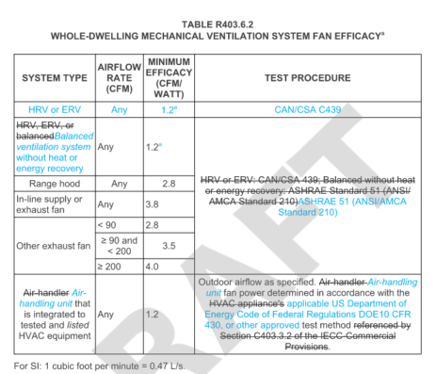
a. For balanced systems balanced ventilation systems, HRVs, and ERVs, determine the efficacy as the outdoor airflow divided by the total fan power.

