**Proposed Modification to REPI-157-21**

**DELETE AND REPLACE REPI-157-21 WITH THE FOLLOWING:**

**APPENDIX RC (APPENDIX AX)**

**NET ZERO ENERGY RESIDENTIAL BUILDING PROVISIONS**

**SECTION RC102 (AX102)**

**NET ZERO ENERGY RESIDENTIAL BUILDINGS**

**RC102.1 General.** New *residential buildings* shall comply with Section RC102.2.

**~~RC102.2 (AX102.2)~~ ~~Energy Rating Index zero energy score.~~** ~~Compliance with this section requires that the rated design be shown to have a score less than or equal to the values in Table RC102.2 when compared to the Energy Rating Index (ERI) reference design determined in accordance with RESNET/ICC 301 for both of the following:~~

1. ~~ERI value not including on-site power production (OPP) calculated in accordance with RESNET/ICC 301.~~
2. ~~ERI value including on-site power production calculated in accordance with RESNET/ICC 301 with the OPP in Equation 4.1.2 of RESNET/ICC 301 adjusted in accordance with Equation RC-1.~~

**RC102.2 (AX102.2) Rating Index**New residential buildings shall comply with one the following:

1. The Energy Rating Index (ERI) not including OPP calculated in accordance with RESNET/ICC 301 for the rated design shall be not more than the values listed in Table RC102.2 and the requirements of Sections 406.3, 406.6 and 406.7 and Table R406.2 shall be met, or
2. The requirements of ASHRAE/IES Standard 90.2, including the ERI requirements of ASHRAE/IES 90.2 Table 6-1 without the use of on-site power production (OPP), and the requirements of Sections R402.4.1.1, R402.4.1.2, R404.4 (Electric Readiness), and R404.4

(Electric Vehicle Power Transfer Infrastructure) shall be met.

***Note to staff: The section # R404.4 was proposed in several different proposals. As multiple proposals are approved there will need to be a renumbering, so I have included R404.4 with the title of the proposed sections to aid in establishing the final section numbers.***

**RC102.2.1 (AX102.2.1) On-site Power Production** New residential buildings shall achieve an Energy Rating Index (ERI) value including onsite power production not more than the values in Table RC 102.2. The ERI shall be calculated in accordance with RESNET/ICC 301 with the OPP in Equation 4.1.2 of RESNET/ICC 301 adjusted in accordance with Equation RC-1

Adjusted OPP = OPP + CREF + REPC **(Equation RC-1)**

where:

CREF = Community Renewable Energy Facility power production—the yearly energy, in kilowatt hour equivalent (kWheq), contracted from a community renewable energy facility that is qualified under applicable state and local utility statutes and rules, and that allocates bill credits to the rated home.

REPC = Renewable Energy Purchase Contract power production—the yearly energy, in kilowatt hour equivalent (kWheq), contracted from an energy facility that generates energy with photovoltaic, solar thermal, geothermal energy or wind systems, and that is demonstrated by an energy purchase contract or lease with a duration of not less than 15 years.

**TABLE RC102.2**

**MAXIMUM ENERGY RATING INDEX~~a~~**

**~~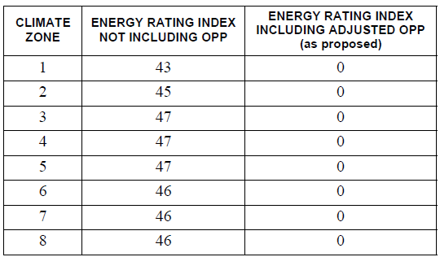~~**

~~a. The building shall meet the requirements of Table R406.2, and the building thermal envelope shall be greater than or equal to the levels of efficiency and SHGC in Table R402.1.2 or R402.1.3.~~

***Add new standard(s) as follows:***

|  |  |
| --- | --- |
| **ASHRAE** | ASHRAE180 Technology Parkway NWPeachtree Corners GA 30092 |

|  |  |
| --- | --- |
| ASHRAE/IES 90.2-2018: | Energy-Efficient Design of Low-Rise Residential Buildings |

Including approved addenda (Addenda A (approved Jan 2021), B (June 2021) and D (February 2022))

**Modification Reason:**

REPI-157 as originally proposed replaced the ERI Table with ASHRAE 90.2. This modification allows ASHRAE 90.2 as a compliance option while maintaining the current Appendix RC as an option.

This modification also adds the mandatory requirements to the base ERI score. The mandatory requirements are from Table R406.2 and Sections 406.3, 406.6 and 406.7.

The following mandatory requirements were added to the 90.2 option:

* R402.4.1.1 (Air barrier and insulation installation)
* R402.4.1.2 (Air barrier testing)
* R404.4 (Electric readiness) ---------------------------------------- (see REPI-111)
* R404.4 (Electric Vehicle Power Transfer Infrastructure) --- (see RECPI-6)

Updates reference standard ASHRAE 90.2 with approved Addenda:

* Addenda A (January 2021) – Updates referenced standards including updates of ANSI/RESNET/ICC 301 to 2019 edition, ANSI/RESNET/ICC 380 to 2019 edition and the addition of ASTM E3158 *Standard Test Method for Measuring the Air Leakage Rate of Large or Multizone Building*
* Addenda B (June 2021) – Clarifies lighting provisions for common areas in multifamily structures
* Addenda D (February 2022) – Adds basic indoor environmental quality requirements for lighting systems. Adds reference to *2019 CA Title 24 Part 6 JA8, Building Energy Efficiency Standards Joint Appendix 8*