REPI 167 Modification

Replace original proposal with the following:

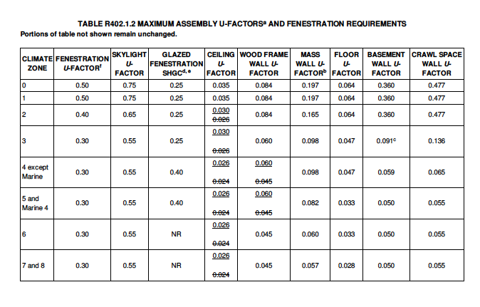

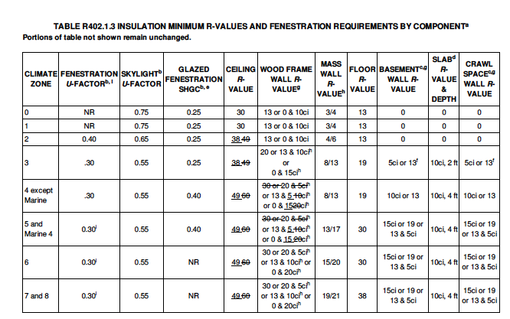

R408.2 Additional efficiency credits package options. Two of the Aadditional efficiency package options for compliance with Section R401.2.1 are set forth in Sections R408.2.1 through R408.2.5. measures shall be selected from Table R408.2 that meet or exceed the total of thirteen credits in climate zones 4 and 5 or the total of ten credits in other climate zones. Each measure selected shall meet the relevant subsections of Section R408 and receive credit as indicated in the Table for the specific Climate Zone. Interpolation of credits between measures shall not be permitted.

