**REPI-39 Knee Wall**

**Definition**

Knee wall – ~~usually~~ ~~short~~ ~~less~~ ~~than full height~~ A wall assembly of any height ~~of the~~ *~~building thermal envelope~~* that ~~may~~ ~~supports~~ terminates above at rafters or is defined by ~~ceiling trusses~~ vertical truss members ~~and is used to separated conditioned space from unconditioned buffered space such as ventilated attics.~~

**R402.2.3 (N1102.2.3) Attic knee ~~or pony~~ wall.**

~~R402.2.3 Attic knee or pony wall.~~

Attic knee ~~or pony~~ wall assemblies that separate conditioned space from unconditioned attic spaces shall be constructed to be insulated to the R-value of the above grade wall. ~~described in Table R402.1.3.~~ Such Knee ~~or pony~~ walls shall have a sealed air barrier between conditioned and ~~to the~~ unconditioned space and shall have an air barrier on the attic or unconditioned side of the assembly.

~~Air permeable insulation installed in knee or pony wall cavities shall be enclosed on six sides of the cavity. Insulation installed in knee or pony wall cavities shall be installed in substantial contact with the air barrier.~~

R402.2.3.1 Where vertical ~~Knee or pony wall cavities defined by~~ roof truss framing members are used to separate conditioned space and unconditioned space, they shall be insulated to the same R-value as the above grade wall.

~~level as other exterior above grade walls. Vertical or diagonal surfaces that are greater than 1 foot (305 mm) in height into a ventilated attic shall be considered a knee or pony wall. Vertical or diagonal surfaces that are 1 foot (305 mm) or less in height into a ventilated attic shall be buried with insulation to maintain the ceilings required Rvalue~~.

**Table R402.4.1.1**

**AIR BARRIER, AIR SEALING AND INSULATION INSTALLATION a**

|  |  |  |
| --- | --- | --- |
| **COMPONENT** | **AIR BARRIER, AIR SEALING CRITERIA** | **INSULATION INSTALLATION CRITERIA** |
| Knee ~~or pony~~ wall~~s~~ | Knee ~~or pony~~ walls shall have a sealed air barrier between conditioned and unconditioned space.  ~~and shall be sheathed on the attic or unconditioned side of the assembly.~~  ~~be constructed to have a sealed air barrier on six sides of the wall assembly including to the unconditioned side of the assembly.~~ | Insulation installed in a knee ~~or pony~~ wall assembly shall be aligned and enclosed with an air barrier  ~~installed in accordance with Section R402.2.3~~ |
| Walls | The junction of the foundation and sill plate shall be sealed.  The junction of the top plate and the top of exterior walls shall be sealed.  ~~Knee walls shall be sealed.~~ | Cavities within corners and headers of frame walls shall  be insulated by completely filling the cavity with a material having a thermal resistance, *R*-value, of not less than R-3 per inch. Exterior thermal envelope insulation for framed walls shall be installed in substantial contact and  continuous alignment with the air barrier. |

Reason Statement

Attic knee walls, in the field, are a unique assembly that have been overlooked by the IECC. The assembly separates interior conditioned space from exterior unconditioned space but is buffered from directly being connected to the ambient outdoors by a ventilated attic. The ventilated attic space often has harsher unconditioned side temperatures than normal above grade walls causing more significant heat loss or gain through the assembly than through normal insulated above grade walls. This being the case we see across the country, in the field, that attic knee walls are often insulated to a lower R-value than the exterior walls associated with the same house. In addition, the IECC has not been clear about the need for attic sheathing and a sealed air barrier systems installation.

This proposal defines, describes how to address, and adds this unique assembly to the list of required assemblies that must be detailed in the requirements section of the IECC. It will ensure proper air barriers, insulation installation, air sealing of the assembly and will increase the performance of the home.

Raised ceiling that protrude into the attic are unique knee wall applications on which the code offers no guidance. They are particularly troublesome for maintaining the continuity of the building thermal envelope and therefore have been added to this section as a means to define when the vertical or diagonal surface must be treated as a knee wall and when normal attic insulation can be mounded over the raised ceiling.

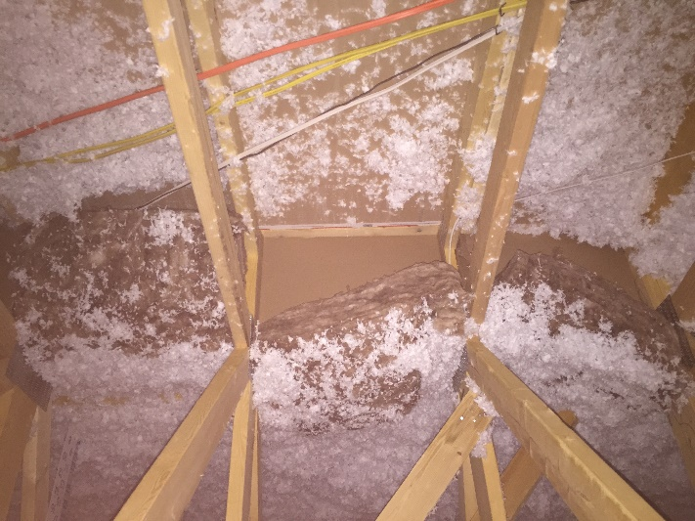

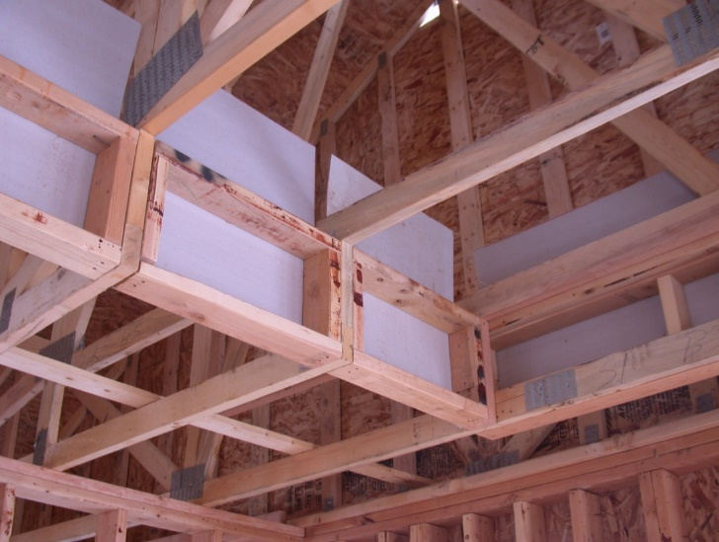

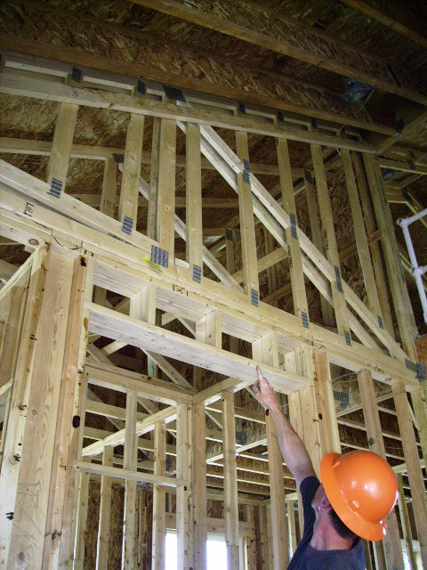

**Cost**

In theory, this assembly has been addressed as an above grade wall so this new section of code should not add cost to the construction of a home. In reality, this assembly has not been viewed in most of the country as a typical above grade wall so cost will be added to construction because of the realization of the significance of the assembly and the heat loss and gain that is driven through it because of it being adjacent to the ventilated attic.

The R-value of this part of the above grade wall assembly could be traded off to a lower R-value, or the same R-value that is currently being installed when using the UA alternative, Total Building Performance, or ERI compliance pathways. This would lower the cost associated with this code proposal. However, as cost goes down implementation would still become better because the proposal would ensure that the installed insulation is enclosed with sheathing on the attic side and that an air barrier has been defined this making the assembly perform better.