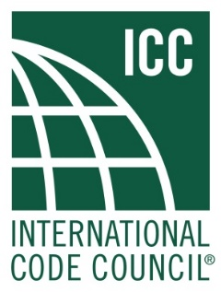

**International Energy Conservation Code**

**Residential Existing Building Subcommittee**

**Meeting Agenda**

May 10, 2022

2:00 PM EST to 4:00 PM EST (2 hours)

[Webex Link](https://iccsafe.webex.com/iccsafe/j.php?MTID=mbd13befdc2d24a7421301754da21bd86)

**Sub-Committee Chair:** Gil Rossmiller

**Sub-Committee Vice Chair:** Edwin Hensley

1. Call to order.

2. Meeting Conduct. Staff

a. Identification of Representation/Conflict of Interest

b. ICC [Council Policy 7](https://www.iccsafe.org/wp-content/uploads/CP07-04.pdf) Committees: Section 5.1.10 Representation of Interests

c. ICC [Code of Ethics](https://www.iccsafe.org/wp-content/uploads/CodeOfEthics.pdf): ICC advocates commitment to a standard of professional behavior that exemplifies the highest ideals and principles of ethical conduct which include integrity, honesty, and fairness. As part of this commitment it is expected that participants shall act with courtesy, competence and respect for others.

3. Roll Call – Vice-Chair Edwin Hensley

4. Approval of May 10, 2022 meeting minutes

5. Approval of agenda

6. Action Items.

6.1 Discussion:

6.1.1: RECPI-5-22

6.1.2: REPI-144-21

7. Other business.

8. Upcoming meetings.

9. Adjourn.

FOR FURTHER INFORMATION BE SURE TO VISIT THE ICC WEBSITE:

[ICC Energy webpage](https://www.iccsafe.org/products-and-services/codes-standards/energy/)

[Code Change Monograph](https://www.iccsafe.org/wp-content/uploads/2021-Public-Input-Complete-Monograph.pdf)

FOR ADDITIONAL INFORMATION, PLEASE CONTACT:

Subcommittee Chair

Gil Rossmiller

[gil.rossmiller@shumscoda.com](mailto:gil.rossmiller@shumscoda.com)