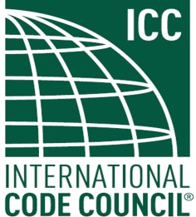

FIRST PUBLIC REVIEW DRAFT

BACKGROUND REPORT

OCTOBER 25, 2013

ICC/ANSI A117.1 STANDARD
DEVELOPMENT - 2014 EDITION

ICC A117.1 Standard – Accessible and Usable Buildings and Facilities
First Public Review Draft – Background Report
October 25, 2013

This document is an informational companion to the First Public Review Draft of the 2014 edition of the ICC A117.1 Standard. The First Public Review Draft only shows the actual changes to the text of the standard as approved by the A117.1 Committee. These changes were approved based on background information provided by the proponents and supplemented through the Committee’s consideration. This Background Report contains the information supporting each approved change. Each change is identified by a number assigned when originally proposed – for example 9-7-12. These numbers are used in this report for each corresponding change.

For further information please see the following documents:

1. First Public Review Draft.

2. First Public Review Draft – Supplement.

For these items, please go to: www.iccsafe.org/A117

Providing Public Comment on the Public Review Draft

Comments can be made to the First Public Review Draft. Comments will only be accepted on the changes which have been approved by the Committee and are included First Public Review Draft. Comments unrelated to the changes in the First Public Review Draft will be set aside for consideration after the 2014 edition is published.

If you have questions, please direct them to Kermit Robinson, krobinson@iccsafe.org

Closing Date for Public Comments – Monday, December 9, 2013.

