4-2 – 12
402.2

Proposed Change as Submitted

Proponent: Ed Roether, representing the ADA/A117 Harmonization Task Group

Revise as follows:

402.2 Components. Accessible routes shall consist of one or more of the following components: Walking surfaces with a running slope not steeper than 1:20, doors and doorways, ramps, curb ramps excluding the flared sides, elevators, and platform lifts. All components of an accessible route shall comply with the applicable portions of this standard.

Reason: The ADA/A117 Harmonization Task Group (HTG) was created as a task group of the A117.1 Committee to compare the 2010 ADA with the 2009 A117.1 Standard. The HTG has recommend a series of changes through a set of change proposals. The HTG is recommending changes, for the most part, address where the ADA was viewed as more stringent than the A117. Where the A117 contained provisions not addressed in the ADA, these were not considered a conflict needing action to amend the A117. In addition there are a number of places where the ADA and A117.1 are different as a result of specific actions, by the A117.1 Committee during the development of the 2009 edition, to remain or create a difference where, in the judgment of the committee the ADA was deficient.

Reason: for 402.2. To provide consistent language with ADA Section 403.3.
input.doc

Committee Action

Approved

Committee Reason: To provide consistency between the Standard and the 2010 ADA.

4-5 – 12
403.5
Proposed Change as Submitted

Proponent: Ed Roether, representing the ADA/A117 Harmonization Task Group

Revise as follows:

403.5 Clear Width. Except as provided in 403.5.2 and 403.5.3, the clear width of an accessible route shall be 36 inches (915 mm) minimum.

Reason: The ADA/A117 Harmonization Task Group (HTG) was created as a task group of the A117.1 Committee to compare the 2010 ADA with the 2009 A117.1 Standard. The HTG has recommend a series of changes through a set of change proposals. The HTG is recommending changes, for the most part, address where the ADA was viewed as more stringent than the A117. Where the A117 contained provisions not addressed in the ADA, these were not considered a conflict needing action to amend the A117. In addition there are a number of places where the ADA and A117.1 are different as a result of specific actions, by the A117.1 Committee during the development of the 2009 edition, to remain or create a difference where, in the judgment of the committee the ADA was deficient.

Reason for 403.5. To provide consistent language with the ADA. This is a simple addition of text directing the users of the standard to provisions where the width is required to be other than 36 inches. A117.1 has the corresponding provisions, but not the text helping the users get to them.
input.doc

Committee Action

Approved

Committee Reason: The proposal provides clear reference to locations in the Standard where wider widths are required.

BALLOT COMMENTS

4-5.1
Commenter: Rick Lupton, Representing WABO
Ballot: Negative with comment:

Comment: This proposal creates a conflict with the existing exception to Section 403.5 and omits clear door widths specified in Section 404.2.2.

Committee Review of Comments and Action – July 2013

Approval with Modifications based on Comments

Committee Reason: The committee considered a revised proposal which changed the format of the code from a requirement and 2 exceptions into a 3 part requirement. Application of the sections will be clearer.

Modification

Replace the proposal with the following:

403.5 Clear width. The clear width of an accessible route shall comply with Section 403.5.1. 403.5.2 or 403.5.3 as applicable.

403.5.1 General. The clear width of an accessible route shall be 36 inches (915 mm) minimum.

EXCEPTION: The clear width shall be permitted to be reduced to 32 inches (815 mm) minimum for a length of 24 inches (610 mm) maximum provided the reduced width segments are separated by segments that are 48 inches (1220 mm) minimum in length and 36 inches (915 mm) minimum in width.

403.5.2 403.5.1 Clear Width at 180 Degree Turn. Where an accessible route makes a 180 degree turn around an object that is less than 48 inches (1220 mm) in width, clear widths shall be 42 inches (1065 mm) minimum approaching the turn, 48 inches (1220 mm) minimum during the turn, and 42 inches (1065 mm) minimum leaving the turn.

EXCEPTION: Section 403.5.2 403.5.1 shall not apply where the clear width during the turn is 60 inches (1525 mm) minimum.

403.5.3 403.5.2 Passing Space. An accessible route with a clear width less than 60 inches (1525 mm) shall provide passing spaces at intervals of 200 feet (61 m) maximum. Passing spaces shall be either a 60-inch (1525 mm) minimum by 60-inch (1525 mm) minimum space, or an intersection of two walking surfaces that provide a T-shaped turning space complying with Section 304.3.2, provided the base and arms of the T-shaped space extend 48 inches (1220 mm) minimum beyond the intersection.

4-6 – 12
403.5, Figure 403.5, 403.5.1, Figure 403.5.1(c) (New), 403.5.2

Proposed Change as Submitted

Proponent: Edward Steinfeld, IDEA Center, School of Architecture and Planning, University at Buffalo, State University of New York

Revise as follows:

403.5 Clear Width. The clear width of an accessible route shall be 36 inches (915 mm) minimum.

EXCEPTION: The clear width shall be permitted to be reduced to 32 34 inches (815 860 mm) minimum for a length of 24 inches (610 mm) maximum provided the reduced width segments are separated by segments that are 48 54 inches (1220 1370 mm) minimum in length and 36 inches (915 mm) minimum in width.

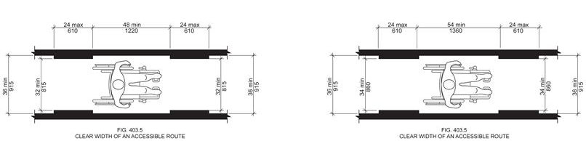

403.5.1 Clear Width at 180 Degree Turn Around Object. Where an accessible route makes a 180 degree turn around an object that is less than 48 inches (1220 mm) in width, clear widths shall be 42 inches (1065 mm) minimum approaching the turn, 48 inches (1220 mm) minimum during the turn, and 42 inches (1065 mm) minimum leaving the turn.

EXCEPTIONS:

- Section 403.5.1 shall not apply where the clear width during the turn is 60 inches
(1525 mm) minimum.

- Section 403.5.1 shall not apply where a minimum clear width of 43 inches (1090 mm) is provided approaching, during, and leaving the turn.

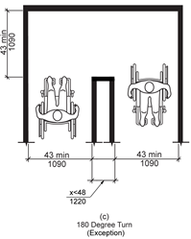
FIG. 403.5.1 ( c )
403.5.2 Passing Space. An accessible route with a clear width less than 60 64 inches (1525 1625 mm) shall provide passing spaces at intervals of 200 feet (61 m) maximum. Passing spaces shall be either a 60-inch (1525 mm) minimum by 60-inch 64-inch (1525 1625 mm) minimum space, or an intersection of two walking surfaces that provide a T-shaped turning space complying with Section 304.3.2, provided the base and arms of the T-shaped space extend 48 54 inches (1220 1360 mm) minimum beyond the intersection.

Reason: Many of the technical requirements of the ICC/ANSI A117.1 (2009) Accessible and Usable Buildings and Facilities (ICC/ANSI) designed to accommodate wheeled mobility users are based on research completed from 1974 to 1978 using a research sample that included about 60 individuals who used manual wheelchairs (Steinfeld et al., 1979).
The Center for Inclusive Design and Environmental Access (IDeA) at the University at Buffalo, SUNY recently completed an anthropometric study of 500 wheeled manual and powered mobility device users (Steinfeld, et al., 2010). Measurements of body and device size were captured in three dimensions. The functional anthropometric measurements required measuring reaching ability, grip strength and the minimum space needed for turning. It is the most extensive anthropometric study of wheeled mobility device users in the United States. Additional information about the study can be found at http://www.udeworld.com/ansi-standards-review. The proposed revisions are based on new anthropometric information that was generated from the database of anthropometric measurements developed as part of the study.

Analysis

Clear floor space represents the space required for a stationary wheeled mobility device. This area is typically depicted as a rectangular space the dimensions of which are based on measurements of occupied length and occupied breadth of wheeled mobility devices, which are defined as follows:
- Occupied length: measured as the horizontal distance between the forward-most point and the rear-most point on the wheelchair or occupant.
- Occupied width: measured as the horizontal distance between the side-most points of the wheelchair or participant on the right and left sides.
The results of our analysis suggest that the existing standard on clear floor space (48” length, 30” width) does not accommodate the occupied lengths and widths of the wheeled mobility user population and excludes powered wheeled mobility device users disproportionately as compared to manual device users. A length of 48” accommodates the occupied length of 75% of manual wheelchair users and only about 50% of powered chair and scooter users. A width of 30” accommodates the occupied width of 90% of manual wheeled mobility device users and only 75% of powered chair users.
We have taken the position that the clear floor space standards should accommodate the occupied lengths and widths of at least 90% of manual and powered wheeled mobility device users. A length of 54” accommodates the occupied lengths of 95% of manual chair users, and 90% of the powered chair users. A width of 32” accommodates the occupied widths of over 95% of manual wheeled mobility device users and 90% of the powered wheelchair users. Proposed changes to subsections 403 (Walking Surfaces) would accommodate an occupied length of 54 inches and occupied width of 32 inches (adjusted to 34 inches to be consistent with the 2 inch increase in the standard to accommodate width changes related to movement) for those parts of the standard based on occupied length and width.
A new exception is proposed for the 180-degree turns, based on an analysis also completed for the Anthropometry of Wheeled Mobility report. The analysis suggested that 95% of manual wheelchair users, as well as 95% of power chair and scooter users could accomplish a turn around a barrier when all three sides of the turn were 43 inches (Steinfeld, et al., 2010, pg. 166).
The analysis was summarized in the Final Project Report to the U.S. Access Board and in a memorandum entitled “Evaluation of Clear Floor Space Requirements,” that was submitted to the ICC/ANSI A117 Task Force on Anthropometry of Wheeled Mobility Subcommittee on Clear Floor Space Clearances.

References (See http://www.udeworld.com/ansi-standards-review)

Paquet, V. (2012). Evaluation of Clear Floor Space Requirements. A memorandum submitted to the ICC/ANSI A117 Task Force on Anthropometry of Wheeled Mobility Subcommittee on Clear Floor Space Clearances.

Steinfeld, E., Paquet, V., D’Souza, C., Joseph, C, and Maisel, J. (2010). Final Report: Anthropometry of Wheeled Mobility Project. Washington, DC: U.S. Access Board.

Steinfeld, E. Schroeder, S. and Bishop, M. (1979). Accessible buildings for people with walking and reaching limitations. Washington, DC: U.S. Department of Housing and Urban Development.
input.doc

Committee Action

Approval as Modified

Modification – The original proposal is replaced with the following

403.5 Clear Width. The clear width of an accessible route shall be 36 inches (915 mm) minimum.

EXCEPTION: The clear width shall be permitted to be reduced to 32 inches (815 mm) minimum for a length of 24 inches (610 mm) maximum provided the reduced width segments are separated by segments that are 48 52 inches (1220 ???? mm) minimum in length and 36 inches (915 mm) minimum in width.

403.5.2 Passing Space. An accessible route with a clear width less than 60 inches (1525 mm) shall provide passing spaces at intervals of 200 feet (61 m) maximum. Passing spaces shall be either a 60-inch (1525 mm) minimum by 60-inch (1525 mm) minimum space, or an intersection of two walking surfaces that provide a T-shaped turning space complying with Section 304.3.2, provided the base and arms of the T-shaped space extend 48 52 inches (1220 ???? mm) minimum beyond the intersection.

Committee Reason: The Committee agreed to a revised clear floor space of 30 by 52 inches in Proposal 3-13-12. The original proposal here assumed a larger clear floor space, therefore the Committee approved only changes needed to address the 30 by 52 dimensions. Changes to Section 403.5.1 were not approved because the Committee felt the changes approved in proposal 4-8-12 were more appropriate.

BALLOT COMMENTS

4-6.1
Commenter: Gene Boecker, Representing NATO
Ballot: Negative with comment:

Comment: This should only be added to the next edition if the increase in wheelchair length is approved. Otherwise the standard will be disjointed and inconsistent. In the proposal, the “???” metric dimension for 52 inches should be 1320 mm to be consistent with its measure elsewhere in the standard.

4-6.2
Commenter: Ron Burton, Representing BOMA
Ballot: Negative with comment:

Comment: 90% of the manual and powered Wheeled Mobility Devices (WhMD) users can navigate the current 32 Inch width according to the proponents own reason statement. This argues against making the change to 34 inches for the allowable width. In addition, data in the study does not support the need for the increased dimension because the study places emphasis on mobility devices that have limited mobility. As we previously emphasized, the study does not take into consideration the availability of mobility devices that have greater mobility, and in fact may include devices intended only for outdoor use. We also oppose the proposed 52 inch length as this will have a significant impact on the interior of dwelling units where the occupant may not utilize the larger wheeled mobility devices.

4-6.3
Commenter: David Collins, Representing AIA
Ballot: Negative with comment:

Comment: The work of the study group isn’t finalized and the research that formed the basis for this change has not been validated.

4-6.4
Commenter: M. Bradley Gaskins, Representing NACS
Ballot: Negative with comment:

Comment: There has been no evidence presented that this is a necessary change and will be a burden on the public due to an increase in the area required. The evidence presented only addresses the wide variety of mobility devices in service today. It does not address whether the problem is in the manufacture of these mobility devices that do not conform to the current requirement or whether the built-environment needs to change to accommodate mobility devices that need a larger space and cannot be designed and manufactured in such a way as to fit within the current space. We don’t continue to let automobile manufacturers build wider and wider autos to go on our roads… they must be built to standards that allow them to work with our current road system.

4-6.5
Commenter: Gerald Gross, Representing AHLA
Ballot: Negative with comment:

Comment: The AHLA does not accept the singular results of the anthropometric study conducted by the Center for Inclusive Design and Environmental Access. It is understood that the work of the Wheelchair Mobility Task Group is ongoing and has submitted a series of proposal changes to the base building blocks of A117.1 Standard. At this time we believe that the proposed changes to the building blocks are unacceptable and should not be adopted by the Committee; therefore no additional changes are required in this portion of the standard with reference to the building block changes.
As an example: According to the IDEA analysis (4-6-12) a clear width of 30” accommodates the occupied width of 90% of manual wheelchair users and 75% of power chair users. An increase of the clear width to 32” would accommodate the occupied widths of 95% of manual users and 90% of powered chair users. The 2” would increase the manual wheelchair users by 5% and the power chair users by 15%. If this hypothesis is adopted than passage doors must comply with this theory.
According to the IDEA analysis (4-12-12) a width of 32” accommodates the width of over 95% of manual wheelchair users and 90% of power chair users. Therefore, the proposed changes to subsection 404 (Doors and Doorways) should be adjusted to 34” to be consistent with the increased standard to accommodate width changes related to movement.

4-6.6
Commenter: Gina Hilberry, Representing UCP
Ballot: Negative with comment:

Comment: Part of the justification the committee used for leaving the clear floor space building block at a width of 30” was that the building block applies only to a person and wheeled device in a stationary position. In this section, we are looking at the person in motion and the width of the person + hand and forearm should be considered. The proposal as modified should be additionally modified to say: “Exception: the clear width shall be permitted to be reduced to 34 inches minimum….” If the committee wishes to reduce the maximum depth of the reduced width segment, the 32” may be functional.

Revise as follows:

403.5 Clear Width. The clear width of an accessible route shall be 36 inches (915 mm) minimum.

EXCEPTION: The clear width shall be permitted to be reduced to 32 34 inches (815 mm) minimum for a length of 24 inches (610 mm) maximum provided the reduced width segments are separated by segments that are 52 inches (???? mm) minimum in length and 36 inches (915 mm) minimum in width.

403.5.2 Passing Space. An accessible route with a clear width less than 60 inches (1525 mm) shall provide passing spaces at intervals of 200 feet (61 m) maximum. Passing spaces shall be either a 60-inch (1525 mm) minimum by 60-inch (1525 mm) minimum space, or an intersection of two walking surfaces that provide a T-shaped turning space complying with Section 304.3.2, provided the base and arms of the T-shaped space extend 52 inches (???? mm) minimum beyond the intersection.

4-6.7
Commenter: Ronald G. Nickson, Representing NMHC
Ballot: Negative with comment:

Comment: Data in the study does not support the need for the increased dimension because the study places emphasis on mobility devices that have limited mobility. The study does not take into consideration the availability of mobility devices that have great mobility and that are not limited because of improper design.

4-6.8
Commenter: Steve Orlowski, Representing NAHB
Ballot: Negative with comment:

Comment: In the proponents own reason statement… 90% of the manual and powered Wheeled Mobility Devices (WhMD) users can navigate the current 32 Inch width, thereby not supporting the need for the change to 34 inches for the allowable width. In addition the proposed 52 inch length will have a significant impact on the interior of dwelling units where the occupant may not utilize the larger WhMD.

4-6.9
Commenter: Kim Paarlberg, Representing ICC
Ballot: Negative with comment:

Comment: Same comment as 3-6-12.

Committee Review of Comments and Action – July 2013

Approval as Modified.

Committee Reason: After discussion of issues raised by the comments, the committee sustained its previous decision to approve as modified. A proposal to change the exception to a width of 34 inches rather than the current 32 was debated. The argument was that the study is indicating people will be occupying more of the 30 inch width of a moving chair or other device, and extra space is needed. The committee felt that for the short length of these excepted spaces that 32 inches was still acceptable and was consistent with the width of doors.

Ballot Comments on July 2013 Committee Action Report

ICC – Kim Paarlberg
Negative: Ballot:
Comment/reason: See comment for Proposal 3-6 – 12.

NACS – Bradley Gaskins
Negative: Ballot:
Comment/reason: This change is predicated on the assumption that a larger CFS is required. While it may be true that wheeled mobility devices are getting larger is there a basis or need for them to become larger? This is a bigger question that should be answered before increasing the CFS size. Size of the units should be dictated, where possible, to have a minimal impact on the size of buildings. I am not convinced that the units cannot be designed and manufactured within the current space limitations dictated and still serve those who need wheeled mobility devices. At best this change is premature based upon the evidence. Even the wheeled mobility task group states that their findings have not been validated. Further, the impact of the larger CFS has not been analyzed for any building types.

NAHB – Steven Orlowski
Negative: Ballot:
Comment/reason: See comment for Proposal 3-6 – 12.

NMHC – Ron Nickson
Negative: Ballot:
Comment/reason: Data in the study does not support the need for the increased dimension because the study places emphasis on mobility devices that have limited mobility. The study does not take into consideration the availability of mobility devices that have great mobility and that are not limited because of improper design.

AIA – Dave Collins
Negative Ballot
Comment/reason: I agree with ICC-Kim Paarlberg’s comment. Also see additional comment added to 3-6-12.

4-7 – 12
403.5, 406.1, 406.4, 406.7, 406.10, 705.5.4

Proposed Change as Submitted

Proponent: Gina Hilberry, United Cerebral Palsy Association

Revise as follows:

403.5 Clear Width. The clear width of an interior accessible route shall be 36 inches (915 mm) minimum. The clear width of an exterior accessible route shall be 48 inches (1220 mm) minimum.

Exceptions:

1. The clear width shall be permitted to be reduced to 32 inches (815 mm) minimum for a length of 24 inches (610 mm) maximum provided the reduced width segments are separated by segments that are 48 inches (1220 mm) minimum in length and 36 inches (915 mm) minimum in width.

2. The clear width of an exterior ramp shall be permitted to be reduced to 36 inches (915 mm) minimum.

406.1 General. Curb ramps on accessible routes shall comply with Sections 406, 405.2, 405.3, and 405.10.

Exceptions:

1. The curb ramp running slope shall not exceed 8.3 percent maximum but shall not required the ramp length to exceed 15.0 feet (4.5 m).

2. The running slope of blended transitions shall be 5 percent maximum.

406.4 Width. Curb ramps shall be 36 inches (915 mm) 48 inches (1220 mm) minimum in width, exclusive of flared sides.

406.7 Landings. Landings shall be provided at the tops of curb ramps. The clear length of the landing
shall be 36 inches (915 mm) 48 inches (1220 mm) minimum. The clear width of the landing shall be at least as wide as the curb ramp, excluding flared sides, leading to the landing. Where the turning space or landing is constrained at the back-of-sidewalk, the landing shall be 48 inches (1220 mm) wide minimum and 60 inches (1550 mm) deep minimum.

Exception: In alterations, where there is no landing at the top of curb ramps, curb ramp flares shall be provided and shall not be steeper than 1:12.

406.10 Diagonal Curb Ramps. Diagonal or corner-type Curb ramps with returned curbs or other well-defined edges shall have the edges parallel to the direction of pedestrian flow. The bottom of diagonal curb ramps shall have 48 inches (1220 mm) minimum clear space outside active traffic lanes of the roadway. Diagonal Curb ramps provided at marked crossings shall provide the 48 inches (1220 mm) minimum clear space within the markings. Diagonal Curb ramps with flared sides shall have a segment of curb 24 inches (610 mm) minimum in length on each side of the curb ramp and within the marked crossing.

705.5.4 Alignment. Truncated domes shall be aligned in a square or radial grid pattern.

Reason: These proposals all relate to current best practices in the Public Right-of-Way and exterior environments.
Section 403.5 Width of exterior accessible route: this change matches the current language in the PROW guidelines. The edges of sidewalks and other accessible routes are clearly different from the edges of hallways and corridors and similar interior surfaces. Dropping off the edge of a sidewalk can have serious consequences. Passing oncoming pedestrians on 36 inch wide is impossible.
Section 406.4 Width of curb ramps and Section 406.7 Landings. These changes bring A117.1 into harmony with the current PROW guidelines.
Section 406.10 Diagonal ramps are no longer recommended design layouts. Deletion of the word diagonal allows the requirements to remain largely in place but to be applied to other curb ramps plan types.
Section 705.5.4 At blended transitions where the slope of the surface is at 5% maximum, it is important that the truncated domes align with the path of travel. Adding "or radial" permits the installation of domes aligned with the path of travel.
input.doc

Committee Action

Approval as Modified

Modification – Only the revisions to Section 403.5 were accepted.

403.5 Clear Width. The clear width of an interior accessible route shall be 36 inches (915 mm) minimum. The clear width of an exterior accessible route shall be 48 inches (1220 mm) minimum.

Exceptions:

1. The clear width shall be permitted to be reduced to 32 inches (815 mm) minimum for a length of 24 inches (610 mm) maximum provided the reduced width segments are separated by segments that are 48 inches (1220 mm) minimum in length and 36 inches (915 mm) minimum in width.

2. The clear width of an exterior ramp shall be permitted to be reduced to 36 inches (915 mm) minimum.

Committee Reason: The proposal was reduced to just addressing the width of exterior accessible routes. A few states already have adopted a greater exterior width. Ramps need to be exempted because of how ramps and their handrails located on both sides are used. Some members of the Committee expressed concern that changing the width from 36 to 48 moves the standard away from providing only the minimum needed for accessibility. It was questioned whether there is simply a need for better edge protection of such routes and not simply widening them.

BALLOT COMMENTS

4-7.1
Commenter: Todd Andersen
Ballot: Negative with comment:

Comment: No evidence was provided that there is a need for wider accessible routes outdoors. Other than donning a parka I think of nothing that would cause the person using a wmd to become wider after leaving a building.

4-7.2
Commenter: Ron Burton, Representing BOMA
Ballot: Negative with comment:

Comment: This change is based on proposals that have not been finalized and, because they could change, should not be used as the basis for a change to the A117.1 standard.

4-7.3
Commenter: Ronald G. Nickson, Representing NMHC
Ballot: Negative with comment:

Comment: The change is based on proposals that have not been finalized and, because they could change, should not be used as the basis for a change to the A117.1 standard.

4-7.4
Commenter: Rick Lupton, Representing WABO
Ballot: Negative with comment:

Comment: The reason statement appears to intend that this provision apply to such structures as sidewalks. However, the proposed language goes beyond that, also including such elements as an exterior balcony.

4-7.5
Commenter: Steve Orlowski, Representing NAHB
Ballot: Negative with comment:

Comment: The proposed PROW guidelines that were released for public comment in 2011 have not been finalized. The previous versions of the PROW still in the have not been accepted nor adopted by any federal agency since it was first developed by the US Access Board. In addition, in one section the maximum slope is given in percentages and the other is given in inches. Deleting diagonal curb ramps will be an additional hardship to those jurisdictions which spent funds to put them in the first place and will not be able to repair them or alter them in the future.

4-7.6
Commenter: Edward Steinfeld, Representing RESNA
Ballot: Negative with comment:

Comment: The 48 in. width for exterior routes is far too restrictive. It would be impossible to comply with this requirement in many existing sites and also would unnecessarily lead to excessive pavement, conflicting with other important design goals. There is no evidence that a 48 in. clear width is needed for one way passage on curb ramps nor on sidewalks. Beyond a width of 36 in. min., the width of circulation spaces should be based on the amount of traffic which is something to be considered by designers of each project, not standards. If the intent is to require enough space for two way traffic, the width has to be greater, e.g. 22+36 = 58. But there are many locations where two way traffic is not needed. A good example is a curb ramp leading to an access aisle at a reserved parking space.

Committee Review of Comments and Action – July 2013

Approval with Modifications based on Comments.

Committee Reason: The committee reconsidered whether it is appropriate to require a wider minimum width for exterior accessible routes. The different factors affecting exterior versus interior accessible routes and how people must use them continued to convince the committee that a wider exterior route is necessary. The modification reflects a clarification of the exterior ramp section. There is more to ramp width than 36 inches, therefore a reference to the ramp section provides better guidance to the users of the standard.

Modification

403.5 Clear Width. The clear width of an interior accessible route shall be 36 inches (915 mm) minimum. The clear width of an exterior accessible route shall be 48 inches (1220 mm) minimum.

Exceptions:

1. The clear width shall be permitted to be reduced to 32 inches (815 mm) minimum for a length of 24 inches (610 mm) maximum provided the reduced width segments are separated by segments that are 48 inches (1220 mm) minimum in length and 36 inches (915 mm) minimum in width.

2. The clear width of an exterior ramp shall be permitted to be reduced to 36 inches (915 mm) minimum comply with Section 405.5.

Ballot Comments on July 2013 Committee Action Report

ATBCB – Marsha Mazz
Affirmative with Comment Ballot:
Comment: Motion to modify as follows:

403.5 Clear Width. The clear width of an interior accessible route shall be 36 inches (915 mm) minimum. The clear width of an exterior accessible route shall be 48 inches (1220 mm) minimum.

Exceptions:

1. The clear width shall be permitted to be reduced to 32 inches (815 mm) minimum for a length of 24 inches (610 mm) maximum provided the reduced width segments are separated by segments that are 48 inches (1220 mm) minimum in length and 36 inches (915 mm) minimum in width.

2. The clear width of an exterior ramp shall be permitted to comply with Section 405.5.

Reason: Because this is an exception, it cannot convey a mandatory requirement and is rewritten to only permit, not require, compliance with the widths specified in 405.5.

NAHB – Steven Orlowski
Negative Ballot:
Comment/reason: NAHB continues to oppose this proposed change which is based on the guidelines put forth by the US Access Board related to public right-of-way which have not been finalized through the federal regulatory process. In addition, the committee has yet to provide evidence or justification that the exterior accessible route must be wider than the interior accessible route.

Todd Andersen
Abstains:

Reason: I urge the Committee to vote against this proposal at the final ballot for the reasons previously given.

4-8 – 12
403.5.1

Proposed Change as Submitted

Proponent: Gina Hilberry and David Collins, Co-Chairs Wheeled Mobility Task Group

Revise as follows:

403.5.1 Clear Width at 180 Degree Turn. Where an accessible route makes a 180 degree turn around an object that is less than 48 inches (1220 mm) in width, clear widths shall be 42 inches (1065 mm) minimum approaching the turn, 48 inches (1220 mm) minimum during the turn and 42 (1065 mm) inches minimum leaving the turn 52 inches (1320 mm) in width minimum, clear widths shall be as permitted for turn complying with 405.5.1. Where an accessible route makes a 180 degree turn around an object that is less than 52 inches (1320 mm) inches, the clear widths approaching the turn, during the turn and leaving the turn, shall be one of the following sets of dimensions:

1. Approaching 36 inches (915 mm) minimum, during 60 inches (1525 mm) minimum, and leaving 36 inches (915 mm) minimum.
2. Approaching 42 (1065 mm) inches minimum, during 48 inches (1220 mm) minimum, and leaving 42 (1065 mm) inches minimum.
3. Approaching 43 inches (1090 mm) minimum, during 43 inches (1090 mm) minimum, and leaving 43 inches (1090 mm) minimum.

Reason: The Wheeled Mobility Task Group (WMTG) was created as a task group of the A117.1 Committee to analyze the results of the anthropometric study of a variety of mobility device users conducted by The Center for Inclusive Design and Environmental Access (IDeA) at the University at Buffalo, SUNY recently completed an anthropometric study of 500 wheeled manual and powered mobility device users. The study indicates that the technical provisions contained in the A117.1 standard do not address the needs of the full range of users of mobility devices. The work of the WMTG is ongoing, but it has submitted a series of proposed changes to the base building blocks of the A117.1 standard. If the changes to the building blocks are adopted by the Committee, then additional changes will need to be made in other portions of the standard.
input.doc

Committee Action

Approval as Modified

Modification

403.5.1 Clear Width at 180 Degree Turn. Where an accessible route makes a 180 degree turn around an object that is less equal to or greater than 48 inches (1220 mm) in width, clear widths shall be 42 inches (1065 mm) minimum approaching the turn, 48 inches (1220 mm) minimum during the turn and 42 (1065 mm) inches minimum leaving the turn 52 inches (1320 mm) in width, the clear widths in the turn shall comply with Section 405.5.1. Where an accessible route makes a 180 degree turn around an object that is less than 52 inches (1320 mm) inches in width, the clear widths approaching the turn, during the turn and leaving the turn, shall be one of the following sets of dimensions:

1. Approaching width is 36 inches (915 mm) minimum, during width is 60 inches (1525 mm) minimum, and leaving width is 36 inches (915 mm) minimum.

2. Approaching width is 42 (1065 mm) inches minimum, during width is 48 inches (1220 mm) minimum, and leaving width is 42 (1065 mm) inches minimum.

3. Approaching width is 43 inches (1090 mm) minimum, during width is 43 inches (1090 mm) minimum, and leaving width is 43 inches (1090 mm) minimum.

EXCEPTION: Section 403.5.1 shall not apply where the clear width during the turn is 60 inches (1525 mm) minimum.

Committee Reason: The Committee looked at the geometries of the L-turn; 180 degree turn and the T-turn. This represents the options of the 180 degree turn. The Committee recognized that between these specific measurements are likely to be additional combinations that do provide adequate space. The text may be better presented in a table format.

BALLOT COMMENTS

4-8.1
Commenter: Gene Boecker, Representing NATO
Ballot: Affirmative with comment:

Comment: Figures should be provided to illustrate these dimensional options.

4-8.2
Commenter: Ron Burton, Representing BOMA
Ballot: Negative with comment:

Comment: We agree with the Committee vote to allow the three different options as that will provide increased maneuverability. However, this should be based on the current clear floor space of 30 x 48.

4-8.3
Commenter: Gerald Gross, Representing AHLA
Ballot: Negative with comment:

Comment: The AHLA does not accept the singular results of the anthropometric study conducted by the Center for Inclusive Design and Environmental Access. It is understood that the work of the Wheelchair Mobility Task Group is ongoing and has submitted a series of proposal changes to the base building blocks of A117.1 Standard. At this time we believe that the proposed changes to the building blocks are unacceptable and should not be adopted by the Committee; therefore no additional changes are required in this portion of the standard with reference to the building block changes.

4-8.4
Commenter: Ronald G. Nickson, Representing NMHC
Ballot: Negative with comment:

Comment: Allowing the three different options will provide increased flexibility in maneuvering, however they should be based on the current clear floor space of 30 x 48.

4-8.5
Commenter: Steve Orlowski, Representing NAHB
Ballot: Negative with comment:

Comment: We do not disagree with the committee’s decision to allow the three additional options, but rather the increased dimension based upon a clear floor space dimension of 30 x 52.

4-8.6
Commenter: Kim Paarlberg, Representing ICC
Ballot: Negative with comment:

Comment: Same comment as 3-6-12.

Committee Review of Comments and Action – July 2013

Approved as Modified.

Committee Reason: The committee considered the information provided by the comments and decided to take no action to change its original approval as modified.

Ballot Comments on July 2013 Committee Action Report

ICC – Kim Paarlberg
Negative: Ballot:
Comment/reason: See comment for Proposal 3-6 – 12.

NAHB – Steven Orlowski
Negative: Ballot:
Comment/reason: While we agree that the standard should allow for additional options, we oppose the dimensions that are used in this proposed change that were based on the increase of the clear floor space dimension as approved by 3-13 – 12.

NMHC – Ron Nickson
Negative: Ballot:
Comment/reason: Allowing the three different options will provide increased flexibility in maneuvering, however they should be based on the current clear floor space of 30 x 48.

AIA – Dave Collins
Negative Ballot
Comment/reason: I agree with ICC-Kim Paarlberg’s comment. Also see additional comment added to 3-6-12.

4-9 – 12
403.5.2 (NEW)

Proposed Change as Submitted

Proponent: Gina Hilberry and David Collins, Co-Chairs Wheeled Mobility Task Group

Revise as follows:

403.5.2 Clear Width at 90 Degree Turn. Where an accessible route makes a 90 degree turn the clear widths approaching the turn and leaving the turn shall be one of the following sets of dimensions:

1. Both legs of the turn shall be 40 inches (1016 mm) minimum.
2. Where one leg of the turn is 40 inches (1016 mm) minimum for a distance of 68 inches (1727 mm) from the interior corner of the turn, the other leg shall be 36 inches (915 mm) minimum.
3. Where the interior corners of the turn are chamfered for 8 inches minimum along both walls, both legs of the turn shall be 36 inches (915 mm) minimum.

Reason: The Wheeled Mobility Task Group (WMTG) was created as a task group of the A117.1 Committee to analyze the results of the anthropometric study of a variety of mobility device users conducted by The Center for Inclusive Design and Environmental Access (IDeA) at the University at Buffalo, SUNY recently completed an anthropometric study of 500 wheeled manual and powered mobility device users. The study indicates that the technical provisions contained in the A117.1 standard do not address the needs of the full range of users of mobility devices. The work of the WMTG is ongoing, but it has submitted a series of proposed changes to the base building blocks of the A117.1 standard. If the changes to the building blocks are adopted by the Committee, then additional changes will need to be made in other portions of the standard.
input.doc

Committee Action

Approval as Modified

Modification

403.5.2 Clear Width at 90 Degree Turn. Where an accessible route makes a 90 degree turn the clear widths approaching the turn and leaving the turn shall be one of the following sets of dimensions:

- Both legs of the turn shall be 40 inches (1016 mm) minimum.in width

2. Where one leg of the turn is 40 inches (1016 mm) minimum in width for a distance of 68 inches (1727 mm) minimum in length from the interior corner of the turn, the other leg shall be 36 inches (915 mm) minimum in width.

2. Where the interior corners of the turn are chamfered for 8 inches minimum (205 mm) along both walls, both legs of the turn shall be 36 inches (915 mm) minimum in width.

Committee Reason: This WMTG, and the Committee concluded that the Standard needed to more clearly address how a 90 turn occurs in an accessible route. The options considered addressed the range of equipment used. After considerable evaluation of the geometry and use mechanics of various dimensions, the Committee concluded that the 2 options provided for a range of compliant designs.

BALLOT COMMENTS

4-9.1
Commenter: Gerald Gross, Representing AHLA
Ballot: Negative with comment:

Comment: The AHLA does not accept the singular results of the anthropometric study conducted by the Center for Inclusive Design and Environmental Access. It is understood that the work of the Wheelchair Mobility Task Group is ongoing and has submitted a series of proposal changes to the base building blocks of A117.1 Standard. At this time we believe that the proposed changes to the building blocks are unacceptable and should not be adopted by the Committee; therefore no additional changes are required in this portion of the standard with reference to the building block changes.

4-9.2
Commenter: Kim Paarlberg, Representing ICC
Ballot: Negative with comment:

Comment: Same comment as 3-6-12.

Committee Review of Comments and Action – July 2013

Approved as Modified

Committee Reason: The committee considered the information provided by the comments and decided to take no action to change its original approval as modified of this proposal.

Ballot Comments on July 2013 Committee Action Report

ICC – Kim Paarlberg
Negative: Ballot:
Comment/reason: See comment for Proposal 3-6 – 12.

NACS – Bradley Gaskins
Negative: Ballot:
Comment/reason: This change is predicated on the assumption that a larger CFS is required. While it may be true that wheeled mobility devices are getting larger is there a basis or need for them to become larger? This is a bigger question that should be answered before increasing the CFS size. Size of the units should be dictated, where possible, to have a minimal impact on the size of buildings. I am not convinced that the units cannot be designed and manufactured within the current space limitations dictated and still serve those who need wheeled mobility devices. At best this change is premature based upon the evidence. Even the wheeled mobility task group states that their findings have not been validated. Further, the impact of the larger CFS has not been analyzed for any building types.

NAHB – Steve Orlowski
Negative Ballot
Comment/reason: See comment for proposal 3-6-12.

NMHC – Ron Nickson
Negative: Ballot:
Comment/reason: See comment for proposal 3-6-12.

4-10 – 12
403.5.3 (New)

Proposed Change as Submitted

Proponent: Jonathan White, representing himself

Add new text as follows:

403.5.3 Clear Width at 90 Degree Turn. Where an accessible route makes a 90 degree turn, the clear width shall be 40 inches (1015 mm) minimum. At least one leg of the turn shall be clear of obstructions for a length of 14 inches (355 mm) minimum with the other leg clear of obstructions for at least 28 inches (710 mm) minimum.

EXCEPTIONS:

1. Where one leg of the turn is 42 inches (1065 mm) minimum in width, the other shall be permitted to be 38 inches (965 mm) minimum in width, with the narrower leg being clear of obstructions for a length of 26 inches (660 mm) minimum, and the other leg being clear of obstructions for a length of 15 inches (380 mm) minimum.

2. Where one leg of the turn is 44 inches (1115 mm) minimum in width, the other shall be permitted to be 36 inches (915 mm) minimum in width, with the narrower leg being clear of obstructions for a length of 24 inches (610 mm) minimum, and the other leg being clear of obstructions for a length of 16 inches (405 mm) minimum.

Reason: Many of the technical requirements of the ICC/ANSI A117.1 (2009) Accessible and Usable Buildings and Facilities (ICC/ANSI) designed to accommodate wheeled mobility users are based on research completed from 1974 to 1978 using a research sample that included about 60 individuals who used manual wheelchairs (Steinfeld et al., 1979).
The Center for Inclusive Design and Environmental Access (IDeA) at the University at Buffalo, SUNY recently completed an anthropometric study of 500 wheeled manual and powered mobility device users (Steinfeld, et al., 2010). Measurements of body and device size were captured in three dimensions. The functional anthropometric measurements required measuring reaching ability, grip strength and the minimum space needed for turning. It is the most extensive anthropometric study of wheeled mobility device users in the United States. Additional information about the study can be found at http://www.udeworld.com/ansi-standards-review. The proposed revisions are based on new anthropometric information that was generated from the database of anthropometric measurements developed as part of the study.

Analysis

The results of our analysis suggest that the existing standard on a 90-degree turn does not accommodate the occupied lengths and widths of the wheeled mobility user population and excludes powered wheeled mobility device users disproportionately as compared to manual device users. This is based on the IDEA center’s 90-degree turn data in Final Report: Anthropometry of Wheeled Mobility Project. Fewer than 75% of manual and power wheelchair users could negotiate a L-turn that was 36 inches width (pg. 154). A width of 40 inches would accommodate 94% of manual wheelchair users, 99% of power wheelchair users, and 92% of scooter users.
The exceptions are the results of estimated percentages by the IDEA center in a memorandum by Edward Steinfeld, to the ANSI subcommittee on Turning. The estimated percentages for Option B, C and D are the actual percentages for the narrower 90 degree turns. In other words, we tested a 90 degree turn of 38 x 38 without a chamfer. We are using that data to estimate the minimum percentage accommodated by the chamfered version. Thus, this is a conservative estimate because widening one side and adding the chamfer would clearly increase the percentage accommodated.
The table in the memorandum is below:
Proportion of the sample accommodated in each of the four alternatives for a L-turn

% Accommodated | Data Source | Manual (n=208) | Power (n=150) | Scooter (n=23)
Option A (40”x40”) | Measured data for 40” x 40” | 94% | 99% | 92%
Option B (42”x38”) | Estimate based on data for 38”x38” | Min. 85% | Min. 87% | Min. 67%
Option C (44”x36”) | Estimate based on data for 36”x36” | Min. 71% | Min. 71% | Min. 46%
Option D (36”x36” w/chamfer) | Estimate based on data for 36”x36” | Min. 71% | Min. 71% | Min. 46%

The analysis was summarized in the Final Project Report to the U.S. Access Board and in a memorandum entitled “Evaluation of Clear Floor Space Requirements,” that was submitted to the ICC/ANSI A117 Task Force on Anthropometry of Wheeled Mobility Subcommittee on Clear Floor Space Clearances.

References (See http://www.udeworld.com/ansi-standards-review)

Steinfeld, E. (2012). Summary of Turning Discussion and Responses and Recommended Dimensions for Turning Spaces. A memorandum submitted to the ICC/ANSI A117 Task Force on Anthropometry of Wheeled Mobility Subcommittee on Turning Spaces.

Steinfeld, E., Paquet, V., D’Souza, C., Joseph, C, and Maisel, J. (2010). Final Report: Anthropometry of Wheeled Mobility Project. Washington, DC: U.S. Access Board.

Steinfeld, E. Schroeder, S. and Bishop, M. (1979). Accessible buildings for people with walking and reaching limitations. Washington, DC: U.S. Department of Housing and Urban Development.
input.doc

Committee Action

Approval as Modified

Modification

403.5.3 Clear Width at 90 Degree Turn. Where an accessible route makes a 90 degree turn, the clear width shall be 40 inches (1015 mm) minimum. At least one leg of the turn shall be clear of obstructions for a length of 14 inches (355 mm) minimum with the other leg clear of obstructions for at least 28 inches (710 mm) minimum. The width of each leg of the turn shall be maintained for 28 inches minimum from the inner corner.

EXCEPTIONS:

1. Where one leg of the turn is 42 inches (1065 mm) minimum in width, the other shall be permitted to be 38 inches (965 mm) minimum in width, with the narrower leg being clear of obstructions for a length of 26 inches (660 mm) minimum, and the other leg being clear of obstructions for a length of 15 inches (380 mm) minimum.

2. Where one leg of the turn is 44 inches (1115 mm) minimum in width, the other shall be permitted to be 36 inches (915 mm) minimum in width, with the narrower leg being clear of obstructions for a length of 24 inches (610 mm) minimum, and the other leg being clear of obstructions for a length of 16 inches (405 mm) minimum.

Committee Reason: The Committee approved both Proposal 4-9-12 and 4-10-12 as providing optional geometries for accomplishing a 90 degree turn in an accessible route. It was the Committee’s intent that 4-9 and 4-10 both be reflected in the standard. The committee recognized that merged text of these 2 proposals may be best presented in a table format. The Committee hopes the Editorial Task Group can develop the table format. Figures would also be helpful in presenting this information.

BALLOT COMMENTS

4-10.1
Commenter: M. Bradley Gaskins, Representing NACS
Ballot: Negative with comment:

Comment: There has been no evidence presented that this is a necessary change and will be a burden on the public due to an increase in the area required. The evidence presented only addresses the wide variety of mobility devices in service today. It does not address whether the problem is in the manufacture of these mobility devices that do not conform to the current requirement or whether the built-environment needs to change to accommodate mobility devices that need a larger space and cannot be designed and manufactured in such a way as to fit within the current space. We don’t continue to let automobile manufacturers build wider and wider autos to go on our roads… they must be built to standards that allow them to work with our current road system.

4-10.2
Commenter: Gerald Gross, Representing AHLA
Ballot: Negative with comment:

Comment: The AHLA does not accept the singular results of the anthropometric study conducted by the Center for Inclusive Design and Environmental Access. It is understood that the work of the Wheelchair Mobility Task Group is ongoing and has submitted a series of proposal changes to the base building blocks of A117.1 Standard. At this time we believe that the proposed changes to the building blocks are unacceptable and should not be adopted by the Committee; therefore no additional changes are required in this portion of the standard with reference to the building block changes.

4-10.3
Commenter: Kim Paarlberg, Representing ICC
Ballot: Negative with comment:

Comment: Same comment as 3-6-12.

Committee Review of Comments and Action – July 2013

Approved as Modified.

Committee Reason: The committee considered the information provided by the comments and decided to take no action to change its original approval as modified of this proposal.

Ballot Comments on July 2013 Committee Action Report

ICC – Kim Paarlberg
Negative: Ballot:
Comment/reason: See comment for Proposal 3-6 – 12.

NACS – Bradley Gaskins
Negative: Ballot:
Comment/reason: This change is predicated on the assumption that a larger CFS is required. While it may be true that wheeled mobility devices are getting larger is there a basis or need for them to become larger? This is a bigger question that should be answered before increasing the CFS size. Size of the units should be dictated, where possible, to have a minimal impact on the size of buildings. I am not convinced that the units cannot be designed and manufactured within the current space limitations dictated and still serve those who need wheeled mobility devices. At best this change is premature based upon the evidence. Even the wheeled mobility task group states that their findings have not been validated. Further, the impact of the larger CFS has not been analyzed for any building types.

NAHB – Steve Orlowski
Negative Ballot
Comment/reason: See comment for proposal 3-6-12.

NMHC – Ron Nickson
Negative: Ballot:
Comment/reason: See comment for proposal 3-6-12.

4-11 – 12
404, 404.1, 404.2, 404.2.3, 404.2.3.2, 404.2.3.4, 404.2.3.5, 404.2.4.1, 404.2.5, 404.2.6, 404.2.7, 404.2.8, 404.2.9, 404.2.10, 404.3, 404.3.2, 404.3.4

Proposed Change as Submitted

Proponent: Ed Roether, representing the ADA/A117 Harmonization Task Group

Revise as follows:

404 Doors, and Doorways and Gates

404.1 General. Doors, and doorways and gates that are part of an accessible route shall comply with Section 404.

EXCEPTION: Doors, doorways, and gates designed to be operated only by security personnel shall not be required to comply with 404.2.3, 404.2.6, 404.2.7, 404.2.8, 404.3.2 and 404.3.4 through 404.3.6.

404.2 Manual Doors, Doorways and Manual Gates. Manual doors and doorways, and manual gates, intended for user passage including ticket gates, shall comply with Section 404.2.

EXCEPTION: Doors, doorways, and gates designed to be operated only by security personnel shall not be required to comply with Sections 404.2.6, 404.2.7, and 404.2.8.

404.2.3 Maneuvering Clearances. Minimum maneuvering clearances at doors and gates shall comply with Section 404.2.3.and shall include the full clear opening width of the doorway and the required latch side or hinge side clearance. Required door maneuvering clearances shall not include knee and toe clearance.

404.2.3.2 Swinging Doors and Gates. Swinging doors and gates shall have maneuvering clearances complying with Table 404.2.3.2.

Fig. 404.2.3.2
Maneuvering Clearance at Manual Swinging Doors and Gates

Table 404.2.4.1 Maneuvering Clearances at Manual Swinging Doors and Gates
Table 404.2.3.2—Maneuvering Clearances at Manual Swinging Doors and Gates
TYPE OF USE |  | MINIMUM MANEUVERING CLEARANCES
Approach  Direction | Door or Gate Side | Perpendicular to Doorway | Parallel to Doorway (beyond latch unless noted)
From front | Pull | 60 inches (1525 mm) | 18 inches (455 mm)
(Balance of table is not changes)

404.2.3.4 Doorways without Doors or Gates. Doorways without doors or gates that are less than 36 inches (915 mm) in width shall have maneuvering clearances complying with Table 404.2.3.3

Fig. 404.2.3.4
Maneuvering Clearance at Doorways without Doors or Gates

Table 404.2.3.4—Maneuvering Clearances for Doorways without Doors or Gates
Approach Direction | MINIMUM MANEUVERING CLEARANCES  Perpendicular to Doorway
From front | 48 inches (1220 mm)

404.2.3.5 Recessed Doors and Gates. Where any obstruction within 18 inches (455 mm) of the latch side of a doorway projects more than 8 inches (205 mm) beyond the face of the door or gate, measured perpendicular to the face of the door, maneuvering clearances for a forward approach shall be provided.

Fig. 404.2.3.5
Maneuvering Clearance at Recessed Doors and Gates

404.2.5 Two Doors and Gates in Series. Distance between two hinged or pivoted doors or gates in series shall be 48 inches (1220 mm) minimum plus the width of any door or gate swinging into the space. The space between the doors shall provide a turning space complying with Section 304

Fig. 404.2.5
Two Doors or Gates in a Series

404.2.6 Door and Gate Hardware. Handles, pulls, latches, locks, and other operable parts on accessible doors and gates shall have a shape that is easy to grasp with one hand and does not require tight grasping, pinching, or twisting of the wrist to operate. Operable parts of such hardware shall be 34 inches (865 mm) minimum and 48 inches (1220 mm) maximum above the floor. Where sliding doors are in the fully open position, operating hardware shall be exposed and usable from both sides.

EXCEPTION: Locks used only for security purposes and not used for normal operation shall not be required to comply with Section 404.2.6.

404.2.7 Closing Speed. Door and gate closing speed shall comply with 404.2.8.

404.2.7.1 Door Closers and Gate Closers. Door closers and gate closers shall be adjusted so that from an open position of 90 degrees, the time required to move the door to an open position of 12 degrees shall be 5 seconds minimum.

404.2.7.2 Spring Hinges. Door and gate spring hinges shall be adjusted so that from an open position of 70 degrees, the door or gate shall move to the closed position in 1.5 seconds minimum.

404.2.8 Door and Gate Opening Force. Fire doors shall have the minimum opening force allowable by the appropriate administrative authority. The force for pushing or pulling open doors or gates other than fire doors shall be as follows:

1.Interior hinged doors and gates: 5.0 pounds (22.2 N) maximum
.
2.Sliding or folding doors: 5.0 pounds (22.2 N) maximum

These forces do not apply to the force required to retract latch bolts or disengage other devices that hold the door or gate in a closed position.

404.2.9 Door and Gate Surface. Door and gate surfaces within 10 inches (255 mm) of the floor, measured vertically, shall be a smooth surface on the push side extending the full width of the door or gate. Parts creating horizontal or vertical joints in such surface shall be within ¹/₁₆ inch (1.6 mm) of the same plane as the other. Cavities created by added kick plates shall be capped.

EXCEPTIONS:

(Exceptions 1 and 2 are not changed)

3. Doors and gates that do not extend to within 10 inches (255 mm) of the floor shall not be required to comply with Section 404.2.9.

404.2.10 Vision Lites. Doors, gates and sidelites adjacent to doors or gates containing one or more glazing panels that permit viewing through the panels shall have the bottom of at least one panel on either the door or an adjacent sidelite 43 inches (1090 mm) maximum above the floor.

(Exception is not changed)

404.3 Automatic Doors and Power-Assisted Doors and Gates. Automatic doors and automatic gates shall comply with Section 404.3. Full powered automatic doors shall comply with ANSI/BHMA A156.10 listed in Section 105.2.4. Power–assist and low–energy doors shall comply with ANSI/BHMA A156.19 listed in Section 105.2.3.

EXCEPTION: Doors, doorways, and gates designed to be operated only by security personnel shall not be required to comply with Sections 404.3.2, 404.3.4, and 404.3.5.

404.3.2 Maneuvering Clearances. Maneuvering clearances at power–assisted doors and gates shall comply with Section 404.2.3.

404.3.4 Two Doors or Gates in Series. Doors or gates in series shall comply with Section 404.2.5.

Reason: The ADA/A117 Harmonization Task Group (HTG) was created as a task group of the A117.1 Committee to compare the 2010 ADA with the 2009 A117.1 Standard. The HTG has recommend a series of changes through a set of change proposals. The HTG is recommending changes, for the most part, address where the ADA was viewed as more stringent than the A117. Where the A117 contained provisions not addressed in the ADA, these were not considered a conflict needing action to amend the A117. In addition there are a number of places where the ADA and A117.1 are different as a result of specific actions, by the A117.1 Committee during the development of the 2009 edition, to remain or create a difference where, in the judgment of the committee the ADA was deficient.

Reason for 404 To provide consistent language with the ADA. ADA consistently uses gates when discussing doors. The amendments through this section are simply providing consistent coverage. The exception to Section 404.1 is relocating an existing exception found in A117.1 Section 404.2 and others to a location similar to ADA.
input.doc

Committee Action

Approved

Committee Reason: The change provides consistency in terminology between the Standard and the ADA.

BALLOT COMMENTS

4-11.1
Commenter: Rick Lupton, Representing WABO
Ballot: Affirmative with comment:

Comment: Gates should also be added to Section 402.2, regarding components of an accessible route.

Committee Review of Comments and Action – July 2013

Approval with Modifications based on Comment.

Committee Reason: Comment 4.11-1 pointed out another section to which ‘gates’ should be added. The committee approved such as an editorial clarification to its original approval.

Modification:

402.2 Components. Accessible routes shall consist of one or more of the following components: Walking surfaces with a slope not steeper than 1:20, doors and doorways, gates, ramps, curb ramps excluding the flared sides, elevators and platform lifts. All components of an accessible route shall comply with the applicable portion of this standard.

(The balance of the proposal remains unchanged.)

Ballot Comments on July 2013 Committee Action Report

RESNA – Edward Steinfeld
Negative: Ballot:
Comment/reason: This requirement is overly restrictive in existing buildings and sites. It conflicts with sustainable design goals and is unsupported by research. There are other solutions than the ones proposed, including tracks. Moreover, a thorough investigation of porous materials should be conducted to learn what the issues really are. In other words, research is needed before taking action.

4-13 – 12
404.2.3
Proposed Change as Submitted

Proponent: Ed Roether, representing the ADA/A117 Harmonization Task Group

Revise as follows:

404.2.3 Maneuvering Clearances. Minimum maneuvering clearances at doors shall comply with Section 404.2.3. Maneuvering clearances and shall include the full clear opening width of the doorway and the required latch side or hinge side clearance. Required door maneuvering clearances shall not include knee and toe clearance.

EXCEPTION: Entry doors to hospital patient rooms shall not be required to provide the clearance beyond the latch side of the door.

Reason: The ADA/A117 Harmonization Task Group (HTG) was created as a task group of the A117.1 Committee to compare the 2010 ADA with the 2009 A117.1 Standard. The HTG has recommended a series of changes through a set of change proposals. The HTG is recommending changes, for the most part, address where the ADA was viewed as more stringent than the A117. Where the A117 contained provisions not addressed in the ADA, these were not considered a conflict needing action to amend the A117. In addition there are a number of places where the ADA and A117.1 are different as a result of specific actions, by the A117.1 Committee during the development of the 2009 edition, to remain or create a difference where, in the judgment of the committee the ADA was deficient.

Reason for 404.2.3: The added text is ADA language not currently in A117.1. The text that is being struck out was an attempt in the standard to allow maneuvering clearances to go under some objects where the knees/toes of a wheelchair user would still have adequate space to operate the door. However, the text is unclear. Further, current interpretation of the ADA is that maneuvering spaces must be clear for the full height of 80 inches. The exception is also found in the IBC, but adding it here provides clarity as well as consistency with the ADA.
input.doc

Committee Action

Approval as Modified

Modification

404.2.3 Maneuvering Clearances. Minimum maneuvering clearances at doors shall comply with Section 404.2.3. Maneuvering clearances shall include the full clear opening width of the doorway and the required latch side or hinge side clearance.

EXCEPTION: Entry doors to hospital patient rooms shall not be required to provide the clearance beyond the latch side of the door.

Committee Reason: The Committee previously deleted this exception and keeping it out of the Standard will simply make the Standard more stringent than the ADA – not in conflict. The issue is centered on operational standards of hospital where historically patient room doors have remained open, therefore negating the need for this clearance. The Committee does not believe that such operational standards are universal and feels that the maneuvering clearances should be provided.

BALLOT COMMENTS

4-13.1
Commenter: Gene Boecker, Representing NATO
Ballot: Affirmative with comment:

Comment: The rationale that the maneuvering space extends upward from the floor for a height of 80 inches should be included in the standard in some manner. This is not clear. Can this be included in a definition for “maneuvering clearance” - such as “The area next to the face of a door and extending upward for 80 inches which is used for approach and operation of the door and door hardware.”? Such information would improve the ability to apply the standard and address the intent of this section. Otherwise, it should be included in the Commentary.

4-13.2
Commenter: Kim Paarlberg, Representing ICC
Ballot: Negative with comment:

Comment: The exception should remain in the proposal. This exception is found in ADA. The increased size of doors in hospitals to allow for the movement of beds provide a wider maneuvering clearance at the doors. No studies have showed that this is not adequate for opening the door. Requirements for visual supervision of patients will have the doors open except when a procedure requiring some privacy is being performed, and then there is staff in the room with the patient. Typical layouts for a patient hospital room is to walk in past the room’s bathroom to get to the main room. Therefore, the required increase in maneuvering clearance will typically mean a loss of space in the bathroom. Since patients often need assistance in use of the toilet or bathing, the loss of space in the bathroom for door maneuvering space is not justified.

PROPONENT COMMENT

4-13.3
Commenter: Ed Rother, representing the ADA/A117 Harmonization Task Group

Further revise 4-13 as follows:

404.2.3 Maneuvering Clearances. Minimum maneuvering clearances at doors shall comply with Section 404.2.3. Maneuvering clearances and shall include the full clear opening width of the doorway and the required latch side or hinge side clearance. Required door maneuvering clearances shall not include knee and toe clearance.

EXCEPTION: Entry doors to hospital patient rooms shall not be required to provide the clearance beyond the latch side of the door.

Reason: The modification deleted the exception. The exception should remain in the proposal for several reasons. This exception is found in ADA. The increased size of doors in hospitals to allow for the movement of beds provide a wider maneuvering clearance at the doors. No studies have showed that this is not adequate for opening the door. Requirements for visual supervision of patients will have the doors open except when a procedure requiring some privacy is being performed, and then there is staff in the room with the patient. Typical layouts for a patient hospital room is to walk in past the room’s bathroom to get to the main room. Therefore, the required increase in maneuvering clearance will typically mean a loss of space in the bathroom. Since patients often need assistance in use of the toilet or bathing, the loss of space in the bathroom for door maneuvering space is not justified.

Committee Review of Comments and Action – July 2013

Approval as Modified.

Committee Reason: The committee considered restoring the exception for hospital doors contained in the original proposal. Representatives of health care providers urged the committee to consider restoring the exception because it compounded with other demands to force larger and larger patient rooms. While some hospitals have a policy that patient room doors remain open, there was much anecdotal evidence presented that such policy is not universal. Also of concern are rehabilitation hospitals where closing these doors is more common. The committee reaffirmed its early action to approve with modifications which eliminates the exception for maneuvering clearances at patient room doors.

Ballot Comments on July 2013 Committee Action Report

HLAA – Sharon Toji
Affirmative with Comment Ballot:
Comment/reason: In regard to Gene Boecker's comment 4-13.1, his request that there be clarity regarding the fact that the maneuvering space extends from the floor upward to 80 inches also is of importance for sign placement. When projecting objects are placed within this space, they often make it impossible for sign readers to approach signs closely, or even within 3 inches. I don't know if this is solved through the wording by Ed Rother in 4-13.3. I presume this language is included in the approved item. However, some sort of explanation as to its meaning may still be required, as Gene Boecker has suggested.
There may still be a problem when we refer to the table and see that rooms and spaces approached from the front on the push side require no space parallel to the door. Unless these doors require an automatic closer and have no hold open devices and the sign can be placed on the door, where should it be placed? Perpendicular walls do not normally provide appropriate locations for signs, since they often cannot be seen along corridors and don't appear to be related to the rooms they identify.
See also Item # 7-10-12: There was an attempt to deal with this as a sign issue, and it was just too complicated a task to deal with "on the fly." It needs, however, to be addressed. There are so many problems with sign placement, especially in older buildings, that people who are blind tell me that they have mostly given up on even trying to find tactile signs and use them to identify destinations. Surely, this would be worthy of a task force that could tackle it, along with other issues important to those with disabilities affecting communications in the built environment, for the next cycle.

ICC – Kim Paarlberg
Negative: Ballot:
Comment/reason: A very common question for ICC is what is permitted to overlap the maneuvering space for a door. The last sentence was added in 2009 to specifically address this question. While this is not in ADA, it does not conflict and should remain in ICC A117.1 to provide that additional clarification. Otherwise, a conservative interpretation is to not allow any overlap, including items such as handrails, grab bars, light sconces – everything up to the 6’-8” height.

AIA – Dave Collins
Negative Ballot
Comment/reason: I agree with ICC-Kim Paarlberg’s comment. Also see additional comment added to 3-6-12.

4-14 – 12
Table 404.2.3.2
Proposed Change as Submitted

Proponent: Kim Paarlberg, International Code Council

Revise as follows:

TABLE 404.2.3.2—MANEUVERING CLEARANCES AT MANUAL SWINGING DOORS
TYPE OF USE |  | MANEUVERING CLEARANCES AT MANUAL SWINGING DOORS
Approach Direction | Door Side | Perpendicular to Doorway | Parallel to Doorway  (beyond latch unless noted)
From front | Pull | 60 inches (1525 mm) | 18 inches (455 mm)
From front | Push | 48 inches (1220 mm) | 0 inches (0 mm)³
From hinge side | Pull | 60 inches (1525 mm) | 36 inches (915 mm)
From hinge side | Pull | 54 inches (1370 mm) | 42 inches (1065 mm)
From hinge side | Push | 42 inches (1065 mm)¹ | 22 inches (560 mm)^{3 & 4}
From latch side | Pull | 48 inches (1220 mm)¹ | 24 inches (610 mm)
From latch side | Push | 42 inches (1065 mm)² | 24 inches (610 mm)
¹Add 6 inches (150 mm) if closer and latch provided.
²Add 6 inches (150 mm) if closer provided.
³Add 12 inches (305 mm) beyond latch if closer and latch provided.
⁴Beyond hinge side.

Reason: The quantity of change proposals submitted by International Code Council is reflective of three elements of our work: 1. ICC is the Secretariat for the Standard and some changes reflect inconsistencies or improvements suggested by staff; 2. ICC develops and publishes a Commentary on the standard and writing the commentary illuminates issues of the text and figures; and 3. ICC provides an interpretation service for the standard which results in the observation of provisions the users find most confusing.
Coordination with the 2012 ADA Standards for Accessible Design.
The A117.1 requires there 12 inches beyond the latch side on this door if both a closer and a latch are provided on the door. The ADA does not have this 12 inch requirement.
This requirement was added to the A117.1 standard between the 1998 and 2003 editions by proposal 4-015 and was modified by public comment that cleaned up the footnote reference for it. The proponent’s reason statement said that figure (b) the front approach push side and figure (e) the hinge approach push side are similar situations and that having the 12 inches on the forward approach should also be provided on the hinge approach.
Because this extra requirement creates a discrepancy between the A117.1 and ADA which is not readily apparent and well known, the elimination of the footnote reference would help to coordinate the two standards and make this basic issue of door maneuvering clearances consistent. It seems that the addition of this requirement was probably not well justified when it was added into the 2003 A117.1 standard and with the change made in Section 404.2.3 of the 2009 edition which prevented door maneuvering clearances from including knee and toe clearance it made the difference between the A117.1 and the federal requirements that much greater. With some of the task groups looking at changing the ‘building blocks’ which could further affect maneuvering clearances, it would seem that this difference between the two standards should be eliminated or better justification should be provided so that it could be added into the federal requirements and coordinated that way.
The graphic representations of the various layouts are provided to better illustrate the differences. In the 2009 standard it is Fig 404.2.3.2(e) and in the 2010 ADA it is Figure 404.2.4.1(g). See ADA figure 404.2.4.1(f) for base condition.
The following is Figure 404.2.3.2(e) from the A117.1-2009 standard.

The following is Figure 404.2.4.1(g) from the 2010 ADA Standards for Accessible Design. This is the comparable requirement for the door shown in Figure 404.2.3.2(e) from the A117.1-2009 standard.

The following is Figure 404.2.4.1(f) from the 2010 ADA Standards for Accessible Design. This is the comparable base requirement for the door shown in Figure 404.2.3.2(e) from the A117.1-2009 standard (hinge approach/push side of door which does not have BOTH a closer and a latch).

input.doc

Committee Action

Approval as Modified

Modification

TABLE 404.2.3.2—MANEUVERING CLEARANCES AT MANUAL SWINGING DOORS
TYPE OF USE |  | MANEUVERING CLEARANCES AT MANUAL SWINGING DOORS
Approach Direction | Door Side | Perpendicular to Doorway | Parallel to Doorway  (beyond latch unless noted)
From front | Pull | 60 inches (1525 mm) | 18 inches (455 mm)
From front | Push | 48 52 inches (1220 mm) | 0 inches (0 mm)³
From hinge side | Pull | 60 inches (1525 mm) | 36 inches (915 mm)
From hinge side | Pull | 54 inches (1370 mm) | 42 inches (1065 mm)
From hinge side | Push | 42 inches (1065 mm)¹ | 22 inches (560 mm)⁴
From latch side | Pull | 48 inches (1220 mm)¹ | 24 inches (610 mm)
From latch side | Push | 42 inches (1065 mm)² | 24 inches (610 mm)
¹Add 6 inches (150 mm) if closer and latch provided.
²Add 6 inches (150 mm) if closer provided.
³Add 12 inches (305 mm) beyond latch if closer and latch provided.
⁴Beyond hinge side.

Committee Reason: The original purpose of the proposal was to eliminate the 12 inch beyond the latch requirement (footnote 3) from the provision of doors approached from the hinge side/push side. Such requirement isn’t in the ADA. The proposal was amended to be consistent with earlier actions to increase the clear floor space to a length of 52 inches (see Proposal 3-13-12).

BALLOT COMMENTS

4-14.1
Commenter: M. Bradley Gaskins, Representing NACS
Ballot: Negative with comment:

Comment: There has been no evidence presented that this is a necessary change and will be a burden on the public due to an increase in the area required. The evidence presented only addresses the wide variety of mobility devices in service today. It does not address whether the problem is in the manufacture of these mobility devices that do not conform to the current requirement or whether the built-environment needs to change to accommodate mobility devices that need a larger space and cannot be designed and manufactured in such a way as to fit within the current space. We don’t continue to let automobile manufacturers build wider and wider autos to go on our roads… they must be built to standards that allow them to work with our current road system.

4-14.2
Commenter: Kim Paarlberg, Representing ICC
Ballot: Negative with comment:

Comment: I agree with the original proposal. However, the modification is an increase in maneuvering clearance based on the building block changes. For the modification, by reason is the same comment as 3-6-12.

Proponent Comment

4-14.3
Commenter: Kim Paarlberg, Representing ICC

Request the Proposal be Approved as Submitted

Reason: I agree with the original proposal. However, the modification is an increase in maneuvering clearance based on the building block changes. I am asking for disapproval of the modification.

Note

The size increase in the building blocks and accessible routes proposed by the series of changes from the Wheeled Mobility Task Group will have significant impacts on the design of buildings and facilities as well as the cost of construction. There has not been adequate study of the impact of these changes. Proto-type designs should be prepared to determine the impact of these standards. The Appendix B of the ADA, which did a series of bathrooms to show the impact of new requirements, is a wonderful example of what the Committee really needs to see in order to understand the impact of these requirements on tight spaces like bathrooms, kitchens, dressing rooms, locker rooms, configurations with 36” wide corridors or aisles, doorways in alcoves, etc. What is the impact on an residential, such as apartments, dormitories, assisted living facilities – Accessible/Type A vs. Type B units?
The ICC A117.1 is a minimum standard for accessibility – not a best practice or universal design standard. We question whether these new dimensions still reflect the minimum needed for accessibility. We acknowledge that certain wheeled mobility devices have larger footprints and more limited turning capability, but are we comfortable that we know the true size of the population using such devices? What is the increase of population served? Perhaps a solution would be to move these scooter and reclining/powered chair dimension into an appendix to the standard (something along the line of ‘best practices’) which could be selected by building designers, but not mandatory for all new buildings until this is fully understood. This might allow the industry to evaluate the impact before the requirements become mandatory. Or to allow for the options in scoping – an example being to ask for the larger spaces in the family use/assisted use bathrooms.
While there is nothing to say that the A117.1 can’t require greater access than the ADA, what are the ramifications of having the base building blocks significantly different? Would it not be better for compliance with accessibility standards for the two predominant standards in the country to be in sync for the next few years?
Finally, the ramifications of these new base standards on the remodeling of existing buildings needs to be fully considered. Are we really wanting to say buildings built under the 2012 IBC and the 2009 A117.1 standard are no longer accessible? The committee already understands the impact of just the change in reach range from 48” to 54” (Section 308.3.1 Exception). How much greater the ramification to corridors, bathrooms, etc.?

Committee Review of Comments and Action – July 2013

Approval as Modified.

Committee Reason: The committee considered the information provided by the comments and decided to take no action to change its original approval as modified for this proposal.

Ballot Comments on July 2013 Committee Action Report

ICC – Kim Paarlberg
Negative: Ballot:
Comment/reason: See comment on proposal 3-6-12. My objection is for the modification to the size only, not the deletion of the note.

NACS – Bradley Gaskins
Negative: Ballot:
Comment/reason: This change is predicated on the assumption that a larger CFS is required. While it may be true that wheeled mobility devices are getting larger is there a basis or need for them to become larger? This is a bigger question that should be answered before increasing the CFS size. Size of the units should be dictated, where possible, to have a minimal impact on the size of buildings. I am not convinced that the units cannot be designed and manufactured within the current space limitations dictated and still serve those who need wheeled mobility devices. At best this change is premature based upon the evidence. Even the wheeled mobility task group states that their findings have not been validated. Further, the impact of the larger CFS has not been analyzed for any building types.

NAHB – Steve Orlowski
Negative Ballot
Comment/reason: See comment for proposal 3-6-12.

NMHC – Ron Nickson
Negative: Ballot:
Comment/reason: See comment for proposal 3-6-12.

4-15 – 12
Figure 404.2.3.2, Table 404.2.3.2, Figure 404.2.3.3(a), Table 404.2.3.3, Table 404.2.3.4, Figure 404.2.3.4, Figure 404.2.3.5 (b), (c)

Proposed Change as Submitted

Proponent: Edward Steinfeld, IDEA Center, School of Architecture and Planning, University at Buffalo, State University of New York

Delete and substitute as follows:

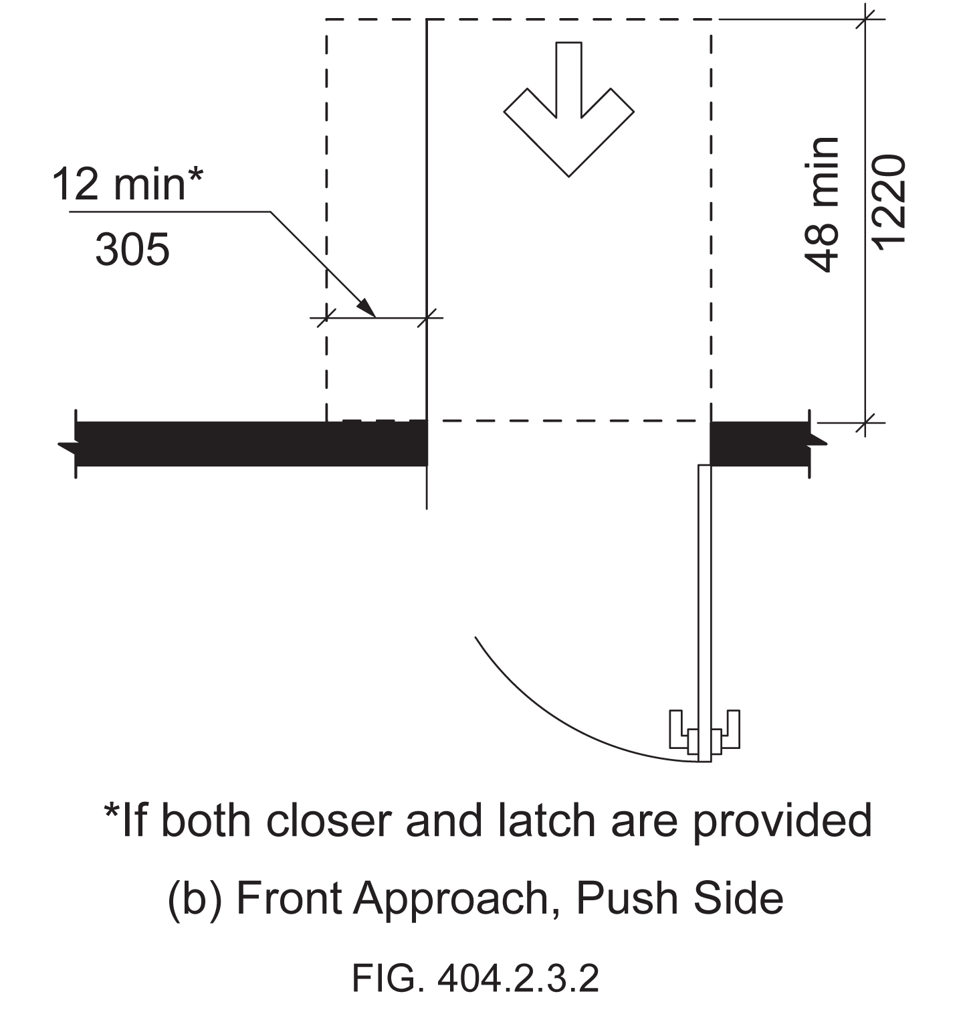

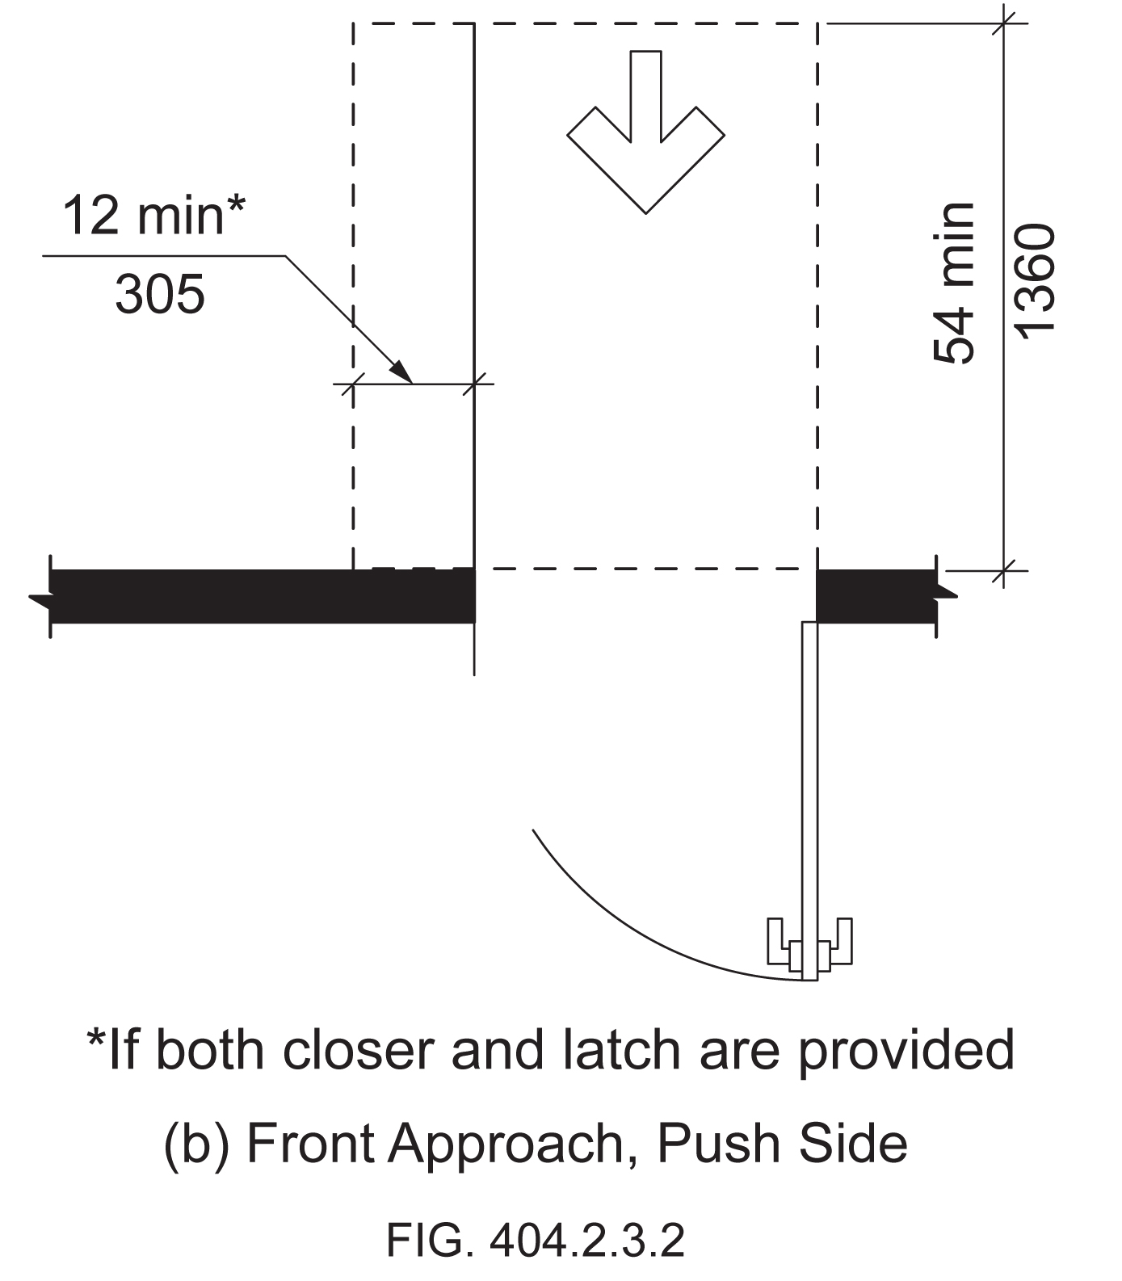

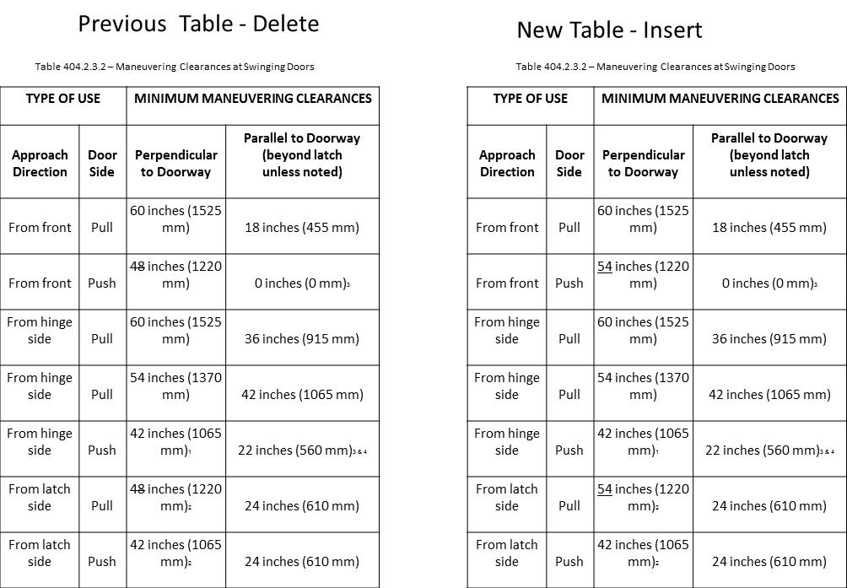

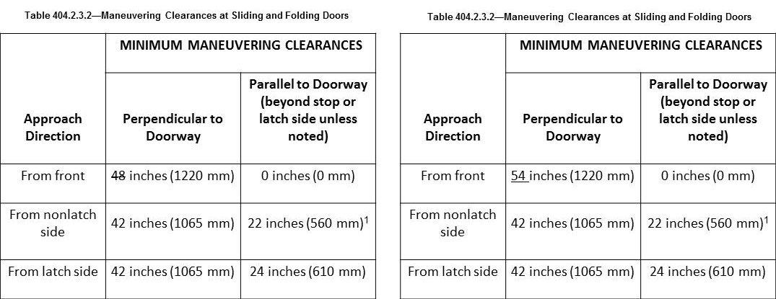

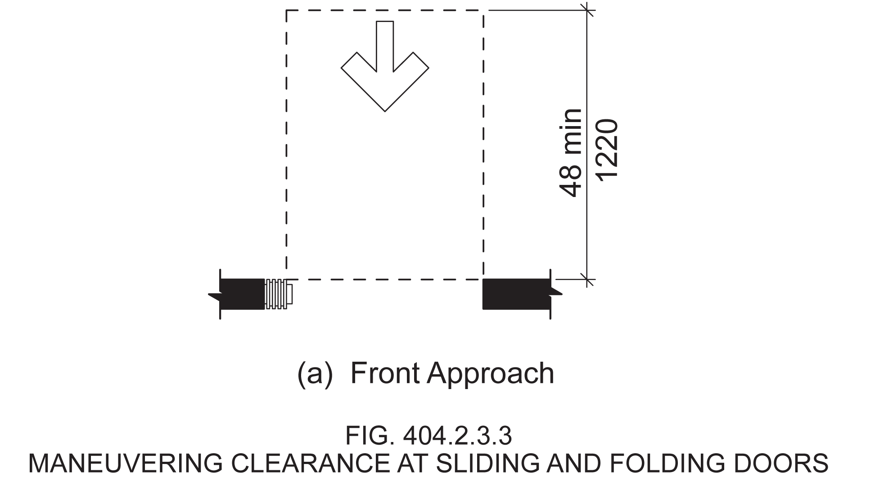

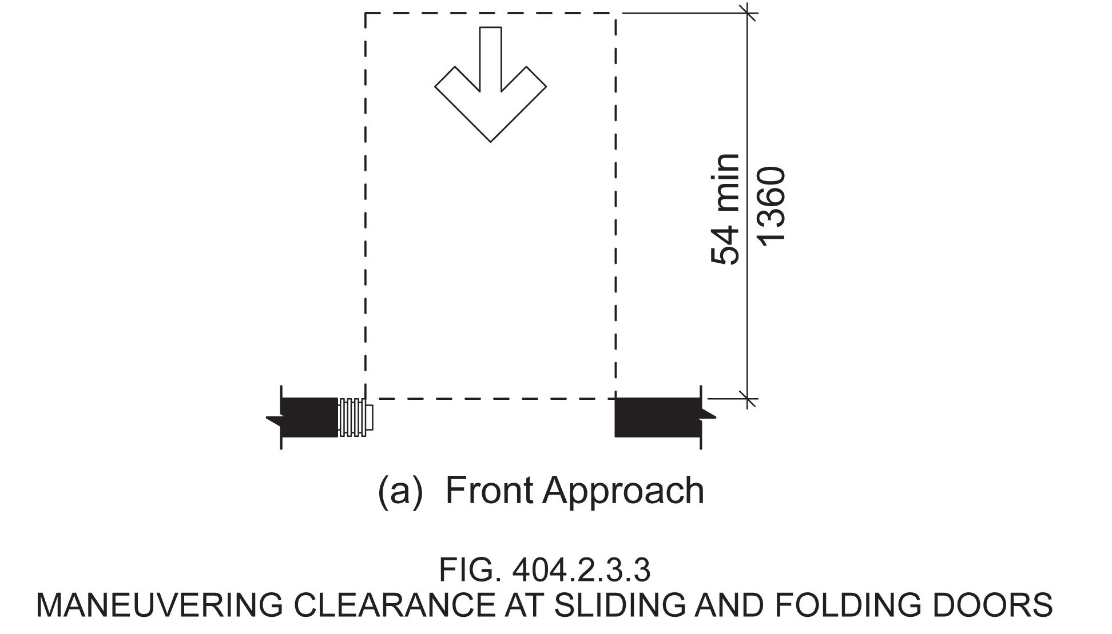

Revise Table as follows:

TABLE 404.2.3.4 - MANEUVERING CLEARANCES FOR DOORWAYS WITHOUT DOORS
Approach direction | MINIMUM MANEUVERING CLEARANCES  Perpendicular to Doorway
From front | 48 54 inches (1220 1370 mm)
From side | 42 inches (1065 mm)

Delete and substitute Figure as follows:

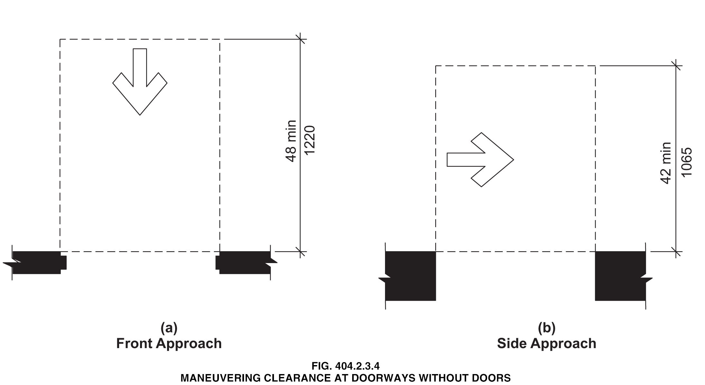

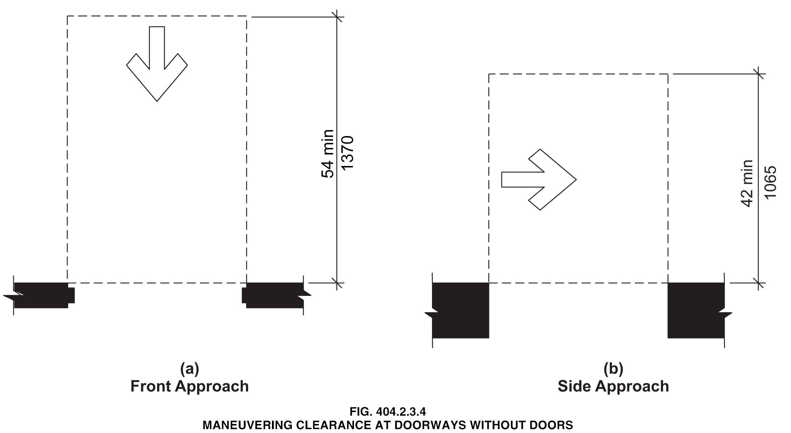

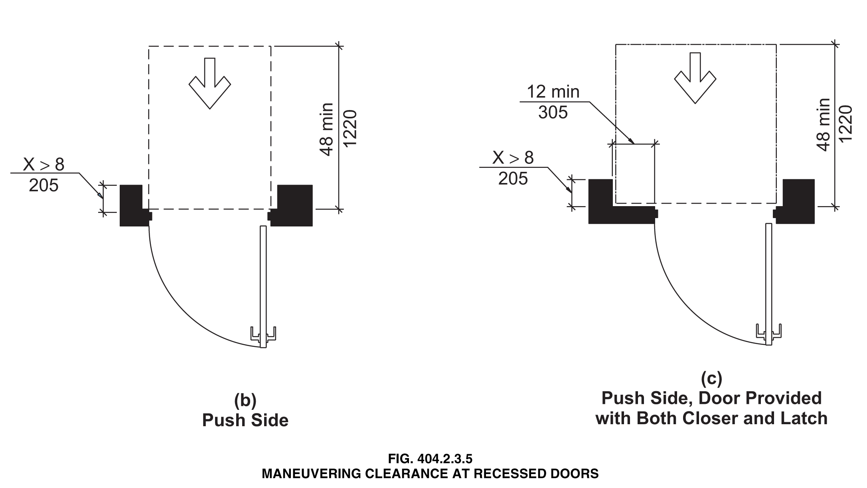

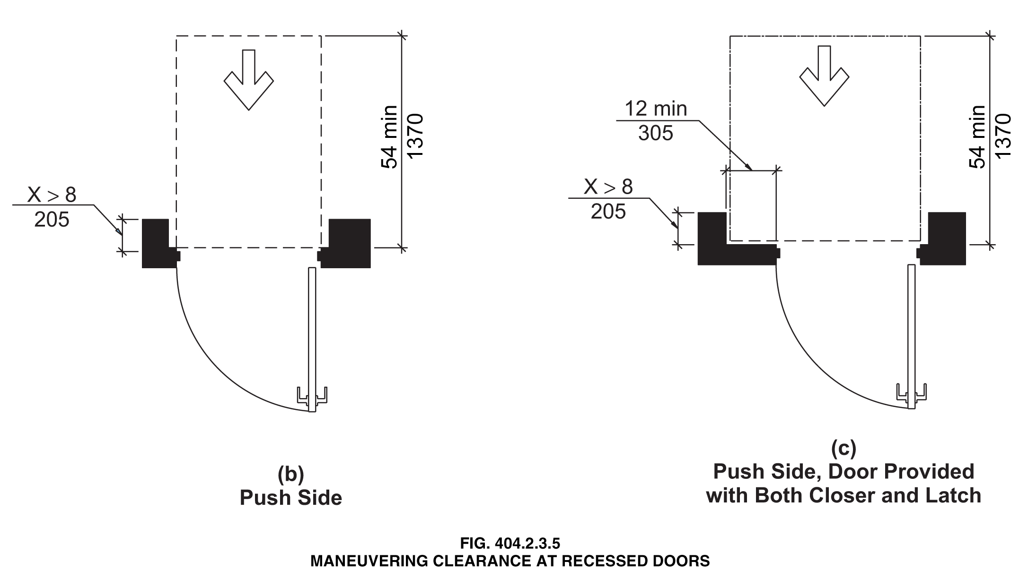

Reason: Many of the technical requirements of the ICC/ANSI A117.1 (2009) Accessible and Usable Buildings and Facilities (ICC/ANSI) designed to accommodate wheeled mobility users are based on research completed from 1974 to 1978 using a research sample that included about 60 individuals who used manual wheelchairs (Steinfeld et al., 1979).
The Center for Inclusive Design and Environmental Access (IDeA) at the University at Buffalo, SUNY recently completed an anthropometric study of 500 wheeled manual and powered mobility device users (Steinfeld, et al., 2010). Measurements of body and device size were captured in three dimensions. The functional anthropometric measurements required measuring reaching ability, grip strength and the minimum space needed for turning. It is the most extensive anthropometric study of wheeled mobility device users in the United States. Additional information about the study can be found at http://www.udeworld.com/ansi-standards-review. The proposed revisions are based on new anthropometric information that was generated from the database of anthropometric measurements developed as part of the study.

Analysis

Clear floor space represents the space required for a stationary wheeled mobility device. This area is typically depicted as a rectangular space the dimensions of which are based on measurements of occupied length and occupied breadth of wheeled mobility devices, which are defined as follows:
- Occupied length: measured as the horizontal distance between the forward-most point and the rear-most point on the wheelchair or occupant.
- Occupied width: measured as the horizontal distance between the side-most points of the wheelchair or participant on the right and left sides.
The results of our analysis suggest that the existing standard on clear floor space (48” length, 30” width) does not accommodate the occupied lengths and widths of the wheeled mobility user population and excludes powered wheeled mobility device users disproportionately as compared to manual device users. A length of 48” accommodates the occupied length of 75% of manual wheelchair users and only about 50% of powered chair and scooter users. A width of 30” accommodates the occupied width of 90% of manual wheeled mobility device users and only 75% of powered chair users.
We have taken the position that the clear floor space standards should accommodate the occupied lengths and widths of at least 90% of manual and powered wheeled mobility device users. A length of 54” accommodates the occupied lengths of 95% of manual chair users, and 90% of the powered chair users. A width of 32” accommodates the occupied widths of over 95% of manual wheeled mobility device users and 90% of the powered wheelchair users. Proposed changes to subsection 404 (Doors and Doorways) would accommodate an occupied length of 54 inches and occupied width of 32 inches for those parts of the standard based on occupied length and width.
The calculation used to determine the appropriate clearances are based on the three-dimensional database of wheeled mobility device user dimensions developed by the IDEA Center for the Anthropometry of Wheeled Mobility Project. The analysis was summarized in the Final Project Report to the U.S. Access Board and in a memorandum entitled “Evaluation of Clear Floor Space Requirements,” that was submitted to the ICC/ANSI A117 Task Force on Anthropometry of Wheeled Mobility Subcommittee on Clear Floor Space Clearances.

References (See http://www.udeworld.com/ansi-standards-review)

Paquet, V. (2012). Evaluation of Clear Floor Space Requirements. A memorandum submitted to the ICC/ANSI A117 Task Force on Anthropometry of Wheeled Mobility Subcommittee on Clear Floor Space Clearances.

Steinfeld, E., Paquet, V., D’Souza, C., Joseph, C, and Maisel, J. (2010). Final Report: Anthropometry of Wheeled Mobility Project. Washington, DC: U.S. Access Board.

Steinfeld, E. Schroeder, S. and Bishop, M. (1979). Accessible buildings for people with walking and reaching limitations. Washington, DC: U.S. Department of Housing and Urban Development.
input.doc

Committee Action

Approval as Modified - The following revisions replace the original proposal.

TABLE 404.2.3.2—MANEUVERING CLEARANCES AT MANUAL SWINGING DOORS
TYPE OF USE |  | MANEUVERING CLEARANCES AT MANUAL SWINGING DOORS
Approach Direction | Door Side | Perpendicular to Doorway | Parallel to Doorway  (beyond latch unless noted)
From front | Pull | 60 inches (1525 mm) | 18 inches (455 mm)
From front | Push | 48 52 inches  (1220 1321mm) | 0 inches (0 mm)³
From hinge side | Pull | 60 inches (1525 mm) | 36 inches (915 mm)
From hinge side | Pull | 54 inches (1370 mm) | 42 inches (1065 mm)
From hinge side | Push | 42 inches (1065 mm)¹ | 22 inches (560 mm)^{3 & 4}
From latch side | Pull | 48 inches (1220 mm)¹ | 24 inches (610 mm)
From latch side | Push | 42 inches (1065 mm)² | 24 inches (610 mm)
¹Add 6 inches (150 mm) if closer and latch provided.
²Add 6 inches (150 mm) if closer provided.
³Add 12 inches (305 mm) beyond latch if closer and latch provided.
⁴Beyond hinge side.

TABLE 404.2.3.3 – MANEUVERING CLEARANCES AT SLIDING AND FOLDING DOORS
Approach Direction | MINIMUM MANEUVERING CLEARANCES
Approach Direction | Perpendicular to Doorway | Parallel to Doorway  (beyond stop or latch side unless noted)
From front | 48 52 inches (1220 1321 mm) | 0 inches (0 mm)
From nonlatch side | 42 inches (1065 mm) | 22 inches (560 mm) ¹
From latch side | 42 inches (1065 mm) | 24 inches (610 mm)
^{1.} Beyond pocket or hinge side.

TABLE 404.2.3.4 - MANEUVERING CLEARANCES FOR DOORWAYS WITHOUT DOORS
Approach direction | MINIMUM MANEUVERING CLEARANCES  Perpendicular to Doorway
From front | 48 52 inches (1220 1321 mm)
From side | 42 inches (1065 mm)

Committee Reason: These revisions reflect the decision in Proposal 3-13-12 to change the length of the clear floor space to 52 inches. Figures will be revised accordingly by the Editorial Task Group.

BALLOT COMMENTS

4-15.1
Commenter: Gene Boecker, Representing NATO
Ballot: Negative with comment:

Comment: This should only be added to the next edition if the increase in wheelchair length is approved. Otherwise the standard will be disjointed and inconsistent.

4-15.2
Commenter: Ron Burton, Representing BOMA
Ballot: Negative with comment:

Comment: See reason on 3-6-12.

4-15.3
Commenter: David Collins, Representing AIA
Ballot: Negative with comment:

Comment: The work of the study group isn’t finalized and the research that formed the basis for this change has not been validated.

4-15.4
Commenter: M. Bradley Gaskins, Representing NACS
Ballot: Negative with comment:

Comment: There has been no evidence presented that this is a necessary change and will be a burden on the public due to an increase in the area required. The evidence presented only addresses the wide variety of mobility devices in service today. It does not address whether the problem is in the manufacture of these mobility devices that do not conform to the current requirement or whether the built-environment needs to change to accommodate mobility devices that need a larger space and cannot be designed and manufactured in such a way as to fit within the current space. We don’t continue to let automobile manufacturers build wider and wider autos to go on our roads… they must be built to standards that allow them to work with our current road system.

4-15.5
Commenter: Gerald Gross, Representing AHLA
Ballot: Negative with comment:

Comment: The AHLA does not accept the singular results of the anthropometric study conducted by the Center for Inclusive Design and Environmental Access. It is understood that the work of the Wheelchair Mobility Task Group is ongoing and has submitted a series of proposal changes to the base building blocks of A117.1 Standard. At this time we believe that the proposed changes to the building blocks are unacceptable and should not be adopted by the Committee; therefore no additional changes are required in this portion of the standard with reference to the building block changes.

4-15.6
Commenter: Ronald G. Nickson, Representing NMHC
Ballot: Negative with comment:

Comment: See comment on proposal 3-6-12.

4-15.7
Commenter: Steve Orlowski, Representing NAHB
Ballot: Negative with comment:

Comment: See comment on proposal 3-6-12.

4-15.8
Commenter: Kim Paarlberg, Representing
Ballot: Negative with comment:

Comment: Same comment as 3-6-12.

Committee Review of Comments and Action – July 2013

Approval as Modified.

Committee Reason: For the same reasons that the committee sustained Item 3-13-12 which establishes a 30 by 52 clear floor space, the committee reaffirmed this change to adjust the maneuvering clearances to accommodate the 52 inch length.

Ballot Comments on July 2013 Committee Action Report

ICC – Kim Paarlberg
Negative: Ballot:
Comment/reason: See comment on proposal 3-6-12.

NACS – Bradley Gaskins
Negative: Ballot:
Comment/reason: This change is predicated on the assumption that a larger CFS is required. While it may be true that wheeled mobility devices are getting larger is there a basis or need for them to become larger? This is a bigger question that should be answered before increasing the CFS size. Size of the units should be dictated, where possible, to have a minimal impact on the size of buildings. I am not convinced that the units cannot be designed and manufactured within the current space limitations dictated and still serve those who need wheeled mobility devices. At best this change is premature based upon the evidence. Even the wheeled mobility task group states that their findings have not been validated. Further, the impact of the larger CFS has not been analyzed for any building types.

NAHB – Steven Orlowski
Negative: Ballot:
Comment/reason: See comment on proposal 3-6-12.

NMHC – Ron Nickson
Negative: Ballot:
Comment/reason: See reason on 3-6-12.

AIA – Dave Collins
Negative Ballot
Comment/reason: I agree with ICC-Kim Paarlberg’s comment. Also see additional comment added to 3-6-12.

4-23 – 12
404.2.8
Proposed Change as Submitted

Proponent: Gene Boecker, Code Consultants, Inc

Revise as follows:

404.2.8 Door-Opening Force. Fire doors shall have the minimum opening force allowable by the appropriate administrative authority. The force for pushing or pulling open doors other than fire doors shall be as follows:

1. Interior hinged door: 5.0 pounds (22.2 N) maximum
2. Sliding or folding door: 5.0 pounds (22.2 N) maximum

These forces do not shall also apply to the force required to retract latch bolts or disengage other devices that hold the door in a closed position.

EXCEPTION: The 5.0 pounds force to retract latch bolts or disengage other devices that hold the door in a closed position shall not apply to panic hardware, delayed egress devices or fire-rated hardware.

Reason: The usability of doors depends on the functionality of all aspects of door usage including retracting the bolt. However, certain types of doors require additional force to open. These types of door hardware are those which the various building and fire codes prescribe for user safety. Panic hardware is used in higher occupancy locations to avoid occupant crush. Where a number of people could press on the door, a force parallel to the door may not be possible if there is sufficient force jamming the door against the frame. Panic devices require operation in the direction of travel, obviating the possible binding of the door hardware. Because if this single operation to open the door, it must be able to resist casual contact and therefore requires an operating force greater than 5.0 pounds
Delayed egress doors are provided where security or protection of the occupants is necessary. In Alzheimer’s wings in the hospitals and nursing homes, delayed egress devices are often used to slow down the person’s ability to walk out. This delay allows staff to intercept the individual and bring them back into the building, avoiding possible injury outside due to traffic or other potential hazards. These types of hardware also need to avoid casual contact, similar to that noted for panic hardware.
input.doc

Committee Action

Approval as Modified

Modification

404.2.8 Door-Opening Force. Fire doors and doors required to be equipped with panic hardware, break away features or other factors requiring higher opening force for safety reasons shall have the minimum opening force allowable by the appropriate administrative authority. For other doors, the The force for pushing or pulling open doors other than fire doors shall be as follows:

1. Interior hinged door: 5.0 pounds (22.2 N) maximum
2. Sliding or folding door: 5.0 pounds (22.2 N) maximum

These forces do not shall also apply to the force required to retract latch bolts or disengage other devices that hold the door in a closed position.

Committee Reason: The modification establishes 2 groups of standards: Those addressed in the first sentence which will have opening forces set by the jurisdiction; those ‘others’ addressed in the 2nd sentence. The revision clarifies the force requirements for all doors.

Ballot Comments on July 2013 Committee Action Report

BHMA – Michael Tierney
Negative: Ballot:
Comment/reason: While it was not the intent of the change, the new wording could be interpreted to prohibit vertical rod exit devices with bottom rod guards that currently meet the requirement for “smooth surface on the push side”.
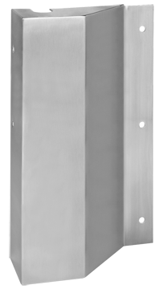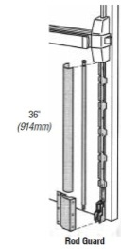

4-27– 12
404.2.9
Proposed Change as Submitted

Proponent: : Kim Paarlberg, International Code Council

Revise as follows:

404.2.9 Door Surface. Door surfaces within 10 inches (255 mm) of the floor, measured vertically, shall be a smooth surface on the push side extending the full width of the door. Door hardware, or any other obstruction or protrusion shall not be mounted in nor extend into the area within 10 inches (255 mm) of the floor. Parts creating horizontal or vertical joints in such the smooth surface shall be within ¹/₁₆ inch (1.6 mm) of the same plane as the other. Cavities created by added kick plates shall be capped.

EXCEPTIONS:

- Sliding doors shall not be required to comply with Section 404.2.9.
- Tempered glass doors without stiles and having a bottom rail or shoe with the top leading edge tapered at no less than 60 degrees from the horizontal shall not be required to comply with the 10-inch (255 mm) bottom rail height requirement.

Doors that do not extend to within 10 inches (255 mm) of the floor shall not be required to comply with Section 404.2.9.

Reason: The quantity of change proposals submitted by International Code Council is reflective of three elements of our work: 1. ICC is the Secretariat for the Standard and some changes reflect inconsistencies or improvements suggested by staff; 2. ICC develops and publishes a Commentary on the standard and writing the commentary illuminates issues of the text and figures; and 3. ICC provides an interpretation service for the standard which results in the observation of provisions the users find most confusing.
This proposal is intended to address an issue that has come up on several interpretation requests. The added language should provide better clarity as to how the provision is to be applied and enforced. While the person raising the question knew the intent of the provision, they were being challenged on the issue because of a literal reading of what the standard says it is regulating.
As currently written, the provision regulates the “door surface” but does not indicate whether it also includes items like the door hardware or any other type of object that may not be on the “door surface”. An example of the question I received dealt with a decorative door pull that went the full height of the door. The question was whether the “door surface” requirement only applied to the door itself or whether the hardware was also regulated.
Clearly the intent of the existing provision is to provide a minimum 10 inch smooth surface that would allow the footrest of a wheelchair or some other type of mobility device to slide along the door as the user opened it. A door pull or any other object which prevents this free movement along the lower 10 inches should be prohibited.
The attached figure illustrates the two door pulls that were being proposed. The first example shows the door hardware being attached within the 10 inch vertical distance. The second shows the hardware being attached above the 10 inch vertical height but with the door pull still extending to within 10 inches of the floor. Therefore, while the “door surface” is smooth the obstruction would prevent free movement along the bottom of the door.
input.doc

Committee Action

Approved

Committee Reason: The bottom 10 inches of a door, on its push side, is to be a smooth surface to prevent the toes and feet of persons pushing the door from being caught or restricted. The proposal clarifies that even door hardware should not be in this 10 inch range.

BALLOT COMMENTS

4-27.1
Commenter: Allan B. Fraser, Representing NFPA
Ballot: Negative with comment:

Comment: This is going to prohibit certain types of hardware that have been used for a long time without any clear data to demonstrate that there’s a problem.

Committee Review of Comments and Action – July 2013

Approved

Committee Reason: The committee considered whether the proposed change would unduely restrict a certain type of hardware. The limitation is already in the code, and compliant designs are available.

4-29– 12
404.2.9
Proposed Change as Submitted

Proponent: Ed Roether, representing the ADA/A117 Harmonization Task Group

Revise as follows:

404.2.9 Door Surface. Door surfaces within 10 inches (255 mm) of the floor, measured vertically, shall be a smooth surface on the push side extending the full width of the door . Parts creating horizontal or vertical joints in such surface shall be within ¹/₁₆ inch (1.6 mm) of the same plane as the other. Cavities created by added kick plates shall be capped.

EXCEPTIONS:

(Exceptions 1 through 3 are not changed)

4. Existing doors and gates without smooth surfaces within 10 inches (255 mm) of the finish floor or ground shall not be required to provide smooth surfaces complying with 404.2.9 provided that if added kick plates are installed, cavities created by such kick plates are capped,

Reason: The ADA/A117 Harmonization Task Group (HTG) was created as a task group of the A117.1 Committee to compare the 2010 ADA with the 2009 A117.1 Standard. The HTG has recommend a series of changes through a set of change proposals. The HTG is recommending changes, for the most part, address where the ADA was viewed as more stringent than the A117. Where the A117 contained provisions not addressed in the ADA, these were not considered a conflict needing action to amend the A117. In addition there are a number of places where the ADA and A117.1 are different as a result of specific actions, by the A117.1 Committee during the development of the 2009 edition, to remain or create a difference where, in the judgment of the committee the ADA was deficient.

Reason for 404.2.9: Exception number 4 is new text in ADA not in the 2009 A117.1.
input.doc

Committee Action

Approval as Modified

Modification Replace the original proposal with the following:

404.2.9 Door Surface. Door surfaces within 10 inches (255 mm) of the floor, measured vertically, shall be a smooth surface on the push side extending the full width of the door. Parts creating horizontal or vertical joints in such surface shall be within ¹/₁₆ inch (1.6 mm) of the same plane as the other. Cavities created by added kick plates shall be capped.

EXCEPTIONS:

(Exceptions 1 through 3 are not changed)

4. The installation of kick plates on existing doors and gates without a smooth surface within 10 inches (255 mm) of the floor shall be permitted. The kick plates shall extend to 10 inches (255 mm) above the floor and no more than 1 inch (26 mm) from the sides and bottom of the door. Cavities created by such kickplates shall be capped.

Committee Reason: The change provides consistency between the Standard and the ADA. The modification was to provide a more clear statement regarding when kickplates are installed on existing doors.

4-30– 12
404.3, 404.3.2, 4043.5

Proposed Change as Submitted

Proponent: Ed Roether, representing the ADA/A117 Harmonization Task Group

Revise as follows:

404.3 Automatic Doors and Power-Assisted Doors and Gates. Automatic doors and automatic gates shall comply with Section 404.3. Full powered automatic doors shall comply with ANSI/BHMA A156.10 listed in Section 105.2.4. Power–assist and low–energy doors shall comply with ANSI/BHMA A156.19 listed in Section 105.2.3.

EXCEPTION: Doors, doorways, and gates designed to be operated only by security personnel shall not be required to comply with Sections 404.3.2, 404.3.4, and 404.3.5.

404.3.2 Maneuvering Clearances. Maneuvering clearances at power–assisted doors shall comply with Section 404.2.3. Clearances at swinging automatic doors and gates without standby power and serving an accessible means of egress shall comply with Section 404.2.3.

EXCEPTION: Where automatic doors and gates remain open in the power-off condition, compliance with Section 404.2.3 shall not be required.

404.3.5 Controls Switches. Manually operated controls switches shall comply with Section 309. The clear floor space adjacent to the control switch shall be located beyond the arc of the door swing.

Reason: The ADA/A117 Harmonization Task Group (HTG) was created as a task group of the A117.1 Committee to compare the 2010 ADA with the 2009 A117.1 Standard. The HTG has recommend a series of changes through a set of change proposals. The HTG is recommending changes, for the most part, address where the ADA was viewed as more stringent than the A117. Where the A117 contained provisions not addressed in the ADA, these were not considered a conflict needing action to amend the A117. In addition there are a number of places where the ADA and A117.1 are different as a result of specific actions, by the A117.1 Committee during the development of the 2009 edition, to remain or create a difference where, in the judgment of the committee the ADA was deficient.

Reason: for 404.3.2: ADA specifies that automatic doors without standby power need to provide maneuvering clearances. Such is not currently in A117. In Section 404.3.5, the controls are not limited to switches.
input.doc

Committee Action

Approved

Committee Reason: Approved to provide consistency with the ADA and to provide for controls which aren’t traditional ‘switches’.

BALLOT COMMENT

4-30.1
Commenter: Gene Boecker, Representing NATO
Ballot: Affirmative with comment:

Comment: The text from 4-31 and this proposal should be blended and presented before a final vote is made so that the committee can determine whether the intent for each is maintained.

Committee Review of Comments and Action – July 2013

Approved.

Committee Reason: The committee considered the information provided by the comments and decided to take no action to change its original approval of this proposal.

4-31– 12
404.3, 404.3.2, 404.3.4, 404.3.5, 404.3.6 (NEW)

Proposed Change as Submitted

Proponent: Kim Paarlberg, International Code Council

Revise as follows:

404.3 Automatic Doors. Automatic doors and automatic gates shall comply with Section 404.3. Full powered automatic doors shall comply with ANSI/BHMA A156.10 listed in Section 105.2.4. Power-assist doors and low-energy automatic doors shall comply with ANSI/BHMA A1 56.19 listed in Section 105.2.3.

EXCEPTION: Doors, doorways, and gates designed to be operated only by security personnel shall not be required to comply with Sections 404.3.2, 404.3.4, and 404.3.5.

404.3.2 Maneuvering Clearances. Maneuvering clearances at power-assisted doors shall comply with Section 404.2.3. Maneuvering clearances shall be provided on the egress side of low-energy automatic doors and full power automatic doors that serve as part of the accessible means of egress.

EXCEPTIONS:

- Low-energy automatic doors and full power automatic doors that have standby power or battery back-up shall not be required to comply with this section.
- Low-energy automatic doors and full power automatic doors that remain open in the power-off condition shall not be required to comply with this section.
- Full power automatic sliding doors that include a break-away feature shall not be required to comply with this section.

404.3.4 Two Doors in Series. Doors in series shall comply with Section 404.2.5.

EXCEPTION: Where both doors are power assist doors, low energy automatic doors or full power automatic doors, two doors in a series shall not be required to provide a turning space between the doors.

404.3.5 Controls Switches. Manually operated controls switches shall comply with Section 309. The clear floor space adjacent to the control switch shall be located beyond the arc of the door swing.

404.3.6 Break Out Opening. Where full power automatic sliding doors and gates are equipped with a break out feature, the clear break out opening shall be 32 inches (815 mm) minimum when operated in emergency mode.

Reason: The quantity of change proposals submitted by International Code Council is reflective of three elements of our work: 1. ICC is the Secretariat for the Standard and some changes reflect inconsistencies or improvements suggested by staff; 2. ICC develops and publishes a Commentary on the standard and writing the commentary illuminates issues of the text and figures; and 3. ICC provides an interpretation service for the standard which results in the observation of provisions the users find most confusing.
The purpose for the change is to align the standard content with terminology common to the automatic door industry, its products, and the standards that govern them.
There is confusion in the requirements for doors addressed by BHMA A156.10 and A156.19. The following information was provided by Joe Hetzel representing the American Association of Automatic Door Manufacturers (AAADM).

* A low energy automatic door is different from a power assist door
* A power assist door is more like a manual door that employs power to assist the user in manually operating the door
* An automatic door can be either a full power door or a low energy door
* Full power doors are addressed in BHMA A156.10
* Low energy doors are addressed in BHMA A156.19
* Power assist doors are also addressed in BHMA A156.19, but they are separate from low energy

Definitions from A156.19:

Low Energy Power Operated Door: A door with (a) power mechanism(s) that opens and closes the door upon receipt of an actuating signal and does not generate more kinetic energy than specified in this Standard.
Power Assist Door: A door with a power mechanism that reduces the opening resistance of a self closing door.

The reasons for the changes are as follows:
- 404.3 – this clarifies what is an automatic door and what is power assist regardless of the referenced standard
- 404.3.2 – clarify that means of egress is only maneuvering clearance is only on one side; exceptions are for when there is there is power or options that swing free
- 404.3.4 – Automatic doors do not need the extra turning space that is required in A117.1.
- 404.3.5 – controls can be other than switches
- 404.3.6 – trying to address ADA 404.3.6 where break out options are actually used, but not sure this is not addressed already in 404.3.1.
input.doc

Committee Action

Approved

Committee Reason: The Committee expressed concern that elements of this proposal were inappropriate to be located in the A117.1 Standard and perhaps should be located within the scoping document such as the International Building Code. It uses terms such as standby power and accessible means of egress that are defined in the IBC, not the Standard. The Committee voted to approve the change because it does coordinate better with industry terms. It enhances the information in the ADA, and therefore is not in conflict.

BALLOT COMMENT

4-31.1
Commenter: Gene Boecker, Representing NATO
Ballot: Affirmative with comment:

Comment: The text from 4-30 and this proposal should be blended and presented before a final vote is made so that the committee can determine whether the intent for each is maintained.

Committee Review of Comments and Action – July 2013

Approved.

Committee Reason: The committee considered the information provided by the comments and decided to take no action to change its original approval of this proposal.

4-34– 12
404.3.4, 404.3.5, 404.3.6 (New)

Proposed Change as Submitted

Proponent: Kim Paarlberg, International Code Council

Revise as follows:

404.3.4 Two Doors in Series. Doors in series shall comply with Section 404.2.5.

EXCEPTION: Automatic doors in a series are not required to provide a turning space complying with Section 304.

404.3.5 Control Switches. Manually operated control switches shall comply with Section 309. The clear floor space adjacent to the control switch shall be located beyond the arc of the door swing. Where automatic doors are doors in a series, the clear floor space for the control switches shall be located outside the arc of both doors.

404.3.6 Door Hardware. Handles, pulls, latches, locks, and other operable parts on accessible doors shall have a shape that is easy to grasp with one hand and does not require tight grasping, pinching, or twisting of the wrist to operate. Operable parts of such hardware shall be 34 inches (865 mm) minimum and 48 inches (1220 mm) maximum above the floor. Where sliding doors are in the fully open position, operating hardware shall be exposed and usable from both sides.

EXCEPTION: Locks and control switches used only for security purposes and not used for normal operation are not required to comply with Section 404.3.6.

Reason: The quantity of change proposals submitted by International Code Council is reflective of three elements of our work: 1. ICC is the Secretariat for the Standard and some changes reflect inconsistencies or improvements suggested by staff; 2. ICC develops and publishes a Commentary on the standard and writing the commentary illuminates issues of the text and figures; and 3. ICC provides an interpretation service for the standard which results in the observation of provisions the users find most confusing.
There is not an entrapment issue in vestibules with automatic doors on both sides. Therefore the turning space in the vestibule is should not be required. This exception may be appropriate for both automatic and power assist door.
In a two doors in a series situation, if a 2nd button for the 2nd door is provided inside the vestibule, it should be outside the swing of the 1st door as well as the 2nd. If someone outside hits the button for the 1st door, you do not want it to swing open and hit the person trying to reach the 2nd button.
Power assisted doors should have the same hardware requirements as manual doors. Power doors have switched on top of the door that is used to turn the power operation and/or sensor on and off at the beginning and end of the business day. Therefore the exception is needed for automatic door.
input.doc

Committee Action
Approval as Modified

Modification – Replace the original proposal with the following:

404.3.4 Two Doors in Series. Doors in series shall comply with Section 404.2.5.

EXCEPTION: Automatic doors in a series are not required to provide a turning space complying with Section 304.

404.3.5 Control Switches. Manually operated control switches shall comply with Section 309. The clear floor space adjacent to the control switch shall be located beyond the arc of the door swings.

404.3.6 Door Hardware. Handles, pulls, latches, locks, and other operable parts shall comply with Section 404.2.6,

Committee Reason: The proposal addressed issues which need to be clarified, however the Committee approved a version which does the clarification more simply and eliminates the repetition of requirements found elsewhere.

BALLOT COMMENTS

4-34.1
Commenter: Todd Andersen
Ballot: Negative with comment:

Comment: I object to the Exception at 404.3.4 that exempts vestibules with two automatic doors in a series from the obligation to provide a turning space. Imagine situations such as at many supermarkets, security check points, and similar conditions where the 'in' and 'out' traffic flows are segregated from each other. The proposed text would permit the vestibule to be no wider than the door leaf as the person using the vestibule only experiences these door from the push side. The IBC and NFPA 101 both require backup power for automatic doors that are part of a means of egress unless the space served has no more than 10 occupants. Even where backup power will be provided, these doors are required to be manually operable (ie after the backup power fails or is exhausted), however, the required forces are three to six times greater than 5 pounds. I summary: too little room to retreat and too heavy a door to move forward, sounds like the definition of being trapped.

Because we often use power and automatic doors to solve access problems where proper maneuvering space at an existing door is not to be had, I can support a partial exception from the turning space requirement in existing buildings.

4-34.2
Commenter: Gene Boecker, Representing NATO
Ballot: Negative with comment:

Comment: Although I sympathize with the intent, automatic doors, although requiring no manual action to operate, can still be switched off manually. If the interior set of automatic doors is not turned on because it is prior to the start of the day, but access is allowed into the vestibule for whatever reason, a turning space should be provided.

4-34.3
Commenter: Marsha K. Mazz, Representing Access Board
Ballot: Negative with comment:

Comment: Disapprove this proposal.
The new exception to 404.3.4 Two Doors in Series applies to “automatic doors” in a series. The concern with this proposal is that it isn’t clear that both doors in the series would be simultaneously opened by a single control or that the doors would have emergency back-up power. Therefore, a wheelchair user could be entrapped between the doors. Please review proposal 4-31-12 describing the differing types of automatic doors. Power-assist doors require the operator to exert force on the door before the mechanism engages so, opening the first door will have no effect on the second door in the series.

4-34.4
Commenter: Edward Steinfeld, Representing RESNA
Ballot: Negative with comment:

Comment: This proposal could trap wheelchair users in a vestibule when the outside door is open, the inside door is locked and the control or buzzers are out of reach. Locking the inside door is a very common situation in a multifamily apartment building or a small commercial building. Buzzers and intercoms are typically located in the vestibule. The door can be opened remotely by a resident in their apartment or an employee but if they are not present, the door cannot be opened. While it may not be necessary to turn to get back outside the vestibule, no thought as yet has been given to the space and configuration needed to activate the outside door control and back out. So more work on this is needed.

Committee Review of Comments and Action – July 2013

Approval with Modifications based on Comments.

Committee Reason: The committee realized the new exception to Section 404.3.4 covered too many installations unless it was clarified that these were full powered automatic doors. Unless they open without any assistance, there remains a potential need for a turn-around space.

Modification:

404.3.4 Two Doors in Series. Doors in series shall comply with Section 404.2.5.

EXCEPTION: Full power automatic doors in a series are not required to provide a turning space complying with Section 304.

Ballot Comments on July 2013 Committee Action Report

DREDF – Marilyn Golden
Negative Ballot
Comment/reason: Your comment/reason: This twice-modified exception should be defeated. It now provides that “Full power automatic doors in a series are not required to provide a turning space complying with Section 304.” But no two doors in a series, however powered or not, should be exempt from providing a complying turning space. Automatic doors can still be switched off manually. A wheelchair user could become trapped between the doors, such as when the outside door is open, the inside door is locked and the control or buzzers are out of reach. For example, locking the inside door is common in a multifamily apartment building or a small commercial building. Buzzers and intercoms are typically located in the vestibule. A resident in their apartment or an employee can open the door remotely, but if they are not present, the door cannot be opened.
If the turning space will be provided automatically, because the 52 inch clearance and latch side clearance are provided, as has been mentioned, this exception should still be deleted, because it would strongly suggest that those clearances are not otherwise required, risking confusion and misapplication, here and elsewhere.

HUD – Cheryl Kent
Negative Ballot
Comment/reason: This twice-modified exception is not clear and does not address all of the negative comments that are included in the CAR. The exception now states, “Full power automatic doors in a series are not required to provide a turning space complying with Section 304.” This language still does not justify exempting these doors from providing turning space. There is no guarantee both doors will always be provided with power. They can be switched off manually. There may be other situations when not both doors will be powered at once. For example in a multifamily apartment building or office building, locking an inside door is a common practice. Buzzers and intercoms are typically located in the vestibule. A resident in their apartment or an employee can open the door remotely, but if they are not present, the door cannot be opened.
If the turning space will be provided automatically, because the 52 inch clearance and latch side clearance are provided, this exception should still be deleted, because it would strongly suggest that those clearances are not otherwise required.

Todd Andersen
Abstains:
Reason: I urge the Committee to vote against this proposal at the final ballot for the reasons previously given.

NMGCD – Hope Reed
Negative Ballot
Comment/reason: The exception for automatic doors should be rejected. Many automatic doors receive no maintenance until they are totally and completely not working. Some automatic doors are continually breaking down and fully repaired ever 3 to 6 months. This exception is not appropriate for new construction.

UCP – Gina Hilberry
Negative Ballot
Comment/reason: Two doors in series should have a turning space provided without exception. Turning off power doors is very common.

4-38– 12
106.5, 405.5, 405.8

Proposed Change as Submitted

Proponent: Ed Roether, representing the ADA/A117 Harmonization Task Group

Revise as follows:

405.5 Clear Width. The clear width of a ramp run shall be 36 inches (915 mm) minimum. Handrails and handrail supports that are provided on the ramp run shall not project into the required clear width of the ramp run.

EXCEPTION: Within employee work areas, the required clear width of ramps that are a part of common use circulation paths shall be permitted to be decreased by work area equipment provided that the decrease is essential to the function of the work being performed.

405.8 Handrails. Ramp runs with a rise greater than 6 inches (150 mm) shall have handrails complying with 505.

EXCEPTION: Within employee work areas, handrails shall not be required where ramps that are part of common use circulation paths, and which are used for the movement of equipment, are designed to permit the installation of handrails complying with 505. Ramps not subject to the exception to 405.5 shall be designed to maintain a 36 inch (915 mm) minimum clear width when handrails are installed.

106.5 Defined terms

circulation path. An exterior or interior way of passage provided for pedestrian travel, including but not limited to, walks, hallways, courtyards, elevators, platform lifts, ramps, stairways, and landings.

common use. Interior or exterior circulation paths, rooms, spaces, or elements that are not for public use and are made available for the shared use of two or more people.

employee work area. All or any portion of a space used only by employees and used only for work. Corridors, toilet rooms, kitchenettes and break rooms are not employee work areas.

Reason: The ADA/A117 Harmonization Task Group (HTG) was created as a task group of the A117.1 Committee to compare the 2010 ADA with the 2009 A117.1 Standard. The HTG has recommend a series of changes through a set of change proposals. The HTG is recommending changes, for the most part, address where the ADA was viewed as more stringent than the A117. Where the A117 contained provisions not addressed in the ADA, these were not considered a conflict needing action to amend the A117. In addition there are a number of places where the ADA and A117.1 are different as a result of specific actions, by the A117.1 Committee during the development of the 2009 edition, to remain or create a difference where, in the judgment of the committee the ADA was deficient.
Reason for Sections 405.5 and 405.8. These are two exceptions added to the ADA to address issues in facilities where ramps are frequently used for movement of goods and equipment. Often this is accomplished by motorized means such as forklifts as well as non-motorized devices. In order to incorporate the definitions in the A117.1 and make sure they are limited in application to employee work areas, the 3 definitions are needed.
input.doc

Committee Action

Approved

Committee Reason: To allow the same exceptions for employee work areas as allowed by the ADA.

4-40– 12
405.7.4
Proposed Change as Submitted

Proponent: Ed Roether, representing the ADA/A117 Harmonization Task Group

Revise as follows:

405.7.4 Change in Direction. Ramps that change direction between runs at ramp landings shall be sized to provide a turning space complying with Section 304.3 shall have a clear landing 60 inches (1525 mm) minimum by 60 inches (1525 mm) minimum.

Reason: The ADA/A117 Harmonization Task Group (HTG) was created as a task group of the A117.1 Committee to compare the 2010 ADA with the 2009 A117.1 Standard. The HTG has recommend a series of changes through a set of change proposals. The HTG is recommending changes, for the most part, address where the ADA was viewed as more stringent than the A117. Where the A117 contained provisions not addressed in the ADA, these were not considered a conflict needing action to amend the A117. In addition there are a number of places where the ADA and A117.1 are different as a result of specific actions, by the A117.1 Committee during the development of the 2009 edition, to remain or create a difference where, in the judgment of the committee the ADA was deficient.

Reason for 405.7.4: ADA specifies a 60 by 60 space at ramp landings where a change of direction occurs. A117.1 language would allow a T-turn not allowed by ADA.
input.doc

Committee Action

Approved

Committee Reason: The change de-couples the landing from the concept of a turning space because of the allowance of a T-shaped turn. The intent of the standard has consistently been that these landings simply be an open 60 by 60 inches.

4-42– 12
406, 406.1, 406.2, 406.3, 406.4, 406.5, 406.6, 406.7, 406.8, 406.9, 406.10, 406.11

Proposed Change as Submitted

Proponent: Kim Paarlberg, International Code Council

Revise as follows:

406 Curb Ramps
406.1 General. Curb ramps on accessible routes shall comply with Sections 406, 405.2, 405.3, and 405.10.
406.2 Counter Slope. Counter slopes of adjoining gutters and road surfaces immediately adjacent to the curb ramp shall not be steeper than 1:20. The adjacent surfaces at transitions at curb ramps to walks, gutters and streets shall be at the same level.
406.3 Sides of Curb Ramps. Where provided, curb ramp flares shall comply with Section 406.3.
406.3.1 Slope. Flares shall not be steeper than 1:10.
406.4 Width. Curb ramps shall be 36 inches (915 mm) minimum in width, exclusive of flared sides.
406.5 Floor Surface. Floor surfaces of curb ramps shall comply with Section 302.
406.7 Landings. Landings shall be provided at the tops of curb ramps. The clear length of the landing shall be 36 inches (915 mm) minimum. The clear width of the landing shall be at least as wide as the curb ramp, excluding flared sides, leading to the landing.
EXCEPTION: In alterations, where there is no landing at the top of curb ramps, curb ramp flares shall be provided and shall not be steeper than 1:12.
406.10 Diagonal Curb Ramps. Diagonal or corner- type curb ramps with returned curbs or other well- defined edges shall have the edges parallel to the direction of pedestrian flow. The bottoms of diagonal curb ramps shall have 48 inches (1220 mm) minimum clear space outside active traffic lanes of the roadway. Diagonal curb ramps provided at marked crossings shall provide the 48 inches (1220 mm) minimum clear space within the markings. Diagonal curb ramps with flared sides shall have a segment of curb 24 inches (610 mm) minimum in length on each side of the curb ramp and within the marked crossing.
406.11 Islands. Raised islands in crossings shall be a cut-through level with the street or have curb ramps at both sides. Each curb ramp shall have a level area 48 inches (1220 mm) minimum in length and 36 inches (915 mm) minimum in width at the top of the curb ramp in the part of the island intersected by the crossings. Each 48-inch (1220 mm) by 36-inch (915 mm) area shall be oriented so the 48-inch (1220 mm) length is in the direction of the running slope of the curb ramp it serves. The 48-inch (1220 mm) by 36-inch (915 mm) areas and the accessible route shall be permitted to overlap.

406 Curb Ramps and Blended Transitions

406.1 General. Curb ramps and blended transitions on accessible route shall comply with Section 406

406.2 Perpendicular Curb Ramps. Perpendicular curb ramps shall comply with Sections 406.2 and 406.5.

406.2.1 Turning Space. A turning space 48 inches (1220 mm) minimum by 48 inches (1220 mm) minimum shall be provided at the top of the curb ramp and shall be permitted to overlap other turning spaces and clear spaces. Where the turning space is constrained at the back-of-sidewalk, the turning space shall be 48 inches (1220 mm) minimum by 60 inches (1525 mm) minimum. The 60 inches (1525 mm) dimension shall be provided in the direction of the ramp run.

406.2.2 Running Slope. The running slope of the curb ramp shall cut through or shall be built up to the curb at right angles or shall meet the gutter grade break at right angles where the curb is curved. The running slope of the curb ramp shall be 5 percent minimum and 8.3 percent maximum but shall not require the ramp length to exceed 15 feet (4573 mm). The running slope of the turning space shall be 2 percent maximum.

406.3 Parallel Curb Ramps. Parallel curb ramps shall comply with Sections 406.3 and 406.5.

406.3.1 Turning Space. A turning space 48 inches (1220 mm) minimum by 48 inches (1220 mm) minimum shall be provided at the bottom of the curb ramp and shall be permitted to overlap other turning spaces and clear spaces. If the turning space is constrained on 2 or more sides, the turning space shall be 4 feet (1.2 m) minimum by 60 inches (1525 mm) . The 60 inches (1525 mm) dimension shall be provided in the direction of the pedestrian street crossing.

406.3.2 Running Slope. The running slope of the curb ramp shall be in-line with the direction of sidewalk travel. The running slope of the curb ramp shall be 5 percent minimum and 8.3 percent maximum but shall not require the ramp length to exceed 15 feet (4573 mm). minimum. The running slope of the turning space shall be 2 percent maximum.

406.4 Blended Transitions. Blended transitions shall comply with Sections 406.4 and 406.5.

406.4.1 Running Slope. The running slope of blended transitions shall be 5 percent maximum.

406.5 Common Requirements. Curb ramps and blended transitions shall comply with Section 406.5.

406.5.1 Width. The clear width of curb ramp runs (excluding any flared sides), blended transitions, and turning spaces shall be 48 inches (1220 mm) minimum.

406.5.2 Grade Breaks. Grade breaks at the top and bottom of curb ramp runs shall be perpendicular to the direction of the ramp run. Grade breaks shall not be permitted on the surface of ramp runs and turning spaces. Surface slopes that meet at grade breaks shall be flush.

406.5.3 Cross Slope. The cross slope of curb ramps, blended transitions, and turning spaces shall be 2 percent maximum. At pedestrian street crossings without yield or stop control and at midblock pedestrian street crossings, the cross slope shall be permitted to equal the street or highway grade.

406.5.4 Counter Slope. The counter slope of the gutter or street at the foot of curb ramp runs, blended transitions, and turning spaces shall be 5 percent maximum.

406.5.5 Clear Space. Beyond the bottom grade break, a clear space 48 inches (1220 mm) minimum by 48 inches (1220 mm) minimum shall be provided within the width of the pedestrian street crossing and wholly outside the parallel vehicle travel lane.

406.5.6 406.3.2 Marking. If curbs adjacent to the ramp flares are painted, the painted surface shall extend along the flared portion of the curb.

406.5.7 406.6 Location. Curb ramps and the flared sides of curb ramps shall be located so they do not project into vehicular traffic lanes, parking spaces, or parking access aisles. Curb ramps at marked crossings shall be wholly contained within the markings, excluding any flared sides.

406.5.9 406.8 Obstructions. Curb ramps shall be located or protected to prevent their obstruction by parked vehicles.

406.5.10 406.9 Handrails. Handrails shall not be required on curb ramps.

Reason: The quantity of change proposals submitted by International Code Council is reflective of three elements of our work: 1. ICC is the Secretariat for the Standard and some changes reflect inconsistencies or improvements suggested by staff; 2. ICC develops and publishes a Commentary on the standard and writing the commentary illuminates issues of the text and figures; and 3. ICC provides an interpretation service for the standard which results in the observation of provisions the users find most confusing.
This proposal is using the proposed regulations for curb cuts in Section R304 in the Access Board’s proposal: Public right-or-way. Items currently in A117.1 that still seemed relevant are proposed to be maintained. The issue of detectable warnings is addressed in a separate proposal.
input.doc

Committee Action

Approved

Committee Reason: The proposal replaces existing curb cut/curb ramp standards with the updated provisions and terminology being developed in the Access Board’s Public right of way. These are used within a large development where street like features are developed within a larger property. See also Proposal 4-44-12.

BALLOT COMMENTS

4-42.1
Commenter: Gina Hilberry, Representing UCP
Ballot: Affirmative with comment:

Comment: I would like to resubmit a revised last sentence for 406.5.2 as follows: “Grade breaks shall be flush.”

Revise as follows:

406.5.2 Grade Breaks. Grade breaks at the top and bottom of curb ramp runs shall be perpendicular to the direction of the ramp run. Grade breaks shall not be permitted on the surface of ramp runs and turning spaces. Surface slopes that meet at Grade breaks shall be flush.

4-42.2
Commenter: Kim Paarlberg, Representing ICC
Ballot: Affirmative with comment:

Comment: Some editorial correction to be consistent with ICC A117.1 format.

406.2.2 Running Slope. The running slope of the curb ramp shall cut through or shall be built up to the curb at right angles or shall meet the gutter grade break at right angles where the curb is curved. The running slope of the curb ramp shall be 5 percent 1:20 minimum and 8.3 percent 1:12 maximum but shall not require the ramp length to exceed 15 feet (4573 mm). The running slope of the turning space shall be 2 percent 1:48 maximum.

406.3.1 Turning Space. A turning space 48 inches (1220 mm) minimum by 48 inches (1220 mm) minimum shall be provided at the bottom of the curb ramp and shall be permitted to overlap other turning spaces and clear spaces. If the turning space is constrained on 2 or more sides, the turning space shall be 4 feet (1.2 m) 48 inches (1220 mm) minimum by 60 inches (1525 mm). The 60 inches (1525 mm) dimension shall be provided in the direction of the pedestrian street crossing.

406.3.2 Running Slope. The running slope of the curb ramp shall be in-line with the direction of sidewalk travel. The running slope of the curb ramp shall be 5 percent 1:20 minimum and 8.3 percent 1:12 maximum but shall not require the ramp length to exceed 15 feet (4573 mm) minimum. The running slope of the turning space shall be 2 percent 1:48 maximum.

406.4.1 Running Slope. The running slope of blended transitions shall be 5 percent 1:20 maximum.

406.5.3 Cross Slope. The cross slope of curb ramps, blended transitions, and turning spaces shall be 2 percent 1:48 maximum. At pedestrian street crossings without yield or stop control and at midblock pedestrian street crossings, the cross slope shall be permitted to equal the street or highway grade.

406.5.4 Counter Slope. The counter slope of the gutter or street at the foot of curb ramp runs, blended transitions, and turning spaces shall be 5 percent 1:20 maximum.

Additional modifications – Add the following definitions:

Blended transition. A raised pedestrian street crossing, depressed corner, or similar connection between the pedestrian access route at the level of the sidewalk and the level of the pedestrian street crossing that has a grade of 1:20 or less.

Curb line. A line at the face of the curb that marks the transition between curb and the gutter, street or highway.

Curb ramp. A short ramp cutting through a curb or built up to it. Curb ramps can be perpendicular or parallel, or a combination of parallel and perpendicular ramps.

Grade break. The line where tow surface planes with different grades meet.

4-42.3
Commenter: Todd Andersen
Ballot: Negative with comment:

Comment: I object to the inconsistency introduced into the standard when we say in the proposed text at Section 406.3.4 that a turning space at a curb ramp need be no bigger than 48 x 48 inches, but should the ramp not be at a curb the turning space must be 67 inches in diameter. Please understand that curb ramps exist indoors as well as out, so this text is not restricted to sidewalks. Further, the base requirement of providing a turning space should be based on situations where pedestrians must turn at the top or bottom of the curb ramp (i.e. a turning space ought not required where traveler does not change course. I recommend rejection of 406.3.4 in favor of reliance on the new turning spaces we appear to be ready to adopt.

I object to reducing the maximum curb ramp slope from 1:12 to 8.3 percent. No data were presented suggesting there will be any measurable gain in accessibility, nor why ramps not at curbs are permitted to be steeper.

4-42.4
Commenter: Ron Burton, Representing BOMA
Ballot: Negative with comment:

Comment: We disagree with the approval of the proposal since these proposed public right-of-way guidelines are still going through the federal rule making process and have not been adopted by any federal agency. No changes to the standard should be approved regarding any features that may be affected by the proposed guidelines, until the guidelines are have been finalized and adopted by the appropriate agency.

4-42.5
Commenter: Steve Orlowski, Representing NAHB
Ballot: Negative with comment:

Comment: We disagree with the approval of the proposal since these proposed public right-of-way guidelines are still going through the federal rule making process and have not been adopted by any federal agency. No changes to the standard should be approved regarding any features that may be affected by the proposed guidelines, until the guidelines are have been finalized and adopted by the appropriate agency. There is potential for some of the proposed guidelines to be changed and altered which would put the standard in conflict with the proposed guidelines.
Keep in mind that these proposed guidelines of the PROW are for public spaces to which this standard does not apply.

4-42.6
Commenter: Edward Steinfeld, Representing RESNA
Ballot: Negative with comment:

Comment: The 48 in. width for curb ramps is far too restrictive. It would be impossible to comply with this requirement in many existing locations. There is no evidence that a 48 in. clear width is needed for one way passage on curb ramps. Beyond a width of 36 in. min. the width of curb ramps should be based on the amount of traffic which is something to be considered by designers of each project, not standards. If the intent is to provide enough space for two way traffic, the width has to be greater, e.g. 22+36 = 58. But there are many locations where two-way traffic is not needed. A good example is a curb ramp leading to an access aisle at a reserved parking space. Just because the ADAAG has a requirement is not a reason for including something that is clearly excessive. Harmonization should apply only to the requirements that our committee confirms.

Proponent Comments

4-42.7
Commenter: Kim Paarlberg, Representing ICC

Further modify the proposal as follows:

406.2.2 Running Slope. The running slope of the curb ramp shall cut through or shall be built up to the curb at right angles or shall meet the gutter grade break at right angles where the curb is curved. The running slope of the curb ramp shall be 5 percent 1:20 minimum and 8.3 percent 1:12 maximum but shall not require the ramp length to exceed 15 feet (4573 mm). The running slope of the turning space shall be 2 percent 1:48 maximum.

406.3.1 Turning Space. A turning space 48 inches (1220 mm) minimum by 48 inches (1220 mm) minimum shall be provided at the bottom of the curb ramp and shall be permitted to overlap other turning spaces and clear spaces. If the turning space is constrained on 2 or more sides, the turning space shall be 4 feet (1.2 m) 48 inches (1220 mm) minimum by 60 inches (1525 mm). The 60 inches (1525 mm) dimension shall be provided in the direction of the pedestrian street crossing.

406.3.2 Running Slope. The running slope of the curb ramp shall be in-line with the direction of sidewalk travel. The running slope of the curb ramp shall be 5 percent 1:20 minimum and 8.3 percent 1:12 maximum but shall not require the ramp length to exceed 15 feet (4573 mm) minimum. The running slope of the turning space shall be 2 percent 1:48 maximum.

406.4.1 Running Slope. The running slope of blended transitions shall be 5 percent 1:20 maximum.

406.5.3 Cross Slope. The cross slope of curb ramps, blended transitions, and turning spaces shall be 2 percent 1:48 maximum. At pedestrian street crossings without yield or stop control and at midblock pedestrian street crossings, the cross slope shall be permitted to equal the street or highway grade.

406.5.4 Counter Slope. The counter slope of the gutter or street at the foot of curb ramp runs, blended transitions, and turning spaces shall be 5 percent 1:20 maximum.

Reason: Some editorial correction to be consistent with ICC A117.1 format.

4-42.8
Commenter: Kim Paarlberg, Representing ICC

Add the following definitions:

Blended transition. A raised pedestrian street crossing, depressed corner, or similar connection between the pedestrian access route at the level of the sidewalk and the level of the pedestrian street crossing that has a grade of 1:20 or less.

Curb line. A line at the face of the curb that marks the transition between curb and the gutter, street or highway.

Curb ramp. A short ramp cutting through a curb or built up to it. Curb ramps can be perpendicular or parallel, or a combination of parallel and perpendicular ramps.

Grade break. The line where two surface planes with different grades meet.

Reason: These definitions are in the PROWAG and would clarify requirements in the new language in the original proposal.

Committee Review of Comments and Action – July 2013

Approval with Modifications based on Comments.

Committee Reason: The committee accepted comments 4-42.7 and 4-42.8 as editorial corrections and adding useful definitions, respectively, to the approved version of 4-42. The committee again considered whether adopting these standards was premature as they had yet to be finalized by the Department of Justice. The committee remained comfortable that these standards which have been in existence for 10 years, although not finalized have been substantially implemented. The Committee believes they should be extended to address campus type facilities with interior roadways.

Modification

Further modify the proposal as follows:

406.2.2 Running Slope. The running slope of the curb ramp shall cut through or shall be built up to the curb at right angles or shall meet the gutter grade break at right angles where the curb is curved. The running slope of the curb ramp shall be 5 percent 1:20 minimum and 8.3 percent 1:12 maximum but shall not require the ramp length to exceed 15 feet (4573 mm). The running slope of the turning space shall be 2 percent 1:48 maximum.

406.3.1 Turning Space. A turning space 48 inches (1220 mm) minimum by 48 inches (1220 mm) minimum shall be provided at the bottom of the curb ramp and shall be permitted to overlap other turning spaces and clear spaces. If the turning space is constrained on 2 or more sides, the turning space shall be 4 feet (1.2 m) 48 inches (1220 mm) minimum by 60 inches (1525 mm). The 60 inches (1525 mm) dimension shall be provided in the direction of the pedestrian street crossing.

406.3.2 Running Slope. The running slope of the curb ramp shall be in-line with the direction of sidewalk travel. The running slope of the curb ramp shall be 5 percent 1:20 minimum and 8.3 percent 1:12 maximum but shall not require the ramp length to exceed 15 feet (4573 mm) minimum. The running slope of the turning space shall be 2 percent 1:48 maximum.

406.4.1 Running Slope. The running slope of blended transitions shall be 5 percent 1:20 maximum.

406.5.3 Cross Slope. The cross slope of curb ramps, blended transitions, and turning spaces shall be 2 percent 1:48 maximum. At pedestrian street crossings without yield or stop control and at midblock pedestrian street crossings, the cross slope shall be permitted to equal the street or highway grade.

406.5.4 Counter Slope. The counter slope of the gutter or street at the foot of curb ramp runs, blended transitions, and turning spaces shall be 5 percent 1:20 maximum.

Add the following definitions:

Blended transition. A raised pedestrian street crossing, depressed corner, or similar connection between the pedestrian access route at the level of the sidewalk and the level of the pedestrian street crossing that has a grade of 1:20 or less.

Curb line. A line at the face of the curb that marks the transition between curb and the gutter, street or highway.

Curb ramp. A short ramp cutting through a curb or built up to it. Curb ramps can be perpendicular or parallel, or a combination of parallel and perpendicular ramps.

Grade break. The line where two surface planes with different grades meet.

(Balance of the proposal remains unchanged)

Ballot Comments on July 2013 Committee Action Report

NAHB – Steven Orlowski
Negative: Ballot:
Comment/Reason: We continue to oppose this proposed change and want to reiterate that this proposal is based on the proposed public right-of-way guidelines which are still going through the federal rule making process and have not been adopted by any federal agency. Until such time this standard should not include any provisions which may ultimately be in conflict with the final PROW guidelines. It is better to be silent on this issue rather than be in conflict with federal regulations.

RESNA – Edward Steinfeld
Negative: Ballot:
Comment/reason: Many parts of this item will severely restrict options in existing older buildings and sites. There is not enough supporting evidence to justify this action. While the Board’s PROW guidelines are a good document, they are not minimal standards and the impact of the guidelines was never studied in depth. For example, the grade break requirement. Why shouldn’t grade breaks be permitted? They often help to provide an accessible ramp in retrofit of existing curb ramps, reducing costs and disruptions. The maximum angle of the grade break should be established rather than prohibiting them entirely. Another example is the 5% counter slope. No research has been done to establish if this is adequate to prevent bottoming out of footrests or if a larger counter slope might be ok. These are only two of the issues that need more attention.

4-44– 12
406.12, 406.13, 406.13.1, 406.13.2, 406.14, 705.6 (New), 705.7 (New), 805.10

Proposed Change as Submitted

Proponent: Kim Paarlberg, International Code Council

Revise as follows:

406.12 Detectable Warnings at Raised Marked Crossings. Marked crossings that are raised to the same level as the adjoining sidewalk shall be preceded by a detectable warning 24 inches (610 mm) in depth complying with Section 705. The detectable warning shall extend the full width of the marked crossing.

406.12 Where detectable warnings are required. Detectable warning surfaces complying with Section 705 shall be provided at the following locations on pedestrian access routes and at transit stops:

1. Curb ramps and blended transitions at pedestrian street crossings;
2. Pedestrian refuge islands;
3. Pedestrian at-grade rail crossings not located within a street or highway;
4. Boarding platforms at transit stops for buses and rail vehicles where the edges of the boarding platform are not protected by screens or guards; and
5. Boarding and alighting areas at sidewalk or street level transit stops for rail vehicles where the side of the boarding and alighting areas facing the rail vehicles is not protected by screens or guards.

Exception: Detectable warning surfaces are not required at pedestrian refuge islands that are cut-through at street level and are less than 6 feet (1829 mm) in length in the direction of pedestrian travel.

406.13 Detectable Warnings at Curb Ramps. Where detectable warnings are provided on curb ramps, they shall comply with Sections 406.13 and 705.

406.13.1 Area Covered. Detectable warnings shall be 24 inches (610 mm) minimum in depth in the direction of travel. The detectable warning shall extend the full width of the curb ramp or flush surface.

406.13.2 Location. The detectable warning shall be located so the edge nearest the curb line is 6 inches (150 mm) minimum and 8 inches (205 mm) maximum from the curb line.

406.14 Detectable Warnings at Islands or Cut-through Medians. Where detectable warnings are provided on curb ramps or at raised marked crossings leading to islands or cut-through medians, the island or cut-through median shall be provided with detectable warnings complying with Section 705, that are 24 inches (610 mm) in depth, and extend the full width of the pedestrian route or cut-through. Where such island or cut-through median is less than 48 inches (1220 mm) in depth, the entire width and depth of the pedestrian route or cut-through shall have detectable warnings.

705.6 Size. Detectable warning surfaces shall extend 24 inches (610 mm) minimum in the direction of pedestrian travel. At curb ramps and blended transitions, detectable warning surfaces shall extend the full width of the curb ramp run excluding any flared sides or blended transition. At pedestrian at-grade rail crossings not located within a street or highway, detectable warnings shall extend the full width of the crossing. At boarding platforms for buses and rail vehicles, detectable warning surfaces shall extend the full length of the public use areas of the platform. At boarding and alighting areas at sidewalk or street level transit stops for rail vehicles, detectable warning surfaces shall extend the full length of the transit stop.

705.7 Placement. The placement of detectable warning surfaces shall comply with Section 705.7.

705.7.1 Perpendicular Curb Ramps. On perpendicular curb ramps, detectable warning surfaces shall be placed as follows:

- Where the ends of the bottom grade break are in front of the back of curb, detectable warning surfaces shall be placed at the back of curb.

- Where the ends of the bottom grade break are behind the back of curb and the distance from either end of the bottom grade brake to the back of curb is 60 inches (1525 mm) or less, detectable warning surfaces shall be placed on the ramp run within one dome spacing of the bottom grade break.

- Where the ends of the bottom grade break are behind the back of curb and the distance from either end of the bottom grade brake to the back of curb is more than 60 inches (1525 mm), detectable warning surfaces shall be placed on the lower landing at the back of curb.

705.7.2 Parallel Curb Ramps. On parallel curb ramps, detectable warning surfaces shall be placed on the turning space at the flush transition between the street and sidewalk.

705.7.3 Blended Transitions. On blended transitions, detectable warning surfaces shall be placed at the back of curb. Where raised pedestrian street crossings, depressed corners, or other level pedestrian street crossings are provided, detectable warning surfaces shall be placed at the flush transition between the street and the sidewalk.

705.7.4 Pedestrian Refuge Islands. At cut-through pedestrian refuge islands, detectable warning surfaces shall be placed at the edges of the pedestrian island and shall be separated by a 24 inches (610 mm) minimum length of surface without detectable warnings.

705.7.5 Pedestrian At-Grade Rail Crossings. At pedestrian at-grade rail crossings not located within a street or highway, detectable warning surfaces shall be placed on each side of the rail crossing. The edge of the detectable warning surface nearest the rail crossing shall be 72 inches (1829) minimum and 15 feet (4679 mm) maximum from the centerline of the nearest rail. Where pedestrian gates are provided, detectable warning surfaces shall be placed on the side of the gates opposite the rail.

705.7.6 Boarding Platforms. At boarding platforms for buses and rail vehicles, detectable warning surfaces shall be placed at the boarding edge of the platform.

705.7.7 Boarding and Alighting Areas. At boarding and alighting areas at sidewalk or street level transit stops for rail vehicles, detectable warning surfaces shall be placed at the side of the boarding and alighting area facing the rail vehicles.

805.10 Track Crossings. Where a circulation path crosses tracks, it shall comply with Section 402 and shall have a detectable warning 24 inches (610 mm) in depth complying with Section 705 extending the full width of the circulation path. The detectable warning surface shall be located so that the edge nearest the rail crossing is 6 foot (1830 mm) minimum and 15 foot (4570 mm) maximum from the centerline of the nearest rail.

EXCEPTION: Openings for wheel flanges shall be permitted to be 2¹/₂ inches (64 mm) maximum.

Reason: The quantity of change proposals submitted by International Code Council is reflective of three elements of our work: 1. ICC is the Secretariat for the Standard and some changes reflect inconsistencies or improvements suggested by staff; 2. ICC develops and publishes a Commentary on the standard and writing the commentary illuminates issues of the text and figures; and 3. ICC provides an interpretation service for the standard which results in the observation of provisions the users find most confusing.
This language for where detectable warnings are required and how to size and locate them is consistent with R208.1 and R305 of the Access Board’s Proposal: Public Right-of-way. The location and size is not in 705 and more specifically addressed.
input.doc

Committee Action

Approved

Committee Reason: The provisions were accepted to address street like development which was on private property such as large campus facilities such as universities, office complexes, government centers and large multiple building residential complexes.

BALLOT COMMENTS

4-44.1
Commenter: Melanie Hughes, Representing AERBVI
Ballot: Affirmative with comment:

Comment: Shopping centers should be included in the language. The area in front of large grocery stores and department stores is frequently a blended transition all the way across the length of the building but usually without detectable warning surfaces.
Also, I’m wondering if there is an error in this sentence starting on pg 126. It seems to contradict itself on blended transitions: At curb ramps and blended transitions, detectable warning surfaces shall extend the full width of the curb ramp run excluding any flared sides or blended transition.

4-44.2
Commenter: Edward Steinfeld, Representing RESNA
Ballot: Affirmative with comment:

Comment: It is questionable as to whether 24 in. is a sufficient length for a DWS. But, the re-write is better than before.

4-44.3
Commenter: Ron Burton, Representing BOMA
Ballot: Negative with comment:

Comment: See reason on 4-42-12.

4-44.4
Commenter: Steve Orlowski, Representing NAHB
Ballot: Negative with comment:

Comment: See negative comment on proposal 4-42-12.

Committee Review of Comments and Action – July 2013

Approved.

Committee Reason: The committee considered the information provided by the comments and decided to take no action to change its original approval of this proposal.

Ballot Comments on July 2013 Committee Action Report

Ed Roether
Negative: Ballot:
Comment/Reason: Although the locations where detectable warnings would be required seem reasonable, locating the scoping provisions for where such is required here could raise confusion where it conflicts with the scoping requirements of the codes/standards that reference the A117.1. Whether A117.1 also needs to include scoping versus just being a technical standard should be carefully considered. Harmonization with ADA would be enhanced by the inclusion of scoping, but managing conflicts with the scoping provisions in the building code may be overwhelming.

NAHB – Steven Orlowski
Negative: Ballot:
Comment/Reason: See negative comment on proposal 4-42-12.

RENSA – Edward Steinfeld
Negative: Ballot:
Comment/reason: The proposal for locating warnings at the bottom edge of curb ramps ignores research that demonstrates that warnings should be located further back tso people would not put themselves at risk if they overrun the warning surface. We should not adopt a bad idea in the interests of consistency with other standards.

4-49– 12
407.4.6.1

Proposed Change as Submitted

Proponent: Kim Paarlberg, International Code Council

Revise as follows:

407.4.6.1 Location. Controls shall be located within one of the reach ranges specified in Section 308.

EXCEPTIONS:

- Where the elevator panel complies with Section 407.4.8.
- In existing elevators, where a parallel approach is provided to the controls, car control buttons with floor designations shall be permitted to be located 54 inches (1370 mm) maximum above the floor. Where the panel is changed, it shall comply with Section 407.4.6.1 308.

Reason: The quantity of change proposals submitted by International Code Council is reflective of three elements of our work: 1. ICC is the Secretariat for the Standard and some changes reflect inconsistencies or improvements suggested by staff; 2. ICC develops and publishes a Commentary on the standard and writing the commentary illuminates issues of the text and figures; and 3. ICC provides an interpretation service for the standard which results in the observation of provisions the users find most confusing.
The current reference accomplishes nothing other than referring back to the base paragraph and therefore to Section 308. It seemingly will also create a circular reference because as you work through 407.4.6.1 you end up back at exception 2 and then get sent right back up to the beginning. Why not just reference 308 directly at this point?
This issue came up based upon a revision that was made in the exception to Section 308.3.1 in the 2009 code. The 2009’s revised exception says “existing elements that are not altered shall be permitted at 54 inches (1370 mm) above the floor.” It seems that with the “that are not altered” text being added in 2009 it will now allow a direct reference to Section 308 and it will still coordinate with the exception in 407.4.6.1 that says “where the panel is changed.”
input.doc

Committee Action

Disapproved

Committee Reason: The proposal would appear to eliminate options for elevator numbering.

BALLOT COMMENTS

4-49.1
Comment Rescinded

4-49.2
Commenter: Kim Paarlberg, Representing ICC
Ballot: Negative with comment:

Comment: The proposal does not eliminate any option for numbering. The committee reason statement does however show there is a problem with the existing 407.4.6.1, Exception 2. It is important that we clarify the intent of this exception and eliminate what appears to be a conflict within the standard.
Exception 2 as it currently is written would allow existing parallel approach elevator car control buttons to be located at 54 inches. The problem comes with the last sentence of Exception 2 which states “Where the panel is changed, it shall comply with Section 407.4.6.1” Is the purpose of that statement to (a) require the changed panel to comply with Section 308 as stated in the base paragraph, (b) allow the changed panel to be installed at any height provided a sequential step scanning system is installed as required by 407.4.6.1, Exception 1, or (c) require the changed panel’s buttons to be installed at 54 inches as required by the first sentence in Section 407.4.6.1, Exception 2?
How does that last sentence in Section 407.4.6.1, Exception 2 coordinate with the exception in 308.3.1? The language of 308.3.1 will only allow “existing elements that are not altered” to be at the 54 inch height. Does the last sentence in Section 407.4.6.1, Exception 2 override or conflict with the exception in 308.3.1? This relationship between the two provisions should be clarified or the exception should be revised to specifically address what the reach range requirements for a changed panel is intended to be.
The sequential step scanning requirements of Section 407.4.8 would still be applicable whether the user loops back up through 407.4.6.1 to Exception 1 or goes to 308 directly. As stated in Section 407.4.8 sequential step scanning is required to be provided “where car control buttons are provided more than 48 inches above the floor.”
Perhaps a modification as indicated below will help clarify how the provisions should be applied.

Modify proposal as follows:

407.4.6.1 Location. Controls shall be located within one of the reach ranges specified in Section 308.

EXCEPTIONS:

- Where the elevator panel complies with Section 407.4.8.
- In existing elevators, where a parallel approach is provided to the controls, car control buttons with floor designations shall be permitted to be located 54 inches (1370 mm) maximum above the floor. Where the panel is changed, it shall comply with Section 407.4.6.1.with one of the following:
  - Be located within one of the reach ranges specified in Section 308, or
  - Be reinstalled at the existing reach range, provided sequential step scanning in accordance with Section 407.4.8 is provided.

If the committee believes that the 54 inch maximum height should still be applicable to changed panels, then item 2.2 should be revised to reflect that fact.

Proponent Comment

4-49.3
Commenter: Kim Paarlberg, Representing ICC

Replace the proposal with the following:

407.4.6.1 Location. Controls shall be located within one of the reach ranges specified in Section 308.

EXCEPTIONS:

1. Where the elevator panel complies with Section 407.4.8.
2. In existing elevators, where a parallel approach is provided to the controls, car control buttons with floor designations shall be permitted to be located 54 inches (1370 mm) maximum above the floor. Where the panel is changed, it shall comply with Section 407.4.6.1.with one of the following:
2.1. Be located within the reach ranges specified in Section 308, or
2.2. Be reinstalled at the existing height, provided sequential step scanning in accordance with Section 407.4.8 is provided.

Reason: The proposal does not eliminate any option for numbering. The committee reason statement does however show there is a problem with the existing 407.4.6.1, Exception 2. It is important that we clarify the intent of this exception and eliminate what appears to be a conflict within the standard.
Exception 2 as it currently is written would allow existing parallel approach elevator car control buttons to be located at 54 inches. The problem comes with the last sentence of Exception 2 which states “Where the panel is changed, it shall comply with Section 407.4.6.1” Is the purpose of that statement to (a) require the changed panel to comply with Section 308 as stated in the base paragraph, (b) allow the changed panel to be installed at any height provided a sequential step scanning system is installed as required by 407.4.6.1, Exception 1, or (c) require the changed panel’s buttons to be installed at 54 inches as required by the first sentence in Section 407.4.6.1, Exception 2?
How does that last sentence in Section 407.4.6.1, Exception 2 coordinate with the exception in 308.3.1? The language of 308.3.1 will only allow “existing elements that are not altered” to be at the 54 inch height. Does the last sentence in Section 407.4.6.1, Exception 2 override or conflict with the exception in 308.3.1? This relationship between the two provisions should be clarified or the exception should be revised to specifically address what the reach range requirements for a changed panel is intended to be.
The sequential step scanning requirements of Section 407.4.8 would still be applicable whether the user loops back up through 407.4.6.1 to Exception 1 or goes to 308 directly. As stated in Section 407.4.8 sequential step scanning is required to be provided “where car control buttons are provided more than 48 inches above the floor.”

Committee Review of Comments and Action – July 2013

Approved

Committee Reason: The proposal raises issues which the committee believes need to be resolved for the next edition but found the proposal and comments to provide insufficient clarity. The committee voted to approve this proposal as originally submitted in order to provide an opportunity to explore other language through the review of the Public Draft phase.

4-50– 12
407.4.6.2.2, 407.4.7.1.2 (New)

Proposed Change as Submitted

Proponent: Gene Boecker, Code Consultants, Inc.

Revise as follows:
407.4.6.2.2 Arrangement. Buttons shall be arranged with numbers in ascending order. Floors shall be designated . . . -4, -3, -2, -1, 0, 1, 2, 3, 4, etcetera, with floors below the main entry floor designated with minus numbers. Numbers shall be permitted to be omitted, provided the remaining numbers are in sequence. Where a telephone keypad arrangement is used, the number key (“#”) shall be utilized to enter the minus symbol (“-”). When two or more columns of buttons are provided they shall read from left to right.

407.4.7.1.2 Designation. Floors shall be designated . . . -4, -3, -2, -1, 0, 1, 2, 3, 4, etcetera, with floors below the main entry floor designated with minus numbers. Numbers shall be permitted to be omitted, provided the remaining numbers are in sequence. Where a telephone keypad arrangement is used, the number key (“#”) shall be utilized to enter the minus symbol (“-”). Ancillary letters shall be permitted to be used in conjunction with the numbers provided the letters are located to the right of the numbers and not more than two letters are used for each floor designation.

Reason: The intent is two-fold: first, to relocate the designation information to the section which requires car control designations; and second, to clarify the intent that numbers must be used but letters can accompany the numbers to assist in the designation.
Relocation. The current text is in the section of the standard which deals with the arrangement of the buttons on the car control panel. The text which addresses the numbers to be in ascending order is appropriate in here as is the text relating to left/right arrangement where there are columns. The rest of the information deals with the actual content of what is supposed to be designated. The proposal moves this text to a new section in the existing section titled “Designations. . . .” The title of the new section is “Designation” to make it clear that the intent is that the arrangement is addressed in the arrangement section and the designation on the car buttons is in the designation section of the standard.
Numbers/Letters. The text is copied from the prior location beginning with the phrase “Floors shall be. . .” and ending with “the minus symbol (“-“).” An additional sentence is added to indicate that letters may be used in conjunction with the numbers but that the primary designation is numeric while letters can be used to help identify levels based on local culture. For example, the negative floors are known as basements in some parts of the country but referred to as cellars in other parts. This would allow the “-1” level to be designated “-1B” (first basement) or “-1C” (first cellar) as well as the “-1” intended by the original text. Alternately, two letters could be used in a manner such as “-1LL” to indicate the Lower Level - common language for conference centers. However, the proposal is specific in that not more than two letters can be used. Otherwise, the size of the designation text and Braille grows and the subsequent length becomes too great to be able to quickly identify the desired floor.
The section is intended to be inserted near the beginning of the section so the subsection “Location” should be renumbered as will subsequent subsections.
input.doc

Committee Action
Approved

Committee Reason: The proposal improves the clarity of the requirement.

BALLOT COMMENTS

4-50.1
Commenter: Rick Lupton, Representing WABO
Ballot: Affirmative with comment:

Comment: The addition of identifying letters is an improvement –and while I recognize my complaint is outside the scope of the proposed change, the proposed floor identifiers are still problematic and may cause confusion with IBC story designations. What is the main entry floor on a sloped site where the building may have multiple main entry floors?

Committee Review of Comments and Action – July 2013

Approved.

Committee Reason: The committee considered the information provided by the comments and decided to take no action to change its original approval of this proposal.

4-53– 12
407.4.9.1.1

Proposed Change as Submitted

Proponent: Brian Black, BDBlack & Associates, representing National Elevator Industry Inc.

Revise as follows:

407.4.9.1.1 Size. Characters shall be 1/2 5/8 inch (13 16 mm) minimum in height.

Reason: ASME A17.1/CSA B44 includes Nonmandatory Appendix E: Elevator Requirements for Persons with Physical Disabilities in Jurisdictions enforcing the National Building Code of Canada. In 2011 the Appendix E Subcommittee of the Canadian Standards Association (CSA) B44 Technical Committee undertook an effort to harmonize its document with ICC/ANSI A117.1-2009. This item was identified as a Canadian requirement that the US standard should adopt. Note that it provides greater accessibility than the existing text.
input.doc

Committee Action

Approved

Committee Reason: Provides consistency between the American and Canadian standards.

BALLOT COMMENTS

4-53.1
Commenter: Todd Andersen
Ballot: Affirmative with comment:

Comment: I support the increase in character height, but suggest we may wish to consider an exception for existing control panels not otherwise being modified.

Committee Review of Comments and Action – July 2013

Approved.

Committee Reason: The committee considered the information provided by the comments and decided to take no action to change its original approval of this proposal.

4-54– 12
407.4.10

Proposed Change as Submitted

Proponent: Hansel Bauman, Architect, representing National Association of the Deaf

Revise as follows:

407.4.10 Emergency Communications. Visual and audible emergency two-way communication systems between the elevator car and a point outside the hoistway shall comply with Section 407.4.10 and ASME A17.1/CSA B44 listed in Section 105.2.5.

Reason: The addition of the term visual and audible is recommended to stress the need for emergency visual communication in elevators for deaf and hard of hearing individuals. In order to provide deaf and hard of hearing individuals with clear and immediate communication during emergency situations in elevators a text screen pad is recommended to be included in public elevators and at a location outside the hoistway.
input.doc

Committee Action

Disapproved

Committee Reason: Were this change made to the Standard, the resulting changes to the communication systems is unclear. The original intent of the requirement was to simply provide notification.

BALLOT COMMENTS

4-54.1
Commenter: Brian Black, Representing NEII
Ballot: Affirmative with comment:

Comment: NEII agrees with the committee reason for disapproval. It should be noted that the current standard already requires visual and audible indicators, and that while the proponent’s reason statement mentions a text screen pad, this is not specifically required in the proposal.
NEII supports the idea of making two-way communication systems in elevators more accessible for deaf persons where warranted, and has been in discussions with the US Access Board and a manufacturer in British Columbia toward this end. However, to require this type of system in every passenger elevator, including vandalism-prone installations like parking garages and public housing is not practical.

4-54.2
Commenter: Hansel Bauman, Representing NAD
Ballot: Negative with comment:

Comment: The intent of this proposal is just and reasonable. The proposal is intended to offer fair 2-way communication access to deaf individuals during emergency situations. The proponent should be given an opportunity to work with industry representatives
and fellow committee members to re draft the text to address committee concerns.

4-54.3
Commenter: Gene Boecker, Representing NATO
Ballot: Negative with comment:

Comment: To address the proponent’s original concern, retain the existing language as it is and add a second sentence: “A method shall be provided to visually indicate that the call has been received.” This alternative is in keeping with the committee’s statement regarding the intent and still addresses the need for visual notification for the hearing impaired.

PROPONENT COMMENT

4-54.4
Commenter: Hansel Bauman, Representing NAD

Revise the proposal as follows:

407.4.10 Emergency Communications. Visual and audible emergency two-way communication systems between the elevator car and a point outside the hoistway shall comply with Section 407.4.10 and ASME A17.1/CSA B44 listed in Section 105.2.5 and provide a two-way visual communication device.

407.4.10.1 Visual Display Device shall be provided for two-way visual communication to be activated by the elevator occupant. Visual communication devices shall consist of a key pad and monitor to enable text based or sign-language communication provided through a certified Visual relay Service.

Reason:
As written the current Standard does not allow fair communication access to deaf individuals. Two-way audible emergency communication allows for oral conversation during emergencies yet denies this same access to deaf individuals. As a result the proponent disagrees with the Committee Action. Text is provided here to address the Committee’s stated reason for disapproval.

Committee Review of Comments and Action – July 2013

Approval with Modifications based on Comment

Committee Reason: The committee had a long discussion regarding the need to improve these emergency communications to better serve all communities. There is concern that this proposal will be in conflict with the A17.1 standard. There is also concern that there will actually be sufficient room on the elevator panels to accomplish this. Because the issues need further exploration and resolution, the committee voted to approve the proposal with modifications in order to preserve the opportunity to discuss and amend further.

Modification:

407.4.10 Emergency Communications. Visual and audible emergency two-way communication systems between the elevator car and a point outside the hoistway shall comply with Section 407.4.10 and ASME A17.1/CSA B44 listed in Section 105.2.5 and provide a two-way visual communication device.

407.4.10.1 Visual Display Device shall be provided for two-way visual communication to be activated by the elevator occupant. Visual communication devices shall consist of a key pad and monitor to enable text based or sign-language communication provided through a certified Visual relay Service.

Ballot Comments on July 2013 Committee Action Report

AEMA – Kevin Brinkman
Negative: Ballot:
Comment/Reason The committee passed this so it could be ‘fixed’ later in the cycle. This is in conflict with ASME A17.1 requirements and should not be passed. A visual indicator is already required to let someone know that a signal has been sent.

AIA – David Collins
Negative: Ballot:
Comment/Reason: It has been brought to our attention that this change would require significantly costly installations in elevators and should not be approved.

ICC - Kim Paarlberg
Negative: Ballot:
Comment/Reason: This is a requirement for two-way communication within an elevator car. The implications for the height of the device, the cost/changes necessary with the current system, etc. need to be discussed. Is there an option for ‘message received’ as satisfactory if that is what everyone would get?

NEII – Brian Black
Negative: Ballot:
Comment/Reason: The proposal, however well-intended cannot improve emergency communication for deaf persons in stalled elevators, and would actually diminish the safety of these riders in an emergency. For this reason, 4-54-12 should be disapproved by the committee. It is important to understand how elevator emergency communications work to understand why 4-54-12 does not work.
Two way communications are typically connected to one or more elevator cars by a single telephone line (though other means like VOIP, network, intercom, etc. are permitted). This phone line is a dedicated line that connects to a single location. It is similar to courtesy phones sometimes found in hotels that connect guests to someone at the front desk. Neither hotel guests nor elevator passengers have the option of calling a different person.
When a call is made from an elevator car it does two things: It connects a passenger with authorized personnel on the other end of the line that have been trained on how to respond to the emergency and it conveys (electronically or by recorded message), without the intervention of the person in the car, the building location and elevator number to that authorized person. The authorized person may be an elevator company employee with the knowledge and equipment to respond to the emergency, or may be a third-party call center that then calls the appropriate elevator personnel. As most systems employ an electronic signal to convey the building location and car number, the call center must be equipped to decode this message. Once the call has been received by the authorized person he will send an electronic signal to the car that will illuminate a visual signal that indicates that the message has been received and help is on the way. He will also convey this information verbally, though this may be a prerecorded message. Elevator personnel then respond to the correct building and the correct elevator and restart the system, move the car to the closest floor landing to evacuate the passengers, or otherwise evacuate persons from the elevator car.
Proposed 407.4.10.1 requires a visual communication device that would provide text-based or sign language communication through a certified Visual Relay Service. The problem is that a deaf passenger does not have the option of calling a relay service on the dedicated line (any more than he has the option of calling a relay service on a hotel courtesy phone to talk to the front desk). Additionally the relay service would not have the technology to decode the electronic message from the emergency communications system.
Providing a second, dedicated phone line to a Certified Relay Service is not part of this proposal and should not be as this would fall into the scope of the ASME A17.1/CSA B44 Elevator Safety Code that establishes elevator emergency operation and signaling devices. But even if this connection could be made (or made today by a deaf passenger using a cell phone) it would not result in the level of protection currently afforded by the current mandated ASME A17.1/CSA B44 requirements.
First, A17.1/B44 requires its system to convey the proper building location and elevator number for the stalled elevator because most passengers will not have that information available to them in an emergency. A deaf person will probably not be able to tell the relay service staff that he is in elevator #3 (because he doesn’t have that information) and may not know the correct location of the building (150 North Main or South Main, 200 Hotel Way or 210 Hotel Drive, etc.).
More critically, what business is the relay service going to call? Relay staff will have no idea who or where the authorized personnel are that can respond to an emergency in that particular building. What company will respond to an elevator emergency at 1331 F Street NW in Washington, and what is the direct number for the relevant authorized personnel in that company? Compound that by the dozens of elevators located within a block of the US Access Board offices and the scores of possible businesses that might be responsible for those elevators, and it becomes obvious that the relay service staff have been given a task with an impossible answer: “Who do I relay this emergency call to?” (The Police or Fire Department would be inappropriate, as they have no more idea who services the elevator in question than does the relay service staff.)
Simply, a deaf person who wants to call my office needs to tell the relay service to call “555-302-1234”.
What number should the deaf passenger call from a stalled elevator? Even if a number were provided in the elevator car, there would be no guarantee it would be current or correct. Even if the person in the car can see that it is an Otis, KONE, Dover, or ThyssenKrupp elevator, that company may not be servicing the elevators at the time of the incident or may no longer be in business (e.g. Dover). Conversely, the system is programmed by the company maintaining the elevator to send the call on the normal system to the correct authorized personnel.
ASME A17.1/CSA B44 states “Two-way communications shall be directed to a location(s) staffed by authorized personnel who can take appropriate action”. Authorized personnel are defined as “persons who have been authorized in the operation of the equipment. . . “. Relay Service staff are not authorized personnel and will be incapable of conveying an emergency call to the proper authorized personnel, so this new subsection contradicts not only A17.1/B44 but the charging A117 Section 407.4.10 which requires compliance with the elevator code.
Safety for deaf passengers would be reduced in that this new Visual Display Device would convey the idea that deaf people are being given the same level of protection as others, which obviously is not the case. Worse, manufacturers could remove some of the features on their current two-way communication devices that do serve deaf persons because this is viewed as an acceptable alternate.
Another concern is the vulnerability of this new system in some occupancies (e.g. garages, public housing, dormitories, etc.) where vandalism is rampant. That is one of the main reasons you do not see the typical phone in elevators. Where vandalism is an issue the industry has had to go so far as to design and install vandal proof fixtures. It is doubtful the proposed system can be made vandal proof, and thus it will not be available to persons who need to communicate a stalled elevator situation.

NMHC – Ron Nickson
Negative: Ballot:
Comment/reason: This proposal will add a major cost to the emergency communications system in elevators that will only make the user think that he/she has communicated with the appropriate people capable of resolving the issue that has created the energy in the elevator. Any required communications of this type, if they are included in elevators, should be accomplished by inclusion in the elevator standard where it can be appropriately coordinated with the other features of the elevator.

4-55– 12
407.4.10.3 (New)

Proposed Change as Submitted

Proponent: Brian Black, BDBlack & Associates, representing National Elevator Industry Inc.

Add new text as follows:

407.4.10.3 Instructions. If instructions for use are provided, essential information shall be presented in both visual form and raised characters and braille complying with Sections 703.2, 703.3 and 703.4.

Reason: ASME A17.1/CSA B44 includes Nonmandatory Appendix E: Elevator Requirements for Persons with Physical Disabilities in Jurisdictions enforcing the National Building Code of Canada. In 2011 the Appendix E Subcommittee of the Canadian Standards Association (CSA) B44 Technical Committee undertook an effort to harmonize its document with ICC/ANSI A117.1-2009. This item was identified as a Canadian requirement that should be added to the US standard.
This proposed change would ensure an equivalent level of accessibility for persons who are blind or visually impaired where visual instructions on the use of the emergency communications is provided.
input.doc

Committee Action

Approval as Modified

Modification

407.4.10.3 Instructions. If Where instructions for use are provided, essential information they shall be presented in both visual form and raised characters and braille complying with Sections 703.2, 703.3 and 703.4.

Committee Reason: The change provides consistency between American and Canadian standards. The phrasing ‘essential information’ was not needed because such judgment assumes that some of the instructions are less important than others.

BALLOT COMMENTS

4-55.1
Commenter: Kim Paarlberg, Representing ICC
Ballot: Affirmative with comment:

Comment: Suggested editorial revision. The first is for clarification of what “they” is, and striking ‘both’ was in my notes for the floor modification.

407.4.10.3 Instructions. Where instructions for use are provided, they the instructions shall be presented in both visual form and raised characters and braille complying with Sections 703.2, 703.3 and 703.4.

4-55.2
Commenter: Edward Steinfeld, Representing RESNA
Ballot: Negative with comment:

Comment: The Committee did not give this enough thought. This will result in manufacturers and owners eliminating instructions entirely when they are too extensive to fit in raised characters 5/8 in. high. There are other possible solutions to this problem, like recorded instructions that automatically are announced when the emergency button is pressed.

4-55.3
Commenter: Brian Black, Representing NEII
Ballot: Negative with comment:

Comment: NEII proposed this addition to the standard at the request of a Canadian Standards Association B44 Task Group in an attempt to harmonize the access requirements of our respective documents. The modifications made by the committee do not achieve this end.
The “essential information” language with which the committee took exception is performance language that permits the designer to distill the print information to what is critical for usability by riders that are blind or visually impaired. Requiring all of the instructions to be replicated in raised characters and braille would be virtually impossible for some products as the signage would take up all of the space required for the other buttons on a car operating panel (see example).
This proposal should either be approved as submitted in order to harmonize with our Canadian counterpart or should be disapproved. The committee’s “fix” has made this a terrible requirement.

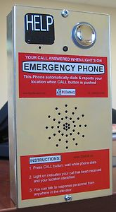

Committee Review of Comments and Action – July 2013

Approval with Modifications based on Comments.

Committee Reason: Members of the committee remain concerned about who will be determining what is ‘essential information’. The phrase is in the A17.1 standard and will remain even if the A117.1 committee removes it. The essence of the approved version, below is to make sure that all 3 relevant sections are referenced. The considerations regarding essential information will be able to continue.

Modification:

407.4.10.3 Instructions. If Where instructions for use are provided, essential information shall be presented in both visual form, and raised characters and braille complying with Sections 703.2, 703.3 and 703.4.

Ballot Comments on July 2013 Committee Action Report

RESNA – Edward Steinfeld
Affirmative with Comment Ballot:
Comment: “Essential” has to be defined going forward.

AEMA – Kevin Brinkman
Negative: Ballot:
Comment/reason: The committee passed this so it could be ‘fixed’ later in the cycle. This is in conflict with ASME A17.1 requirements and should not be passed. A visual indicator is already required to let someone know that a signal has been sent.

NEII – Brian Black
Negative: Ballot:

Revise as follows:

407.4.10.3 Instructions. Where instructions for use are provided, they shall be presented in visual form, raised characters and braille complying with Sections 703.2, 703.3 and 703.4.

Exception: Instructions related to lighted signals or other features providing communication to deaf or hard of hearing persons.

Instructions for elements that are provided solely to communicate with persons who are deaf or hard of hearing do not need to be accessible to blind persons as they are served by the audible aspects of the two-way communication system. It is important to note that these devices are relatively small and do not have the “real estate” to contain unnecessary raised lettering and braille.

4-56– 12
408.4.1
Proposed Change as Submitted

Proponent: Kim Paarlberg, International Code Council

Revise as follows:

408.4.1 Inside Dimensions. Elevator cars shall provide a clear floor width of 42 inches (1065 mm) minimum. The clear floor area shall not be less than 15.75 square feet (1.46 m²). The elevator car shall provide a clear floor space complying with Section 305.3.

EXCEPTION: For installations in existing buildings, elevator cars that provide a clear floor area of 15 square feet (1.4 m²) minimum, and provide a clear inside dimension of 36 inches (915 mm) minimum in width and 54 inches (1370 mm) minimum in depth, shall be permitted. This exception shall not apply to cars with doors on adjacent sides.

Reason: This proposal is intended to ensure that the depth of the elevator car can accommodate the 48 inch depth requirement for a clear floor space. It will really have a fairly limited application but will close a loophole that exists when the elevator car is built to the minimum area requirements.
As it is currently written a 47.62 inch by 47.62 inch car would meet the currently imposed 42 inch minimum width and 15.75 sq. ft. size. However, it would not accommodate the 48 inch depth required for a clear floor space. Once the “width” goes over 47.25 inches, they would no longer get the 48 inch depth unless the car does exceed the 15.75 sq. ft. minimum area.
The possibility of a 47.62 by 47.62 inch elevator car would represent the worst case scenario for the minimum depth. This new text would address the situation where the width is between 47.25 and 47.62 inches and the car is exactly 15.75 square feet in area. If the car gets “wider” and is not “deep” enough, the door location provisions of Section 408.3.3 will kick in and move the door to the “narrow end” of the car.
Because this proposal does have a very limited range of application (minimum area elevator car with width between 47.25 and 47.62 inches) it may not be worth making this change; but approving it does close an apparent loophole which could allow the LULA elevator to have a depth which could not accommodate the generally required 48 inch clear floor space.
input.doc

Committee Action

Disapproved

Committee Reason: The Committee preferred its action to approve as modified Proposal 4-57-12

BALLOT COMMENTS

4-56.1 Comment Rescinded

4-56.2
Commenter: Kim Paarlberg, Representing ICC
Ballot: Negative with comment:

Comment: This proposal was disapproved in favor of 4-57. In the last cycle the committee modified this section to allow additional options for the car sizes. This current proposal simply cleans up a problem with the committee action in the last cycle. During the last cycle the original proposal to modify Section 408.4.1 (proposal #62) was originally disapproved by the committee. Kevin Brinkman and Curt Wiehle submitted negative ballot comments which ultimately led to this item being reconsidered and ultimately approved based on Kevin’s ballot comment. Part of Kevin’s comment stated “As the width is increased, the length would be allowed to decrease but it not below the 48 inch minimum required elsewhere in this standard”. Unfortunately this 48 inch requirement was not directly referenced within the approved code text and therefore it appears that Section 408.4.1 may in some situations allow an elevator car which is less than 48 inches in depth, which was NOT the intent of the committee. The currently submitted proposal does correct this problem.
The committee should approve 4-56 to keep the work of the last cycle and provide additional options for elevator car sizes. The committee should disapprove 4-57 since it would take the standard back to the 2003 text and create arbitrary limitations that would exclude certain size elevators which are usable and accessible.
See additional information under 4-57.

Proponent Comment

4-56.3
Commenter: Kim Paarlberg, Representing ICC

Request approval as submitted:

Reason: This proposal was disapproved in favor of 4-57. In the last cycle the committee modified this section to allow additional options for the car sizes. This current proposal simply cleans up a problem with the committee action in the last cycle. During the last cycle the original proposal to modify Section 408.4.1 (proposal #62) was originally disapproved by the committee. Kevin Brinkman and Curt Wiehle submitted negative ballot comments which ultimately led to this item being reconsidered and ultimately approved based on Kevin’s ballot comment. Part of Kevin’s comment stated “As the width is increased, the length would be allowed to decrease but it not below the 48 inch minimum required elsewhere in this standard”. Unfortunately this 48 inch requirement was not directly referenced within the approved code text and therefore it appears that Section 408.4.1 may in some situations allow an elevator car which is less than 48 inches in depth, which was NOT the intent of the committee. The currently submitted proposal does correct this problem.
The committee should approve 4-56 to keep the work of the last cycle and provide additional options for elevator car sizes. The committee should disapprove 4-57 since it would take the standard back to the 2003 text and create arbitrary limitations that would exclude certain size elevators which are usable and accessible.
See additional information under 4-57 provided as part of the ballot.
If there is a change to the clear floor space, this revision needs to be re-evaluated.

Committee Review of Comments and Action – July 2013

Approval with Modifications based on Comments.

Committee Reason: The committee first approved the original proposal amending Section 408.4.1 because the proposal added a direct reference to the requirement rather than the 2 step reference currently in the standard. Exception 2 was also approved to provide a secondary exception for existing buildings that is allowed under ADA. This incorporates the essence of proposal 4-57-12 into this change.

408.4.1 Inside Dimensions. Elevator cars shall provide a clear floor width of 42 inches (1065 mm) minimum. The clear floor area shall not be less than 15.75 square feet (1.46 m²). The elevator car shall provide a clear floor space complying with Section 305.3.

EXCEPTIONS:
1. For installations in existing buildings, elevator cars that provide a clear floor area of 15 square feet (1.4 m²) minimum, and provide a clear inside dimension of 36 inches (915 mm) minimum in width and 54 inches (1370 mm) minimum in depth, shall be permitted. This exception shall not apply to cars with doors on adjacent sides.

2. For installations in existing buildings, cars that provide a clear width 51 inches (1295 mm) minimum shall be permitted to provide a clear depth 51 inches (1295 mm) minimum provided that car doors provide a clear opening 36 inches (915 mm) wide minimum.

Ballot Comments on July 2013 Committee Action Report

AEMA – Kevin Brinkman
Affirmative with Comment: Ballot:
Comment: This change is consistent with the proposed change in 3-13, but it should only proceed if the proposed change in 3-13 remains approved.

