6-2– 12
602.3
Proposed Change as Submitted

Proponent: Kim Paarlberg, International Code Council

Revise as follows:

602.3 Operable Parts. Operable parts shall comply with Section 309.

EXCEPTION: Where bottled water fillers are provided as part of drinking fountains serving wheelchair and standing person, the bottled water filler in the drinking fountain for standing persons is not required to comply with Section 309.

Reason: The quantity of change proposals submitted by International Code Council is reflective of three elements of our work: 1. ICC is the Secretariat for the Standard and some changes reflect inconsistencies or improvements suggested by staff; 2. ICC develops and publishes a Commentary on the standard and writing the commentary illuminates issues of the text and figures; and 3. ICC provides an interpretation service for the standard which results in the observation of provisions the users find most confusing.
Bottled water fillers are being provided in many university and park settings. Not using disposable bottled water is an important part of recycling efforts. However, if the bottled water filler is behind the standing drinking fountain, it cannot be located in reach ranges. The intent of the exception is to allow for this option only if there is a bottled water filler over the accessible drinking fountain.

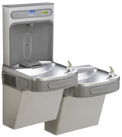
input.doc

Committee Action

Disapproved

Committee Reason: Committee was receptive to concept, but concerned the language didn't accomplish purpose. Perhaps a separate section would be better rather than an exception. Does it need both standing and seated levels?

BALLOT COMMENTS

6-2.1
Commenter: Gene Boecker, Representing NATO
Ballot: Negative with comment:

Comment: Bottle filling stations need to have a part in the standard. Major metropolitan areas are already addressing these within their plumbing codes. The means to address these elements from an accessibility standpoint is important. By the time the standard is effective hundreds of these will already be installed and many more on the way.

Revise as follows:

602 Drinking Fountains and Bottle Filling Stations.

602.7 Bottle Filling Stations. Bottle filling stations which shall comply with sections 602.7.1 and 602.7.2.

Exception: Where bottle filling stations are part of the drinking fountain for standing persons, the bottle filling station is not required to comply with this section provided a bottle filling station is located at the wheelchair accessible drinking fountain.

602.7.1 Clear Floor Space. A clear floor space complying with Section 305, positioned for a forward or side approach, shall be provided.

602.7.2 Controls. Controls for bottle filling stations shall be hand operated or automatic. Hand operated controls shall comply with Section 309.

6-2.2
Commenter: Kim Paarlberg, Representing ICC
Ballot: Negative with comment:

Comment: These bottled water fillers are increasing common in airports and university settings. They are an important part of ‘green’ considerations in many states. How to make them accessible needs to be addressed.

Replace proposal as follows:

602 Drinking Fountains and Bottle Filling Stations.

602.7 Bottle Filling Stations. Bottle filling stations which shall comply with sections 602.7.1 and 602.7.2.

Exception: Where bottle filling stations are part of the drinking fountain for standing persons, the bottle filling station is not required to comply with this section provided a bottle filling station is located at the wheelchair accessible drinking fountain.

602.7.1 Clear Floor Space. A clear floor space complying with Section 305, positioned for a forward or side approach, shall be provided.

602.7.2 Controls. Controls for bottle filling stations shall be hand operated or automatic. Hand operated controls shall comply with Section 309.

6-2.3
Commenter: Hope Reed, Representing NMGCD
Ballot: Negative with comment:

Comment: Water bottle fillers, located at the top of drinking fountains, need to be accessible.

Proponent Comment

6-2.4
Commenter: Kim Paarlberg, Representing ICC

Replace the proposal with the following:

602 Drinking Fountains and Bottle Filling Stations.

602.7 Bottle Filling Stations. Bottle filling stations which shall comply with sections 602.7.1 and 602.7.2.

Exception: Where bottle filling stations are part of the drinking fountain for standing persons, the bottle filling station is not required to comply with this section provided a bottle filling station is located at the wheelchair accessible drinking fountain.

602.7.1 Clear Floor Space. A clear floor space complying with Section 305, positioned for a forward or side approach, shall be provided.

602.7.2 Controls. Controls for bottle filling stations shall be hand operated or automatic. Hand operated controls shall comply with Section 309.

Reason: These bottled water fillers are increasing common in airports and university settings. They are an important part of ‘green’ considerations in many states. How to make them accessible needs to be addressed.
This new proposal will address when bottled water fillers are stand alone or part of a drinking fountain system. The exception is an allowance that the standing drinking fountain requirements would not allow for reach over the fountain. Therefore, the bottle water filler must be over both fountains or over the wheelchair fountain

Committee Review of Comments and Action – July 2013

Approval with Modifications based on Comment.

Committee Reason: The revised proposal contained in comment 6-2.4 addressed the concerns the committee had in disapproving the original proposal. The increased installation of these fixtures demands that the accessibility standard addresses them.

Modification.

Replace the proposal with the following:

602 Drinking Fountains and Bottle Filling Stations.

602.7 Bottle Filling Stations. Bottle filling stations which shall comply with sections 602.7.1 and 602.7.2.

Exception: Where bottle filling stations are part of the drinking fountain for standing persons, the bottle filling station is not required to comply with this section provided a bottle filling station is located at the wheelchair accessible drinking fountain.

602.7.1 Clear Floor Space. A clear floor space complying with Section 305, positioned for a forward or side approach, shall be provided.

602.7.2 Controls. Controls for bottle filling stations shall be hand operated or automatic. Hand operated controls shall comply with Section 309.

6-5– 12
604.4, Figure 604.4
Proposed Change as Submitted

Proponent: Edward Steinfeld, IDEA Center, School of Architecture and Planning, University at Buffalo, State University of New York

Revise as follows:

604.4 Height. The height of water closet seats shall be 17 inches (430 mm) minimum and to 19 20 inches (485 510 mm) maximum above the floor, measured to the top of the seat. Seats shall not be sprung to return to a lifted position.
EXCEPTIONS:
1. An accessible water closet which is adjustable in height or which provides multiple hinged seats is permitted to provide adjustability within a range of 11 inches (280 mm) minimum to 25 inches (635 mm) maximum, provided that at least one adjustment setting provides a seat within the range specified in Section 604.4.
2. A water closet in a toilet room for a single occupant, accessed only through a private office and not for common use or public use, shall not be required to comply with Section 604.4.
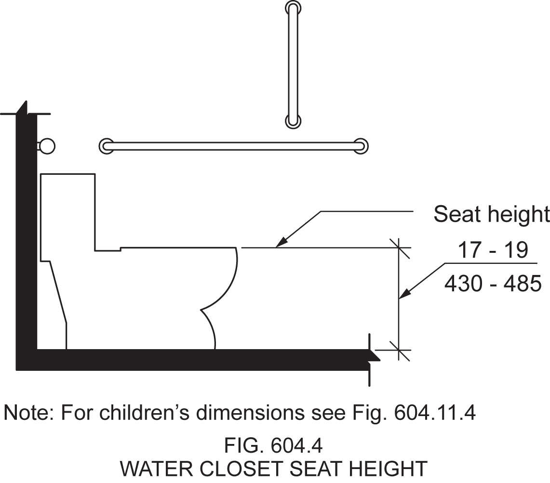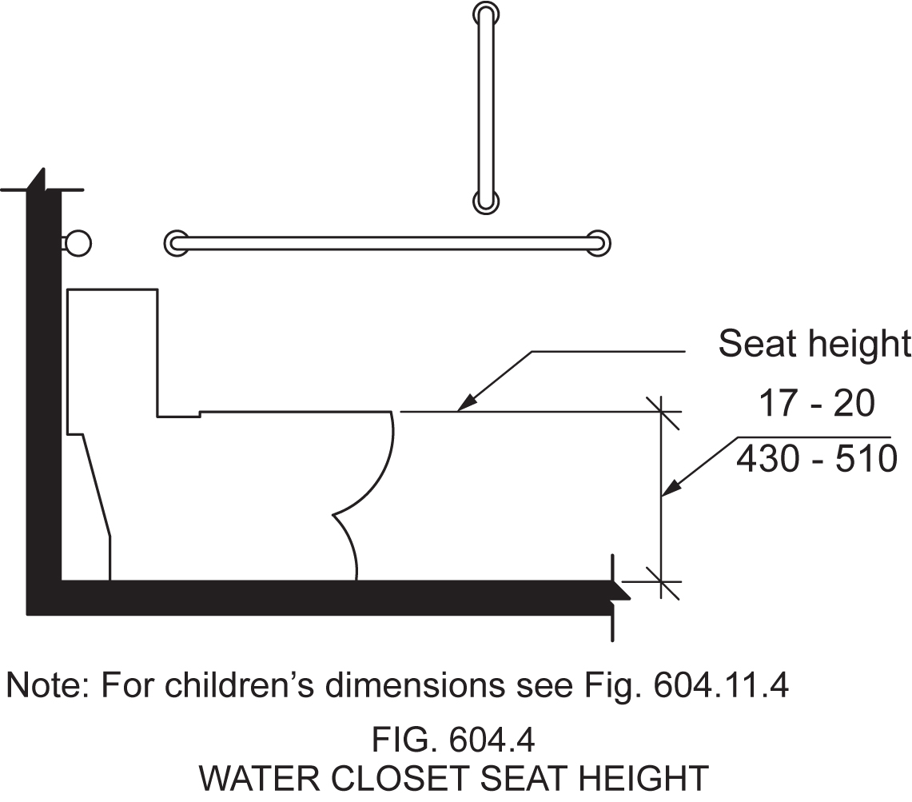

Reason: Many of the technical requirements of the ICC/ANSI A117.1 (2009) Accessible and Usable Buildings and Facilities (ICC/ANSI) designed to accommodate wheeled mobility users are based on research completed from 1974 to 1978 using a research sample that included about 60 individuals who used manual wheelchairs (Steinfeld et al., 1979).
The Center for Inclusive Design and Environmental Access (IDeA) at the University at Buffalo, SUNY recently completed an anthropometric study of 500 wheeled manual and powered mobility device users (Steinfeld, et al., 2010). Measurements of body and device size were captured in three dimensions. The functional anthropometric measurements required measuring reaching ability, grip strength and the minimum space needed for turning. It is the most extensive anthropometric study of wheeled mobility device users in the United States. Additional information about the study can be found at http://www.udeworld.com/ansi-standards-review. The proposed revisions are based on new anthropometric information that was generated from the database of anthropometric measurements developed as part of the study.

Analysis

In addition to the findings reported in Steinfeld, et al., 2010, the IDeA Center developed a Design Resource entitled, Analysis of Seat Height for Wheeled Mobility Devices that provides more detailed information about the study reported in Steinfeld, et al., 2010. Analysis of Seat Height for Wheeled Mobility Devices indicates that the current maximum height of 19 inches (485 mm) accommodates 51% of female manual wheelchair users, 30% of manual wheelchair users, and fewer than 20% of power and scooter users. The report indicates a seat height of 25 inches (635 mm) would accommodate over 95% of all wheeled mobility device users (D’Souza and Steinfeld, 2011, pg. 5).
Increasing the maximum seat height to 20 inches (510 mm) would allow 75% of female manual wheelchair and 53% of male manual wheelchair users (D’Souza and Steinfeld, 2011, pg. 5) to transfer comfortably. Comfort in this case is determined by how closely the height of the transfer surface matches the height of a wheelchair seat. Steinfeld, et. Al., 2010 (pg. 85) report that “keeping the height of a transfer surface close to the height of a wheelchair seat reduces the effort necessary to transfer and provides a safer environment, especially in bathing and toilet rooms.”
However, a fixed seat any higher than 20 inches (510 mm) would likely disadvantage people of short stature, particularly if it was the only water closet. Encouraging innovation would help to accommodate a greater number of wheeled mobility users without disadvantaging people of short stature. Adjustability is the best option to accommodate the widest population but in the meantime, the upper limit should be raised to 20 inches (Steinfeld, et al., 2010, pgs. 85-86).
Since the current standard indicates a seat height of 11 inches (280 mm) is acceptable for children’s use (604.11.4), any product which is adjustable could reasonably lower to such a level at a minimum.
NOTE: This change necessitates a change to Fig. 604.4 to ensure consistency. Thus, the proposed revised figure has been attached, along with the existing figure for comparison purposes.

References (See http://www.udeworld.com/ansi-standards-review for full text)

D’Souza, C. and Steinfeld, E. (2011). Analysis of Seat Height for Wheeled Mobility Devices. Buffalo, NY: University at Buffalo Center for Inclusive Design and Environmental Access.

Steinfeld, E., Paquet, V., D’Souza, C., Joseph, C, and Maisel, J. (2010). Final Report: Anthropometry of Wheeled Mobility Project. Washington, DC: U.S. Access Board.

Steinfeld, E. Schroeder, S. and Bishop, M. (1979). Accessible buildings for people with walking and reaching limitations. Washington, DC: U.S. Department of Housing and Urban Development.
input.doc

Committee Action

Disapproved

Committee Reason: The Committee was not convinced that changes in demography and equipment that raising the range to 20 inches was appropriate. Among the concerns was the application to ambulatory accessible compartments. Little persons would find the 20 inch height problematic. Regarding the exception, there was also concern about the durability and usability of the specified equipment.

BALLOT COMMENTS

6-5.1
Commenter: Kim Paarlberg, Representing ICC
Ballot: Affirmative with comment:

Comment: See comments to 3-6-12.

In addition, the adjustable seat is not practical from the point of how it should be used and maintained in a safe and healthy manner.

6-5.2
Comment rescinded

6-5.3
Commenter: Edward Steinfeld, Representing RESNA
Ballot: Negative with comment:

Comment: The research results clearly shows that a higher range would be beneficial for wheeled mobility users but allowing fixed heights as high as 25 in. could cause difficulty for people who need low seat heights, as the committee noted in defeating the original proposal. I didn’t think about an amendment when we voted on the proposal but only exception #1 was changed it would allow a range from 11-25 in. for adjustable water closets. This would mean that, as adjustable products come on the US market, they would provide a great alternative to the fixed seat height that would be too low for many people yet not disadvantage people of short stature or children with disabilities. At the July meeting, I will offer this proposal.

Committee Review of Comments and Action – July 2013

Approval with Modifications based on Comment

Committee Reason: The committee was asked to consider just approving the proposed exception. There remain concerns regarding the structural stability and durability of the devices. There is also concerns regarding ability of keeping the devices sanitary. The proponent encouraged the approval of generic language which would allow the market to address the concept and make sure that any device could adjust to provide a height within the standard's range of accessibility.

Modification:

Replace the proposal with the following:

EXCEPTIONS:
1. An accessible water closet which is adjustable in height by the user is permitted provided that at least one adjustment setting provides a seat within the range specified in Section 604.4.
2. A water closet in a toilet room for a single occupant, accessed only through a private office and not for common use or public use, shall not be required to comply with Section 604.4

Ballot Comments on July 2013 Committee Action Report

LPA – Tricia Mason
Affirmative with Comment Ballot:
Comment: LPA is greatly in favor of an exception which allows for adjustability and provides a lower height option for individuals of short stature who are unable to ‘climb’ onto a water closet in an accessible stall but might also require the other access features (turning space, grab bars, etc.) This will also allow users of taller wheeled mobility devices to adjust the height to make transferring much easier and significantly safer.

Todd Andersen
Negative Ballot:
Comment/reason: The current text does not forbid the use of adjustable elements, but adding this text calls into question the use of adjustable devices when seeking to comply with all other requirements not specifically described as allowing adjustability. A better approach may be to add a general statement to Chapter One saying that where an adjustable element is provided, it must be adjustable by the user.

RESNA – Edward Steinfeld
Negative Ballot:
Comment/reason: We propose setting up a committee to develop an adjustability option to discuss and make proposals that would provide encouragement and support for new technologies and approaches. This committee could also address other items where a large range is an issue.

6-7– 12
604.5.1, 604.5.1.1(NEW), 604.5.1.2(NEW)

Proposed Change as Submitted

Proponent: Kim Paarlberg, International Code Council

Revise as follows:

604.5.1 Fixed Side Wall Grab Bars. Fixed side wall grab bars shall include a horizontal bar complying with Section 605.4.1.1 and a vertical grab bar complying with Section 604.5.1.2. The vertical grab bar at water closets primarily for children’s use shall comply with Section 609.4.2

604.5.1.1 Horizontal Grab Bar. A fixed horizontal side-wall grab bars shall be 42 inches (1065 mm) minimum in length, shall be located 12 inches (305 mm) maximum from the rear wall and extending 54 inches (1370 mm) minimum from the rear wall.

604.5.1.2 Vertical Grab Bar. In addition, A vertical grab bar 18 inches (455 mm) minimum in length shall be mounted with the bottom of the bar located 39 inches (990 mm) minimum and 41 inches (1040 mm) maximum above the floor, and with the center line of the bar located 39 inches (990 mm) minimum and 41 inches (1040 mm) maximum from the rear wall.

EXCEPTION: The vertical grab bar at water closets primarily for children’s use shall comply with Section 609.4.2.

Reason: The quantity of change proposals submitted by International Code Council is reflective of three elements of our work: 1. ICC is the Secretariat for the Standard and some changes reflect inconsistencies or improvements suggested by staff; 2. ICC develops and publishes a Commentary on the standard and writing the commentary illuminates issues of the text and figures; and 3. ICC provides an interpretation service for the standard which results in the observation of provisions the users find most confusing.
This proposal does several things including breaking the one long section into a format with single topic sections and moves the exception up to the charging paragraph where it becomes a requirement instead of an exception which would be optional to the user.
This proposal was originally developed by the editorial task group during the last standard development cycle. However, since the limited proposal that was printed in the editorial draft simply showed the words “exception” being deleted and replaced with a section number it did create a substantive change which was not appropriate to make as a part of the editorial process.
While the children’s requirements are always an option, because it was an exception the user would never have been required to follow that exception unless they wished to. This revised proposal provides a cross reference that is necessary to avoid a technical conflict in the grab bar requirements for children’s facilities.
input.doc

Committee Action

Approved

Committee Reason: The change is editorial in nature. It repairs provisions of the code to the intent of the 2009 edition.

6-10– 12
604.5.2, Figure 604.5.2
Proposed Change as Submitted

Proponent: Terry G. Wendt Jr, AIA, Wisconsin Department of Transportation

Revise as follows:

604.5.2 Rear Wall Grab Bars. The rear wall grab bar shall be 36 inches (915 mm) minimum in length and extend from the centerline of the water closet between 12 inches (305) minimum on the side closest to the wall, and 24 inches (610 mm) minimum on the transfer side. and located 5 inches (125 mm) from the side wall.

EXCEPTIONS:

- The rear grab bar shall be permitted to be 24 inches (610 mm) minimum in length, centered on the water closet, where wall space does not permit a grab bar 36 inches (195 mm) minimum in length due to the location of a recessed fixture adjacent to the water closet.

- Where an administrative authority requires flush controls for flush valves to be located ina position that conflicts with the location of the rear grab bar, that grab bar shall be permitted to be split or shifted to the open side of the toilet area.

Revise Figure 604.5.2 to reflect changes of text to Section 604.5.2

Reason: Suggested change will make compliance much easier to accomplish by enabling craftspeople to position the grab bar from a known point (the side wall). Having the grab bar position dependent on the location of the water closet often results in non-compliant installations because the exact position of the water closet fluctuates. The requirement of 5 inches from the side wall was calculated based on the water closet centerline being between 16 and 18 inches from the side wall as required by Section 604.2 – if the end of a 36 inch grab bar is positioned 5 inches from the side wall, the ends will be within 1 inch of the 12 inch / 24 inch relative position currently described in Section 604.5.2 (assuming the water closet is positioned in a compliant manner). This would streamline inspections by only requiring two measurements – distance from the side wall and length. It would also make the rear grab bar requirement similarly described as for the other grab bars (based on distance from walls, not fixtures).
input.doc

Committee Action

Disapproved

Committee Reason: The Committee preferred the current text. The loss of the reference to the centerline of the water closet was not liked. The proposal doesn't specify which side wall the 5 inches is measured from.

BALLOT COMMENTS

6-10.1
Comment rescinded

6-10.2
Commenter: Kim Paarlberg, Representing ICC
Ballot: Negative with comment:

Comment: If this is a concern in the field, as indicated in the reason, the language could be revised to be consistent with the start of the side grab bars.

Replace the proposal as follows:

604.5.2 Rear Wall Grab Bars. The fixed rear wall grab bar shall be 36 inches (915 mm) minimum in length and extend from the centerline of the water closet between 12 inches (305) minimum on the side closest to the wall, and 24 inches (610 mm) minimum on the transfer side. , located 6 inches maximum (150 mm) from the side wall and extending 42 inches (1065 mm) from the side wall.

EXCEPTIONS:

- The rear grab bar shall be permitted to be 24 inches (610 mm) minimum in length, centered on the water closet, where wall space does not permit a grab bar 36 inches (195 mm) minimum in length due to the location of a recessed fixture adjacent to the water closet.

- Where an administrative authority requires flush controls for flush valves to be located in a position that conflicts with the location of the rear grab bar, that grab bar shall be permitted to be split or shifted to the open side of the toilet area.

Committee Review of Comments and Action – July 2013

Approval with Modifications based on Comments.

Committee Reason: The committee accepted the revised version proposed in comment 6-10.2 because it would provide better design and installation guidance than the current text as well as the original proposal.

Modification.

Replace the proposal as follows:

604.5.2 Rear Wall Grab Bars. The fixed rear wall grab bar shall be 36 inches (915 mm) minimum in length and extend from the centerline of the water closet between 12 inches (305) minimum on the side closest to the wall, and 24 inches (610 mm) minimum on the transfer side. , located 6 inches maximum (150 mm) from the side wall and extending 42 inches (1065 mm) from the side wall.

EXCEPTIONS: (No change to exceptions)

Ballot Comments on July 2013 Committee Action Report

NACS – Bradley Gaskins
Negative: Ballot:
Comment/reason: This provision is no longer in compliance with the 2010 ADA Standards. If the toilet is located 16” from wall to centerline the grab bar must be 4” from the adjacent wall under the ADA Standards. This change will allow the grab bar to be 6”from the adjacent wall which conflicts with the ADA Standard.
Installing a grab bar based upon the centerline of the water closet should not be a problem for a craftsman or any other individual. The water closet is customarily already installed prior to installation of the grab bars so a measurement from the centerline should be easy. Second, if the water closet is not installed the sewer pipe connection is installed and that will set the location of the water closet such that the centerline of the sewer connection will be the centerline of the water closet. The plumbing code no longer allows offset flanges.
Lastly it is easy to determine the distance from the wall. It is simply the centerline distance minus 12”.

RESNA – Edward Steinfeld
Negative: Ballot:
Comment/reason: There is no evidence that the rear grab bar is actually necessary. It originated in the 1980 version through political wheeling and dealing on the committee with little research justification and, it’s original intent has been subverted through subsequent modifications of the standard. It is time to rethink it rather than make it more stringent. In many installations it is costly to provide yet will have absolutely no benefit because no one can reach it.

ATBCB – Marsha Mazz
Negative Ballot:
Comment/reason: Mr. Gaskins raises a valid point. The new provision will conflict unnecessarily with the ADA requirement and will not result in improved accessibility.

6-14– 12
604.7, 604.11.7

Proposed Change as Submitted

Proponent: Ed Roether, ADA/A117.1 Harmonization Task Group

Revise as follows:

604.7 Dispensers. Toilet paper dispensers shall comply with Section 309.4. Where the dispenser is located above the grab bar, the outlet of the dispenser shall be located within an area 24 inches (610 mm) minimum and 36 inches (915 mm) maximum from the rear wall. Where the dispenser is located below the grab bar, the outlet of the dispenser shall be located within an area 24 inches (610 mm) minimum and 42 inches (1065 mm) maximum from the rear wall. The outlet of the dispenser shall be located 18 inches (455 mm) minimum and 48 inches (1220 mm) maximum above the floor. Dispensers shall comply with Section 609.3. Dispensers shall not be of a type that control delivery, or do not allow continuous paper flow.

EXCEPTION: Toilet paper dispensers that accommodate a maximum of 2 toilet paper rolls of not more than 5 inch diameter each shall be permitted to be located 7 inches minimum and 9 inches maximum in from the of the water closet measured to the centerline of the dispenser.

604.11.7 Dispensers. Toilet paper dispensers primarily for children’s use shall comply with Section 309.4. The outlet of dispensers shall be located within an area 24 inches (610 mm) minimum and 42 inches (1065 mm) maximum from the rear wall. The outlet of the dispenser shall be 14 inches (355 mm) minimum and 19 inches (485 mm) maximum above the floor. There shall be a clearance of 1^{1/}2 inches (38 mm) minimum below the grab bar. Dispensers shall not be of a type that control delivery or do not allow continuous paper flow.

EXCEPTION: Toilet paper dispensers that accommodate a maximum of 2 toilet paper rolls of not more than 5 inch diameter each shall be permitted to be located 7 inches minimum and 9 inches maximum in from the of the water closet measured to the centerline of the dispenser

Reason: The ADA/A117 Harmonization Task Group (HTG) was created as a task group of the A117.1 Committee to compare the 2010 ADA with the 2009 A117.1 Standard. The HTG has recommend a series of changes through a set of change proposals. The HTG is recommending changes, for the most part, address where the ADA was viewed as more stringent than the A117. Where the A117 contained provisions not addressed in the ADA, these were not considered a conflict needing action to amend the A117. In addition there are a number of places where the ADA and A117.1 are different as a result of specific actions, by the A117.1 Committee during the development of the 2009 edition, to remain or create a difference where, in the judgment of the committee the ADA was deficient.

Reason for dispensers. While the intent of the provisions in the 2009 ICC A117.1 was intended to allow for a larger toilet paper rolls and recessed dispensers within reach of a person using the water closet (and be considered equivalent to the intent of the 2010 ADA standard), there have been concerns that there may be some reviewers that would not consider the option equivalent to what is required by the 2010 ADA Standard. The committee has already identified that the 2010 ADA standard does not work with the mega roll design. Therefore the intent of the exception is to allow for someone using the standard toilet paper roll at the location addressed in the 2010 ADA standard.
input.doc

Committee Action

Approved

604.7 Dispensers. Toilet paper dispensers shall comply with Section 309.4. Where the dispenser is located above the grab bar, the outlet of the dispenser shall be located within an area 24 inches (610 mm) minimum and 36 inches (915 mm) maximum from the rear wall. Where the dispenser is located below the grab bar, the outlet of the dispenser shall be located within an area 24 inches (610 mm) minimum and 42 inches (1065 mm) maximum from the rear wall. The outlet of the dispenser shall be located 18 inches (455 mm) minimum and 48 inches (1220 mm) maximum above the floor. Dispensers shall comply with Section 609.3. Dispensers shall not be of a type that control delivery, or do not allow continuous paper flow.

EXCEPTION: Toilet paper dispensers that accommodate a maximum of 2 toilet paper rolls of not more than 5 inch diameter each shall be permitted to be located 7 inches minimum and 9 inches maximum in front of the water closet measured to the centerline of the dispenser.

604.11.7 Dispensers. Toilet paper dispensers primarily for children’s use shall comply with Section 309.4. The outlet of dispensers shall be located within an area 24 inches (610 mm) minimum and 42 inches (1065 mm) maximum from the rear wall. The outlet of the dispenser shall be 14 inches (355 mm) minimum and 19 inches (485 mm) maximum above the floor. There shall be a clearance of 1^{1/}2 inches (38 mm) minimum below the grab bar. Dispensers shall not be of a type that control delivery or do not allow continuous paper flow.

EXCEPTION: Toilet paper dispensers that accommodate a maximum of 2 toilet paper rolls of not more than 5 inch diameter each shall be permitted to be located 7 inches minimum and 9 inches maximum in front of the water closet measured to the centerline of the dispenser

Committee Reason: The exceptions allow specific compliance with the 2010 ADA within the context of the Standard. The Standard's existing text has been judged as equivalent to the ADA provisions.

Note: The proposal had an editorial error with the use of 'from the' which should have simply been 'front'. The sentences did not read properly with the wrong words.

BALLOT COMMENTS

6-14.1
Commenter: Marsha K. Mazz, Representing Access Board
Ballot: Affirmative with comment:

Comment: The committee’s reason statement should be modified for clarity. It says “The exceptions allow specific compliance with the 2010 ADA within the context of the Standard. The Standard's existing text has been judged as equivalent to the ADA provisions.” In the first sentence, the meaning of the phrase “within the context of the Standard” is an ambiguous qualifier. The second sentence leaves it up to the reader to determine who or what entity “judged” this action “equivalent to the ADA provision”. Given that, under the ADA, only the Department of Justice or a court of law can make this judgment, I recommend revising the statement to say that the “Committee” judged this action to be equivalent.

Committee Review of Comments and Action – July 2013

Approved.

Committee Reason: The committee considered the information provided by the comments and decided to take no action to change its original approval of this proposal.

Ballot Comments on July 2013 Committee Action Report

ACB – Chris Bell
Negative Ballot:
Comment/reason: This provision for a button reducing the water flow on a hand held shower accessory, which has appeared in the Standard for at least two cycles now, is an important accessibility feature. Some in the plumbing industry are newly expressing safety concerns but have presented no data showing a risk, nor even anecdotal instances of problems. Absent a data-based showing of actual, rather than speculative, risk, this provision should not be deleted.

6-18– 12
604.9.2.3 (New)
Proposed Change as Submitted

Proponent: Gina Hilberry, United Cerebral Palsy Association

Add new text as follows:

604.9.2.3 Compartments with Enhanced Approach Area: Where enhanced approach area is required at toilet compartments, the minimum area of an enhanced wheelchair accessible compartment shall be 60 inches (1525 mm) minimum width measured perpendicular to the side wall, and 82 inches (2083 mm) minimum in depth for both wall hung and floor mounted water closets measured perpendicular to the rear wall.

Reason: 604.9.2.3 Standard 56” and 59” deep toilet compartments do not have enough space for people using a front transfer approach to the fixture. By definition the area occupied by the full size chair and person exceeds the space in between the front of the fixture and the partition. Because of this, users are forced to solve the problem by leaving the door open. It should be noted that this is not a scoping suggestion. This is much like the enhanced lavatories or the Type C Units, adding the clause will allow for future editions of the IBC or local jurisdictions to include this requirement in specific circumstances.
input.doc

Committee Action

Approved

Committee Reason: The Committee approved the proposal essentially endorsing the concept. However there was concern regarding using the term 'enhanced' here because it has been used in the Standard previously and, as such, may be confusing. While not a proposal of the Wheeled Mobility Task Group, it addresses similar issues of using other mobility devices.

BALLOT COMMENTS

6-18.1
Commenter: Gene Boecker, Representing NATO
Ballot: Affirmative with comment:

Comment: In addition, another exception must be added to the approved text for 6-19:

3. Toilet compartment doors with enhanced approach in accordance with Section 604.9.2.3 shall be allowed to swing inward, over the minimum compartment size, if the door is 66 inches (1675 mm) minimum from the rear wall.

Without this exception, only outward swinging doors would be permitted for the majority of these compartments. The 66-inch dimension was used because it is compatible with the additional depth needed where toe space is not provided (Section 604.9.5).

6-18.2
Commenter: Kim Paarlberg, Representing ICC
Ballot: Negative with comment:

Comment: While I appreciate the idea, I would like see the justification for the width and depth of the stall. With a 48” wheelchair space, this is assuming a water closet depth of (82-48=34) 34 inches? I also find the name confusing. If this is to allow for both a front and side approach option, we should state that for clarity. Maybe to just call this an alternate wheelchair compartment (similar to alternate roll-in shower) would be a better idea. Is the current graphic Figure 604.9.3.1(c) adequate? Then we might want to also revise the door overlap requirements in Section 604.9.3. The two options for exceptions would allot someone to get into the stall and maneuver. The 2nd option has the same language as 603.2.2 Exception 2.
Is this going to change if the wheelchair space size changes? Then it is even more important to understand the size justification.

Further modify proposal as follows:

604.9.2.3 Alternate wheelchair accessible Compartments with Enhanced Approach Area: Where enhanced approach area an alternate wheelchair compartment is required at toilet compartments, the minimum area of an enhanced alternate wheelchair accessible compartment shall be 60 inches (1525 mm) minimum width measured perpendicular to the side wall, and 82 inches (2083 mm) minimum in depth for both wall hung and floor mounted water closets measured perpendicular to the rear wall.

604.9.3 Doors. Toilet compartment doors, including door hardware, shall comply with Section 404, except if the approach is to the latch side of the compartment door clearance between the door side of the stall and any obstruction shall be 42 inches (1065 mm) minimum. The door shall be self-closing. A door pull complying with Section 404.2.6 shall be placed on both sides of the door near the latch. Toilet compartment doors shall not swing into the required minimum area of the compartment.

Exception: In an alternate wheelchair accessible compartment, the door can swing into the stall where the clear floor space past the swing of the door meets the clearance for a wheelchair accessible compartment.

-or-

Exception: In an alternate wheelchair accessible compartment, the door can swing into the stall where a clear floor space complying with Section 305.3 is provided within the stall beyond the arc of the door swing.

Committee Review of Comments and Action – July 2013

Approval with Modifications based on Comment.

Committee Reason: The committee was persuaded by the rationale of comment 6-18.2 regarding the format of the original proposal and the use of the term 'enhanced'. This further modification supports the original intent of the proposal.

Modification.

Further modify proposal as follows:

604.9.2.3 Alternate wheelchair accessible Compartments with Enhanced Approach Area: Where enhanced approach area an alternate wheelchair compartment is required at toilet compartments, the minimum area of an enhanced alternate wheelchair accessible compartment shall be 60 inches (1525 mm) minimum width measured perpendicular to the side wall, and 82 inches (2083 mm) minimum in depth for both wall hung and floor mounted water closets measured perpendicular to the rear wall.

604.9.3 Doors. Toilet compartment doors, including door hardware, shall comply with Section 404, except if the approach is to the latch side of the compartment door clearance between the door side of the stall and any obstruction shall be 42 inches (1065 mm) minimum. The door shall be self-closing. A door pull complying with Section 404.2.6 shall be placed on both sides of the door near the latch. Toilet compartment doors shall not swing into the required minimum area of the compartment.

Exception: In an alternate wheelchair accessible compartment, the door can swing into the stall where a clear floor space complying with Section 305.3 is provided within the stall beyond the arc of the door swing.

Ballot Comments on July 2013 Committee Action Report

UCP – Gina Hilberry
Negative Ballot:
Comment/reason: The wording needs to change back to “enhanced” to match the approach taken with “enhanced” reach range lavatories. This is not just an alternate – it is a design intended for future scoping.

6-19– 12
604.9.3, 604.10.3

Proposed Change as Submitted

Proponent: Kim Paarlberg, International Code Council

Revise as follows:

604.9.3 Doors. Toilet compartment doors, including door hardware, shall comply with Section 404, except if the approach is to the latch side of the compartment door clearance between the door side of the stall and any obstruction shall be 42 inches (1065 mm) minimum. The door shall be self-closing. A door pull complying with Section 404.2.6 shall be placed on both sides of the door near the latch. Toilet compartment doors shall not swing into the required minimum area of the compartment.

EXCEPTIONS:

1. Outside of the compartment, where the approach is to the latch side of the compartment door clearance between the door side of the stall and any obstruction shall be 42 inches (1065 mm) minimum.
2. Within the compartment, maneuvering clearances at the door are not required to comply with Section 404.

604.10.3 Doors. Toilet compartment doors, including door hardware, shall comply with Section 404, except if the approach is to the latch side of the compartment door the clearance between the door side of the compartment and any obstruction shall be 42 inches (1065 mm) minimum. The door shall be self- closing. A door pull complying with Section 404.2.6 shall be placed on both sides of the door near the latch. Compartment doors shall not swing into the required minimum area of the compartment.

EXCEPTIONS:

1. Outside of the compartment, where the approach is to the latch side of the compartment door, clearance between the door side of the stall and any obstruction shall be 42 inches (1065 mm) minimum.
2. Within the compartment, maneuvering clearances at the door are not required to comply with Section 404.

Reason: The quantity of change proposals submitted by International Code Council is reflective of three elements of our work: 1. ICC is the Secretariat for the Standard and some changes reflect inconsistencies or improvements suggested by staff; 2. ICC develops and publishes a Commentary on the standard and writing the commentary illuminates issues of the text and figures; and 3. ICC provides an interpretation service for the standard which results in the observation of provisions the users find most confusing.
This proposal will do two things:

- Relocating the existing text “except if the approach…..42 inches minimum” from the base paragraph into Exception 1 will match the normal format for exceptions and will clearly show that it is an exception which alters the base requirement to comply with Section 404.
- It will clarify that the 42 inch requirement is intended for the exterior of the compartment and that the interior of the compartment does not need the door to comply with the maneuvering clearances of Section 404. This clarification does require exception 2 be added but it is consistent with the way the requirement has previously been applied.

In essence the only new text within the proposal is the wording “Outside of the compartment” at the beginning of Exception 1 and then all of the text within Exception 2.
input.doc

Committee Action

Approved

Committee Reason: The change clarifies the location of the maneuvering clearance requirements with respect to compartment doors.

BALLOT COMMENTS

6-19.1
Commenter: Kim Paarlberg, Representing ICC
Ballot: Affirmative with comment:

Comment: Editorial correction

Revise as follows:

604.9.3 Doors. Toilet compartment doors, including door hardware, shall comply with Section 404. The door shall be self-closing. A door pull complying with Section 404.2.6 shall be placed on both sides of the door near the latch. Toilet compartment doors shall not swing into the required minimum area of the compartment.

EXCEPTIONS:

1. Outside of the compartment, where the approach is to the latch side of the compartment door clearance between the door side of the stall compartment and any obstruction shall be 42 inches (1065 mm) minimum.
2. Within the compartment, maneuvering clearances at the door are not required to comply with Section 404.

604.10.3 Doors. Toilet compartment doors, including door hardware, shall comply with Section 404. The door shall be self- closing. A door pull complying with Section 404.2.6 shall be placed on both sides of the door near the latch. Compartment doors shall not swing into the required minimum area of the compartment.

EXCEPTIONS:

1. Outside of the compartment, where the approach is to the latch side of the compartment door, clearance between the door side of the stall compartment and any obstruction shall be 42 inches (1065 mm) minimum.
2. Within the compartment, maneuvering clearances at the door are not required to comply with Section 404.

Proponent Comment

6-19.2
Commenter: Kim Paarlberg, Representing ICC

Further modify the proposal as follows:

604.9.3 Doors. Toilet compartment doors, including door hardware, shall comply with Section 404. The door shall be self-closing. A door pull complying with Section 404.2.6 shall be placed on both sides of the door near the latch. Toilet compartment doors shall not swing into the required minimum area of the compartment.

EXCEPTIONS:
1. Outside of the compartment, where the approach is to the latch side of the compartment door clearance between the door side of the stall compartment and any obstruction shall be 42 inches (1065 mm) minimum.
2. Within the compartment, maneuvering clearances at the door are not required to comply with Section 404.

604.10.3 Doors. Toilet compartment doors, including door hardware, shall comply with Section 404. The door shall be self- closing. A door pull complying with Section 404.2.6 shall be placed on both sides of the door near the latch. Compartment doors shall not swing into the required minimum area of the compartment.

EXCEPTIONS:
1. Outside of the compartment, where the approach is to the latch side of the compartment door, clearance between the door side of the stall compartment and any obstruction shall be 42 inches (1065 mm) minimum.
2. Within the compartment, maneuvering clearances at the door are not required to comply with Section 404.

Reason: This should be an editorial correction.

Committee Review of Comments and Action – July 2013

Approval with Modifications based on Comment

Committee Reason: The modification is based on comment 6-19.2. It simply provides consistency in text that the term is toilet compartments, not stalls.

Further modify the proposal as follows:

604.9.3 Doors. Toilet compartment doors, including door hardware, shall comply with Section 404. The door shall be self-closing. A door pull complying with Section 404.2.6 shall be placed on both sides of the door near the latch. Toilet compartment doors shall not swing into the required minimum area of the compartment.

EXCEPTIONS:
1. Outside of the compartment, where the approach is to the latch side of the compartment door clearance between the door side of the stall compartment and any obstruction shall be 42 inches (1065 mm) minimum.
2. Within the compartment, maneuvering clearances at the door are not required to comply with Section 404.

604.10.3 Doors. Toilet compartment doors, including door hardware, shall comply with Section 404. The door shall be self- closing. A door pull complying with Section 404.2.6 shall be placed on both sides of the door near the latch. Compartment doors shall not swing into the required minimum area of the compartment.

EXCEPTIONS:
1. Outside of the compartment, where the approach is to the latch side of the compartment door, clearance between the door side of the stall compartment and any obstruction shall be 42 inches (1065 mm) minimum.
2. Within the compartment, maneuvering clearances at the door are not required to comply with Section 404.

Ballot Comments on July 2013 Committee Action Report

RESNA – Edward Steinfeld
Affirmative with Comment Ballot:
Comment: The first exception is not in the language used for exceptions. It reads like part of the main paragraph rather than an exception.

6-20– 12
Table 604.9.3.1, Figure 604.9.3.1

Proposed Change as Submitted

Proponent: Alan Gettelman, Bobrick Washroom Equipment, Inc.

Revise as follows:

Table 604.9.3.1 – Door Opening Location
Door Opening Location | Measured From | Dimension
Front Wall or Partition | From the side wall or partition closest to the water closet | 56 inches (1420 mm) minimum
Front Wall or Partition | or
Front Wall or Partition | From the side wall or partition farthest from the water closet | 4 inches (102 mm) maximum  4 inches 100 mm) minimum  to 6 inches maximum (150 mm)
Side Wall or Partition  -  Wall-Hung Water Closet | From the rear wall | 52 inches (1320 mm) minimum
Side Wall or Partition  -  Wall-Hung Water Closet | or
Side Wall or Partition  -  Wall-Hung Water Closet | From the front wall or partition | 4 inches (102 mm) maximum  4 inches 100 mm) minimum  to 6 inches maximum (150 mm)
Side Wall or Partition  -  Floor-Mounted Water Closet | From the rear wall | 55 inches (1395 mm) minimum
Side Wall or Partition  -  Floor-Mounted Water Closet | or
Side Wall or Partition  -  Floor-Mounted Water Closet | From the front wall or partition | 4 inches (102 mm) maximum  4 inches 100 mm) minimum  to 6 inches maximum (150 mm)

Revise Figure as follows:

Change the called dimension for door opening location to read: 4 inches (100 mm) minimum to 6 inches (150mm) maximum).

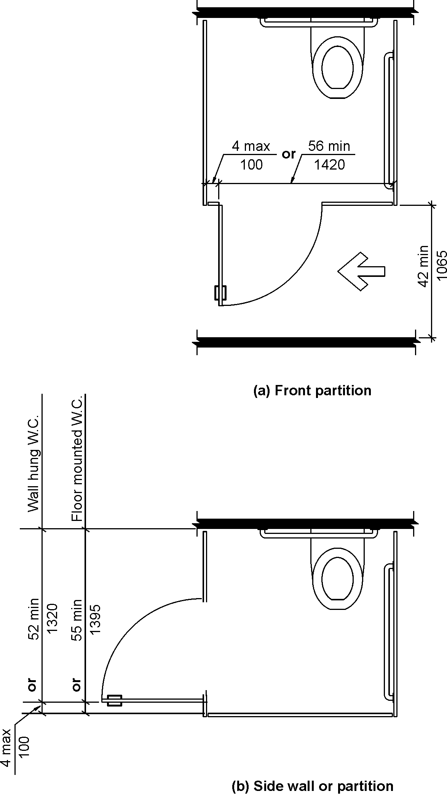
Fig. 604.9.3.1
Wheelchair Accessible Compartment Doors

Reason:

- Current absolute 4 inch (100 mm) maximum space from inside edge of side partition and door opening is an overly restrictive dimension creating installation and structural problems.
- To maintain the 4 inch maximum space with a gap at the side all or with a coved floor into the wall the stile must be moved away from the wall and a 3” wide stile must be used. In many circumstances a 3” wide stile has a single floor anchor point providing minimum structural support for hinging the door.
- As long as it would be allowed under the condition providing a wider compartment at the same time, allowing a range of 4 inches to 6 inches space for the door opening location would accommodate a number of field conditions; allowing the use of a 4” to 6” wide stile with two floor anchor points would greatly enhance the stability of the partition and door without compromising accessibility.
- The 4” to 6” range for the location of the door opening would alleviate a structural issue on the Wheelchair Accessible Compartments wider than 60”. With the current 4 inch maximum space stile at the other side of the door must be very wide reducing design flexibility and installation options.
input.doc

Committee Action

Disapproved

Committee Reason: The change would make the table more difficult to understand and therefore use. Changing from 4 inches maximum to a 4 inch minimum/6 inch maximum range would eliminate currently acceptable installations which are less than 4 inches.

BALLOT COMMENTS

6-20.1
Commenter: Alan Gettelman
Ballot: Negative with comment:

Comment: Change to 4 inch minimum to 6 inch maximum space for stile would be more practical to install and comply. Tables and figures with 4 – 6 inch range would be consistent with other tables and figures that present ranges (Example: Table of Dimensions at Water Closets Serving Children Ages 3 through 12). Since 4 inch wide stiles are industry standard, acceptable installations less than 4 inches are in the minority. Additionally, the 4 inch or less wide stile is not the most ideal from a strength standpoint support from which to hinge a 32 inch plus wide outswing door.

6-20.2
Comment rescinded

Proponent Comment

6-20.3
Commenter: Alan Gettelman

Revise Table as follows:

Table 604.9.3.1 – Door Opening Locations
Door Opening Location | Measured From | Dimension
Front Wall or Partition | From the side wall or partition closest to the water closet | 56 inches (1420 mm) minimum
Front Wall or Partition | or
Front Wall or Partition | From the side wall or partition farthest from the water closet | 4 inches (102mm) maximum  4 inches 100mm) minimum  to 6 inches maximum (150mm)
Side Wall or Partition  -  Wall-Hung Water Closet | From the rear wall | 52 inches (1320 mm) minimum
Side Wall or Partition  -  Wall-Hung Water Closet | or
Side Wall or Partition  -  Wall-Hung Water Closet | From the front wall or partition | 4 inches (102mm) maximum  4 inches 100mm) minimum  to 6 inches maximum (150mm)
Side Wall or Partition  -  Floor-Mounted Water Closet | From the rear wall | 55 inches (1395 mm) minimum
Side Wall or Partition  -  Floor-Mounted Water Closet | or
Side Wall or Partition  -  Floor-Mounted Water Closet | From the front wall or partition | 4 inches (102mm) maximum  4 inches 100mm) minimum  to 6 inches maximum (150mm)

Revise Figure as follows:

Change the called dimension for door opening location to read: 4 inches (100mm) minimum to 6 inches (150mm) maximum.

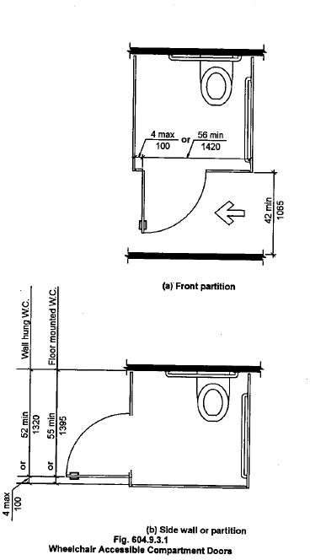

Reasons:

- Change to a single 6 inch maximum dimension is easily understood. This revision to the original proposal overcomes one of Committee’ two reasons for disapproving the original proposal.
- The 6 inch maximum dimension would include current acceptable installations which are less than 4 inches. This revision to the original proposal overcomes the second of Committee’ two reasons for disapproving the original proposal.
- Current 4 inch (100mm) maximum space for the door opening location from side partition or side wall surface to door opening is an overly restrictive dimension. The 4 inch maximum space creates installation problems with the stile and structural support issues with the out-swing door.
- To maintain the 4 inch maximum space for the door opening location at the side wall with a coved floor a 3 inch wide stile must be moved away from the wall to accommodate the radius of the cove. A 3 inch wide stile has a single floor anchor point providing minimum structural support for hinging the 32 + inch wide out-swing door.
- Allowing the 6 inch maximum space for the door opening location would allow the use of stiles wider than 3 inches having two floor anchor points increasing the structural support for hinging the 32+ inch wide out-swing door.

Committee Review of Comments and Action – July 2013

Approval with Modifications based on Comment.

Committee Reason: The current 4 inch maximum results in support and stability issues when the partitions are supported from the floor. The 4 inch maximum usually only allows a single base support. Simply increasing to a 5 inch maximum will allow 2 anchoring supports when installed at the base of the partitions.

Revise Table as follows:

Table 604.9.3.1 – Door Opening Locations
Door Opening Location | Measured From | Dimension
Front Wall or Partition | From the side wall or partition closest to the water closet | 56 inches (1420 mm) minimum
Front Wall or Partition | or
Front Wall or Partition | From the side wall or partition farthest from the water closet | 4 5 inches (102 127 mm) maximum
Side Wall or Partition  -  Wall-Hung Water Closet | From the rear wall | 52 inches (1320 mm) minimum
Side Wall or Partition  -  Wall-Hung Water Closet | Or
Side Wall or Partition  -  Wall-Hung Water Closet | From the front wall or partition | 4 5 inches (102 127 mm) maximum
Side Wall or Partition  -  Floor-Mounted Water Closet | From the rear wall | 55 inches (1395 mm) minimum
Side Wall or Partition  -  Floor-Mounted Water Closet | Or
Side Wall or Partition  -  Floor-Mounted Water Closet | From the front wall or partition | 4 5 inches (102 127 mm) maximum

Revise Figure as follows:

Revise Figure 604.9.3.1 to match table. Change the called dimension for door opening location to read 5 inches (127 mm) maximum.

Ballot Comments on July 2013 Committee Action Report

Ed Roether
Negative: Ballot:
Comment/Reason This proposed language conflicts with the 2010 ADA Standards, therefore should not be approved. The A117.1 needs to be harmonized with ADA to minimize confusion in the design/construction industry. It should be noted that there is a practical issue raised by this proposal regarding the supporting structure. The current dimensions measured from the side closest to the water closet would essentially result in the same thing as proposed here where the compartment width is 2 inches greater than required. This too would literally be in conflict with the 2010 ADA Standards, but consistent practically speaking.

ATBCB – Marsha Mazz
Negative Ballot:
Comment/reason: Motion to disapprove the public comment in its entirety.
The proposal increases the distance between the compartment door and the front wall or partition from 4 inches to 5 inches in order to allow more room for supporting structure. It is possible to support partition walls from the ceiling; this solution was overlooked by the committee. The distance between the front wall and the door opening is carefully controlled in relation to the location of the water closet in order to maximize the usability of the already constricted maneuvering space within the compartment.
Allowing an extra inch will place the unwitting designer and owner in jeopardy of violating the 2010 ADA Standards.

HUD – Cheryl Kent
Negative Ballot:
Comment/reason: The public comment needs to be disapproved in its entirety.
Does not harmonize with the 2010 ADA standards. Allowing an extra inch between the compartment door and the front wall or partition will place the designer and owner in jeopardy of violating the 2010 ADA Standards.

ICC - Kim Paarlberg
Negative Ballot:
Comment/reason: The proponents concern was that the support post was limited to 4”. That is not the case. If someone was willing to provide a larger stall, they could use the 56” measurement and made the support any width. The revision now requires the support to be at least 5”. The end result is that the accessible stalls are now all required to be 1 inch larger. There was no justification for an increase in stall size. There has been no identified issue for accessibility. This is an industry construction issue. The end result is that all bathrooms that used the existing minimum stall requirements are not out of compliance and would have to have partitions reconfigured when a space served was altered.

USA – Dominic Marinelli
Negative Ballot:
Comment/reason: Disapprove the public comment in its entirety.
The proposal increases the distance between compartment door and the front wall or partition from 4 inches to 5 inches in order to allow more room for supporting structure. It is possible to support partition walls from the ceiling. This is a solution that was overlooked by the committee. The distance between the front wall and the door opening is carefully controlled in relation to the location of the water closet in order to maximize the usability of the already constricted maneuvering space within the compartment.
Allowing an extra inch will place the designer and owner in jeopardy of violating the 2010 ADA Standards.

6-22– 12
604.9.5, Figure 604.9.5, 609.5.1, 609.5.2

Proposed Change as Submitted

Proponent: Edward Steinfeld, IDEA Center, School of Architecture and Planning, University at Buffalo, State University of New York

Revise as follows:

604.9.5 Toe Clearance at Accessible Compartments. Toe clearance for compartments primarily for children’s use shall comply with Section 604.9.5.2. Toe clearance for other wheelchair accessible compartments shall comply with Section 604.9.5.1.
604.9.5.1 Toe Clearance at Compartments. The front partition and at least one side partition of compartments shall provide a toe clearance of 9 12 inches (230 305 mm) minimum above the floor and extending 6 8 inches (150 205 mm) beyond the compartment side face of the partition, exclusive of partition support members.
EXCEPTIONS:
1. At compartments not designed for children’s use, toe clearance at the front partition is not required in a compartment greater than 62 64 inches (1575 1625 mm) in depth with a wall-hung water closet, or greater than 65 67 inches (1650 1700 mm) in depth with a floor-mounted water closet.
2. At compartments designed for children’s use, toe clearance at the front partition is not required in a compartment greater than 67 inches (1700 mm) in depth.
23. Toe clearance at the side partition is not required in a compartment greater than 66 68 inches (1675 1730 mm) in width.
604.9.5.2 Toe Clearance at Compartments for Children’s Use. The front partition and at least one side partition of compartments primarily for children’s use shall provide a toe clearance of 12 inches (305 mm) minimum above the floor and extending 6 inches (150 mm) beyond the compartment side face of the partition, exclusive of partition support members.
EXCEPTIONS:
1. Toe clearance at the front partition is not required in a compartment greater than 65 inches (1650 mm) in depth.
2. Toe clearance at the side partition is not required in a compartment greater than 66 inches (1675 mm) in width.
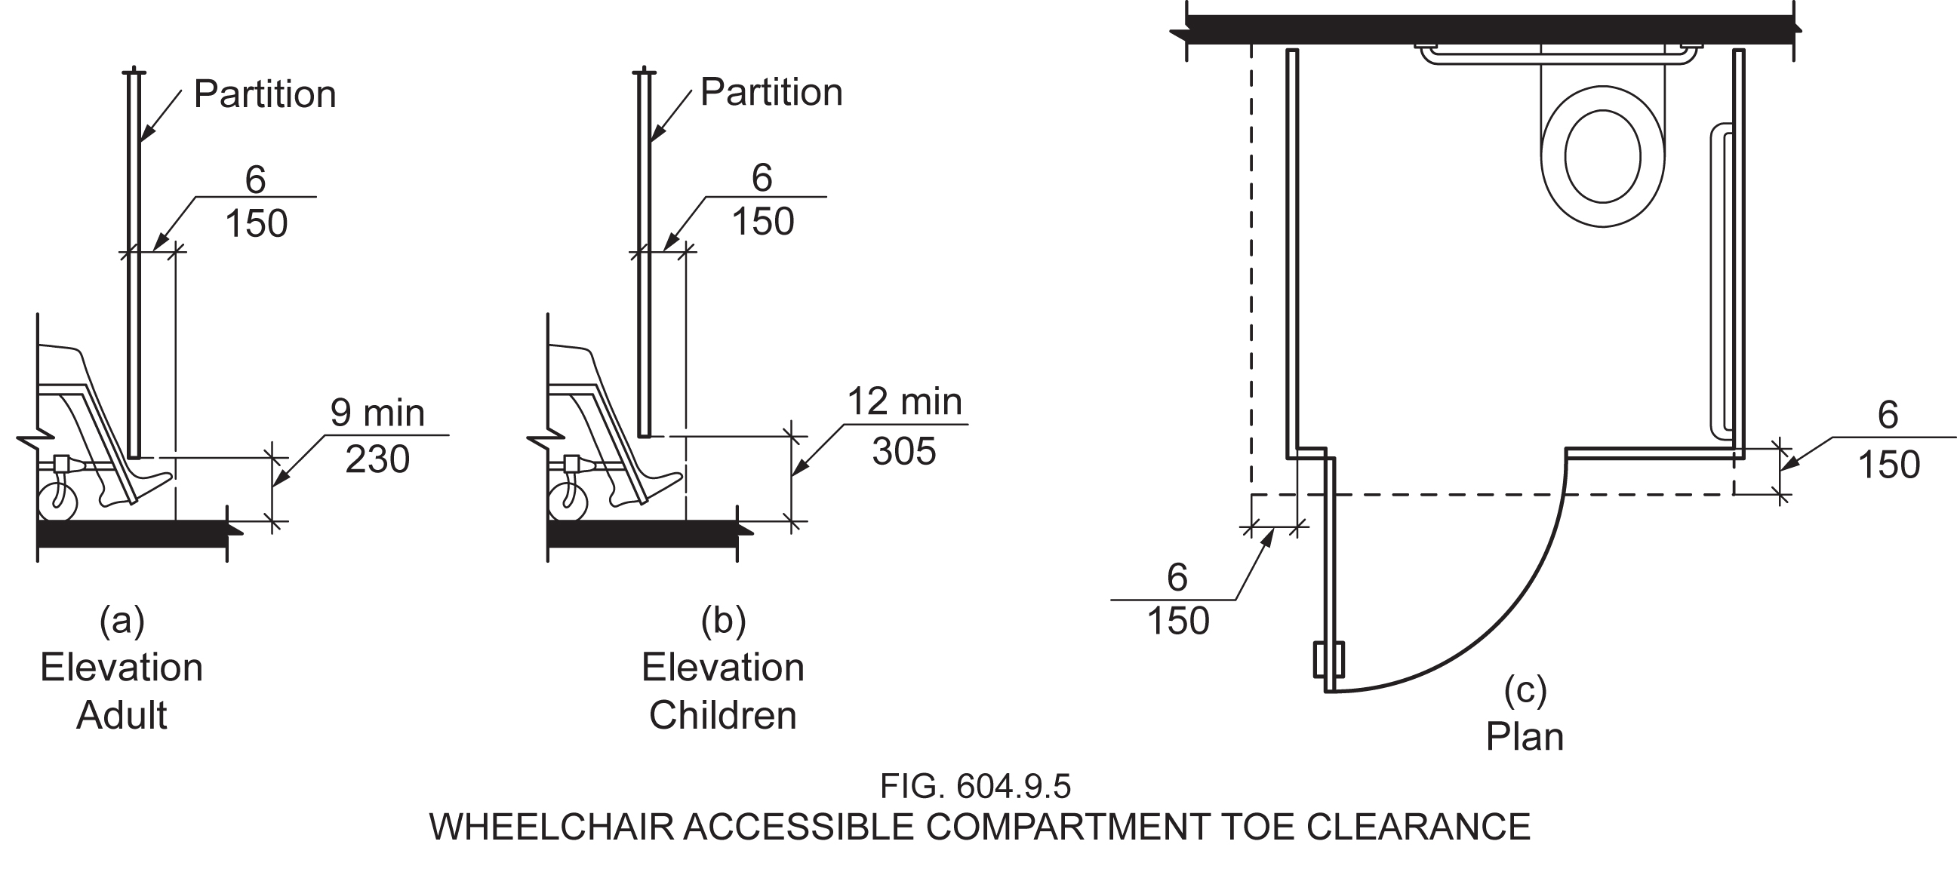

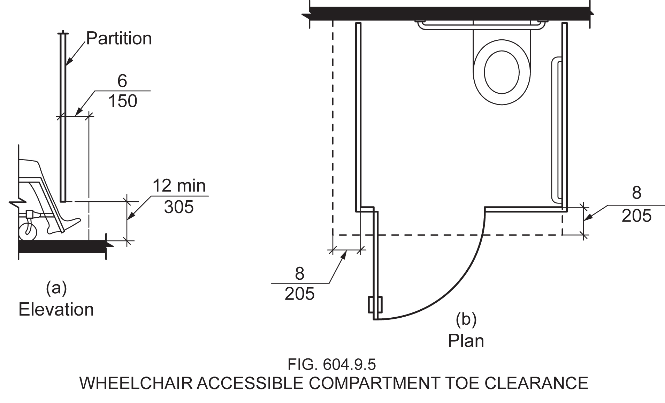

Reason: Many of the technical requirements of the ICC/ANSI A117.1 (2009) Accessible and Usable Buildings and Facilities (ICC/ANSI) designed to accommodate wheeled mobility users are based on research completed from 1974 to 1978 using a research sample that included about 60 individuals who used manual wheelchairs (Steinfeld et al., 1979).
The Center for Inclusive Design and Environmental Access (IDeA) at the University at Buffalo, SUNY recently completed an anthropometric study of 500 wheeled manual and powered mobility device users (Steinfeld, et al., 2010). Measurements of body and device size were captured in three dimensions. The functional anthropometric measurements required measuring reaching ability, grip strength and the minimum space needed for turning. It is the most extensive anthropometric study of wheeled mobility device users in the United States. Additional information about the study can be found at http://www.udeworld.com/ansi-standards-review. The proposed revisions are based on new anthropometric information that was generated from the database of anthropometric measurements developed as part of the study.

Analysis

In addition to the findings reported in Steinfeld, et al., 2010, the IDeA Center developed a Design Resource entitled, Knee and Toe Clearances for Wheeled Mobility Users that provides more detailed information about the study reported in Steinfeld, et al., 2010.

The toe clearance necessary in a toilet compartment is necessarily different from that which is necessary when reaching or using a fixture such as a sink. This is because the objective for providing such clearance in a toilet compartment is to provide sufficient space for a wheeled mobility user to maneuver within the confined space. Hence, the objective is turning, as opposed to moving as close to the wall as possible (as would be the case in reaching).
When a wheeled mobility user is limited by a barrier at the ankle (a toilet compartment partition, for example), the current ANSI height of 9 inches accommodates fewer than 50% of manual wheelchair users. The 6 inches horizontal extension of toe clearance into the adjacent compartment accommodates fewer than 25% of manual wheelchair users. Changing these numbers to 12 inches and 8 inches, respectively, would increase the percentage accommodated to 75%. (D’Souza, et al., 2011, fig. 2)
These figures assume the wheelchair occupant is as far forward to the partition as possible but it does not account for the total occupied length of the device. Based on the existing ANSI standard, we propose that the exceptions be changed accordingly to account for the additional 2 inches of space added for toe clearance. This means that if an adjacent compartment does not have the requisite 8 inches, the accessible compartment must have 2 more inches than previously required in order to be exempted. Further, Steinfeld, et al., 2010 (pg. 95, fig. 4-5) notes that in order to allow 95% of power and manual wheelchair users to perform a 180-degree turn, a 67-inch width is necessary, which is consistent with the proposed change to the exemptions.
There is no research to support changes to the children’s figure, thus our proposal of a 12-inch toe clearance height now aligns with the existing children’s toe clearance height, therefore we have eliminated the distinction in this proposal.
NOTE: This change necessitates a change to Fig. 604.9.5 to ensure consistency. Thus, the proposed revised figure has been attached, along with the existing figure for comparison purposes.

References (See http://www.udeworld.com/ansi-standards-review for full text)

D’Souza, C., White, J., Steinfeld, E., and Paquet, V. (2011). Knee and Toe Clearances for Wheeled Mobility Users. Buffalo, NY: University at Buffalo Center for Inclusive Design and Environmental Access.

Steinfeld, E., Paquet, V., D’Souza, C., Joseph, C, and Maisel, J. (2010). Final Report: Anthropometry of Wheeled Mobility Project. Washington, DC: U.S. Access Board.

Steinfeld, E. Schroeder, S. and Bishop, M. (1979). Accessible buildings for people with walking and reaching limitations. Washington, DC: U.S. Department of Housing and Urban Development.
input.doc

Committee Action

Approved

Committee Reason: The Committee felt the changing range of wheeled mobility equipment in use necessitates these increases.

BALLOT COMMENTS

6-22.1
Commenter: Kim Paarlberg, Representing ICC
Ballot: Negative with comment:

Comment: See the comment to 3-6-12.

In addition, it has proved to be necessary to keep the children’s provisions in a separate section for ease of use of the standard. Even if this proposal goes through to change the size, the format for separate sections should be maintained.

6-22.2
Commenter: David S. Collins, representing American Institute of Architects
Ballot: Negative with comment:

Comment: The work of the study group isn’t finalized and the research that formed the basis for this change has not been validated.

Committee Review of Comments and Action – July 2013

Approval with Modifications based on Comment.

Committee Reason: The committee agreed with comment 6.22-1 that the existing format of the standard with separate sections for children's facilities and other facilities was easier to use. The intent of the original change was maintained and formatted into the existing organization.

Modification.

Replace the proposal as follows:

604.9.5 Toe Clearance at Accessible Compartments. Toe clearance for compartments primarily for children’s use shall comply with Section 604.9.5.2. Toe clearance for other wheelchair accessible compartments shall comply with Section 604.9.5.1.
604.9.5.1 Toe Clearance at Compartments. The front partition and at least one side partition of compartments shall provide a toe clearance of 9 12 inches (230 305 mm) minimum above the floor and extending 6 8 inches (150 205 mm) beyond the compartment side face of the partition, exclusive of partition support members.
EXCEPTIONS:
1. Toe clearance at the front partition is not required in a compartment greater than 62 64 inches (1575 1625 mm) in depth with a wall-hung water closet, or greater than 65 67 inches (1650 1700 mm) in depth with a floor-mounted water closet.
2. Toe clearance at the side partition is not required in a compartment greater than 66 68 inches (1675 1730 mm) in width.
604.9.5.2 Toe Clearance at Compartments for Children’s Use. The front partition and at least one side partition of compartments primarily for children’s use shall provide a toe clearance of 12 inches (305 mm) minimum above the floor and extending 6 8 inches (150 205 mm) beyond the compartment side face of the partition, exclusive of partition support members.

EXCEPTIONS:

1. Toe clearance at the front partition is not required in a compartment greater than 65 67 inches (1650 1700 mm) in depth.

2. Toe clearance at the side partition is not required in a compartment greater than 66 68 inches (1675 1730 mm) in width.

Ballot Comments on July 2013 Committee Action Report

ICC – Kim Paarlberg
Negative: Ballot:
Comment/reason: See comment for Proposal 3-6 – 12.

6-24– 12
This proposal was approved by the committee. No ballot or proponent comments were received. It will be included in the Public Draft. However, please note the editorial correction found after the committee decision.

604.10.2, 604.11.2, 605.2

Proposed Change as Submitted

Proponent: Ed Roether, representing the ADA/A117 Harmonization Task Group

Revise as follows:

604.10.2 Size. The minimum area of an ambulatory accessible compartment shall be 60 inches (1525 mm) minimum in depth and a width of 35 inches (890 mm) minimum and 37 inches (940 mm) maximum 36 inches (915 mm) in width.

Fig. 604.10 Ambulatory Accessible Stall

Revise figure to be consistent with change to Section 604.10.2 -

604.11.2 Location. The water closet primarily for children’s use shall be located with a wall or partition to the rear and to one side. The centerline of the water closet shall be 12 inches (305 mm) minimum and 18 inches (455 mm) maximum from the side wall or partition except that the water closet shall be 17 inches (430 mm) minimum and 19 inches (485 mm) maximum from the side wall or partition in the ambulatory accessible toilet compartment specified in 604.10.1. Water closets located in ambulatory accessible toilet compartments specified in Section 604.10 shall be located as specified in Section 604.2.

605.2 Height and Depth. Urinals shall be of the stall type or shall be of the wall hung type with the rim at 17 inches (430 mm) maximum above the floor. Wall hung Urinals shall be 13 ½ inches (345 mm) minimum in depth measured from the outer face of the urinal rim to the wall.

Reason: The ADA/A117 Harmonization Task Group (HTG) was created as a task group of the A117.1 Committee to compare the 2010 ADA with the 2009 A117.1 Standard. The HTG has recommend a series of changes through a set of change proposals. The HTG is recommending changes, for the most part, address where the ADA was viewed as more stringent than the A117. Where the A117 contained provisions not addressed in the ADA, these were not considered a conflict needing action to amend the A117. In addition there are a number of places where the ADA and A117.1 are different as a result of specific actions, by the A117.1 Committee during the development of the 2009 edition, to remain or create a difference where, in the judgment of the committee the ADA was deficient.
This proposal incorporates all identified issues in Chapter 6

Reason for 604.10.2, 604.11.2, Figure 604.10: ADA has changed the width of the ambulatory accessible stall from a set 36 inches to a range of 35 to 37. This requires adjusting the A117.1.

Reason for 605.2: ADA does not limit the application of this section to just wall hung urinals.
input.doc

Committee Action

Approved

Committee Reason: Provides requirements consistent with the ADA 2010.

Editorial Correction

604.10.2 Size. The minimum area of an ambulatory accessible compartment shall be 60 inches (1525 mm) minimum in depth and a width of 35 inches (890 mm) minimum and 37 inches (940 mm) maximum 36 inches (915 mm) in width.

Reason: The proposal fails to show the text to be crossed out.

6-33– 12
606.2
Proposed Change as Submitted

Proponent: Kim Paarlberg, International Code Council

Revise as follows:

606.2 Clear Floor Space. A clear floor space complying with Section 305.3, positioned for forward approach, shall be provided. Knee and toe clearance complying with Section 306 shall be provided. The dip of the overflow shall not be considered in determining knee and toe clearances.

EXCEPTIONS:

- (unchanged)
- (unchanged)
- A knee clearance of 24 inches (610 mm) minimum above the floor shall be permitted at lavatories and sinks used primarily by children ages 6 through 12 where the higher of the rim or counter surface is 31 inches (785 mm) maximum above the floor.
- (unchanged)
- (unchanged)
- (unchanged)

Reason: The quantity of change proposals submitted by International Code Council is reflective of three elements of our work: 1. ICC is the Secretariat for the Standard and some changes reflect inconsistencies or improvements suggested by staff; 2. ICC develops and publishes a Commentary on the standard and writing the commentary illuminates issues of the text and figures; and 3. ICC provides an interpretation service for the standard which results in the observation of provisions the users find most confusing.
This proposal is intended to coordinate with the language which is used in Section 606.3. The phrasing “higher of the rim or counter surface” is used in Section 606.3.
As it is currently written the standard would appear to allow the measurement to be taken to either the rim of the lavatory or the surface of the counter. Given some of the modern lavatory bowls that are available and being installed, it may be helpful to clarify where the measurement is to be taken.
input.doc

Committee Action

Approved
Committee Reason: The height is specified in Section 606.3 as being the higher of the rim or counter. This change provides consistency between Sec. 606.3 and this exception.

6-36– 12
606.4, 606.5
Proposed Change as Submitted

Proponent: Kim Paarlberg, International Code Council

Revise as follows:

606.4 Faucets. Faucets shall comply with Section 309. Hand-operated metering faucets shall remain open for 10 seconds minimum.

EXCEPTION: Automatic faucets are not required to comply with Section 309 provided that the reach depth to activate the faucets and the water flow is 11 inches maximum.

606.5 Lavatories with Enhanced Reach Range. Where enhanced reach range is required at lavatories, faucets and soap dispenser controls shall have a reach depth of 11 inches (280 mm) maximum or, if automatic, shall be activated within a reach depth of 11 inches (280 mm) maximum. Water and soap flow shall be provided with a reach depth of 11 inches (280 mm) maximum. The rim of the lavatory shall be 34 inches maximum above the floor, measured to the higher of the rim or counter surface.

EXCEPTIONS:

- Enhanced reach range faucets are not required on lavatories provided with automatic faucets where the reach depth to activate the faucets and the water flow has a reach depth 11 inches maximum.
- Enhanced reach range soap dispensers are not required on lavatories provided with automatic faucets where the reach depth to activate the soap dispensers and the soap flow is 11 inches maximum.

Reason: The quantity of change proposals submitted by International Code Council is reflective of three elements of our work: 1. ICC is the Secretariat for the Standard and some changes reflect inconsistencies or improvements suggested by staff; 2. ICC develops and publishes a Commentary on the standard and writing the commentary illuminates issues of the text and figures; and 3. ICC provides an interpretation service for the standard which results in the observation of provisions the users find most confusing.

There are two different ideas expressed in this proposal.
1) The height of the lavatory with enhanced reach range. The current text does not indicate a height. The 34” is from the enhanced reach Table 603.6. While the standard bathroom lavatory used to be about 28 inches, the current standard is not 34” and some of the lavatories are even higher.
2) Automatic faucets at accessible and enhanced reach range lavatories. While automatic faucets might typically be evaluated as alternative means, the enhanced reach lavatories have criteria for automatic faucets, while the accessible lavatory does not. The exceptions will clarify and make the criteria consistent.
There is the question if a touch faucet would be considered an automatic faucet vs. a motion sensor faucet? Need input from the plumbing industry on correct terminology.
input.doc

Committee Action

Approval as Modified

Modification

606.4 Faucets. Faucets shall comply with Section 309. Hand-operated metering faucets shall remain open for 10 seconds minimum.

EXCEPTION: Automatic faucets are not required to comply with Section 309 provided that the reach depth to activate the faucets and the reach depth to the water flow is 11 inches maximum.

606.5 Lavatories with Enhanced Reach Range. Where enhanced reach range is required at lavatories, faucets and soap dispenser controls shall have a reach depth of 11 inches (280 mm) maximum. Water and soap flow shall be provided with a reach depth of 11 inches (280 mm) maximum. The rim of the lavatory shall be 34 inches maximum above the floor, measured to the higher of the rim or counter surface.

EXCEPTIONS:

- Enhanced reach range faucets are not required on lavatories provided with automatic faucets where the reach depth to activate the faucets and the reach depth to the water flow has a reach depth is 11 inches maximum.
- Enhanced reach range soap dispensers are not required on lavatories provided with automatic faucets where the reach depth to activate the soap dispensers and the reach depth to the soap flow is 11 inches maximum.

Committee Reason: The proposal provides for consistent options for both the ‘standard’ lavatory and lavatories with enhanced reach ranges. The modifications of the original proposal provide consistent phrasing with the first sentence of Section 606.5.

6-37– 12
606.5 (New)

Proposed Change as Submitted

Proponent: Judith K. Pipher, IndependenceFirst

Add new text as follows:

606.5 Basin Location. The interior edge of the rim of the lavatory basin shall be located 3 inches (75 mm) maximum from the front edge of the fixture or countertop.

Reason: Lavatory basins need to be accessible not only regarding reach ranges for faucets but for persons performing hygiene activities such as brushing their teeth or using mouthwash. Quite simply, basins need to be located to allow a person in a wheelchair to move his or her head and mouth over the basin to spit out toothpaste, mouthwash or other waste materials. Particularly where lavatories are dropped into countertops (but also where pedestal lavatories have especially deep horizontal ledges between their leading edges and the bowl) the location of the basin should be within a range that makes it usable to persons in a seated position.
A dimension of ±3 inches (75 mm) is typical of kitchen sink locations and should be sufficient to providing this level of access to wheelchair users and persons of short stature at bathroom and toilet room lavatories.
While this issue is greatest in dwelling units, many persons perform hygiene activities in commercial facilities such as office or airport toilet rooms. Because of this, the change in Section 606 is appropriate.
input.doc

Committee Action

Approved
Committee Reason: The proposal provides a reasonable standard to address a growing issue of the placement of lavatory basins. Three inches provide a reasonable setback from the edge of the countertop for inset basins.

BALLOT COMMENTS

6-37.1
Commenter: Rick Lupton, Representing WABO
Ballot: Affirmative with comment:

Comment: To be consistent with our usual policy, the proponent really should provide data that shows the 3-inches is within neck reach range –though it does “seem” adequate.

Committee Review of Comments and Action – July 2013

Approved.

Committee Reason: The committee discussed concerns that a 3 inch set back could result in structural support issues for certain counter top materials. For example a stone counter top may not be able to be cut to a 3 inch minimum without breaking. The committee sees this as an important improvement to the standard and maintained its approval for the public review draft.

6-46– 12
608.2.1.2, Figure 608.2.1

Proposed Change as Submitted

Proponent: Edward Steinfeld, IDEA Center, School of Architecture and Planning, University at Buffalo, State University of New York

Revise as follows:

608.2.1.2 Clearance. A clearance of 48 54 inches (1220 1360 mm) minimum in length measured perpendicular from 12 inches beyond the control seat wall, and 36 inches (915 mm) minimum in depth shall be provided adjacent to the open face of the compartment.

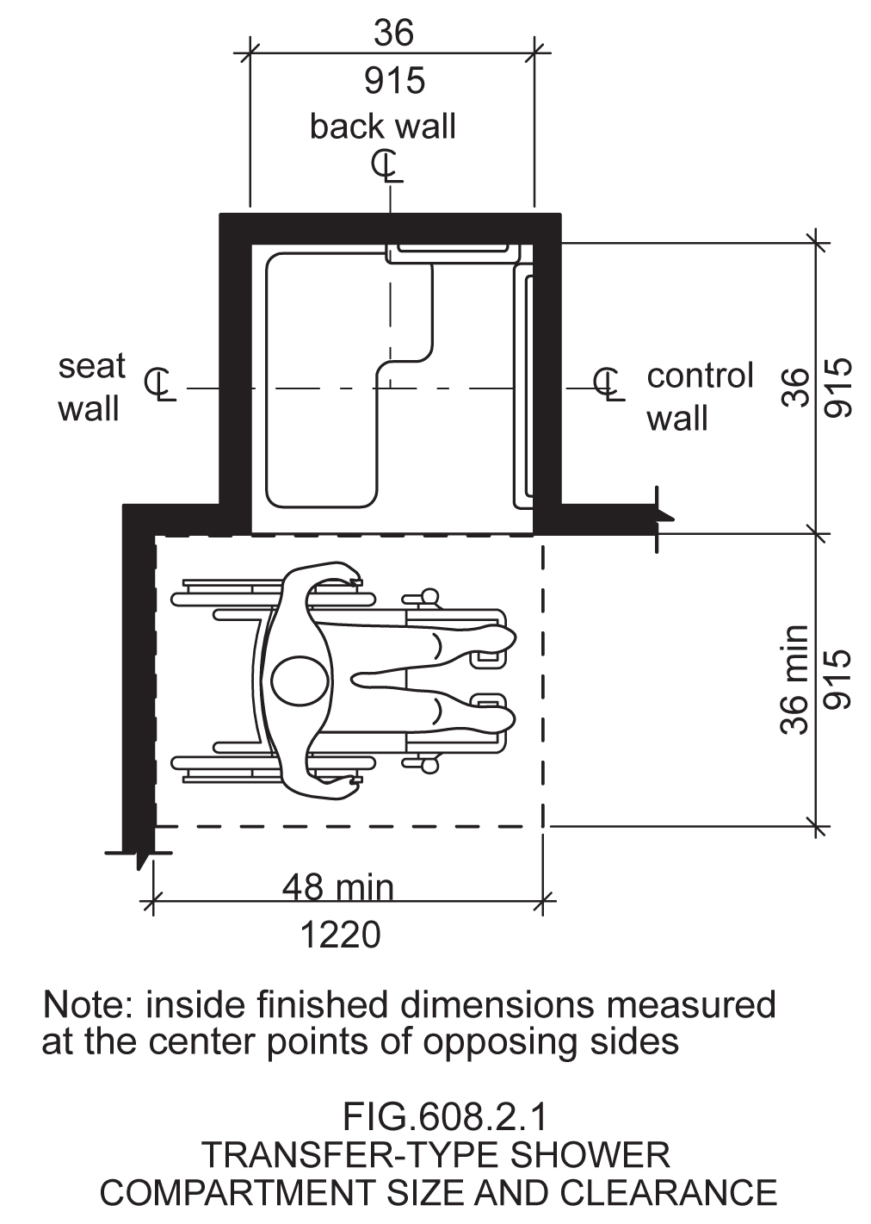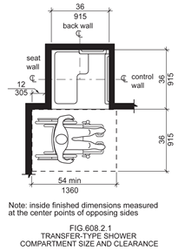

Reason: Many of the technical requirements of the ICC/ANSI A117.1 (2009) Accessible and Usable Buildings and Facilities (ICC/ANSI) designed to accommodate wheeled mobility users are based on research completed from 1974 to 1978 using a research sample that included about 60 individuals who used manual wheelchairs (Steinfeld et al., 1979).
The Center for Inclusive Design and Environmental Access (IDeA) at the University at Buffalo, SUNY recently completed an anthropometric study of 500 wheeled manual and powered mobility device users (Steinfeld, et al., 2010). Measurements of body and device size were captured in three dimensions. The functional anthropometric measurements required measuring reaching ability, grip strength and the minimum space needed for turning. It is the most extensive anthropometric study of wheeled mobility device users in the United States. Additional information about the study can be found at http://www.udeworld.com/ansi-standards-review. The proposed revisions are based on new anthropometric information that was generated from the database of anthropometric measurements developed as part of the study.

Analysis

Unlike turning spaces that are based on dynamic requirements, clear floor space represents the space required for a stationary wheeled mobility device. This area is typically depicted as a rectangular space the dimensions of which are based on measurements of occupied length and occupied breadth of wheeled mobility devices, which are defined as follows:
- Occupied length: measured as the horizontal distance between the forward-most point and the rear-most point on the wheelchair or occupant.
- Occupied width: measured as the horizontal distance between the side-most points of the wheelchair or participant on the right and left sides.
The results of our analysis suggest that the existing standard on clear floor space (48” length, 30” width) does not accommodate the occupied lengths and widths of the wheeled mobility user population and excludes powered wheeled mobility device users disproportionately as compared to manual device users. A length of 48” accommodates the occupied length of 75% of manual wheelchair users and only about 50% of powered chair and scooter users. A width of 30” accommodates the occupied width of 90% of manual wheeled mobility device users and only 75% of powered chair users.
We have taken the position that the clear floor space standards should accommodate the occupied lengths and widths of at least 90% of manual and powered wheeled mobility device users. A width of 32” accommodates the occupied widths of over 95% of manual wheeled mobility device users and 90% of the powered wheelchair users. Proposed changes to subsection 608.2.1.2 Clearance would accommodate an occupied length of 54” while not changing the overall dimensions of the shower facility. Instead, we propose allowing the front of the wheelchair and/or person to extend beyond the control wall by the additional 6” in order to accommodate those with large occupied wheelchair lengths.
The analysis was summarized in the Final Project Report to the U.S. Access Board and in a memorandum entitled “Evaluation of Clear Floor Space Requirements,” that was submitted to the ICC/ANSI A117 Task Force on Anthropometry of Wheeled Mobility Subcommittee on Clear Floor Space Clearances.

References (See http://www.udeworld.com/ansi-standards-review)

Paquet, V. (2012). Evaluation of Clear Floor Space Requirements. A memorandum submitted to the ICC/ANSI A117 Task Force on Anthropometry of Wheeled Mobility Subcommittee on Clear Floor Space Clearances.

Steinfeld, E., Paquet, V., D’Souza, C., Joseph, C, and Maisel, J. (2010). Final Report: Anthropometry of Wheeled Mobility Project. Washington, DC: U.S. Access Board.

Steinfeld, E. Schroeder, S. and Bishop, M. (1979). Accessible buildings for people with walking and reaching limitations. Washington, DC: U.S. Department of Housing and Urban Development.
input.doc

Committee Action

Approval as Modified

Modification

608.2.1.2 Clearance. A clearance of 54 52 inches (1360 mm) minimum in length measured perpendicular from 12 inches beyond the seat wall, and 36 inches (915 mm) minimum in depth shall be provided adjacent to the open face of the compartment.

Committee Reason: With the increase in the clear floor space approved in Proposal 3-13-12, the clearance needs to be revised to accommodate the larger space. The result of the modification is to change the current 48 inches to 52 inches. The added 4 inches will occur ‘at the toes’ of the user. There was considerable debate whether the added space should be at the toes or at the back of the wheelchair or balanced. Information provided by the proponent is the location of the shoulders adjacent to the seat is the most important for this transfer.

Note: The Editorial task group should make sure that the figure clearly shows the measurement of the 12 inches be from the inside of the wall of the shower.

BALLOT COMMENTS

6-46.1
Commenter: Gene Boecker, Representing NATO
Ballot: Negative with comment:

Comment: This should only be added to the next edition if the increase in wheelchair length is approved. Otherwise the standard will be disjointed and inconsistent.

6-46.2
Commenter: Ron Burton, Representing BOMA
Ballot: Negative with comment:

Comment: No technical substantiation was provided in the report to support this change, primarily because the report did not include any anthropometric study on transferring to and from a shower seat. The requirement has been in the standard for several cycles and should not be changed without adequate justification.

6-46.3
Commenter: David S. Collins, Representing AIA
Ballot: Negative with comment:

Comment: The work of the study group isn’t finalized and the research that formed the basis for this change has not been validated.

6-46.4
Commenter: M. Bradley Gaskins, Representing NACS
Ballot: Negative with comment:

Comment: There has been no evidence presented that this is a necessary change and will be a burden on the public due to an increase in the area required. The evidence presented only addresses the wide variety of mobility devices in service today. It does not address whether the problem is in the manufacture of these mobility devices that do not conform to the current requirement or whether the built-environment needs to change to accommodate mobility devices that need a larger space and cannot be designed and manufactured in such a way as to fit within the current space. We don’t continue to let automobile manufacturers build wider and wider autos to go on our roads… they must be built to standards that allow them to work with our current road system.

6-46.5
Commenter: Ronald G. Nickson, Representing NMHC
Ballot: Negative with comment:

Comment: The clearance of 48” should not be changes 54” to align with previous comments to not increase the clear floor space size.

6-46.6
Commenter: Steve Orlowski, Representing NAHB
Ballot: Negative with comment:

Comment: No technical substantiation was provided in the report to support the added requirement of 12 inches beyond the seat wall, since the report did not include any anthropometric study on transferring to and from a shower seat. The requirement has been in the standard for several cycles and should not be changed without adequate justification. Also see negative comment 3-13-12 regarding the CFS increase.

6-46.7
Commenter: Kim Paarlberg, Representing ICC
Ballot: Negative with comment:

Comment: See comment to 3-6-12.

Committee Review of Comments and Action – July 2013

Approved as Modified.

Committee Reason: The committee considered the information provided by the comments and decided to take no action to change its original action on this proposal to approve it as modified. Consistent with the decision to stay with the 30 by 52 clear floor space (Item 3-13-12), a 52 inch space is needed adjacent to these showers.

Ballot Comments on July 2013 Committee Action Report

ICC – Kim Paarlberg
Negative: Ballot:
Comment/reason: See Comment for 3-6-12.
The change in the clearance combined with the 12” offset from the seat wall will result with 4” past the control wall. The result is the transfer shower no longer permitted to be located in the corner, but must instead be at least 4 inches from the wall.

NACS – Bradley Gaskins
Negative: Ballot:
Comment/reason: This change is predicated on the assumption that a larger CFS is required. While it may be true that wheeled mobility devices are getting larger is there a basis or need for them to become larger? This is a bigger question that should be answered before increasing the CFS size. Size of the units should be dictated, where possible, to have a minimal impact on the size of buildings. I am not convinced that the units cannot be designed and manufactured within the current space limitations dictated and still serve those who need wheeled mobility devices. At best this change is premature based upon the evidence. Even the wheeled mobility task group states that their findings have not been validated. Further, the impact of the larger CFS has not been analyzed for any building types.

NAHB – Steven Orlowski
Negative: Ballot:
Comment/reason: NAHB continues to oppose this code change based on the fact that no technical substantiation was provided in the report or in the committee’s statement to support the added requirement of 12 inches of clearance beyond the seat wall..

NMHC – Ron Nickson
Negative: Ballot:
Comment/reason: The clearance of 48” should not be changed to 54” to align with previous comments to not increase the clear floor space size.

AIA – Dave Collins
Negative Ballot
Comment/reason: I agree with ICC-Kim Paarlberg’s comment. Also see additional comment added to 3-6-12.

6-55– 12
608.3.2
Proposed Change as Submitted

Proponent: Kim Paarlberg, International Code Council

Revise as follows:

608.3.2 Standard Roll-in-Type Showers. In standard roll-in type showers, a grab bar shall be provided on the back wall beginning at the edge of the seat. The grab bars shall not be provided above the seat. The back wall grab bar shall extend the length of the wall to within 6 inches (150 mm) of the side wall but shall not be required to exceed 48 inches (1220 mm) in length. Where a side wall is provided opposite the seat within 72 inches (1830 mm) of the seat wall, a grab bar shall be provided on the side wall opposite the seat. The side wall grab bar shall extend the length of the wall but shall not be required to exceed 30 inches (760 mm) in length. Grab bars on the side wall shall be 6 inches (150 mm) maximum from the adjacent back wall.

Reason: The quantity of change proposals submitted by International Code Council is reflective of three elements of our work: 1. ICC is the Secretariat for the Standard and some changes reflect inconsistencies or improvements suggested by staff; 2. ICC develops and publishes a Commentary on the standard and writing the commentary illuminates issues of the text and figures; and 3. ICC provides an interpretation service for the standard which results in the observation of provisions the users find most confusing.
The intent of this proposal is to address a problem within the standard which occurs in gang showers or in a standard roll-in shower which exceeds the minimum size requirements.
Look at the two highlighted sentences below. If the back wall grab bar is only 48” in length in a long (exceeding min. dimension) shower, how can it also be no more than 6” from the intersecting wall opposite the seat?

608.3.2 Standard Roll-in-Type Showers. In standard roll-in type showers, a grab bar shall be provided on the back wall beginning at the edge of the seat. The grab bars shall not be provided above the seat. The back wall grab bar shall extend the length of the wall but shall not be required to exceed 48 inches (1220 mm) in length. Where a side wall is provided opposite the seat within 72 inches (1830 mm) of the seat wall, a grab bar shall be provided on the side wall opposite the seat. The side wall grab bar shall extend the length of the wall but shall not be required to exceed 30 inches (760 mm) in length. Grab bars shall be 6 inches (150 mm) maximum from the adjacent wall.

The initial proposal above is intended to recognize that when the shower exceeds the minimum size that a 48 inch long grab bar may not extend within 6 inches of the side wall. In a minimum size shower the first part of the paragraph adequately addresses the location, position and length of the back wall grab bar. Therefore the last sentence can be modified so it only addresses the side wall grab bar location. Where the shower exceeds the minimum sizes, the first part again adequately locates the back wall grab bar so it is usable on the seat or in the seat location. On these larger showers it is important that the side wall grab bar (if provided) is located near the corner of the shower so it is in a usable position. That is why the 6 inch location from the adjacent wall intersection is important.
Another option (but a bit more complex revision) would be to divide the requirements into separate sections which deal with the back wall and side wall grab bars separately. The primary difference between the proposed Sections 608.3.2.1 and 608.3.2.2 below is seen in the exceptions. The back wall grab bar which is of the 48 inch maximum required length is not required to extend within 6 inches of the side wall. Whereas the side wall grab bar which is of the 30 inch maximum required length is required to extend with 6 inches of the adjacent back wall.
The committee can accept or modify the following alternate proposal if they prefer this format or concept.

608.3.2 Standard Roll-in-Type Showers. Grab bars in standard roll-in showers shall comply with Section 608.3.2.
608.3.2.1 Back wall grab bar. In standard roll-in type showers, a grab bar shall be provided on the back wall beginning at the edge of the seat. The grab bars shall not be provided above the seat. The back wall grab bar shall extend the length of the wall and extend within 6 inches (150 mm) maximum from the adjacent side wall opposite the seat.
Exceptions:
- The back wall grab bar but shall not be required to exceed 48 inches (1220 mm) in length.
- The back wall grab bar is not required to extend within 6 inches (150 mm) of the adjacent side wall opposite the seat if it would require the grab bar length to exceed 48 inches (1220 mm) in length.
608.3.2.2 Side wall grab bars. Where a side wall is provided opposite the seat within 72 inches (1830 mm) of the seat wall, a grab bar shall be provided on the side wall opposite the seat. The side wall grab bar shall extend the length of the wall and extend within 6 inches (150 mm) maximum from the adjacent back wall.
Exception: The side wall grab bar but shall not be required to exceed 30 inches (760 mm) in length. Grab bars shall be 6 inches (150 mm) maximum from the adjacent wall.
input.doc

Committee Action

Approval as Modified

Modification

Replace the original proposal with the following:

608.3.2 Standard Roll-in-Type Showers. Grab bars in standard roll-in showers shall comply with Section 608.3.2.

608.3.2.1 Back wall grab bar. In standard roll-in type showers, a grab bar shall be provided on the back wall beginning at the edge of the seat. The grab bars shall not be provided above the seat. The back wall grab bar shall extend the length of the wall and extend within 6 inches (150 mm) maximum from the adjacent side wall opposite the seat.

Exceptions:

1. The back wall grab bar but shall not be required to exceed 48 inches (1220 mm) in length.

2. The back wall grab bar is not required to extend within 6 inches (150 mm) of the adjacent side wall opposite the seat if it would require the grab bar length to exceed 48 inches (1220 mm) in length.

608.3.2.2 Side wall grab bars. Where a side wall is provided opposite the seat within 72 inches (1830 mm) of the seat wall, a grab bar shall be provided on the side wall opposite the seat. The side wall grab bar shall extend the length of the wall and extend within 6 inches (150 mm) maximum from the adjacent back wall.

Exception: The side wall grab bar but shall not be required to exceed 30 inches (760 mm) in length. Grab bars shall be 6 inches (150 mm) maximum from the adjacent wall.

Committee Reason: The revisions provide greater clarity and flexibility.

6-60– 12
608.4.1, 608.4.2, 608.4.3, 608.5

Proposed Change as Submitted

Proponent: Kim Paarlberg, International Code Council

Revise as follows:

608.4.1 Transfer-Type Showers. In transfer-type showers, the controls and hand shower shall be located:

- On the control wall opposite the seat,
- At a height above the grab bar and of 38 inches (965 mm) minimum and 48 inches (1220 mm) maximum above the shower floor, and
- 15 inches (380 mm) maximum, from the centerline of the control wall toward the shower opening.

608.4.2 Standard Roll-in Showers. In standard roll-in showers, the controls and hand shower shall be located:

- On the back wall,
- At a height above the grab bar and 48 inches (1220 mm) maximum above the shower floor, and
- 16 inches (405 mm) minimum and 27 inches (685 mm) maximum from the end wall behind the seat.

608.4.3 Alternate Roll-in Showers. In alternate roll-in showers, the controls and hand shower shall be located:

- 38 inches (965 mm) minimum and At a height above the grab bar and 48 inches (1220 mm) maximum above the shower floor., and
- In alternate roll-in showers with controls and hand shower Where located on the end wall adjacent to the seat, the controls and hand shower shall be 16 inches (405 mm) minimum and 27 inches (685 mm) maximum from the wall behind the seat wall., or
- In alternate roll-in showers with the controls and hand shower Where located on the back wall opposite the seat, the controls and hand shower shall be located within 15 inches (380 mm) maximum, left or right, of from the centerline of the seat toward the transfer space.

608.5 Hand Showers. A hand shower with a hose 59 inches (1500 mm) minimum in length, that can be used both as a fixed shower head and as a hand shower, shall be provided. The hand shower shall have a control with a nonpositive shut-off feature. Where provided, an adjustable-height hand shower mounted on a vertical bar shall be installed so as to not obstruct the use of grab bars.
EXCEPTIONS:

- Redundant shower head mounts shall be permitted to be installed above 48 inches above the shower floor.
- The vertical bar for adjustable-height shower head mounts shall be permitted to extend above 48 inches maximum above the shower floor.
- In other than Accessible units and Type A units, a fixed shower head located 48 inches (1220 mm) maximum above the shower floor shall be permitted in lieu of a hand shower.

Reason: The quantity of change proposals submitted by International Code Council is reflective of three elements of our work: 1. ICC is the Secretariat for the Standard and some changes reflect inconsistencies or improvements suggested by staff; 2. ICC develops and publishes a Commentary on the standard and writing the commentary illuminates issues of the text and figures; and 3. ICC provides an interpretation service for the standard which results in the observation of provisions the users find most confusing.

There are multiple reasons for this proposal.
1) To make the format of the controls for all three types of showers the same
2) Last cycle 608.4.2 has taken out the 38” minimum height as part of an ADA coordination item. The requirement to be 1-1/2 inches above the grab bar (Section 609.3 Exception 1) would set a lower height depending on what elevation the grab bar was located (33-36 height). 608.4.1 and 608.4.3 should be addressed the same.
3) Section 608.4.3 allows for alternate roll-in shower to
locate controls over the seat (which is in conflict with the roll-in shower) or away from the transfer location (which is in conflict with the transfer shower). This proposal would match the other showers for control locations.
4) Section 608.4 says the hand showers have to comply with 608.4 (location) and (608.5) which says the hand showers have to work as both a fixed head and hand shower. This really means either a mount post on the wall, or a vertical bar with an adjustable mount. Many standing persons cannot shower with a head at 48 inches. For family members or for persons with mobility impairments that are standing, the shower head should be able to work for everyone. The additional exceptions would allow for redundant heights.
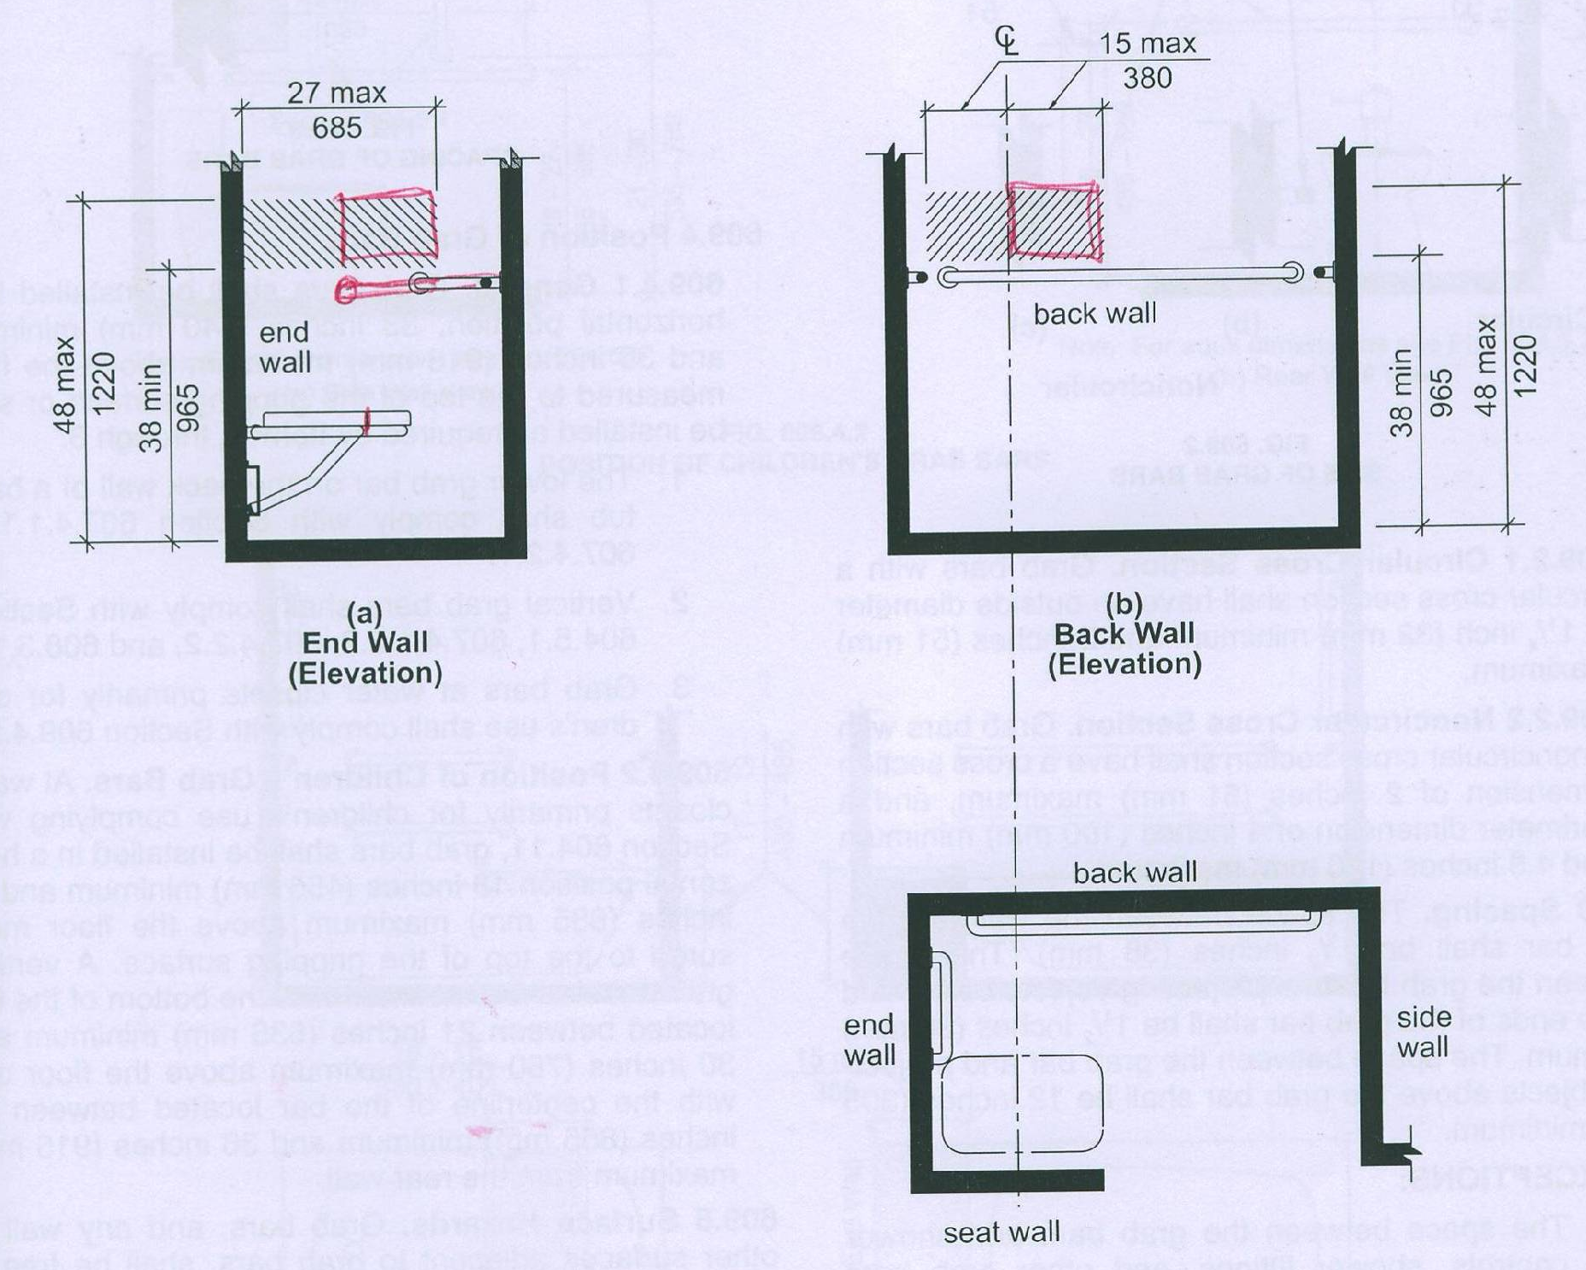

input.doc

Committee Action

Disapproved
Committee Reason: The Committee disapproved the proposal over concerns that the next text would allow a shower head placed over the seat and the attempt to regulate extra shower heads versus simply the regulation of the single head which need to be accessible.

BALLOT COMMENTS

6-60.1
Commenter: Gene Boecker, Representing NATO
Ballot: Negative with comment:

Comment: The proposal should be approved with amendment. The committee’s decision to vote for disapproval hinged on the added text in Exception #1 to Section 608.4.3 regarding “redundant shower head mounts.” There were no problems with the rest of this proposal. If that language is stricken, then the proposal should be approved.

6-60.2
Comment rescinded

6-60.3
Commenter: Kim Paarlberg, Representing ICC
Ballot: Negative with comment:

Comment: This proposal does not do what the committee was concerned about. I will prepare three separate modifications to break this into parts to make it easier to understand.

There will be modifications for this proposal.

6-60.4
Commenter: Hope Reed, representing NMGCD
Ballot: Negative with comment:

Comment: This provides clarification for shower controls in three types of showers.

Proponent Comment

6-60.5
Commenter: Kim Paarlberg, Representing ICC

Replace the proposal with the following 3 comments. This will split the discussion by topic.

608.4.1 Transfer-Type Showers. In transfer-type showers, the controls and hand shower shall be located:

1. On the control wall opposite the seat,
2. At a height above the grab bar and of 38 inches (965 mm) minimum and 48 inches (1220 mm) maximum above the shower floor, and
3. 15 inches (380 mm) maximum, from the centerline of the control wall toward the shower opening.

608.4.2 Standard Roll-in Showers. In standard roll-in showers, the controls and hand shower shall be located:

1. On the back wall,
2. At a height above the grab bar and 48 inches (1220 mm) maximum above the shower floor, and
3. 16 inches (405 mm) minimum and 27 inches (685 mm) maximum from the end wall behind the seat.

608.4.3 Alternate Roll-in Showers. In alternate roll-in showers, the controls and hand shower shall be located:

1. 38 inches (965 mm) minimum and At a height above the grab bar and 48 inches (1220 mm) maximum above the shower floor., and
2. In alternate roll-in showers with controls and hand shower located On the end wall adjacent to the seat, the controls and hand shower shall be 27 inches (685 mm) maximum from the seat wall., or
3, In alternate roll-in showers with the controls and hand shower located On the back wall opposite the seat, the controls and hand shower shall be located within 15 inches (380 mm), left or right, of the centerline of the seat.

Reason: The committee felt the proposed language would either place a shower head over the seat, or require extra shower heads. That is not the case. The proposal has been split and revised so that each point can be reviewed separately.
This makes the controls addressed the same in all three types of showers. The format and control height requirements for all three shower types should be the same. Currently only the transfer shower is numbered. Last cycle the 38 inches was removed from standard roll-in shower (as ADA coordination), but not transfer and alternate roll-in. The grab bar clearance requirements will require 1-1/2” clearance above the grab bar.

6-60.6
Commenter: Kim Paarlberg, Representing ICC

608.4.3 Alternate Roll-in Showers. In alternate roll-in showers, the controls and hand shower shall be located 38 inches (965 mm) minimum and 48 inches (1220 mm) maximum above the shower floor. In alternate roll-in showers with where the controls and hand shower are located on the end wall adjacent to the seat, the controls and hand shower shall be 16 inches (405 mm) minimum and 27 inches (685 mm) maximum from the wall behind the seat wall. In alternate roll-in showers with where the controls and hand shower are located on the back wall opposite the seat, the controls and hand shower shall be located within 15 inches (380 mm) maximum, left or right, of from the centerline of the seat toward the transfer space.

Reason: The committee felt the proposed language would either place a shower head over the seat, or require extra shower heads. That is not the case. The proposal has been split and revised so that each point can be reviewed separately.
6-62-12 AS addressed the issue of over the seat, but not to the right of the center line. Section 608.4.3 allows for alternate roll-in shower to locate controls over the seat (which is in conflict with the roll-in shower) or away from the transfer location (which is in conflict with the transfer shower). This proposal would match the other showers for control locations.

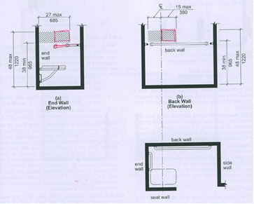

6-60.7
Commenter: Kim Paarlberg, Representing ICC

608.5 Hand Showers. A hand shower with a hose 59 inches (1500 mm) minimum in length, that can be used both as a fixed shower head and as a hand shower, shall be provided. The hand shower shall have a control with a nonpositive shut-off feature. Where provided, an adjustable-height hand shower mounted on a vertical bar shall be installed so as to not obstruct the use of grab bars.

EXCEPTIONS:

- The vertical bar for adjustable-height shower head mounts shall be permitted to extend above 48 inches maximum above the shower floor.
- In other than Accessible units and Type A units, a fixed shower head located 48 inches (1220 mm) maximum above the shower floor shall be permitted in lieu of a hand shower.

Reason: The committee felt the proposed language would either place a shower head over the seat, or require extra shower heads. That is not the case. The proposal has been split and revised so that each point can be reviewed separately.
Section 608.4 says the hand showers have to comply with 608.4 (location) and (608.5) which says the hand showers have to work as both a fixed head and hand shower. This really means either a mount post on the wall, or a vertical bar with an adjustable mount. Many standing persons cannot shower with a head at 48 inches. For family members or for persons with mobility impairments that are standing, the shower head should be able to work for everyone. The additional exceptions would allow for redundant heights.

Committee Review of Comments and Action – July 2013

Approval with Modifications based on Comments.

Committee Reason: The committee considered the revisions based on comments 6-60.5 and 6-60.6, provided the clearest statement of the 3 requirements. The text was revised to make sure the requirements follow the same pattern for each shower type.

Modification.

Replace the proposal as follows:

608.4.1 Transfer-Type Showers. In transfer-type showers, the controls and hand shower shall be located:

1. On the control wall opposite the seat,
2. At a height of 38 inches (965 mm) minimum and 48 inches (1220 mm) maximum above the shower floor, and
3. 15 inches (380 mm) maximum, from the centerline of the control wall toward the shower opening.

608.4.2 Standard Roll-in Showers. In standard roll-in showers, the controls and hand shower shall be located:

1. On the back wall,
2. At a height above the grab bar of 38 inches minimum and 48 inches (1220 mm) maximum above the shower floor, and
3. 16 inches (405 mm) minimum and 27 inches (685 mm) maximum from the end wall behind the seat.

608.4.3 Alternate Roll-in Showers. In alternate roll-in showers, the controls and hand shower shall be located:

- At a height of 38 inches (965 mm) minimum and 48 inches (1220 mm) maximum above the shower floor., and
- In alternate roll-in showers with Where the controls and hand shower are located on the end wall adjacent to the seat, the controls and hand shower shall be 16 inches (405 mm) minimum and 27 inches (685 mm) maximum from the wall behind the seat wall., or
- In alternate roll-in showers with where the controls and hand shower are located on the back wall opposite the seat, the controls and hand shower shall be located within 15 inches (380 mm) maximum from, left or right, of the centerline of the seat toward the transfer space.

6-62– 12
608.4.3, Figure 608.4.3

Proposed Change as Submitted

Proponent: Kim Paarlberg, International Code Council

Revise as follows:

608.4.3 Alternate Roll-in Showers. In alternate roll-in showers, the controls and hand shower shall be located 38 inches (965 mm) minimum and 48 inches (1220 mm) maximum above the shower floor. In alternate roll-in showers with controls and hand shower located on the end wall adjacent to the seat, the controls and hand shower shall be 16 inches (405 mm) minimum and 27 inches (685 mm) maximum from the seat wall. In alternate roll-in showers with the controls and hand shower located on the back wall opposite the seat, the controls and hand shower shall be located within 15 inches (380 mm), left or right, of the centerline of the seat.

Revise Figure 608.4.3 as follows:

Modify figure to show a 16 inch minimum requirement to go along with the existing 27 inch maximum dimension to create a range for controls to be located and measured from seat wall.

Reason: The quantity of change proposals submitted by International Code Council is reflective of three elements of our work: 1. ICC is the Secretariat for the Standard and some changes reflect inconsistencies or improvements suggested by staff; 2. ICC develops and publishes a Commentary on the standard and writing the commentary illuminates issues of the text and figures; and 3. ICC provides an interpretation service for the standard which results in the observation of provisions the users find most confusing.
In the 2009 edition of the standard, Section 608.4.2 dealing with a standard roll-in shower was modified to create this 16 to 27 inch range for the controls. The purpose behind that change was to ensure the controls were not located over the seat and did not require a person using the seat to reach beside or behind them to operate the controls. It seems appropriate to make the alternate roll-in shower requirement consistent and also keep the controls forward where they will be more usable.
Although this will reduce the possible location for the controls on this end wall by creating a more limited range, the alternate roll-in shower has the option to place the controls on the back wall opposite the seat. It seems that additional alternative of being able to use the back wall should make up for the reduced size range on the end wall.
input.doc

Committee Action

Approved
Committee Reason: The proposal provides consistency with the requirement in the roll-in shower.

6-65– 12
608.5

Proposed Change as Submitted

Proponent: Hope Reed, New Mexico Governor’s Commission on Disability (NMGCD)

Revise as follows:

608.5 Hand Showers. A hand shower with a hose 59 inches long (1500 mm) minimum in length, that can be used both as a fixed shower head and as a hand shower, shall be provided. The hand shower shall have a control with a nonpositive shut-off feature. Where provided, an adjustable-height hand shower mounted on a vertical bar shall be installed so as to not obstruct the use of grab bars. A hook,to hold the hand shower wand, while water is running, shall be provided above the grab bar.

EXCEPTIONS: In other than Accessible units and Type A units, a fixed shower head located 48 inches (1220 mm) maximum above the shower floor shall be permitted in lieu of a hand shower.

Reason: Many people with disabilities have to get the hotel staff to come up and unhook the hand shower. Then the hand shower hangs down. Depending on water pressure, kinks in the hose, and similar the hand shower can be difficult to grab and keep from spraying outside the shower when adjusting temperatures.
Some hotels have several hooking places at the bottom of the vertical bar or a hook on the wall to hang the hand shower wand. This keeps the hand shower at a convenient location and allows the spray to be directed back into the shower while adjusting temperatures and soaping up.
input.doc

Committee Action

Disapproved

Committee Reason: There was support for the concept among the members of the Committee, but the wording of the proposal was found wanting. A 'hook' is too restrictive, perhaps a 'means'. The location needs more clarity. Some wondered if this was a minimum requirement of accessibility or simply a nice convenience. The proper term may be hand shower wand.

BALLOT COMMENTS

6-65.1
Commenter: Gina Hilberry, Representing UCP
Ballot: Affirmative with comment:

Comment: Providing a means of hanging the hand shower wand within reach range during a shower is important. This proposed change appears to address this need but needs revision.

6-65.2
Commenter: Rick Lupton, Representing WABO
Ballot: Affirmative with comment:

Comment: Perhaps the term “hook” could be replaced by “device”.

6-65.3
Commenter: Hope Reed, Representing NMGCD
Ballot: Negative with comment:

Comment: A “means” to hold the hand shower wand is needed while people soap up or adjust their wheelchair. People with disabilities who lose their grasp of the hand shower wand have great difficulty grabbing it again, especially with high water pressure pushing the free hanging wand around the compartment.

Proponent Comment

6-65.4
Commenter: Hope Reed, Representing NMGCD

Revise the proposal as follows:

608.5 Hand Showers. A hand shower with a hose 59 inches long (1500 mm) minimum in length, that can be used both as a fixed shower head and as a hand shower, shall be provided. The hand shower shall have a control with a nonpositive shut-off feature. Where provided, an adjustable-height hand shower mounted on a vertical bar shall be installed so as to not obstruct the use of grab bars. A means to hold the hand shower wand while in the on or off position shall be located above the grab bar 38 inches minimum and 48 inches maximum above the shower finish floor.

EXCEPTIONS:

- In other than Accessible units and Type A units, a fixed shower head located 48 inches (1220 mm) maximum above the shower floor shall be permitted in lieu of a hand shower.

Reason: Water pressure pushes the hand shower wand around and often sprays out onto the bathroom floor. Provide a means to secure the shower hand wand while a person is using both hands to soap up, shampoo their hair, grab a wash cloth, etc.. See companion revision to 608.4.2 for Roll-in Showers.

Committee Review of Comments and Action – July 2013

Approval with Modifications based on Comment.

Committee Reason: The proposal was approved based on comment 6-65.4 and wording approved in proposal 6-60. The committee feels it is a good requirement to add to the standard.

Modification.

608.5 Hand Showers. A hand shower with a hose 59 inches long (1500 mm) minimum in length, that can be used both as a fixed shower head and as a hand shower, shall be provided. The hand shower shall have a control with a nonpositive shut-off feature. Where provided, an adjustable-height hand shower mounted on a vertical bar shall be installed so as to not obstruct the use of grab bars. A means to hold the hand shower wand while in the on or off position shall be located at a height of 38 inches minimum and 48 inches maximum above the shower finish floor.

EXCEPTIONS:

1. In other than Accessible units and Type A units, a fixed shower head located 48 inches (1220 mm) maximum above the shower floor shall be permitted in lieu of a hand shower.

6-69– 12
611.3
Proposed Change as Submitted

Proponent: Kim Paarlberg, International Code Council

Revise as follows:

611.3 Operable Parts. Operable parts, including doors, lint screens, detergent and bleach compartments, shall comply with Section 309.

EXCEPTION: The height of the obstruction can be 36 inches (915 mm).

Reason: The quantity of change proposals submitted by International Code Council is reflective of three elements of our work: 1. ICC is the Secretariat for the Standard and some changes reflect inconsistencies or improvements suggested by staff; 2. ICC develops and publishes a Commentary on the standard and writing the commentary illuminates issues of the text and figures; and 3. ICC provides an interpretation service for the standard which results in the observation of provisions the users find most confusing.
You let the door for the top loader be at 36” high, but you literally do not allow for the operable parts to be located over the unit.
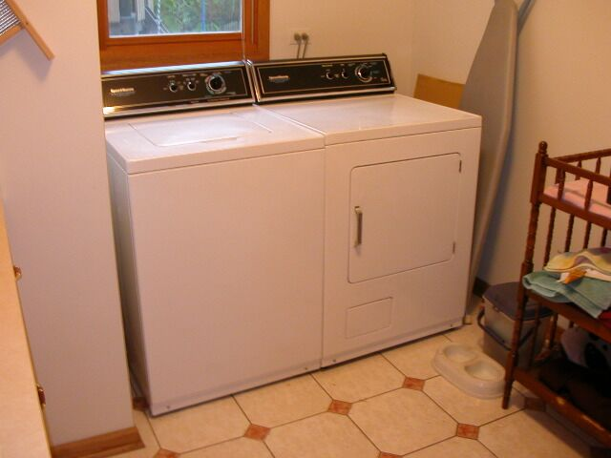

input.doc

Committee Action

Disapproved
Committee Reason: The Committee wanted more study information on reach ranges in order to approve this proposal. The information was not available for the Committee.

BALLOT COMMENTS

6-69.1
Commenter: Kim Paarlberg, Representing ICC
Ballot: Negative with comment:

Comment: The requirements for the washing machines and dryers should be together, not two section references away. See also 3-26.

A modification will be developed for this 3-26 and 6-69.

6-69.2
Commenter: Hope Reed, Representing NMGCD
Ballot: Negative with comment:

Comment: The height of controls for top loading washer/dryers is allowed to be 36 in. high. This exception is needed within 611.

Proponent Comment

6-69.3
Commenter: Kim Paarlberg, Representing ICC

Replace the proposal with the following:

308.3.2 Obstructed High Reach. Where a clear floor space complying with Section 305 allows a parallel approach to an element and the high side reach is over an obstruction, the height of the obstruction shall be 34 inches (865 mm) maximum above the floor and the depth of the obstruction shall be 24 inches (610 mm) maximum. The high side reach shall be 48 inches (1220 mm) maximum above the floor for a reach depth of 10 inches (255 mm) maximum. Where the reach depth exceeds 10 inches (255 mm), the high side reach shall be 46 inches (1170 mm) maximum above the floor for a reach depth of 24 inches (610 mm) maximum.

EXCEPTION: At washing machines and clothes dryers, the height of the obstruction shall be permitted to be 36 inches (915 mm) maximum above the floor.

611.3 Operable Parts. Operable parts, including doors, lint screens, detergent and bleach compartments, shall comply with Sections 308 and 309.

EXCEPTION: The height of the obstruction in Section 308.3.2 shall be permitted to be 36 inches (915 mm) maximum above the floor.

Reason: The allowance for washing machines and clothes dryers in Section 308.3.2 is too remote from the base requirements and the not directly associated with the Section 309 reference (which does reference Section 308). This would not be a technical change, but would be clearer.

Committee Review of Comments and Action – July 2013

Approval with Modifications based on Comments.

Committee Reason: The revision included in comment 6-69.3 provides a better organization of the standard, placing the exception with the requirements applying to washers and dryers versus as an exception to the building block requirement.

Modification.

Replace the proposal with the following:

308.3.2 Obstructed High Reach. Where a clear floor space complying with Section 305 allows a parallel approach to an element and the high side reach is over an obstruction, the height of the obstruction shall be 34 inches (865 mm) maximum above the floor and the depth of the obstruction shall be 24 inches (610 mm) maximum. The high side reach shall be 48 inches (1220 mm) maximum above the floor for a reach depth of 10 inches (255 mm) maximum. Where the reach depth exceeds 10 inches (255 mm), the high side reach shall be 46 inches (1170 mm) maximum above the floor for a reach depth of 24 inches (610 mm) maximum.

EXCEPTION: At washing machines and clothes dryers, the height of the obstruction shall be permitted to be 36 inches (915 mm) maximum above the floor.

611.3 Operable Parts. Operable parts, including doors, lint screens, detergent and bleach compartments, shall comply with Sections 308 and 309.

EXCEPTION: The height of the obstruction in Section 308.3.2 shall be permitted to be 36 inches (915 mm) maximum above the floor.

Ballot Comments on July 2013 Committee Action Report

RESNA – Edward Steinfeld
Negative: Ballot:
Comment/reason: Allowing top loading washers as accessible equipment should be reconsidered. The IDeA Center conducted a study at the Board’s request on this topic and found that top loading equipment is not accessible from the perspective of loading and unloading a machine. So, if top loading equipment is allowed, why worry about the control location at all?

6-70– 12
612.2
Proposed Change as Submitted

Proponent: Kim Paarlberg, International Code Council

Revise as follows:

612.2 Bench. Where seating is provided in saunas and steam rooms, at least one bench shall comply with Section 903. Doors shall not swing into the clear floor space required by Section 903.2.

EXCEPTION: Where the room is for individual use and a clear floor space complying with Section 305.3 is provided within the room beyond the arc of the door swing, the door shall not be required to comply with Section 612.2.

Reason: The quantity of change proposals submitted by International Code Council is reflective of three elements of our work: 1. ICC is the Secretariat for the Standard and some changes reflect inconsistencies or improvements suggested by staff; 2. ICC develops and publishes a Commentary on the standard and writing the commentary illuminates issues of the text and figures; and 3. ICC provides an interpretation service for the standard which results in the observation of provisions the users find most confusing.
This proposal is intended to coordinate with other sections of the standard which do allow a door to swing into a room or floor space if there is adequate space to maneuver away from the swing of the door. This proposed exception was copied from the toilet and bathing room requirements of Section 603.2.2 (with the section reference being revised to be Section 612.2).
If the user can maneuver away from the door, it should not be a problem for the door to swing into the space.
If the committee was feeling more generous, the proposal could be modified to coordinate with the door swing requirements for dressing, fitting and locker rooms in Section 803.3. That section also allows for a door to swing into the room but it does not contain the limitation of the space being “for an individual user.”
input.doc

Committee Action

Approved
Committee Reason: The Committee accepted the proposal as a good solution to address individual use sauna's.

BALLOT COMMENTS

6-70.1
Commenter: Edward Steinfeld, Representing RESNA
Ballot: Negative with comment:

Comment: Somebody tell me what this actually requires. Although the intent is good, as written it is incomprehensible and needs a rewrite.

Committee Review of Comments and Action – July 2013

Approved.

Committee Reason: The committee considered the information provided by the comments and decided to take no action to change its original approval of this proposal.

