9-1– 12
901.1, 905.1
Proposed Change as Submitted

Proponent: Kim Paarlberg, International Code Council

Revise as follows:

901.1 Scope. Built-in furnishings and equipment required to be accessible by the scoping provisions adopted by the administrative authority shall comply with the applicable provisions of Chapter 9.

905.1 General. Accessible built-in storage facilities shall comply with Section 905.

Reason: The quantity of change proposals submitted by International Code Council is reflective of three elements of our work: 1. ICC is the Secretariat for the Standard and some changes reflect inconsistencies or improvements suggested by staff; 2. ICC develops and publishes a Commentary on the standard and writing the commentary illuminates issues of the text and figures; and 3. ICC provides an interpretation service for the standard which results in the observation of provisions the users find most confusing.
The provisions for dining and work surfaces and benches (when required) are applicable to loose and ‘built-in’ elements. Sales and service counters are typically furnishings that are permanent during the life of the store; built-in is not the issue. There is an argument for storage facilities to be limited to built-in, just so you pick up cabinets and closets and not file cabinets and desks.
input.doc

Committee Action

Approved
Committee Reason: The Committee found this to be an improved organization of the requirements.

BALLOT COMMENTS

9-1.1
Commenter: M. Bradley Gaskins, Representing NACS
Ballot: Negative with comment:

Comment: This provision is inappropriate for a building code and will ultimately be unenforceable. Furnishings and equipment are generally not covered under a building code as they are not part of the building. Built-in furnishings are a part of the building and therefore covered. Will this require that a complete furnishing plan be produced at permitting for approval? Will all furnishings be required to be placed prior to a C of O? Will a permit be required to rearrange or replace furnishings? Is this change still only applicable to built-in furnishings and if so this change makes the section less clear as opposed to more clear.

Committee Review of Comments and Action – July 2013

Approved.

Committee Reason: The committee considered the information provided by the comments and decided to take no action to change its original approval of this proposal.

9-2– 12
902.2
Proposed Change as Submitted

Proponent: Kim Paarlberg, International Code Council

Revise as follows:

902.2 Clear Floor Space. A clear floor space complying with Section 305, positioned for a forward approach, shall be provided. Knee and toe clearance complying with Section 306 shall be provided. The clear floor space shall be centered on the work surface.

EXCEPTIONS:

1. At drink surfaces 12 inches (305 mm) or less in depth, knee and toe space shall not be required to extend beneath the surface beyond the depth of the drink surface provided.
2. Dining surfaces that are 15 inches (380 mm) minimum and 24 inches (610 mm) maximum in height are permitted to have a clear floor space complying with Section 305 positioned for a parallel approach.

Reason: The quantity of change proposals submitted by International Code Council is reflective of three elements of our work: 1. ICC is the Secretariat for the Standard and some changes reflect inconsistencies or improvements suggested by staff; 2. ICC develops and publishes a Commentary on the standard and writing the commentary illuminates issues of the text and figures; and 3. ICC provides an interpretation service for the standard which results in the observation of provisions the users find most confusing.
Section 1003.12.3.1 requires that the clear floor space at the kitchen work surface be centered. Section 1003.12.3. applies to Type A kitchens. For kitchens in Accessible units, the work surface is regulated by Section 902. 902 doesn’t require the centering. For consistency the centering should be added to the Accessible units or removed from the Type A requirements.

input.doc

Committee Action

Disapproved
Committee Reason: The Committee felt this change was proposed for the wrong part of the Standard. There are a variety of work surface requirements that should be individually addressed. This requirement would be difficult to apply if the work surface was considerable longer than the minimum length required.

BALLOT COMMENTS

9-2.1
Commenter: Kim Paarlberg, Representing ICC
Ballot: Negative with comment:

Comment: The committee said that instead of applying this to Accessible work surfaces that this should be removed from Type A units. This would allow work surfaces of longer lengths.

Replace proposal as follows:

1003.12.3 Work Surface. At least one section of counter shall provide a work surface 30 inches (760 mm) minimum in length complying with Section 1003.12.3.

1003.12.3.1 Clear Floor Space. A clear floor space, positioned for a forward approach to the work surface, shall be provided. Knee and toe clearance complying with Section 306 shall be provided. The clear floor space shall be centered on the work surface.

EXCEPTION: Cabinetry shall be permitted under the work surface, provided the following criteria are met:

- the cabinetry can be removed without removal or replacement of the work surface,
- the floor finish extends under such cabinetry, and
- the walls behind and surrounding cabinetry are finished.

Proponent Comment

9-2.2
Commenter: Kim Paarlberg, representing ICC

Replace the proposal with the following:

902.2 Clear Floor Space. A clear floor space complying with Section 305, positioned for a forward approach, shall be provided. Knee and toe clearance complying with Section 306 shall be provided.

EXCEPTIONS:

1. At drink surfaces 12 inches (305 mm) or less in depth, knee and toe space shall not be required to extend beneath the surface beyond the depth of the drink surface provided.
2. Dining surfaces that are 15 inches (380 mm) minimum and 24 inches (610 mm) maximum in height are permitted to have a clear floor space complying with Section 305 positioned for a parallel approach.

1003.12.3 Work Surface. At least one section of counter shall provide a work surface 30 inches (760 mm) minimum in length complying with Section 1003.12.3.

1003.12.3.1 Clear Floor Space. A clear floor space, positioned for a forward approach to the work surface, shall be provided. Knee and toe clearance complying with Section 306 shall be provided. The clear floor space shall be centered on the work surface.

EXCEPTION: Cabinetry shall be permitted under the work surface, provided the following criteria are met:
- the cabinetry can be removed without removal or replacement of the work surface,
- the floor finish extends under such cabinetry, and the walls behind and surrounding cabinetry are finished.

Reason: The committee said that instead of applying this to accessible work surfaces that this should be removed from Type A units. This would allow work surfaces of longer lengths.

Committee Review of Comments and Action – July 2013

Approval with Modifications based on Comment.

Committee Reason: The original intent of the proposal was to move a requirement of Type A units to apply to kitchens in the more accessible Accessible units. The committee felt that the reverse action should be done. Based on comment 9-2.2, the requirement to center the clear floor space at work surfaces is removed from the Type A unit requirements. It will provide greater flexibility of the use of the surfaces.

Modification:

Replace the proposal with the following:

1003.12.3 Work Surface. At least one section of counter shall provide a work surface 30 inches (760 mm) minimum in length complying with Section 1003.12.3.

1003.12.3.1 Clear Floor Space. A clear floor space, positioned for a forward approach to the work surface, shall be provided. Knee and toe clearance complying with Section 306 shall be provided. The clear floor space shall be centered on the work surface.

EXCEPTION: Cabinetry shall be permitted under the work surface, provided the following criteria are met:
- the cabinetry can be removed without removal or replacement of the work surface,
- the floor finish extends under such cabinetry, and the walls behind and surrounding cabinetry are finished.

9-4– 12
903.2
Proposed Change as Submitted

Proponent: Ed Roether, representing the ADA/A117 Harmonization Task Group

Revise as follows:

903.2 Clear Floor Space. A clear floor space complying with Section 305, positioned for a parallel approach to the bench seat, shall be provided. at the end of the bench seat and parallel to the short axis of the bench.

Exception. A clear floor space positioned for a parallel approach to the bench seat, shall be permitted where it provides equivalent or greater accessibility.

Reason: The ADA/A117 Harmonization Task Group (HTG) was created as a task group of the A117.1 Committee to compare the 2010 ADA with the 2009 A117.1 Standard. The HTG has recommended a series of changes through a set of change proposals. The HTG is recommending changes, for the most part, address where the ADA was viewed as more stringent than the A117. Where the A117 contained provisions not addressed in the ADA, these were not considered a conflict needing action to amend the A117. In addition there are a number of places where the ADA and A117.1 are different as a result of specific actions, by the A117.1 Committee during the development of the 2009 edition, to remain or create a difference where, in the judgment of the committee the ADA was deficient.

Reason for 903.2: A117.1 specifically states a parallel approach. ADA specifically states a location at the end of the bench. The HTG believes that the A117.1 provides better access, but recognizes that the ADA has a very specific requirement here. The amendment places the ADA language as the requirement and allows a parallel approach as an exception where equivalent or greater accessibility is provided. While the latter phrasing is redundant with Section 103, it is important to state it in this exception.
input.doc

Committee Action

Approved
Committee Reason: The proposal provides a solution for allowing an equivalency for this very specific ADA 2010 standard.

BALLOT COMMENTS

9-4.1
Commenter: Kim Paarlberg, Representing ICC
Ballot: Negative with comment:

Comment: Equivalent access alternatives is permitted in all situations under Section 103. It should not be restated in the text of the standard.

Modify proposal as follows:

903.2 Clear Floor Space. A clear floor space complying with Section 305, positioned at the end of the bench seat and parallel to the short axis of the bench.

Exception: A clear floor space positioned for a parallel approach to the bench seat, shall be permitted where it provides equivalent or greater accessibility.

Committee Review of Comments and Action – July 2013

Approval with Modifications based on Comment.

Committee Reason: The committee was torn between a solution that seemed practical and more usable than that required by the ADA. There other side of the concern was that the approved change would not be consistent with the ADA. After considerable discussion, the committee agreed to a revised exception that allowed a parallel approach without conflicting with the ADA requirement.

Modification.

Replace the proposal as follows:

903.2 Clear Floor Space. A clear floor space complying with Section 305, positioned for a parallel approach to the bench seat, shall be provided. at the end of the bench seat and parallel to the short axis of the bench.

Exception. A clear floor space positioned for a parallel approach to the front of the bench seat, shall be permitted where a clear floor space is also positioned at the end the bench seat.

9-6– 12
904.3
Proposed Change as Submitted

Proponent: Ed Roether, representing the ADA/A117 Harmonization Task Group

Revise as follows:

904.3 Sales and Service Counters. Sales and service counters shall comply with Section 904.3.1 or 904.3.2. The accessible portion of the countertop shall extend the same depth as the sales and service countertop.

EXCEPTION: In alterations, when the provision of a counter complying with Section 904.4 would result in a reduction of the number of existing counters at work stations or a reduction of the number of existing mail boxes, the counter shall be permitted to have a portion which is 24 inches (610 mm) long minimum complying with Section 904.4.1 provided that the required clear floor space is centered on the accessible length of the counter.

Add new Figure from ADA

Figure 904.3 (Exception) Alteration of Sales and Service Counters

Reason: The ADA/A117 Harmonization Task Group (HTG) was created as a task group of the A117.1 Committee to compare the 2010 ADA with the 2009 A117.1 Standard. The HTG has recommend a series of changes through a set of change proposals. The HTG is recommending changes, for the most part, address where the ADA was viewed as more stringent than the A117. Where the A117 contained provisions not addressed in the ADA, these were not considered a conflict needing action to amend the A117. In addition there are a number of places where the ADA and A117.1 are different as a result of specific actions, by the A117.1 Committee during the development of the 2009 edition, to remain or create a difference where, in the judgment of the committee the ADA was deficient.

Reason for 904.3 ADA has added the exception. A117.1 does not have anything equivalent in this portion of the code.
input.doc

Committee Action

Approved
Committee Reason: The change provides an exception in the Standard equivalent to that allowed by the 2010 ADA.

BALLOT COMMENTS

9-6.1
Commenter: Christopher Bell, Representing ACB
Ballot: Negative with comment:

Comment: This proposal compromises accessibility for the sake of harmonization in every detail. Harmonization is positive, but inappropriate when it degrades the accessible environment that is the standard's purpose to provide. That is the principle we have tended to follow. In this case, accessibility could be compromised when providing it would reduce a total count of certain existing, inaccessible features (counters at workstations or mailboxes). Our concern is that we haven't actually heard of problems caused by this part of the standard. It seems like an insufficient reason to compromise accessibility.

9-6.2
Commenter: Marilyn Golden, Representing DREDF
Ballot: Negative with comment:

Comment: This proposal compromises accessibility for the sake of harmonization in every detail. Harmonization is positive, but inappropriate when it degrades the accessible environment that is the standard's purpose to provide. That is the principle we have tended to follow. In this case, accessibility would be compromised when providing it would reduce a total count of certain existing, inaccessible features (counters at workstations or mailboxes). We haven't actually heard of problems caused by this part of the standard. It seems an insufficient reason to compromise accessibility.

Committee Review of Comments and Action – July 2013

Approved.

Committee Reason: The committee considered the information provided by the comments and decided to take no action to change its original approval of this proposal. The alternative provides a reasonable solution for existing facilities.

9-7– 12
904.3
Proposed Change as Submitted

Proponent: M. Bradley Gaskins, AIA, CASp, The McIntosh Group, LLC, representing National Association of Convenience Stores

Revise as follows:

904.3 Sales and Service Counters. Sales and service counters shall comply with Section 904.3.1 or 904.3.2. The accessible portion of the countertop shall extend the same depth as the public side of the sales and service countertop or where a split-height public-side countertop is provided, the depth of the accessible portion shall be equivalent to the upper portion depth.

Reason: This section is constantly being misapplied such that the sales and service countertop is being required to extend from the front to the back edge at the same level. There are no height requirements for the non-public or employee side of the countertop and the language should be clarified. Reading from the DOJ 2010 ADA Standards Guidance we see “Where the counter is a split-height counter, this requirement applies only to the customer side of the counter top.” Further discussion with the DOJ about the intent of a split height-counter is that the desire is not for the counter to extend the full depth of the public side either, but that the lower portion of the public side be equivalent to the upper portion of the public side.
input.doc

Committee Action

Approval as Modified

Modification

904.3 Sales and Service Counters. Sales and service counters shall comply with Section 904.3.1 or 904.3.2. The accessible portion of the countertop shall extend the same depth as the public side portion of the sales and service countertop or where a split-height public-side countertop is provided, the depth of the accessible portion shall be equivalent to the upper portion depth.

Committee Reason: The proposal addresses a common design issue with service counters. The text was amended to consistently use the word ‘portion’.

BALLOT COMMENTS

9-7.1
Commenter: Kim Paarlberg, Representing ICC
Ballot: Negative with comment:

Comment: My notes indicate the modification included the strike out as follows. I think it should be struck because I do not understand what is meant by a split-height public side countertop.

904.3 Sales and Service Counters. Sales and service counters shall comply with Section 904.3.1 or 904.3.2. The accessible portion of the countertop shall extend the same depth as the public side portion of the sales and service countertop or where a split-height public-side countertop is provided, the depth of the accessible portion shall be equivalent to the upper portion depth.

Proponent Comment

9-7.2
Commenter: Bradley Gaskins, AIA, CASp, The McIntosh Group, LLC, representing National Association of Convenience Stores

Further revise the proposal as follows:

904.3 Sales and Service Counters. Sales and service counters shall comply with Section 904.3.1 or 904.3.2. The accessible portion of the countertop shall extend the same depth as the sales and service countertop.

904.3 Sales and Service Counters. Sales and service counters shall comply with Section 904.3.1 or 904.3.2 and 904.3.3. The accessible portion of the countertop shall extend, at a minimum, the same depth as the non-accessible public portion of the sales and service countertop.

904.3.1 Parallel Approach. A portion of the counter surface 36 inches (915 mm) minimum in length and 36 inches (915 mm) maximum in height above the floor shall be provided. Where the counter surface is less than 36 inches (915 mm) in length, the entire counter surface shall be 36 inches (915 mm) maximum in height above the floor. A clear floor space complying with Section 305, positioned for a parallel approach adjacent to the accessible counter, shall be provided.

904.3.2 Forward Approach. A portion of the counter surface 30 inches (760 mm) minimum in length and 36 inches (915 mm) maximum in height above the floor shall be provided. A clear floor space complying with Section 305, positioned for a forward approach to the accessible counter, shall be provided. Knee and toe clearance complying with Section 306 shall be provided under the accessible counter.

904.3.3 Visibility. Where counters are required to be utilized by the public in interacting with personnel on the opposite side of the counter, the accessible portion of the countertop shall be located so that the public is visible at a point located 43 inches (1100 mm) above the center of the clear floor space to a point located 56 inches (1450 mm) above the personnel floor space and 3” (80 mm) behind the countertop.

Reason: Comment in support of 9-7.
Based upon many discussion points the concerns about sales/service counter heights do not appear to be related to the accessible counter height vs. the employee counter height but rather the visibility/eye site line of an individual using a chair by an employee behind the counter.
Attached are sketches that show the eyelevel of a below average 5’-0” high employee with an eyelevel of 4’-9” working with an individual in a chair with an eyelevel of 3’-7” or what would equate to an individual 3’-11” in height. As this demonstrates an individual using a chair or a standing person of short stature is easily visible and able to work with the employee.
To further this concept I would propose the following amendment to proposal 9-7 and Section 904 that the committee took action on to codify the eyelevel/visibility locations.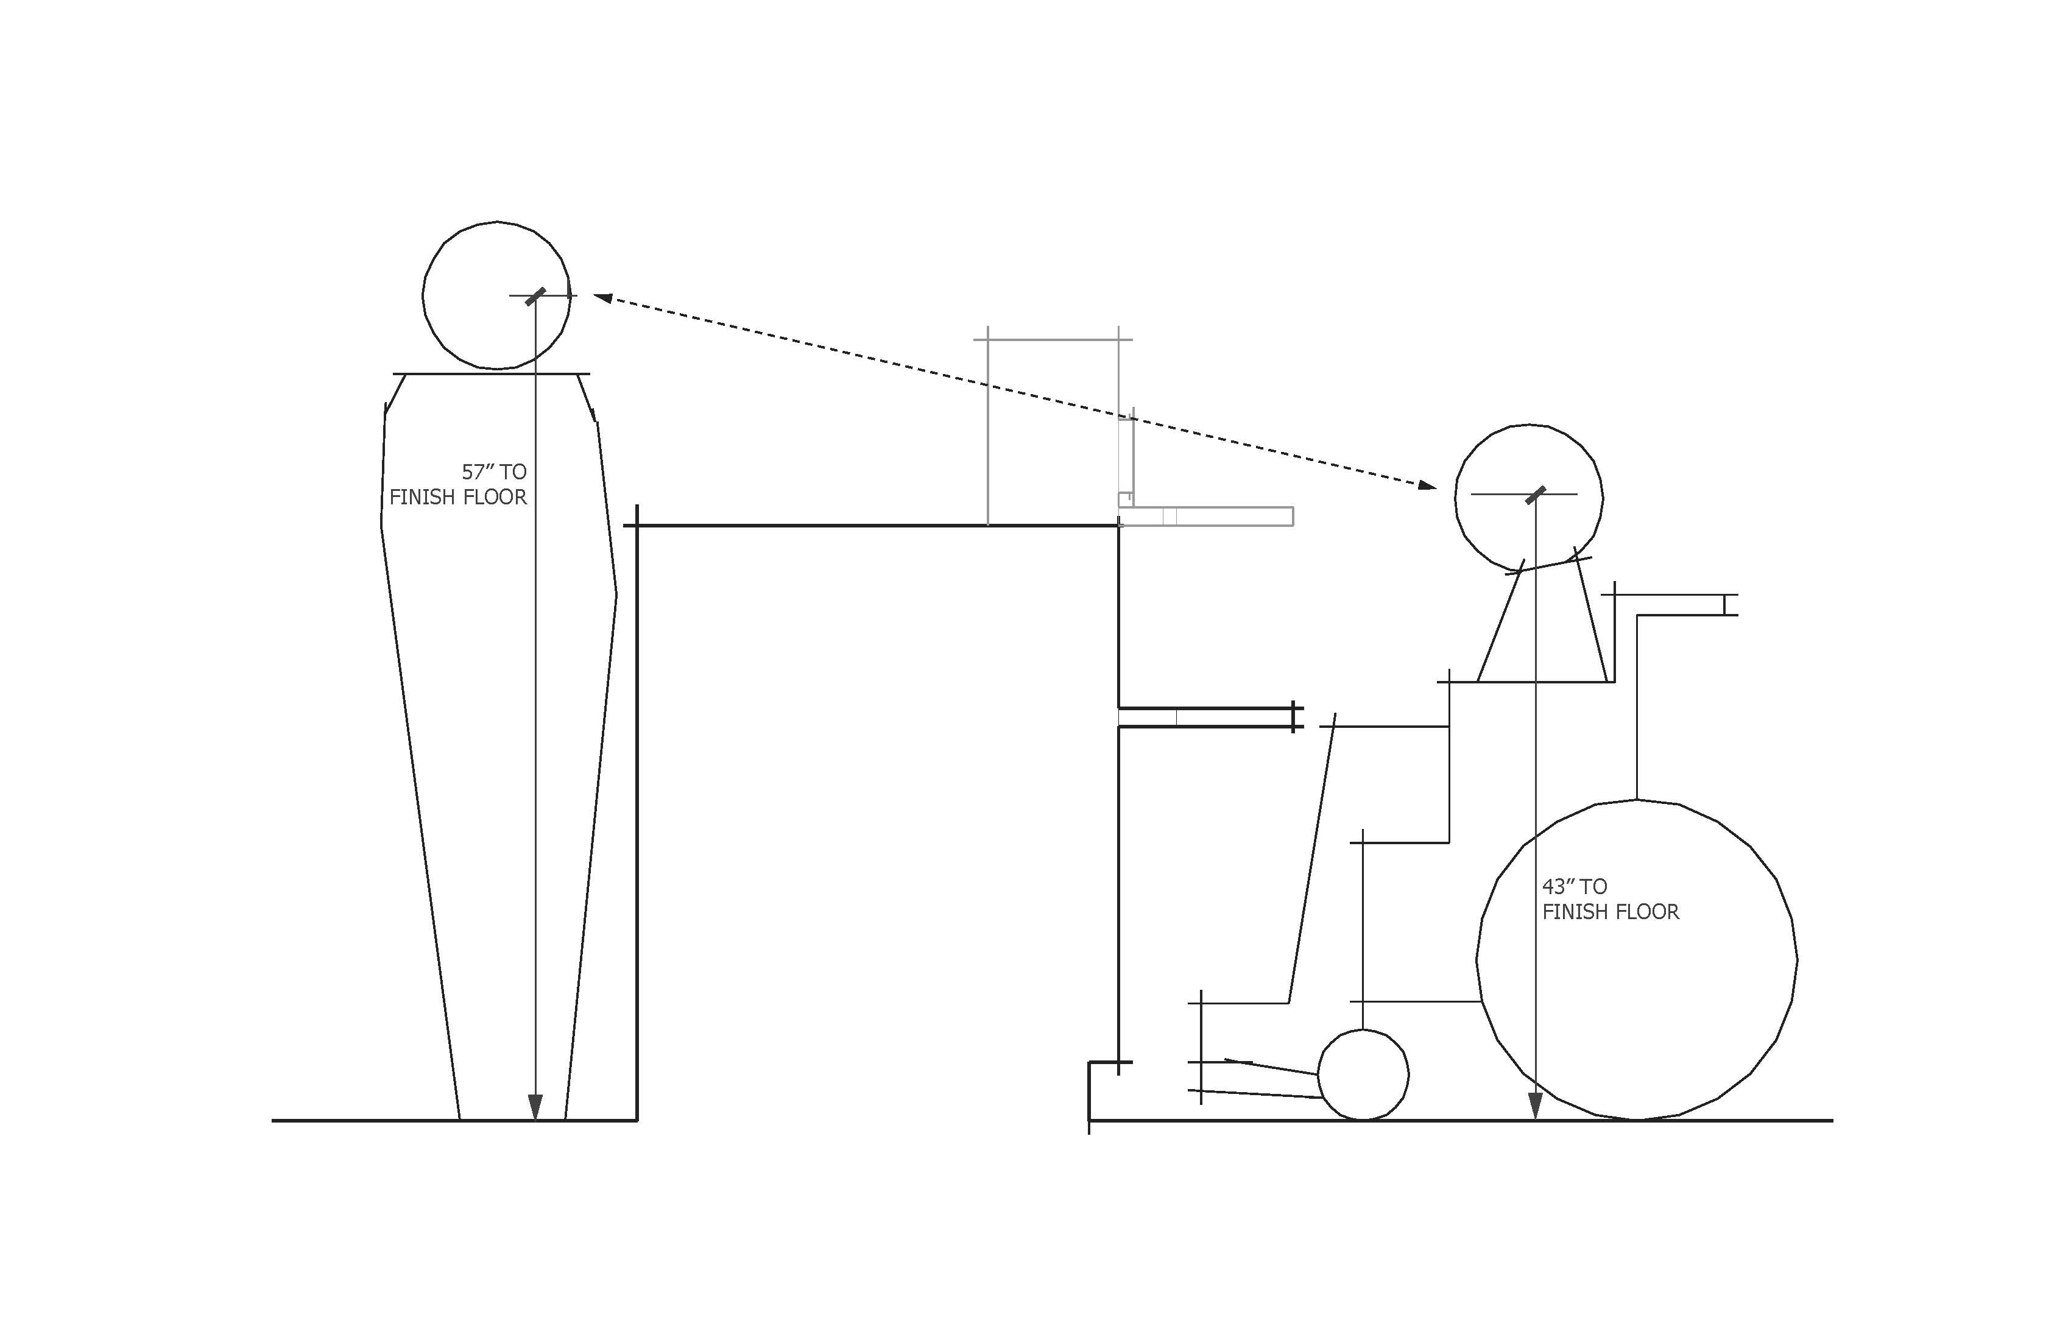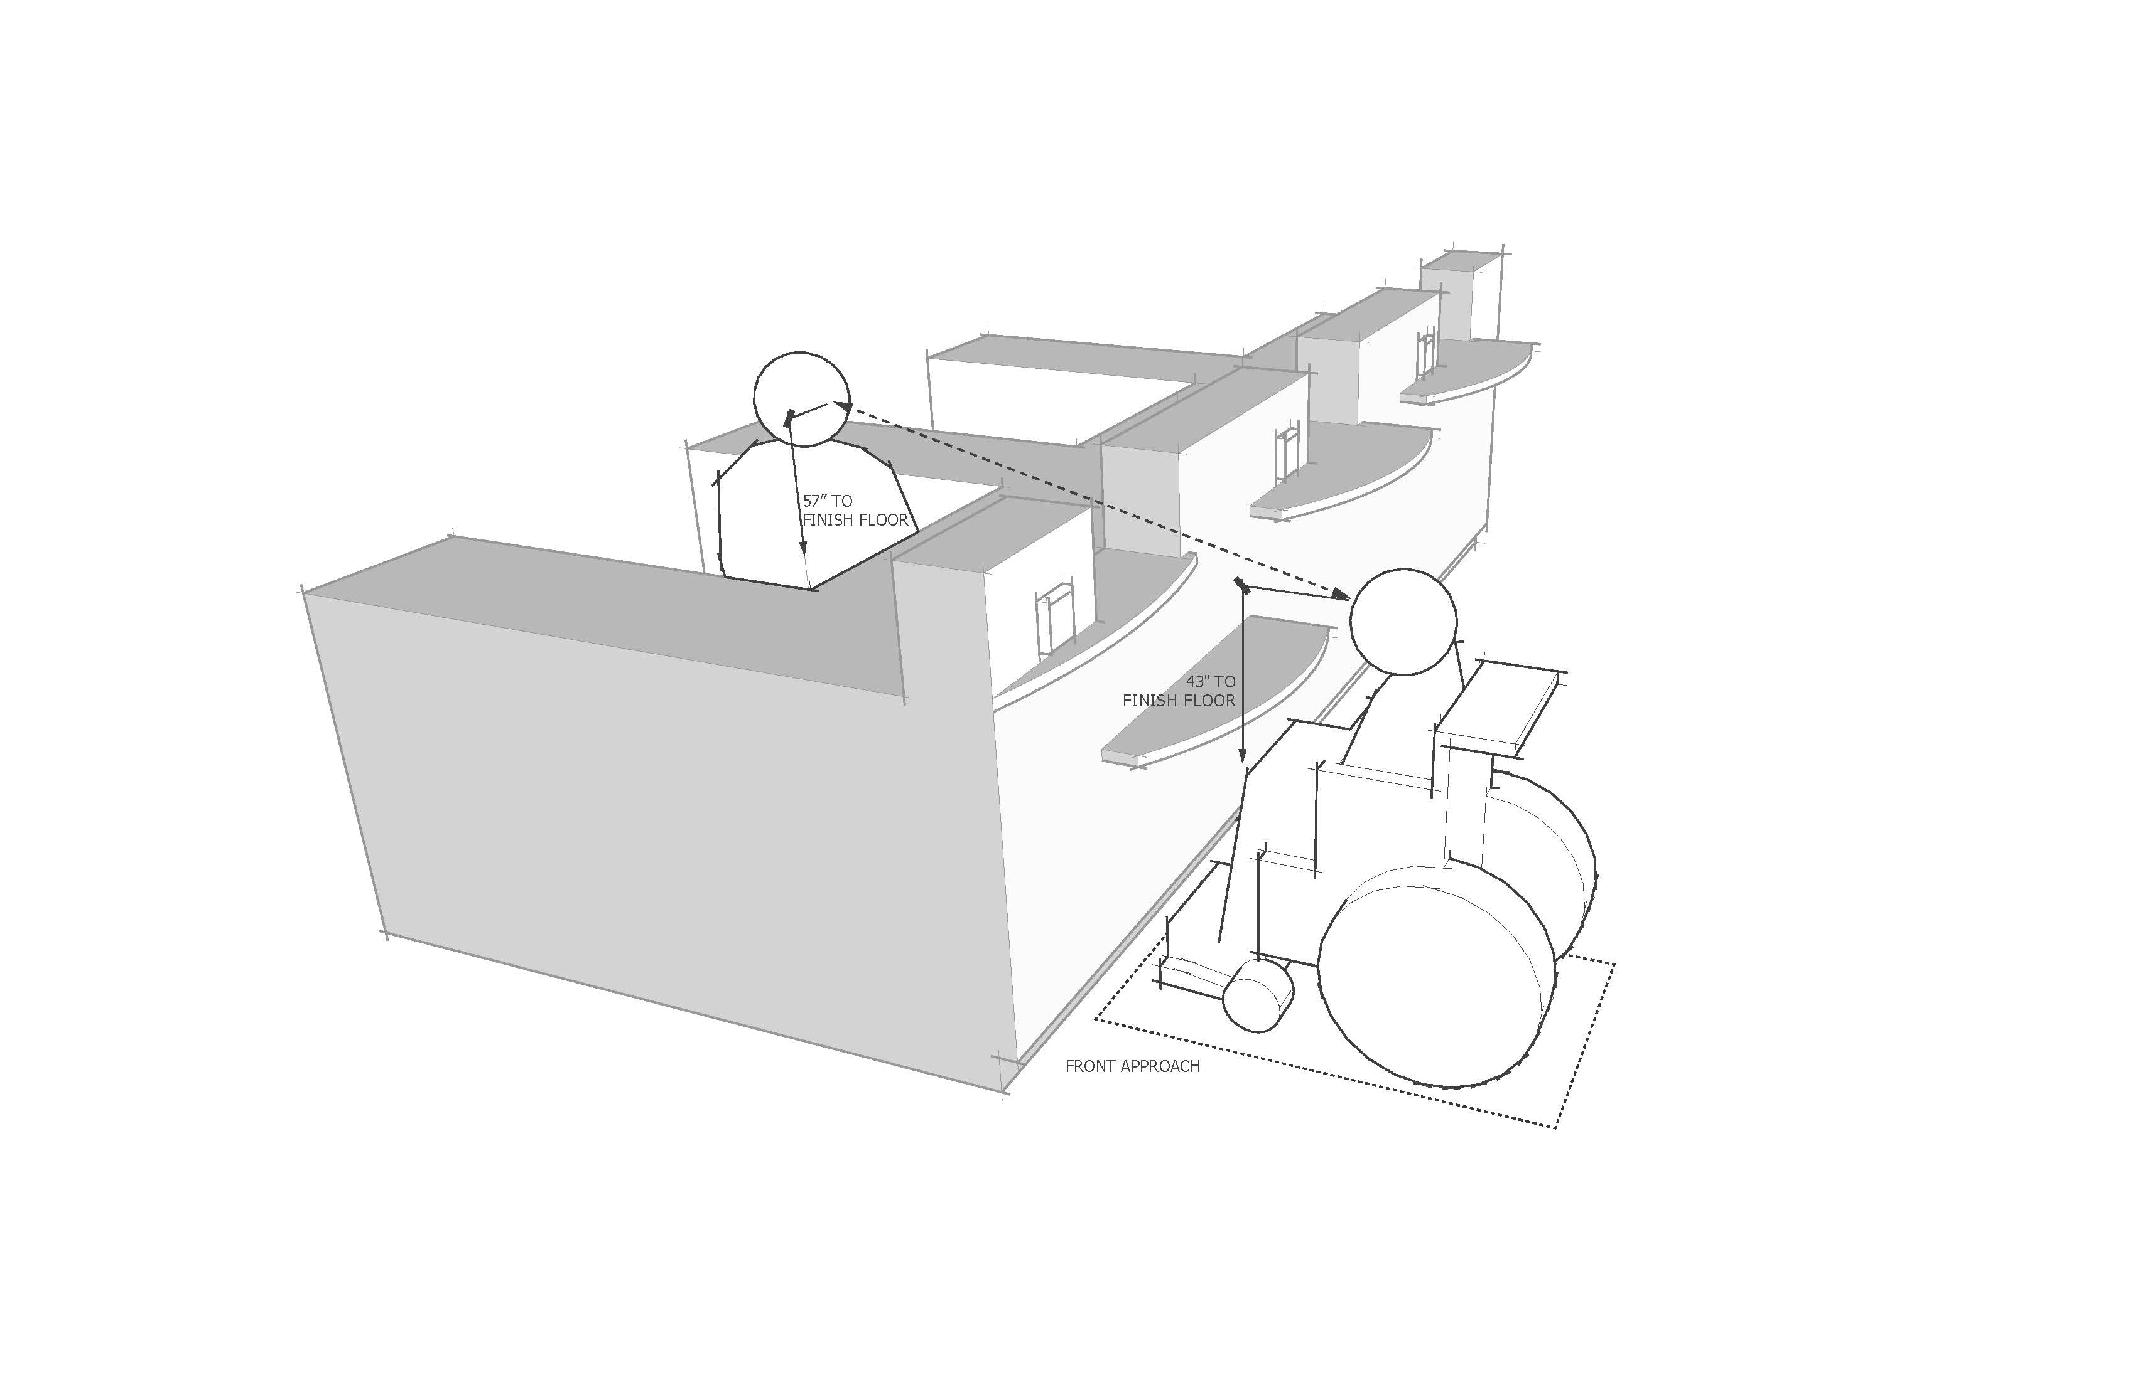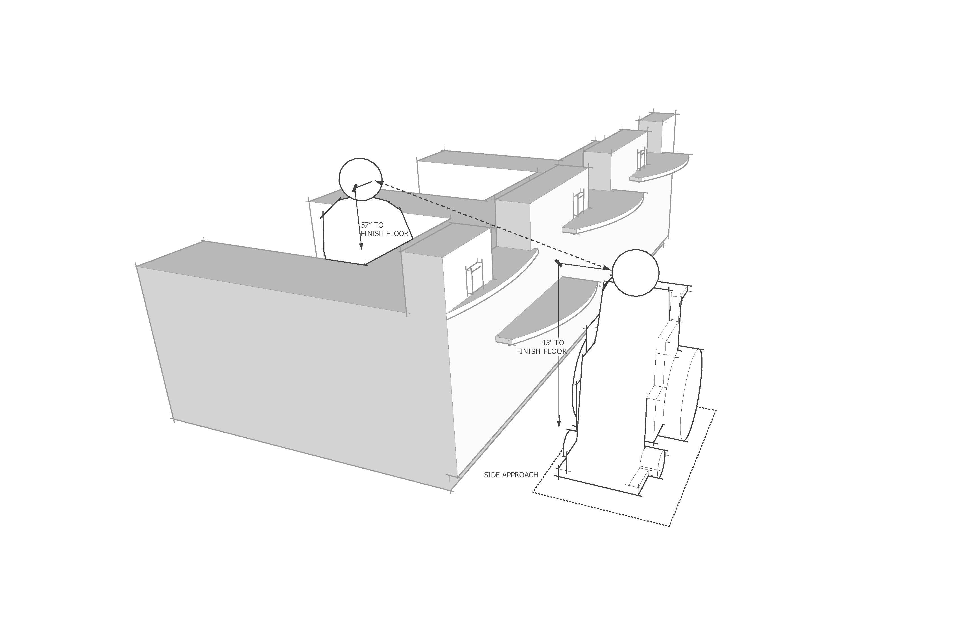

Committee Review of Comments and Action – July 2013

Approval with Modifications based on Comments.

Committee Reason: The revision removes text that would allow a small shelf for the public rather than a full and equal counter for both the sales personnel and the customers. The revision is based on comment 9-7.1. See also discussion on 9-10-12.

Modification.

Further revise the proposal as follows:

904.3 Sales and Service Counters. Sales and service counters shall comply with Section 904.3.1 or 904.3.2. The accessible portion of the countertop shall extend the same depth as the public side portion of the sales and service countertop or where a split-height public-side countertop is provided, the depth of the accessible portion shall be equivalent to the upper portion depth.

9-9– 12
904.3
Proposed Change as Submitted

Proponent: Kim Paarlberg, International Code Council

Revise as follows:

904.3 Sales and Service Counters and Windows. Sales and service counters and windows shall comply with Section 904.3.1 or 904.3.2. Where counters are provided, the accessible portion of the countertop shall extend the same depth as the sales and service countertop.

Reason: The quantity of change proposals submitted by International Code Council is reflective of three elements of our work: 1. ICC is the Secretariat for the Standard and some changes reflect inconsistencies or improvements suggested by staff; 2. ICC develops and publishes a Commentary on the standard and writing the commentary illuminates issues of the text and figures; and 3. ICC provides an interpretation service for the standard which results in the observation of provisions the users find most confusing.
The main text was changed last cycle to include windows, but there were no provisions in the technical requirements for what was applicable.
input.doc

Committee Action

Approved
Committee Reason: The change provides clarity with respect to the application of the Standard to sales and service windows.

BALLOT COMMENTS

9-9.1
Commenter: M. Bradley Gaskins, Representing NACS
Ballot: Negative with comment:

Comment: This is an incorrect application to windows and will create a substantial burden and design issue in regards to the height of a window. This will conflict with the reasoning for the previous action taken on 9-7. A service counter at the appropriate height of 36” served by a window at 42” is accessible and therefore should be allowed. In an example this will cause confusion in the application to a bank teller line as the “window” of the teller line must now be lowered and will contradict the allowance for the teller side of the “window” to not be controlled by this standard as applied in 9-7.

Committee Review of Comments and Action – July 2013

Approved.

Committee Reason: The committee considered the information provided by the comments and decided to take no action to change its original approval of this proposal.

Ballot Comments on July 2013 Committee Action Report

NACS – Bradley Gaskins
Affirmative with Comment: Ballot:
Comment: This needs to be coordinated with 9-7-12.

9-10– 12
904.3
Proposed Change as Submitted

Proponent: Kim Paarlberg, International Code Council

Revise as follows:

904.3 Sales and Service Counters. Sales and service counters shall comply with Section 904.3.1 or 904.3.2. The accessible portion of the countertop shall extend the same depth as the sales and service countertop. The accessible portion of sales and service counter shall be located so that a person using a wheelchair is visible to the staff behind the counter.

Reason: The quantity of change proposals submitted by International Code Council is reflective of three elements of our work: 1. ICC is the Secretariat for the Standard and some changes reflect inconsistencies or improvements suggested by staff; 2. ICC develops and publishes a Commentary on the standard and writing the commentary illuminates issues of the text and figures; and 3. ICC provides an interpretation service for the standard which results in the observation of provisions the users find most confusing.
The current text allows for obstructed counters so that you cannot have the interaction with the service personnel.

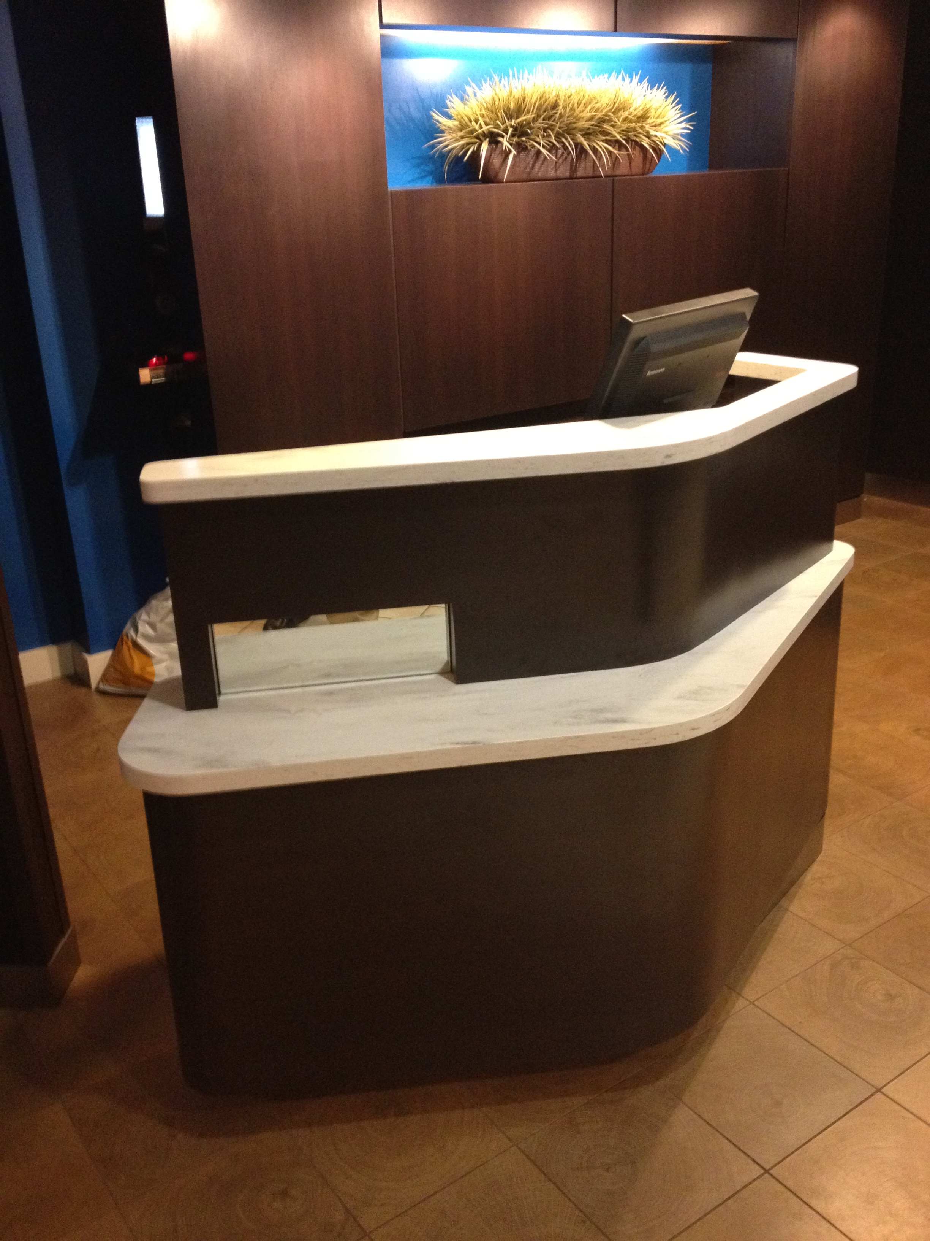
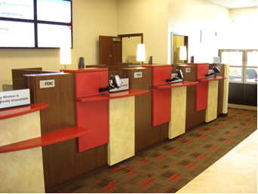

input.doc

Committee Action

Approved
Committee Reason: The Committee recognized that this proposal addresses an issue not adequately covered by the Standard. While the proposal was approved, the Committee acknowledged that the proposed text needs to be improved to be more specific and more measurable.

BALLOT COMMENTS

9-10.1
Commenter: Kim Paarlberg, Representing ICC
Ballot: Affirmative with comment:

Comment: The committee asked for additional work on this idea. I was thinking along the line of using the height of visions panels, 43” maximum, for any solid opaque obstruction. This is based on the lower edge of the eye height of a person using a wheelchair. That would allow a line of sight from a person in a wheelchair to a person sitting on the other side. I did not want to try for allowing higher based on line of sight. There is too much variation on the height of someone standing behind the counter and it is dependent on the depth of the counter and how far out you expect someone to be seen.

There will be a modification proposed.

9-10.2
Commenter: Ken Schoonover
Ballot: Negative with comment:

Comment: The intent of the proposal has merit, but the language is unenforceable and begs a variety of inconsistent interpretations. The standard should not use people as the points of measurement for determining compliance. For example, there may be several staff persons “behind the counter”. The proposal is likely referring to a staff person at the accessible counter location, but that’s not clear. One could interpret this to mean any or all of the staff behind the counter. Is there a standard height of the staff behind the counter that must be assumed? Is the staff assumed to be positioned immediately at the counter location, or is the person using a wheelchair required to visible to the staff person standing near but not immediately at the counter location? I don’t have precise language to offer at this time, but the standard should state this in terms of fixed of definable spaces or elements, such as the accessible counter not being visually obstructed the work station serving the accessible counter.

Proponent Comment

9-10.3
Commenter: Kim Paarlberg, Representing ICC

Replace the proposal with the following:

904 Sales and Service Counters

904.1 General. Accessible sales and service counters and windows shall comply with Section 904 as applicable.

EXCEPTION: Drive up only sales or service counters and windows are not required to comply with Section 904.

904.3 Sales and Service Counters. Sales and service counters and windows shall comply with Sections 904.3.1 or and 904.3.2 or 904.3.3. Where a counter is provided, the accessible portion of the countertop shall extend the same depth as the sales and service countertop provided for standing customers.

904.3.1 Vertical separation. At service windows or service counters, any vertical separation shall be at a height of 43 inches (1090 mm) maximum above the floor.

Exception: Transparent security glazing is permitted above the 43 inches (1090 mm) maximum height.

904.3.1 904.3.2 Parallel Approach. A portion of the counter surface 36 inches (915 mm) minimum in length and 26 inches (660 mm) minimum to 36 inches (915 mm) maximum in height above the floor shall be provided. Where the counter surface is less than 36 inches (915 mm) in length, the entire counter surface shall be 26 inches (660 mm) minimum to 36 inches (915 mm) maximum in height above the floor. A clear floor space complying with Section 305, positioned for a parallel approach adjacent to the accessible counter, shall be provided. The space between the accessible counter surface and any projecting objects above the accessible counter shall be 12 inches (305 mm) minimum.

904.3.2 904.3.3 Forward Approach. A portion of the counter surface 30 inches (760 mm) minimum in length and 36 inches (915 mm) maximum in height above the floor shall be provided. A clear floor space complying with Section 305, positioned for a forward approach to the accessible counter, shall be provided. Knee and toe clearance complying with Section 306 shall be provided under the accessible counter. The space between the accessible counter surface and any projecting objects above the accessible counter shall be 12 inches (305 mm) minimum.

904.4 Checkout Aisles. (no change)

904.5 Food Service Lines. (no change)

904.6 Security Glazing. Where counters or teller windows have security glazing to separate personnel from the public, a method to facilitate voice communication shall be provided. Telephone handset devices, if provided, shall comply with Section 704.3.

Reason: There is constant misinterpretation on what “extend the same depth of as the sales and service counter” means. There are scoping exceptions for counters for employee in IBC and ADA, so this is not intended to be the employee side of a counter. During discussions at the last development meetings, this was stated several times. It is my understanding that to match the employee side is why the customer service window is currently permitted at 36”. The new recommendations for standing employees is to put the work surface at 42” high.
In addition, the discussion for service counters and windows have always been towards allowing for a face to face communication. They current text currently says nothing about this requirement.
The difficulty is that there often is not a distinct separation between the employee side and the customer side. If the counter is the same height on both sides and 36” or lower, this is not an issue. When it is different, the new section 904.3.1 would allow for visual communication regardless if both employee and customer are seated or one is standing. This would also prevent the interpretation that a ‘shelf’ at the accessible height is acceptable on the customer side of a high wall. (For example, the height of the wall at my bank is 60”.)
The dimensional information currently used in the ICC A117.1 is that the eye height of a person using a wheelchair is 43” to 51”. The 43” is currently used for visions panels (404.2.10). That would allow a line of sight from a person in a wheelchair to a person sitting on the other side. I did not want to try for allowing higher based on line of sight. There is too much variation on the height of someone standing behind the counter and it is dependent on the depth of the counter and how far out you expect someone to be seen. This would also put an location where the employee might be handing a customer something to be within the reach range.
The allowance for security glazing would address the issues raised by facilities such as bank and currency exchanges.
The clear height above the accessible service counter would prevent someone from putting an ‘accessible’ shelf immediately below the standing counter. This matches the language used for grab bar clearances (609.3). To stop someone from putting a counter so low that is was unusable, there must be a minimum height for parallel approach. Th3 26” is from work surfaces (902.5.2).

Committee Review of Comments and Action – July 2013

Approval with Modifications based on Comment.

Committee Reason: The committee considered revisions to the original proposal based on comment 9-10.3. The revisions provided much clearer text than currently in the standard. It does not appear to conflict with the ADA. The proposal adds a minimum height of 26 inches which is the same as for work surfaces. Representatives of retail industry found the revision clear and workable.

Modification.

Replace the proposal with the following:

904.3 Sales and Service Counters. Sales and service counters and windows shall comply with Sections 904.3.1 or and 904.3.2 or 904.3.3. Where a counter is provided, the accessible portion of the countertop shall extend the same depth as the sales and service countertop provided for standing customers.

904.3.1 Vertical separation. At service windows or service counters, any vertical separation shall be at a height of 43 inches (1090 mm) maximum above the floor.

Exception: Transparent security glazing is permitted above the 43 inches (1090 mm) maximum height.

904.3.1 904.3.2 Parallel Approach. A portion of the counter surface 36 inches (915 mm) minimum in length and 26 inches (660 mm) minimum to 36 inches (915 mm) maximum in height above the floor shall be provided. Where the counter surface is less than 36 inches (915 mm) in length, the entire counter surface shall be 26 inches (660 mm) minimum to 36 inches (915 mm) maximum in height above the floor. A clear floor space complying with Section 305, positioned for a parallel approach adjacent to the accessible counter, shall be provided. The space between the accessible counter surface and any projecting objects above the accessible counter shall be 12 inches (305 mm) minimum.

904.3.2 904.3.3 Forward Approach. A portion of the counter surface 30 inches (760 mm) minimum in length and 36 inches (915 mm) maximum in height above the floor shall be provided. A clear floor space complying with Section 305, positioned for a forward approach to the accessible counter, shall be provided. Knee and toe clearance complying with Section 306 shall be provided under the accessible counter. The space between the accessible counter surface and any projecting objects above the accessible counter shall be 12 inches (305 mm) minimum.

Ballot Comments on July 2013 Committee Action Report

NACS – Bradley Gaskins
Affirmative with Comment: Ballot:
Comment: This needs to be coordinated with 9-7-12.

9-12– 12
905 (New)
Proposed Change as Submitted

Proponent: Kim Paarlberg, International Code Council

Add new text as follows:

905 Gaming machines and tables

905.1 Clear Floor Space. Accessible gaming machines and tables shall have a clear floor space complying with Section 305 positioned for transfer or for use by an individual seated in a wheelchair. Clear floor spaces required at gaming machines and tables shall be permitted to overlap.

EXCEPTION: Gaming tables or machines complying with Section 902 are not required to comply with Section 905.1.

905.2 Operable parts. Operable parts on gaming machines and tables shall not be required to comply with Section 309.

Reason: The quantity of change proposals submitted by International Code Council is reflective of three elements of our work: 1. ICC is the Secretariat for the Standard and some changes reflect inconsistencies or improvements suggested by staff; 2. ICC develops and publishes a Commentary on the standard and writing the commentary illuminates issues of the text and figures; and 3. ICC provides an interpretation service for the standard which results in the observation of provisions the users find most confusing.
A code change was passed in the IBC that requires one of each type of gaming machine or table to be accessible. The above is an attempt at providing appropriate technical criteria in A117.1. The options are providing a table with knee and toe clearances complying with the same provisions as a work surface, or providing the option of moving to the area of a table or machine and transferring to a seat.
input.doc

Committee Action

Approval as Modified

Modification

905 Gaming machines and tables

905.1 Clear Floor Space. Accessible gaming machines and tables shall have a clear floor space complying with Section 305 positioned for transfer or for use by an individual seated in a wheelchair. Clear floor spaces required at gaming machines and tables shall be permitted to overlap.

EXCEPTION: Gaming tables or machines complying with Section 902 are not required to comply with Section 905.1.

905.2 Operable parts. This portion of the proposal was not approved.

Committee Reason: The Committee agreed that the Standard needs to address casinos and similar facilities. This provides a minimum requirement. An exception for operable parts was not seen as justified.

BALLOT COMMENTS

9-12.1
Commenter: Kim Paarlberg, Representing ICC
Ballot: Negative with comment:

Comment: Gaming tables and machines are now scoped in the IBC to be accessible. It is not the intent to change the nature of the activity. This is consistent with what is permitted for exercise equipment, Section 1101.2.4. It is not reasonable without input from the industry to require operable parts on machines to meet accessibility requirements. This portion of the requirement should be added back into the proposal.

Revise proposal as follows:

905.2 Operable parts. Operable parts on gaming machines and tables shall not be required to comply with Section 309.

Proponent Comment

9-12.2
Commenter: Kim Paarlberg, Representing ICC

Further modify as follows:

905 Gaming machines and tables

905.2 Operable parts. Operable parts on gaming machines and tables shall not be required to comply with Section 309.

Reason: The committee modified the original proposal to delete the exception for operable pars.
Gaming tables and machines are now scoped in the IBC to be accessible. It is not the intent to change the nature of the activity. This is consistent with what is permitted for exercise equipment, Section 1101.2.4. It is not reasonable without input from the industry to require operable parts on machines to meet accessibility requirements. This portion of the requirement should be added back into the proposal.
The committee asked that I try and reach out to providers of gaming machines. While I was unable to reach any suppliers, I did speak with several code officials that were in cities with a high number of casinos. All felt that the exception for operable parts was necessary. The variety of machines on the market is too varied to have any specific limitation.

Committee Review of Comments and Action – July 2013

Approval as Modified.

Committee Reason: The committee considered restoring the exception for operable parts on gaming machines. The committee maintained the original approval as modified. The consensus was that the gaming equipment should have operable parts which are accessible.

9-13– 12
905.1
Proposed Change as Submitted

Proponent: Kim Paarlberg, International Code Council

Revise as follows:

905.1 General. Accessible storage facilities shall comply with Section 905.

EXCEPTION: Kitchen cabinets are not required to comply with Section 905.

Reason: The quantity of change proposals submitted by International Code Council is reflective of three elements of our work: 1. ICC is the Secretariat for the Standard and some changes reflect inconsistencies or improvements suggested by staff; 2. ICC develops and publishes a Commentary on the standard and writing the commentary illuminates issues of the text and figures; and 3. ICC provides an interpretation service for the standard which results in the observation of provisions the users find most confusing.
This proposal is intended as a coordination change related to revisions that were made in the 2009 edition of the standard. In the 2009 development cycle the requirements for kitchen storage in the general kitchens, Accessible units and Type A units were modified. See Sections 804.5, 1002.14, 1003.12.5 and 1003.14 from the 2003 standard; and compare to the 2009 edition where:
(a) the general kitchen storage requirements were deleted,
(b) the Accessible unit storage provisions were modified to exclude kitchen cabinets,
(c) the Type A unit kitchen storage requirements were deleted, and
(d) the Type A unit storage requirements were modified to exclude kitchen cabinets.
While the 2003 edition had a section to specifically address the storage in a general kitchen (Section 804.5 in 2003) there is no comparable section within the 2009 standard. This has caused users to now turn to the general storage requirements of Section 905 and to begin trying to apply them to the general kitchens that are constructed using Section 804.
While it is possible to point to the “intent” of the previous code change, (explaining that 804.5 was removed; plus pointing to the related changes in 1002.14 and 1003.14) there is no language within the standard that would indicate the kitchen cabinets in Section 804 are not required to meet the general storage provisions. Under the 2003 standard it could be argued that the kitchen storage requirements of Section 804.5 were a specific requirement and therefore the provisions of 905 did not apply. With the loss of Section 804.5 there is no longer a specific requirement and therefore it appears that the general requirements may be applicable.
The proposal shown above will really only affect the kitchens constructed under Section 804 since the Accessible units and Type A units already have a similar exception in Sections 1002.14 and 1003.14. The Type B units do not have a storage requirement but could also use this exception if someone did try to impose the general storage requirements on a Type B unit.
The only other option that I can see to clarify this issue is to add a new section into Section 804 and specifically state that kitchen cabinets are not required to comply with Section 905. That would be unusual from a format standpoint because it would simply say something was not required even though there is no longer a base paragraph which would indicate that element is regulated.
input.doc

Committee Action

Approved
Committee Reason: The proposal provides a needed clarification of the actions taken by the Committee for the 2009 edition of the Standard.

