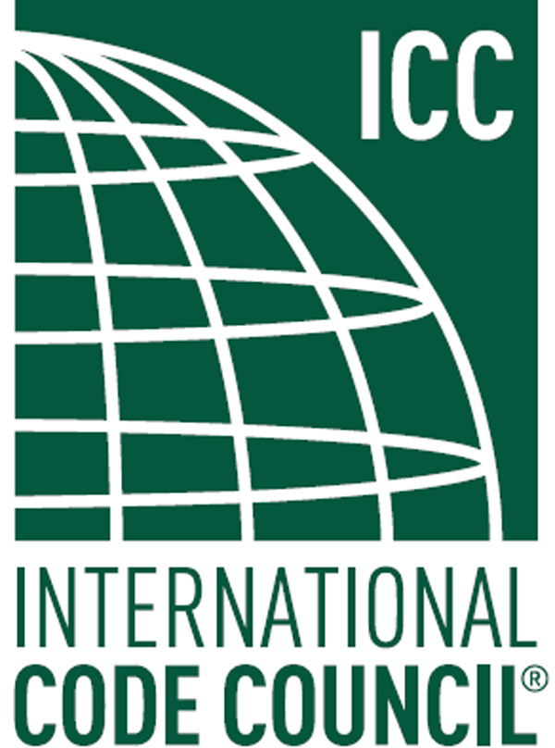

ICC A117.1 STANDARD

PUBLIC COMMENT REPORT

FOURTH PUBLIC REVIEW DRAFT

October 14, 2016

ICC/ANSI A117.1 STANDARD
DEVELOPMENT - 2015 EDITION

A117.1 Standard Committee

2012 Cycle Changes to review for

2015 Edition of the A117.1 Standard
Copyright ©2016 International Code Council, Inc.
ICC A117.1 Standard – Accessible and Usable Buildings and Facilities
Fourth Public Review Draft
Public Comment Report – October 14, 2016

Fourth Public Review Draft: The Fourth Public Review Draft of the ICC A117.1 Standard – 2015 edition was published on August 25, 2016. The public was afforded though October 11, 2016 the opportunity the submit comments on the changes contained in the Fourth Public Review Draft.

No comments were received.

The Fourth Public Review Draft contained the final technical changes approved by the A117.1 Accessibility Standard Committee. These will be incorporated into a complete draft of the 2015 Edition of the A117.1 standard. The A117.1 Committee will be asked to approve publication of the complete revised standard at a meeting in early 2017. Notice of the meeting will be published.

Third Public Review Draft: The Third Public Review Draft of the ICC A117.1 Standard – 2015 edition was published on July 2, 2015. The public was afforded through August 17, 2015 the opportunity to submit comments on the changes contained in the Third Public Review Draft.

Fifteen distinct public comments addressing 9 of the changes in the Third Public Review Draft were received addressing the substantive changes contained in the Third Public Review draft. Those 15 comments are found in this report. Each comment is considered as a separate agenda item. The agenda item numbers are a subnumber to the agenda item number from the February 2015 meeting.. They are also numbered according to the original comment number system for the purposes of keeping a consistent record of the proposals and the subsequent actions affecting each.

No substantive public comments were received on 17 changes published in the Third Public Review Draft. These 17 changes are now complete and will be reflected in the next edition of the standard. They are not subject to further public review. In addition to the 15 comments on the agenda, comments were received which suggested amendments to provisions of the standard which are not currently open to comment. Such comments are outside the scope of the current review. Finally a few comments were purely editorial in nature and will be addressed as such.

The proponents of the 53 public comments to the Second Public Review Draft were asked if they considered the issues raised by their public comment to be resolved by the Committee’s action in February 2015. If not, they could have requested further consideration by the committee. On such request was received regarding an issue which the committee did not approve. A separate report – Unresolved Issue Report – September 25, 2015 will be issued concurrently with this report.

Second Public Review Draft: The Second Public Review Draft of the ICC A117.1 Standard – 2015 edition was published on November 7, 2014. The public was afforded though December 22, 2014 the opportunity the submit comments on the changes contained in the Second Public Review Draft.

Fifty-three distinct public comments addressing 37 of the changes in the 2nd Public Review Draft were received addressing the substantive changes contained in the Second Public Review draft. In February of 2015, the A117.1 Committee considered each public comment and took action on each. Of those actions, 26 resulted in changes to the Second Public Review Draft. Those 26 changes were assembled and published as the Third Public Review Draft.

First Public Review Draft: In October of 2013, the First Public Review Draft of the ICC A117.1 Standard was published and available for public comment. Approximately 200 public comments were received. During 2014, the A117.1 Committee considered each public comment and took action on each. Of those actions, 61 resulted in additional changes to the draft A117.1 standard. Those 61 changes were assembled and published as the Second Public Review Draft.

The proponents of the 200 public comments were asked if they considered the issues raised by their public comment to be resolved. If not, they could have requested further consideration by the committee. Outside of the public comments received on the Second Public Review Draft, no comment proponent provided communication that their issue was unresolved. Therefore there is no unresolved issues report at this stage of the process.

If you have questions, please direct them to Kermit Robinson, krobinson@iccsafe.org

