PKH 04/01/2009
CTC Code Change Proposal – Re: E85-07/08
Code: IBC, IRC
Sections: 1013.2, R312.2
IBC & IRC: Fixed seating – furniture or fixture designed and installed for the use of sitting and secured in place including bench-type seats and seats with or without back or arm rests.
IBC: 1013.2 Height. Required guards shall not be less than 42 inches (1067 mm) high, measured vertically above the following:
1. The highest adjacent walking surface within 22 inches of the required guard,
2. The seat surface of adjacent fixed seating, with or without arm or back rests, within 22 inches of the required guard or
Alternative: 2. For a seat surface of adjacent fixed seating, with or without arm or back rests, within 22 inches of the required guard , the guard height shall provide a minimum 42 inches measured diagonally between the top of the guard and the nearest edge of the seat or
3. For stairs, the line connecting the leading edges of the treads nosings and
4. For ramps, the ramp surface at the guard.
Exceptions:
1. For occupancies in Group R-3… (no change)
2. No change
3. The guard height in front row assembly seating areas complying shall be in accordance with Section 1028.14.2.
4. No change
IRC R312.2 Height. Required guards at open-sided walking surfaces, including stairs, porches, balconies or landings, shall be not less than 36 inches high measured vertically above the following:
1. The highest adjacent walking surface within 22 inches of the required guard,
2. The seat surface of adjacent fixed seating, with or without arm or back rests, within 22” of the required guard, or
Alternative: 2. For a seat surface of adjacent fixed seating, with or without arm or back rests, within 22 inches of the required guard , the guard height shall provide a minimum 36 inches measured diagonally between the top of the guard and the nearest edge of the seat or
3. For stairs, the line connecting the leading edges of the treads nosings and
4. For ramps, the ramp surface at the guard.
Exceptions:
1. Guards on open sides… (no change).
2. Where the top of the guard… (no change).
Reasons: The purposes of this proposal are to address several items raised in the hearings on and consideration for CTC Proposal E85-07/08. In particular, this proposal clarifies what constitutes “fixed seating” and proposes a horizontal distance between an object that reduces the “effective” height of a required guard rather than placing total reliance on “adjacent”.
Definition: The definition of “fixed seating”, if necessary, provides for a common understanding where the term is used.
Application #1: Rather than solely rely on term such as “adjacent”, the highest walking surface within 22 inches of the guard would determine the required guard height above the walking surface. For example, if a walking surface included a step down riser within 22” of and parallel to the guard, the guard height would be required to be increased from 42 inches to 42 inches plus the riser height. If the riser did not extend the length of the guard, the required guard height would be increased for the portion of the guard within 22 inches of the riser (such as measured on an angle). See the Alternative to Application #2 for consideration in dealing with elevated floor surfaces within 22” of the guard.
The horizontal distance from the guard of 22” is based on a “best” or rather “what looks best” guess. The closest current text dealing with this type of issue is Section 1025.14 on Assembly guards and, in particular, the last sentence of Section 1025.14.3 which does not involve the sightlines consideration of exception 2.
Application #2: The concern is fixed seating, with or without arm rests and with or without back rests including bench seating, which provide a potential standing surface within 22’ of the guard. The required guard height would be 42” plus the height of the seat surface within 22” of the guard. The guard would be required to extend past the “last” seat in a row so that the guard is 42” above the last seat until the guard reaches a point of 22 inches from the seat. At that point, the guard height can decrease in height to 42” above the floor. See sketch.
Alternative to Application #2: This text is an alternative for replacement of Application #2. This utilizes the diagonal measurement between the top of the guard and the edge of the seat. The alternative will be more lenient than the application text by allowing lower guards.
Application #3: The current text is modified to indicate that the line is to be between the tread nosings. In the case of a single riser, hence a single nosing, a treat depth on the lower surface establishes the slope. See sketch.
Application #4: The required guard height for a ramp which slopes towards the guard would be determined by the highest point of the walking surface within 22 inches – the guard would be required to have a height of 42 inches plus the vertical distance from the point 22 inches from the guard. If the ramp sloped parallel to the guard, the guard height would be 42 inches with the top of the guard having a parallel slope to that of the ramp. Note that a ramp slope towards the guard of 1/12, the highest point 22’ from the guard would increase the guard height a total of 1.83 inches. If the ramp slope is 1/8, the guard height is increased 2.75 inches.
The exceptions remain unchanged except for consideration for seating in assembly areas, which are not front row seating. The provisions for guard reduction for front row seating are primarily intended to accommodate the sight line for seated occupants- see section 1028.14.2. The seating within 22 inches of the guards elsewhere would necessitate an increase in the required guard height as indicated in Application #2.
Please note that the study group for this proposal included Tom Kuzik Jr., Dave Cooper and Paul Heilstedt. Also the sketches are the property of Tom Kuzik Jr.
Sketch of Application #2 The distance from the standing surface to the guard top approximates the distance from the feet to the center of gravity of an adult’s body; albeit a non-Jewell body. Note that if the elevated walking surface or seat surface is any closer than 22 inches from the guard, the guard height would be required to be 57” (IBC) and 51” (IRC).
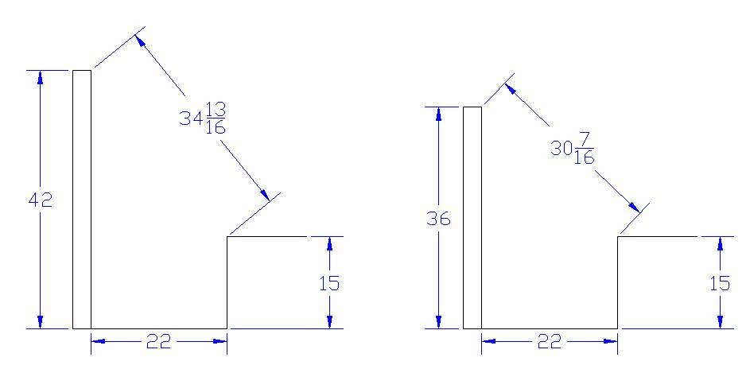
IBC IRC
Sketch of Application #3 A single riser transition of guard height.
