CTC Charge to the Study Group:

"The CTC concurs that all guard configurations are potentially climbable. The study group is charged with developing design criteria for guard configurations, which are “Climb resistant.”

Progress Report of the Climb Resistant Design Configuration Study Group

November 30, 2005

The study group to “develop…(sic) design criteria for guard configurations which are ‘Climb Resistant’” held two teleconference meetings 11/2/05 and 11/17/05 the product of which was three separate drafts of potential criteria to be considered (Exhibits A, B, & C) as well as notes from Bob Lee (Exhibit D)

There being no new data or testing results related to cause or effect available, these drafts were based on the same information previously presented to the CTC. For this reason “study” was limited to discussion and negotiation of how best to compile the existing information; all of which are posted on the CTC web pages. In addition, a task to further develop and combine the three drafts was assigned to a group of three participants: Ron Nickson, Tom Zuzik, and Dave Cooper; who teleconferenced on two occasions 11/18/05 and 11/21/05.
A single draft (Exhibit E) with unanimous agreement by the three participants to test the criteria before recommending adoption, as suggested by Ron Nickson, was brought before the study group in a third teleconference on 11/23/05. In this conference it was noted that this new draft, which included possible offset rail configurations (Diagram 1) did not reflect all of the concerns of the study group (i.e. residential applications, height requirement, horizontal elements, protrusions, recesses, flexibility). Furthermore the basis for some of the prescriptive recommendations was founded on limited, non-scientific testing of a demographic that did not include three to four year old children.

It was also noted that the compiled draft could only give limited direction for any necessary testing. Such testing could eliminate or restrict some climb resistant solutions, and might serve to alleviate the potential replacement of one problem with another. Finally, it was reported that Elliot Stevenson was doing informal testing of grasp resistant profiles, sketches of which (Diagram 2) were presented to the committee, but no testing results are yet available.
After a split vote of 5 to 4 in favor of presenting Exhibit E to the CTC, further concerns were expressed for the fact that in the process to date, the group’s studies have been limited to negotiation and compilation. It was felt that this process could misrepresent or give the impression that actual studies had been conducted, which could, of course, lead to misunderstanding. It was decided by consensus that the extreme limitations of the study group be reported in conjunction with the current work product being submitted for review. Further concerns related to the timeframe for development of design criteria were voiced in this teleconference. These concerns were not quantified by vote but a consensus that additional time could help the study group to sort out the issues not yet addressed (residential applications, height requirement, horizontal elements, protrusions, recesses, flexibility, etc.). A target date of the February CTC meeting was discussed as a possible reasonable deadline.

In a planned meeting held in Las Vegas on November 30, 2005, further negotiations of the study group yielded the following work in progress – Exhibit F submitted by Dan O’Brien, and reviewed documents presented by Elliot Stevenson. The study group will focus on the determination of configurations to be tested for climb resistance.

Based on the foregoing, no conclusive recommendation for ‘design criteria for guard configurations which are ‘Climb resistant’” can be made by the study group at this time.

EXHIBIT A - ZUZIK

1012.6 Horizontal Offset Top Molding. Required guards mounted on landings, walkways, balconies or porches, with the walking surface more than 16 ft (4.8768 m) above the walking surface or ground below, measured to a point 48 inches (1219.2 mm) horizontal off the edge, shall have a minimum off set top molding of 5 inches (127 mm) measured from the inside edge of a 1 sqft section of the infill area of the guard to the inside edge of the offset top molding. The offset top molding must project in towards the walking surface the guard is providing protection for.

Exceptions:

- Guards in Group R-3, or guards on inside landings in individual dwelling units in Group R-2 are exempt and are not required to have a horizontal offset top molding.
- Guards on the open sides of stairs are exempt and are not required to have a horizontal offset top molding.
- Guards in areas which are not open to the public within occupancies in Group I-3, F, H or S, are exempt and are not required to have a horizontal offset top molding.
- Guards with a constant vertical rise that leans in towards the walking surface on an angle of 83.5 degrees or more, resulting with the inside edge of the guards top molding being more than 5 inches (127 mm) horizontal from the inside edge of the bottom of the guard, were the guard attaches to the walking surface or adjacent wall, are acceptable and meet the requirements of 1012.6.
- Guards were the top 8 inches (203.2 mm) of the guard angles a minimum of 45 degrees towards the walking-surface side of the guard, are acceptable and meet the requirements of 1012.6.

EXHIBIT B - MOSS

1012.4 Guard Top Design. Where guard is mounted on a horizontal balcony or porch, with a floor distance more than 14 ft (4.3m) higher than the lower surface, the guard top to have an installation of a 5 inch (127 mm) offset handrail or other protrusion in front of guard, or a large profile top. If guard top is required, use option 1012.4A, 1012.4B, 1012.4C, or 1012.4D

Exceptions:
- Does not apply in Group R-3, as applicable in Section 101.2
- Guards on open side of stairs do not require this offset or top.
- Does not apply where guards are not required, as defined in Section 1012.1.
- Does not apply in areas which are not open to the public within occupancies in Group I-3, F, H or S, where balusters, horizontal intermediate rails or other construction shall not permit a sphere with a diameter of 21 inches (533 mm) to pass through any opening.

1012.4A. Provide a 5 inch (127 mm) offset handrail or protrusion; offset needs to be mounted at top of guard on walking-surface side of guard. Five inch (127 mm) offset to be measured horizontally from the vertical plane of the guard

1012.4B. Angle the entire guard from the vertical such that the top of the guard leans toward the walking-surface side of the guard. The resulting guard top would be five inches in from the bottom of the guard as measured horizontally from the vertical plane of the guard. The top of the guard to be a minimum of 42 inches (1067 mm) high from the walking surface.

1012.4C. Fabricate the top 12 inches (305 mm) of the guard at an angle such that the top of the guard inclines toward the walking-surface side of the guard. The resulting guard top would be five inches in from the bottom of the guard as measured horizontally from the vertical plane of the guard. The top of the guard to be a minimum 42 inches (1067 mm) high from the walking surface.

1012.4D. Provide a top element of the guard that has a circular cross section with an outside diameter of 3 inches (76 mm) minimum. If the top element is not circular, it shall have a perimeter dimension greater than 9.5 inches (241 mm) with a minimum cross-section dimension of 3 inches (76 mm).

EXHIBIT C - COOPER

1012.3 Guard in-fill. Guards shall have in-fill such that a 4-inch (102 mm) diameter sphere cannot pass through . Guards, at elevated surfaces located more than 12 feet (3.66 meters) above the floor or grade below, with solid panel in-fill or in-fill with horizontal elements connecting verticals that create an obvious ladder effect, within the area that is 4 inches (102 mm) to 38 inches (965mm) above the floor, shall have a secondary 3 inch diameter top rail or an equivalent that is not graspable by children less than 4 years of age offset horizontally a minimum of 5 inches (127 mm) from the face of the infill on the floor side of the guard.

Offset rails shall not be permitted at the side of stairways and ramps where handrails are required.

Exceptions:

- The triangular openings formed by the riser, tread and bottom rail at the open side of a stair shall be of a maximum size such that a sphere of 6 inches (152 mm) in diameter cannot pass through the opening.

- At elevated walking surfaces for access to and use of electrical, mechanical or plumbing systems or equipment, guards shall have balusters or be of solid materials such that a sphere with a diameter of 21 inches (533 mm) cannot pass through any opening.

- In areas which are not open to the public within occupancies in Group I-3, F, H or S, balusters, horizontal intermediate rails or other construction shall not permit a sphere with a diameter of 21 inches (533 mm) to pass through any opening.

- In assembly seating areas, guards at the end of aisles where they terminate at a fascia of boxes, balconies and galleries shall have in fill such that a 4-inch-diameter (102 mm) sphere cannot pass through up to a height of 26 inches (660 mm). From a height of 26 inches (660 mm) to 42 inches (1067mm) above the adjacent walking surfaces, a sphere 8 inches (203 mm) in diameter shall not pass.

- Within individual dwelling and sleeping units in Groups R-2 and R-3 in fill for required guards on the side of a stair shall not allow a sphere of 4 3/8" (111 mm) to pass through.

- Within individual dwelling and sleeping units in Group R-3 offset and non-graspable top rails shall not be required.

Exhibit D - Lee

From Bob Lee – Town of Cave Creek

Here are a few versions that I can think of (I haven’t put them into code sections but are looking more at acceptable concept):

- To limit the climbability of guards with elements longer than 4 inches and less than 45º from the horizontal and where the potential for a fall is greater than 12 feet, the top rail must be larger than 2 inches in its least dimension and 5¹/₂ inches in its other dimension.
- To limit the climbability of guards with elements longer than 4 inches and less than 45º from the horizontal, the top rail must be larger than 2 inches in its least dimension and 5¹/₂ inches in its other dimension.
- To limit the climbability of guards with elements longer than 4 inches and less than 45º from the horizontal and where the potential for a fall is greater than 12 feet, the top rail must be larger than 2 inches in its least dimension and protrude 5¹/₂ inches over the protected side of the guard.
- Guards that protect from falls in excess of 12 feet must be constructed to restrict climbability. Guards that restrict climbability are solid vertical surfaces, smooth vertical spindles, those having a top rail of greater than 2 inches by 5¹/₂ inches and others that are determined by the building official to meet or exceed these expectations.
- Guards must be constructed to restrict climbability. Guards that restrict climbability are solid vertical surfaces, smooth vertical spindles, those having a top rail of greater than 2 inches by 5¹/₂ inches and others that are determined by the building official to meet or exceed these expectations.
- Guards that protect from falls in excess of 12 feet must be constructed to restrict climbability. Guards that restrict climbability are solid vertical surfaces, smooth vertical spindles, those having a top rail of greater than 2 inches in its least dimension and protrude 5¹/₂ inches over the protected side of the guard.
- Where guards are more than 12 feet (3658 mm) above the floor or grade below, no part of the guard system to 34 inches (864 mm) and longer than 4 inches (102mm) may be greater than forty-five degrees (45°) from vertical. (Or less than 45° from horizontal).
- When the potential distance of fall from the floor upon which a guard is constructed or installed exceeds 12 feet (3658 mm) above the finish grade or floor below in public areas and in all areas of Group R occupancies, guards shall have no toe-holds or foot-holds more than 6 inches (152 mm) above the adjacent floor finish. Then define toe-holds and footholds as “Toe-Holds in or on guards are clear openings more than 1/2 inch (12.7 mm) in width or protrusions, indentations, cut-outs or attachments exceeding 1/4 inch (6.4 mm) in depth or protrusion” and “Foot-holds in guards are clear openings more than 2 inches (51 mm) in width at which support for a foot or shoe is provided”.

“protected side of the guard” could be substituted with “in front of the railing” from the German, French and Swiss codes with “floor or walking surface protected by the guard” from the Canadian code or with “higher side of the guard” in numbers 3 and 6.

The 12 foot where the requirement becomes effective in numbers 1, 3, 4, 6, 7 and 8 is somewhat arbitrary but is based upon the concept that this more restrictive requirement would only be needed when the potential for injury is greater

EXHIBIT E – NICKSON, ZUZIK, COOPER

SECTION 1013.0 GUARDS

1013.1 Where required. Guards shall be located along open-sided walking surfaces, mezzanines, industrial equipment platforms, stairways, ramps and landings which are located more than 30 inches (762 mm) above the floor or grade below. Guards shall be adequate in strength and attachment in accordance with Section 1607.7. Where glass is used to provide a guard or as a portion of the guard system, the guard shall also comply with Section 2407. Guards shall also be located along glazed sides of stairways, ramps and landings that are located more than 30 inches (762 mm) above the floor or grade below where the glazing provided does not meet the strength and attachment requirements in Section 1607.7.

Exception: Guards are not required for the following locations:

- On the loading side of loading docks or piers.
- On the audience side of stages and raised platforms, including steps leading up to the stage and raised platforms.
- On raised stage and platform floor areas such as runways, ramps and side stages used for entertainment or presentations.
- At vertical openings in the performance area of stages and platforms.
- At elevated walking surfaces appurtenant to stages and platforms for access to and utilization of special lighting or equipment.
- Along vehicle service pits not accessible to the public.
- In assembly seating where guards in accordance with Section 1025.14 are permitted and provided.

1013.2 Height. Guards shall form a protective barrier not less than 42 inches (1067 mm) high, measured vertically above the leading edge of the tread, adjacent walking surface or adjacent seat-board.

Exceptions:

- For occupancies in Group R-3, and within individual dwelling units in occupancies in Group R-2, guards whose top rail also serves as a handrail shall have a height not less than 34 inches (864 mm) and not more than 38 inches (965 mm) measured vertically from the leading edge of the stair tread nosing.
- The height in assembly seating areas shall be in accordance with Section 1025.14.

1013.3 Opening limitations. Open guards shall have balusters or ornamental patterns such that a 4-inch-diameter (102 mm) sphere cannot pass through any opening up to a height of 34 inches (864 mm). From a height of 34 inches (864 mm) to 42 inches (1067 mm) above the adjacent walking surfaces, a sphere 8 inches (203 mm) in diameter shall not pass.

Exceptions:

- The triangular openings formed by the riser, tread and bottom rail at the open side of a stairway shall be of a maximum size such that a sphere of 6 inches (152 mm) in diameter cannot pass through the opening.
- At elevated walking surfaces for access to and use of electrical, mechanical or plumbing systems or equipment, guards shall have balusters or be of solid materials such that a sphere with a diameter of 21 inches (533 mm) cannot pass through any opening.
- In areas which are not open to the public within occupancies in Group I-3, F, H or S, balusters, horizontal intermediate rails or other construction shall not permit a sphere with a diameter of 21 inches (533 mm) to pass through any opening.
- In assembly seating areas, guards at the end of aisles where they terminate at a fascia of boxes, balconies and galleries shall have balusters or ornamental patterns such that a 4-inch-diameter (102 mm) sphere cannot pass through any opening up to a height of 26 inches (660 mm). From a height of 26 inches (660 mm) to 42 inches (1067mm) above the adjacent walking surfaces, a sphere 8 inches (203 mm) in diameter shall not pass.
- Within individual dwelling units and sleeping units in Group R-2 and R-3 occupancies, openings for required guards on the sides of stair treads shall not allow a sphere of 4-3/8” (111 mm) to pass through.

1013.4 Screen porches. Porches and decks which are enclosed with insect screening shall be provided with guards where the walking surface is located more than 30 inches (762mm) above the floor or grade below.

1013.5 Mechanical equipment. Guards shall be provided where appliances, equipment, fans or other components that require service are located within 10 feet (3048 mm) of a roof edge or open side of a walking surface and such edge or open side is located more than 30 inches (762 mm) above the floor, roof or grade below. The guard shall be constructed so as to prevent the passage of a 21-inch-diameter (533 mm sphere.

1013.6 Roof access. Guards shall be provided where the roof hatch opening is located within 10 feet (3048 mm) of a roof edge or open side of a walking surface and such edge or open side is located more than 30 inches (762 mm) above the floor, roof or grade below. The guard shall be constructed so as to prevent the passage of a 21 inch (533 mm) diameter sphere.

1013.7 High elevation guards. Guards on the open sides of landings, walkways, balconies or porches, where the walking surface is more than 16 ft (4.8768 m) above the walking surface or grade below, measured within 42 inches (1067 mm) horizontal from the edge of the elevated walking surface, shall have a top inside edge with a minimum radius of 1-1/2 inches (38 mm) or a equivalently non-graspable profile or a minimum 5 inch (127 mm) inward horizontal offset, measured from the base of the infill to a point 42 inches (1067 mm) above the adjacent walking surface. No infill elements may break the plan of the angle that establishes the off set.

Exceptions:

- Guards where the infill consist of only vertical infill balusters, starting from a horizontal point no higher than 4 inches (102 mm) above the walking surface and terminating at a point no lower than 39 inches (990 mm) above the walking surface. Solid surface and mesh infills are NOT exempt from Section 1013.7.
- Guards in Group R-3 occupancies.
- Guards on the interior of individual dwelling units in Group R-2 occupancies.
- Guards in areas which are not open to the public within occupancies in Group I-3, F, H or S.
- Guards in Section 1013.4 Screen porches.
- Guards in Section 1013.5 Mechanical equipment
- Guards in Section 1013.6 Roof access.

Exhibit F - Dan O’Brien

1013.7 High elevation guards. Guards on the open sides of landings, walkways, balconies or porches, are to be constructed in a manner that does not include straight, non-flexible elements greater than 4 inches in length that are within 30 degree of being horizontal, between the areas of 4 inch to 32 inches measured vertically off of the walking surface.

Exceptions:

- Where guards are not required, as defined in section 1012.1
- Guards in areas which are not open to the public within occupancies in Group I-3, F, H or S.
- Guards in Section 1013.5 Mechanical equipment
- Guards in Section 1013.6 Roof access.
- Guards on the open sides of stairs
- Where an offset rail is provided to resist climbing, such rail shall project inward towards the walking surface a minimum of 5 inches measured horizontally from the base of the guard. No infill element may break the plane of the angle the establishes the offset. The offset rail shall run the entire length of the guard and its top surface shall be mounted vertically within 1 inch of the top of the guard.
- Where alternative measures to an offset rail have been provided that render the guard equally climb resistant.
.

Diagram 1 - Top Molding and Railing Designs/Residential Story Heights –Zuzik
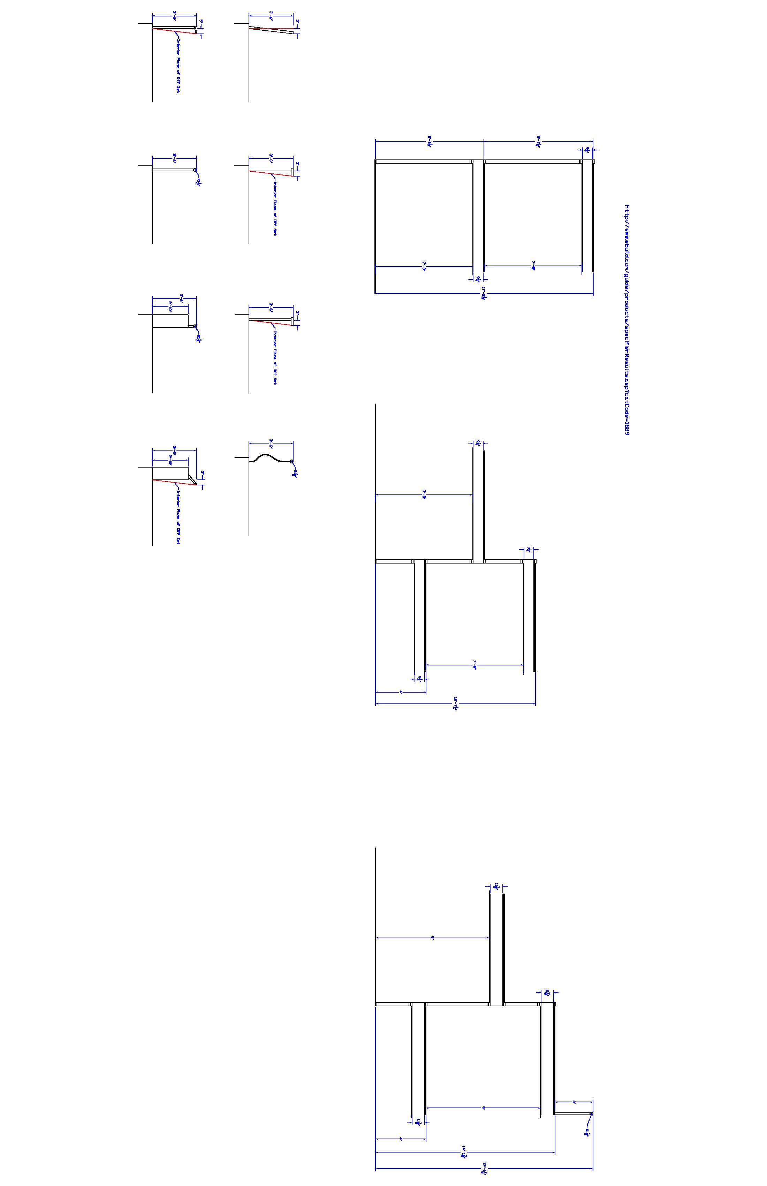
Diagram 2 – Top Rail Shapes to be Tested - Lee

Elliott Stephenson has built a section of guard of parallel, horizontal rails that he is going to use in testing various top rail shapes. The parallel rails are dowels spaced so that a 4” sphere won’t pass but are very climbable by a child. He has contacted a couple of different organizations with children to arrange for the testing. Here are the top rail shapes that Elliott Stephenson is testing:

1-1/2”
6”
1-1/2”
3”
6”
1-1/2”
3”
8”
10”
1-1/2”
This edge is the centerline of the climbable guard
Each of the bevels is at 45º

